Jiujiang Yangtze River Bridge (China)
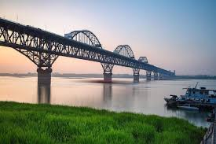

Overview
The Jiujiang Yangtze River Bridge is a combined road and rail bridge located in Jiujiang, Jiangxi Province, China. It crosses the Yangtze River and serves as one of the major transportation links in the region, connecting the cities of Jiujiang and Huangmei in Hubei Province.

History
Construction of the Jiujiang Yangtze River Bridge began in 1973 and was completed in 1992. It was officially opened to traffic in 1993. The bridge has played an important role in improving transportation and economic integration between the eastern and central parts of China.

Structure and Design
The bridge has a total length of approximately 7,675 meters (25,183 feet) and features a double-deck design. The upper deck carries a four-lane highway, while the lower deck accommodates a double-track railway. Its main span measures 216 meters (709 feet), supported by steel arches, making it one of the largest steel truss-arch bridges in China.

Importance
The Jiujiang Yangtze River Bridge significantly enhances the transportation efficiency between northern and southern China. It supports both freight and passenger traffic, contributing to the regional economy, tourism, and trade along the Yangtze River basin.

Interesting Facts
- The bridge combines both road and rail traffic on separate levels.
- It is considered one of the landmark bridges across the Yangtze River.
- The bridge provides scenic views, especially during sunrise and sunset.
- Maintenance and modernization projects have been undertaken to extend its lifespan and ensure safety.

