A footer is found at the bottom of a webpage, it usually contains important information such as a copyright notice, a disclaimer, or a few links to relevant resources for the or about the webpage.

A footer should be made in a way that it accomplishes one or more of a specific goal for your website, even if it does not seem like an important part of a website since it’s at the bottom of the site you still need to keep in mind that it might decide if a visitor stays on or website or leaves for good. Even though a website doesn’t need a footer to function it does provide an effective location to add content such as links, copyright statements and a logo for the website and you can also include a subscription input if the visitor wants to be updated with newsletters or a member card that you can join their member club if the company has such a thing. Here the card is in the footer. Relevant information is placed about becoming a member to gain access to sales benefits and so on.

This is how the footer looks on a mobile device it goes vertically downwards to fit all the content of the footer.

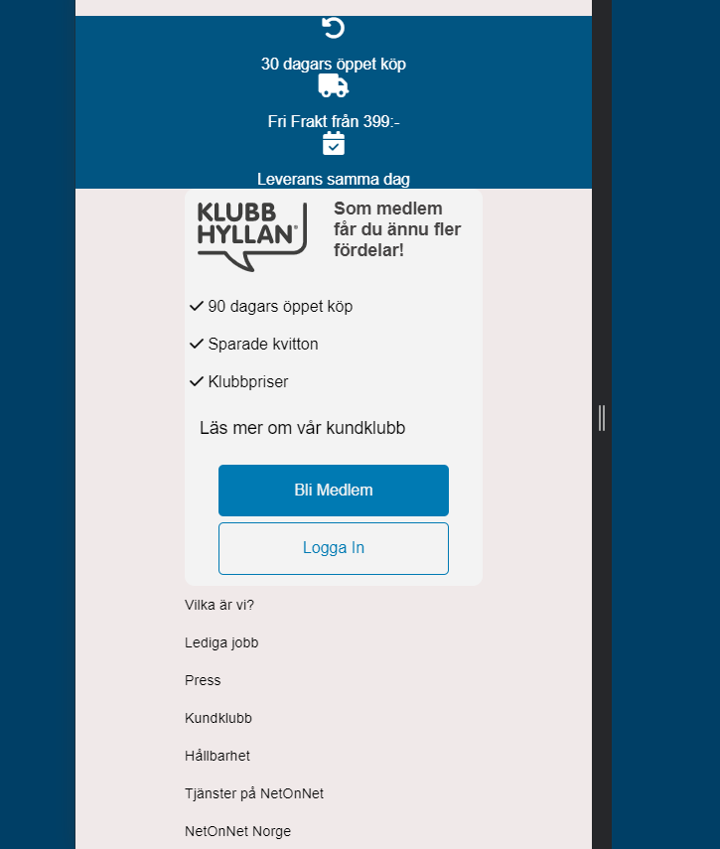

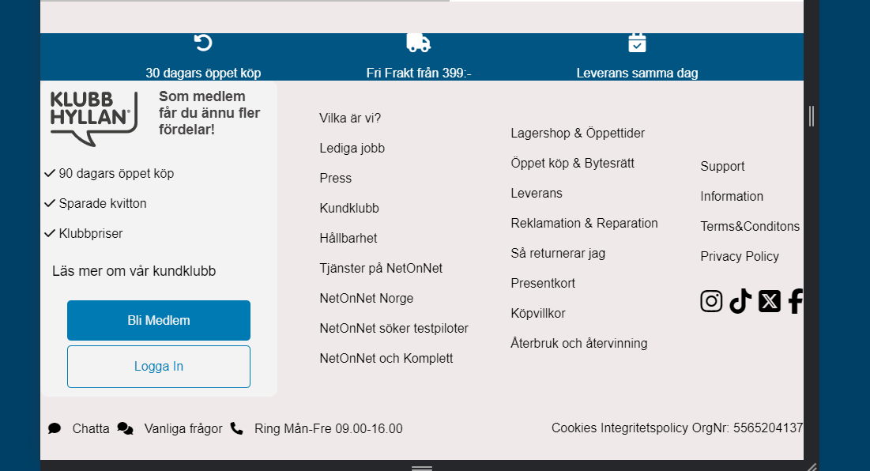

Here you have an image of the footer on a bigger handheld device like an Ipad here it is simply adjusting the spaces of all the different thing in the footer to still fit on a smaller screen.

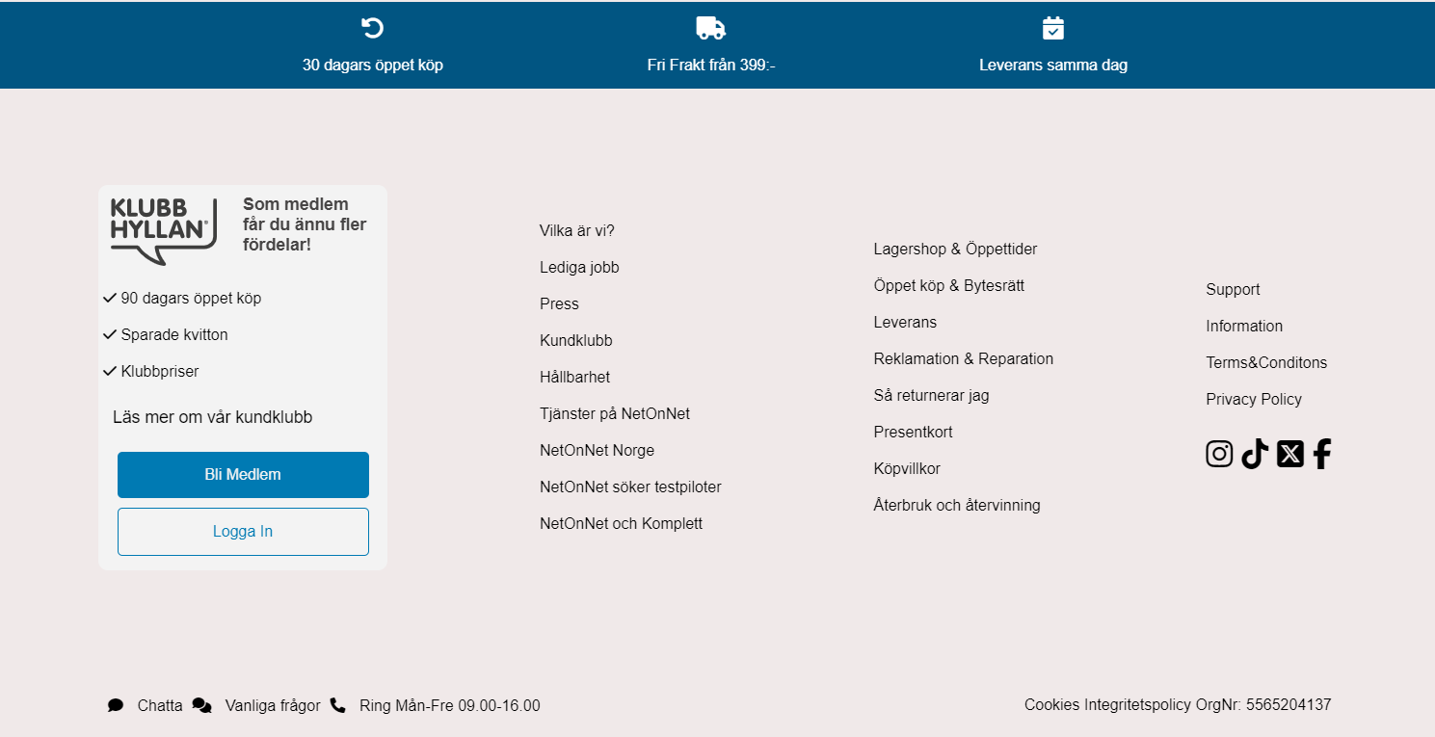

And here is how the footer looks on a computer screen. This one is very spacious as we removed some of the thing the original netonnet footer has as we felt it was unnecessary to have certain things in the footer as well but these things, could also very simply be added in if the client felt it was necessary to have said content in the footer.