Cascading style sheets or CSS for short is like the makeup for a website. This is meant to make it look organized and appealing to the user.
Now CSS Responsiveness is the part of CSS that makes the design made with CSS work on any device like a tablet or mobile device. The goal of CSS Responsiveness is to make the layout adjust automatically to the screen size it is being displayed on. Think of it as a hair tie that will stretch and shrink to fit your needs, making sure the website always looks good and is easy to use for anyone.
Just like how a pair of shoes that fit your feet perfectly is very comfortable to use, and so should the website feel for the user it should feel natural to find everything even if you are on a phone, so the user will not get frustrated when switching between devices.
This ensures the website is user-friendly and accessible for everyone and improves the experience of the users.
Ultimately CSS Responsiveness is like water. It can take any form making it possible to always have a nice and appealing and functional design no matter what you use it on.

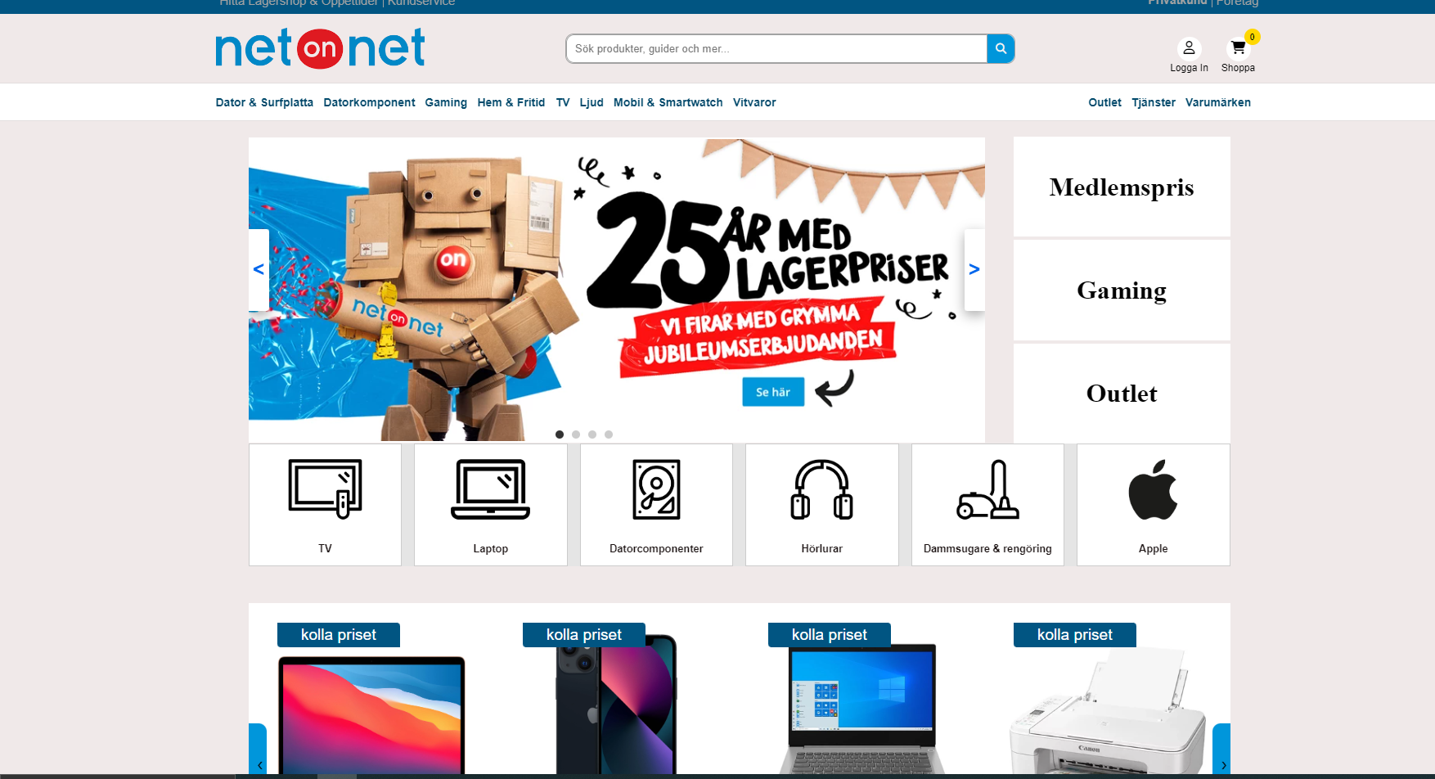
This is how a webpage looks on a computer screen.
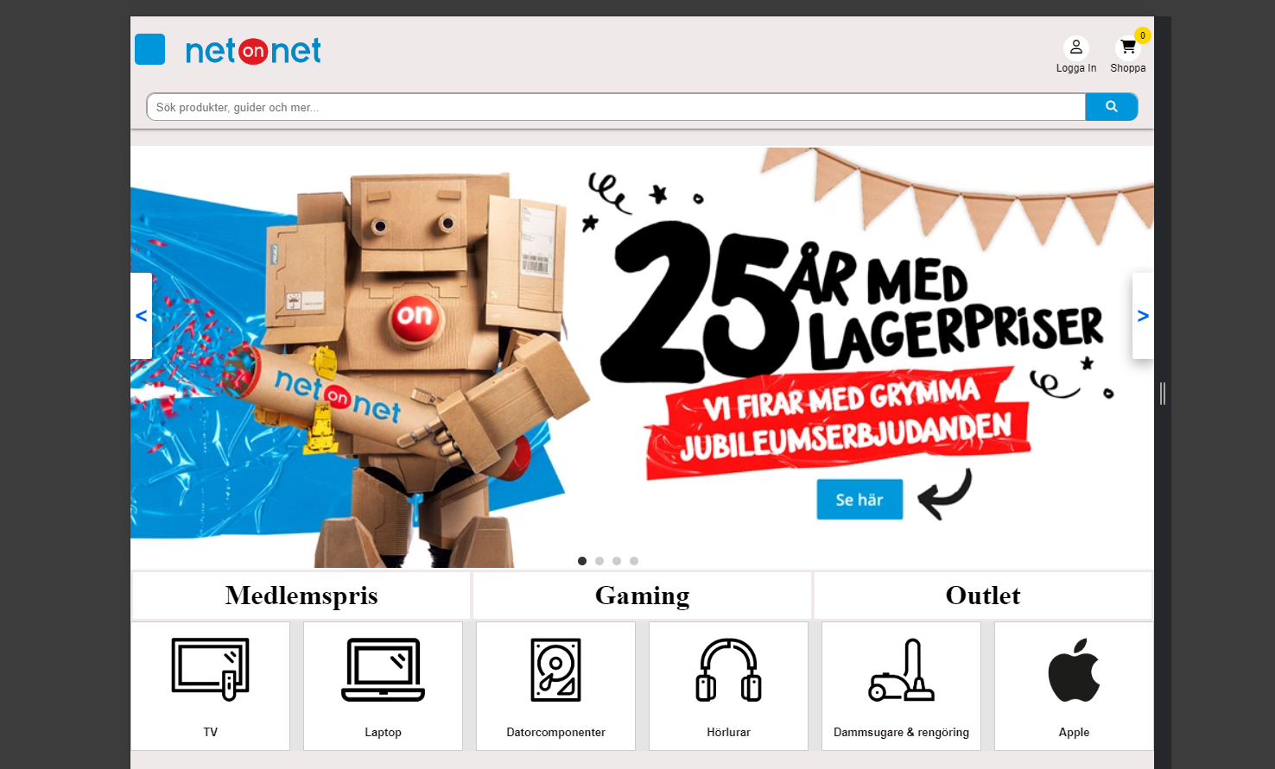
This is the same webpage on a tablet like an Ipad. You can see how the three buttons on the right side have moved under the large image, and how the large image now takes up more space horizontally
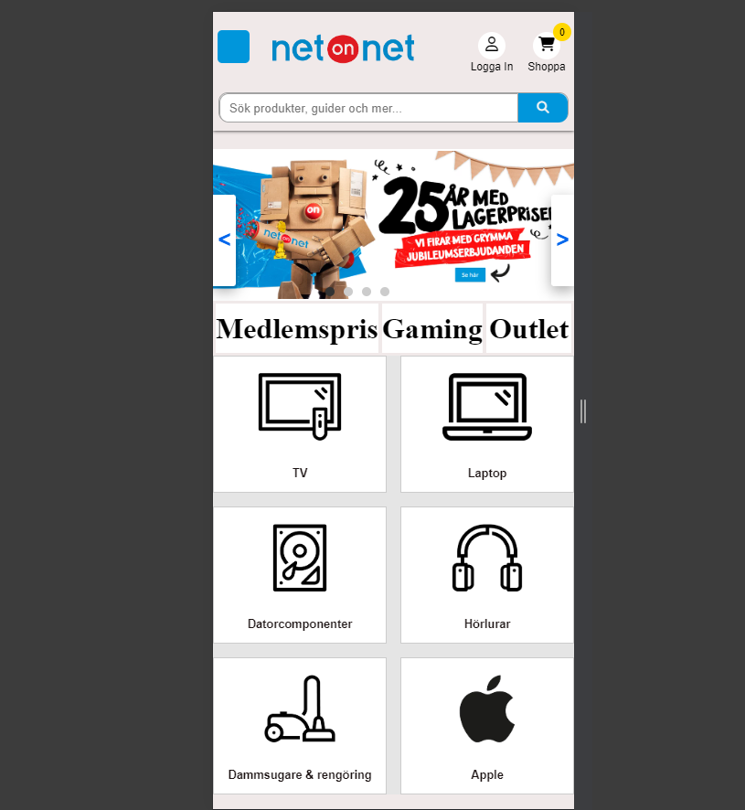
Here you see the webpage in mobile format. Notice how the category buttons are now stacking under each other vertically so you can still, easily see the without having to move your screen horizontally and can simply scroll downwards like normal.

