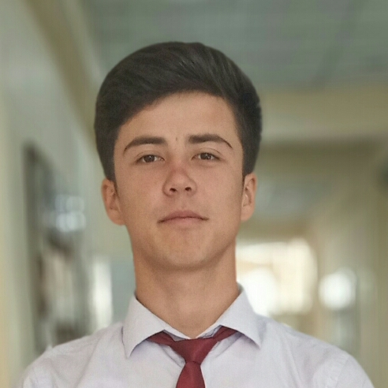

Contact

**Address:**

735610 - street Istaravshan 8 “A”, Istaravshan, Sugd, Tajikistan

**Phone:**

+992 (98) 917-87-71

**Email:**

[raufjonaliboev77@gmail.com](mailto:raufjonaliboev77@gmail.com)

Languages

Russian – A2

English – A1

Hobbies

* Playing football
* Computer games
* Siting on social sites
* Making sites

Summary

Web Developer specializing in front end development. Experienced with beginner stages of the development cycle for dynamic web projects. Well-versed in numerous programming languages including HTML5, PHP OOP, JavaScript, CSS, MySQL and C#. Small experience in project management and customer relations.

Skill Highlights

|  |  |
| --- | --- |
| * Project management * Creative design | * Innovative * Service-focused |

Experience

**Web Developer** – since 2020

**PITTU**, Khudzhand

* Cooperate with designers to create clean interfaces and simple, intuitive interactions and experiences.
* Develop project concepts and maintain optimal workflow.
* Work with senior developer to manage large, complex design projects for corporate clients.
* Complete detailed programming and development tasks for front end public and internal websites as well as challenging back-end server code.
* Carry out quality assurance tests to discover errors and optimize usability.

Education

Bachelor of Science: **Providing program and information technology** - 2020

**PITTU**, KHUDZHAND

Certifications

PHP Framework (certificate): **Zend, SoloLearn, Symfony**.

Programming Languages: **JavaScript, HTML5, PHP OOP, CSS, SQL, MySQL**.

Raufjon -Aliboev