**Project 2 ReadMe**

**Project Description:** A shipping company across the world has hired you to create a form and workflow following their specifications to raise a shipping request.

**Project Screenshots:**

Service Portal Form

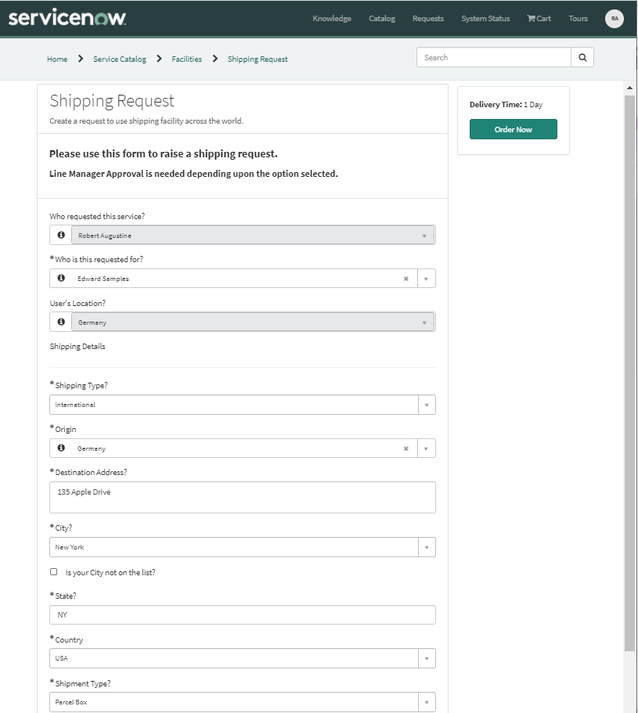

Workflow Diagram

