Assignment 4 – System Testing for SchichtPilot
The purpose of the system test is to evaluate the fully integrated system based on selected use cases from the requirements document and to verify whether the software fulfills the specified functional MUST- requirements.

Selection of Use Cases
One use case for each group member was selected from the system’s core functionalities. The selection covers the main functionalities of job role management, shift management, absence management, and work schedule management.
The following use cases were selected for the system test:
Core Functionality | Use Case ID | Designation
JobRoleService | UC-04-01-01 | Create job role
ShiftService | UC-04-02-02 | Create shift
AbsenceService | UC-02-01-01 | Submit absence request
WorkScheduleService | UC-01-01-01 | Retrieve published work schedule

Aspect | Description
Test Case Design Approach | The test cases were derived specification-based from the selected use cases and their functional requirements.
Focus of Test Design | - normal cases,  - error cases,  - validation  cases that can be derived from the Must requirements
Test Environment | - Local development  - test environment
Proposed Software Version | v1.0.0-dev
Proposed Environment | Windows 11, JetBrains Rider, .NET application executed locally, Firefox browser.

Test Case Documentation
The following table contains the defined system test cases including all attributes.
Please find the table in the attached excel file with screenshots.
Test Case ID | Test Case Title | Author | Tested Requirement | Precondition | Required Test Data | High-Level Test Procedure | Expected Result
TF-UC-04-01-01-01 | Create job role with valid data | Emre Rauhofer | UC-04-01-01 – Create job role | User is logged in as a non-locked registered manager | Role name: Kitchen; Dependency: Chef; | 1. Open job role management. 2. Create a new job role. 3. Enter a valid role name and dependency. 4. Save the role. | A new job role is created successfully and persisted in the database.
TF-UC-04-01-01-02 | Create job role with duplicate name | Emre Rauhofer | UC-04-01-01 – Create job role | User is logged in as a non-locked registered manager; role Kitchen already exists | Role name: Kitchen | 1. Open job role management. 2. Create a new job role. 3. Enter an already existing role name. 4. Save the role. | The system displays an error message, prevents creation, and stores no partial job role data.
TF-UC-04-02-02-01 | Create shift with all mandatory fields | Fariba Rezai | UC-04-02-02 – Create shift | User is logged in as a non-locked registered manager; at least one job role exists | Name: Early Shift; Time Slot: 06:00–14:00; Weekdays: Mon–Fri; Role: Service 2x | 1. Open shift management. 2. Create a new shift. 3. Fill in all mandatory fields. 4. Add role and quantity. 5. Save the shift. | The new shift is stored successfully and displayed in the shift list.
TF-UC-04-02-02-02 | Create shift without mandatory fields | Fariba Rezai | UC-04-02-02 – Create shift | User is logged in as a non-locked registered manager | Empty name; empty time slot; no weekdays; no role definition | 1. Open shift management. 2. Create a new shift. 3. Leave the form incomplete. 4. Save the shift. | The system rejects the request and displays a validation or error message.
TF-UC-04-02-02-03 | Create shift with invalid time slot | Fariba Rezai | UC-04-02-02 – Create shift | User is logged in as a non-locked registered manager | Name: Night Shift; Time Slot: invalid; Weekdays: Mon; Role: Service 1x | 1. Open shift management. 2. Create a new shift. 3. Enter an invalid time slot. 4. Save the shift. | The system validates the time slot, prevents creation, and displays an error message.
TF-UC-02-01-01-01 | Submit absence request with valid data | Fariba Rezai | UC-02-01-01 – Submit absence request | User is logged in and not locked | Date: 2026-09-07 - 2026-09-13; Type: Vacation; Message: Family vacation | 1. Open the absence section. 2. Create a new absence request. 3. Select a valid date and type. 4. Add a message. 5. Submit the request. | The absence request is stored with status Pending and the responsible managers are notified.
TF-UC-02-01-01-02 | Submit absence request with past date | Fariba Rezai | UC-02-01-01 – Submit absence request | User is logged in and not locked | Date: 2026-06-07 - 2026-06-13; Type: Vacation; Message: Family vacation | 1. Open the absence section. 2. Create a new absence request. 3. Select a past date. 4. Submit the request. | The system does not allow to select paste date.
TF-UC-01-01-01-01 | Retrieve published work schedule successfully | Emre Rauhofer | UC-01-01-01 – Retrieve published work schedule | User is logged in as restaurant staff; a published schedule exists | Staff account with access to a published schedule | 1. Open the work schedule view. 2. Load the current published schedule. | The system displays the published work schedule.
TF-UC-01-01-01-02 | Retrieve work schedule when backend retrieval fails | Emre Rauhofer | UC-01-01-01 – Retrieve published work schedule | User is logged in; work schedule data cannot be loaded due to technical failure | Simulated backend or database error | 1. Open the work schedule view. 2. Trigger schedule retrieval under faulty backend conditions. | The system displays a generic error message and shows no schedule data.
TF-UC-01-01-01-03 | Retrieve work schedule when no published schedule exists | Emre Rauhofer | UC-01-01-01 – Retrieve published work schedule | User is logged in as restaurant staff; no published schedule exists | Staff account without assigned published schedule | 1. Open the work schedule view. 2. Retrieve the current schedule. | The system displays no invalid or partial data and instead shows an empty state or suitable information.

Test Case ID | Expected Result | Execution Date | Tester | Software Version | Environment | Test Result | Found Deviations | Execution Comments
TF-UC-04-01-01-01 | A new job role is created successfully and persisted in the database. | 20.06.2026 | Fariba Rezai | v1.0.0-dev | Windows 11, JetBrains Rider, local execution, Chrome | PASSED |  | jobrole is visible in the list and stored in DB
TF-UC-04-01-01-02 | The system displays an error message, prevents creation, and stores no partial job role data. | 20.06.2026 | Fariba Rezai | v1.0.0-dev | Windows 11, JetBrains Rider, local execution, Chrome | PASSED |  | Displays Error message: "JobRole with name Kicthen already exists."
TF-UC-04-02-02-01 | The new shift is stored successfully and displayed in the shift list. | 20.06.2026 | Emre Rauhofer | v1.0.0-dev | Windows 11, JetBrains Rider, local execution, Chrome | PASSED |  | Shift is visible in the list and stored in DB
TF-UC-04-02-02-02 | The system rejects the request and displays a validation or error message. | 20.06.2026 | Emre Rauhofer | v1.0.0-dev | Windows 11, JetBrains Rider, local execution, Chrome | PASSED |  | Displays error message: "Failed to create shift."
TF-UC-04-02-02-03 | The system validates the time slot, prevents creation, and displays an error message. | 20.06.2026 | Emre Rauhofer | v1.0.0-dev | Windows 11, JetBrains Rider, local execution, Chrome | PASSED |  | Displays Error Message: "Starttime must be before end time."
TF-UC-02-01-01-01 | The absence request is stored with status Pending and the responsible managers are notified. | 20.06.2026 | Philipp Huber | v1.0.0-dev | Windows 11, JetBrains Rider, local execution, Chrome | PASSED |  | Absence is visible in the list and stored in DB
TF-UC-02-01-01-02 | The system does not allow to select paste date. | 20.06.2026 | Philipp Huber | v1.0.0-dev | Windows 11, JetBrains Rider, local execution, Chrome | PASSED |  | Past date is not possible to select at all, it is greyed out
TF-UC-01-01-01-01 | The system displays the published work schedule. | 20.06.2026 | Patrick Weiss | v1.0.0-dev | Windows 11, JetBrains Rider, local execution, Chrome | Passed | Logged in user is not assigned because for the automated generated schedule there is enough staff.
TF-UC-01-01-01-02 | The system displays a generic error message and shows no schedule data. | 20.06.2026 | Patrick Weiss | v1.0.0-dev | Windows 11, JetBrains Rider, local execution, Chrome | Failed | Frontend shows normal info 'No workschedule found for this week' instead of Backend Error 'No schedule data available'. See screenshot | No schedule exists → Frontend shows Normal Info, not Backend Error
TF-UC-01-01-01-03 | The system displays no invalid or partial data and instead shows an empty state or suitable information. | 20.06.2026 | Patrick Weiss | v1.0.0-dev | Windows 11, JetBrains Rider, local execution, Chrome | Passed |  | When no schedule is created for the week the list is empty. -> displays message: "No Schedule found for this week."

TF-UC-01-01-01-02
Frontend shows normal info 'No workschedule found for this week' instead of Backend Error 'No schedule data available'. See screenshot
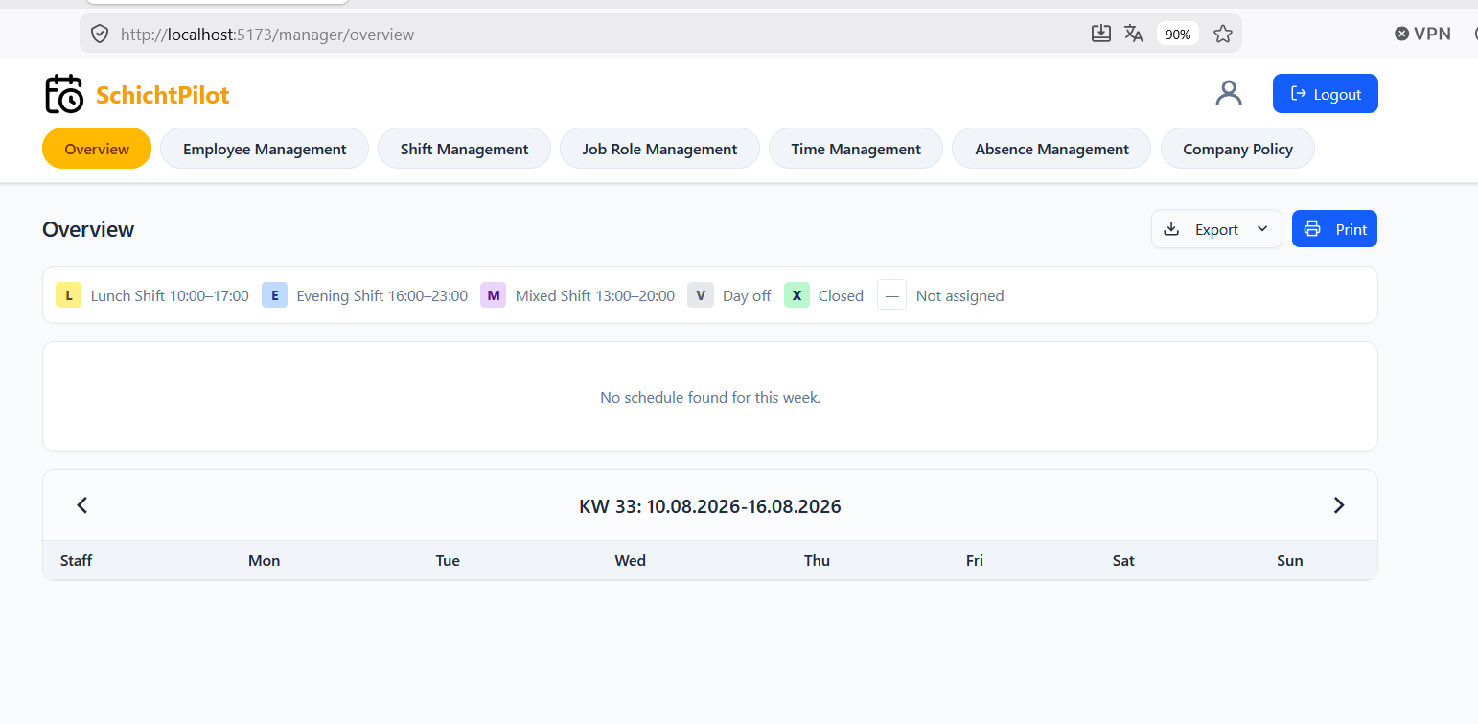

Test Execution
The system test cases defined above are executed manually on the integrated system. During execution, the actual result, possible deviations, and additional comments are documented for each test case. If a defect is found, the deviation is described in the column “Found Deviations” and linked to a screenshot.
The table is also available in as a csv file attached.

The following execution result values are used:
- Passed: The actual result matches the expected result.
- Failed: The expected result is not achieved or a functional deviation occurs.
- Blocked: The test case could not be executed completely due to technical or organizational reasons

