Versions:

Date | Version | Author | Comments
11/1/2024 | 0.1 | Raul Spatariu | First version (partially complete)
11/5/2024 | 1.0 | Raul Spatariu

Analysis&Design for MyDrive

Content:
- General Presentation

- Theoretical Fundamentals

- IT Technology (which will be implemented)

- Functionalities

- Actors and related access rights

- Use Case Diagrams

- System Architecture

- Design (UML Diagrams)

- Operation Mode (Operation Guide, including screen-shots)

- Portability

1. General Presentation

This project is an open-source, self-hostable personal drive, designed to give users complete control over their files. Found on GitHub, it allows individuals to clone, configure, and deploy the application on their own servers, ensuring privacy and full data ownership. This drive solution offers essential file storage functionalities without the dependency on third-party providers, making it ideal for users concerned about data privacy or those who simply prefer managing their own infrastructure.

Built using a carefully selected technology stack, this project employs Golang for efficient and reliable file management, PostgreSQL as a database for storing file metadata, Kotlin Spring for a robust and secure API layer, and JavaScript/React for a simple and responsive frontend. The focus is on simplicity, ease of setup, and customization, making it accessible for developers and non-developers alike who want a personal cloud solution.

- Theoretical Fundamentals

The architecture and features of this personal drive solution are grounded in key concepts of file storage, API design, and client-server communication:
- File Storage and Metadata Management: This system separates file storage from metadata, where the actual files are stored on the server and their metadata (such as file name, size, upload date, and permissions) is stored in a relational database. This structure supports efficient organization, searchability, and scalability.
- API Design and Access Control: The API, built with Kotlin Spring, follows REST principles to provide endpoints for user actions such as uploading, downloading, deleting, and retrieving files. It’s designed to handle access control and user authentication, ensuring that only authorized users can interact with their data. Using JWT (JSON Web Tokens) for authentication can add an extra layer of security, making sure that sessions are safe and user-specific.
- Database and Data Consistency: PostgreSQL is used to store metadata about each file, leveraging its robust query capabilities and ACID compliance for reliable, consistent data. By storing metadata separately from the file data, the application efficiently handles large datasets and supports complex queries.

- Frontend-Backend Communication: The frontend (React) communicates with the backend API over HTTP. Following REST architecture, requests are handled asynchronously, ensuring a responsive experience where users can seamlessly manage and browse their files in real-time.

- IT Technology

This personal drive solution leverages the following technologies to achieve high performance, scalability, and user experience:
- Golang (File Management System): Golang’s performance and concurrency strengths make it ideal for handling file operations. It efficiently manages file uploads, downloads, and storage with minimal latency, and its memory management capabilities ensure that the system performs well even under heavy load.
- PostgreSQL (Database for Metadata): PostgreSQL is used to manage metadata, such as file names, sizes, timestamps, and user permissions. Its ACID compliance guarantees data reliability, and its powerful querying capabilities enable the drive to handle complex metadata requirements, like sorting, filtering, and permissions control.
- Kotlin Spring (Backend API): The backend API, developed with Kotlin Spring, manages communication between the frontend and the file management system. It handles CRUD operations on files, authentication, and manages API requests securely. Kotlin Spring’s integration with JWT authentication ensures that data interactions remain secure.
- JavaScript/React (Frontend): The frontend is a user-friendly interface that allows users to interact with their files. React is chosen for its ability to build responsive, fast, and scalable interfaces. The UI is kept simple and functional, providing essential features like file browsing, uploading, and managing metadata, all with real-time responsiveness and ease of use.

- Functionalities
This personal drive solution provides a range of features that cover essential file management needs for users:
- User Authentication: A secure login system ensures that only authorized users can access and manage their files. This is typically implemented with JWT to handle user sessions and access control.
- File Upload and Download: Users can upload files of various types, view metadata, and download files directly from the drive. This feature ensures a seamless file transfer process with feedback for successful or unsuccessful uploads.
- File Management: Users can perform basic file operations, such as renaming, deleting, and organizing files into folders, creating a structured storage experience similar to popular cloud storage solutions.
- Metadata Management: Each file’s metadata is displayed in the interface, providing users with detailed information such as file size, type, creation date, and last modified date.
- Search and Filtering: Users can search for files based on keywords, file types, or metadata fields. This functionality helps users quickly find the files they need, especially in larger file collections.
- Self-Hosting and Deployment Support: Documentation is provided to help users deploy the application on their own servers. Configurations are made simple to support various hosting environments, and instructions cover setup, dependencies, and initial configuration to make self-hosting straightforward.

- Actors and related access rights

Administrator (“Super-user”)
Access rights: It is the one hosting the drive, therefore it has access to everything.

Invited user

Access rights: It is the one who was invited to visualize certain files from the owner’s drive, therefore it can only access files shared to him, limited to read-only.

- Use Case Diagrams

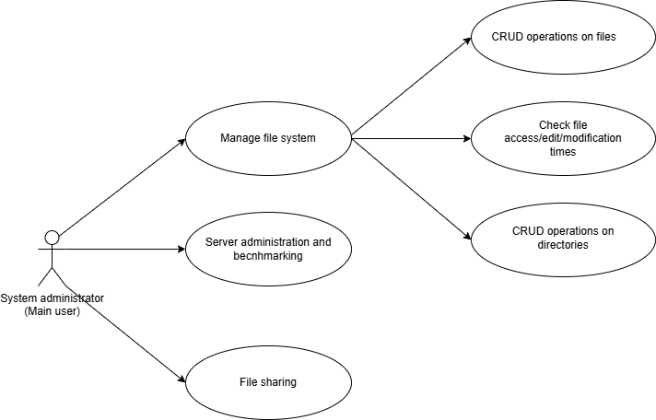

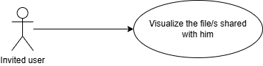

- System Architecture

File System Module

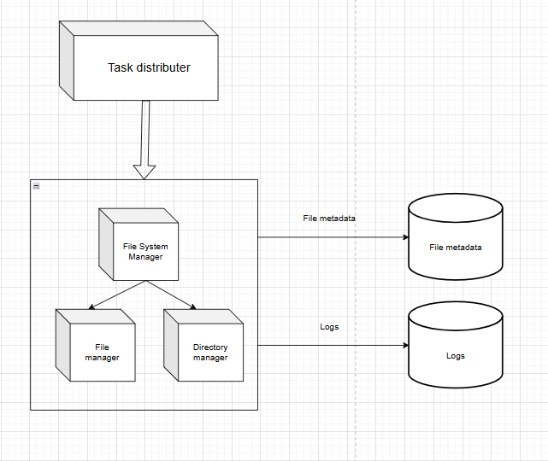

- Design (approx. 12 UML Diagrams!!!)

- Operation Mode (Interactivity presentation) + screen shots (UI design)

- Portability

- Competing software

