Version overview

Date | Version | Author | Comment
10/25/2024 | 0.1 | Raul Spatariu | First version (Partially complete)
10/31/2024 | 1.0 | Raul Spatariu | Finished first version

System requirements for MyDrive

1 Introduction 2
2 General view of actors and use cases 2
3 Detailed description of actors and use cases 2
3.1 Actors 2
3.1.1 Administrator 2
3.1.2 Customer Error! Bookmark not defined.
Type: ……….. Error! Bookmark not defined.
3.1.3 Provider 2
3.2 Use cases 3
3.2.1 Use Case Diagram for Actor1 3
3.2.2 Use Case Diagram for Actor2 4
3.2.3 Use Case Diagram for Actor3 Error! Bookmark not defined.
3.2.4 Use Case Diagram for Actor_{n} Error! Bookmark not defined.
4 Glossary – used terms 4

Introduction
The project will consist in an open source application for allowing users to host their own personal drive. The functionality desired is similar to the one of Google Drive, where users are enabled to manage their own file system stored on the cloud, in this case stored wherever the user decides to.

General view of actors and use cases
Actor | Type | Description
Administrator | Human | The person owning the drive and hosting it.
Invited user | Human | The administrator can decide to share its documents and/or his whole file system with someone else.

Detailed description of actors and use cases

Actors

Administrator

Type: human
Detailed description:
This actor is the person who downloaded the open-source project and hosts it.
This actor is the person administrating the system. The actor is also the main user, meaning the drive is for his own personal use.

Where is used:
This actor is used in the: “Administrator page” use case
“Administrator Log-in “use case.
“Administrator Log-out” use case.
“Deleting an directory/file in the file system” use case
“Editing an directory/file in the file system” use case
“Entering an directory/file in the file system” use case

Invited user
Type: human
Detailed description:
This actor is the person with who the administrator shared some document, or the whole drive system. This actor actions are limited by the right the administrator gave to him when the drive was shared.

Where is used:
This actor is used in the: “Page created by the administrator based on his rights and content”

Use cases

Use Case Diagram for Administrator
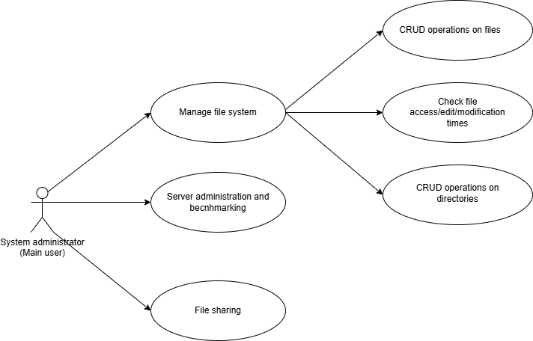

Description: The actor which manages the drive.
Actor: System administrator (Main user)
Precondition: It’s the host of its own drive, so therefore it needs to setup the environment
Postcondition: Host the server for an unknow duration of time.
Behavior: This actor is the super user of the drive, so he can manage the file system from adding new extensions to the codebase.

Use Case Diagram for Invited user
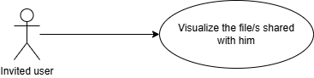

Description: The actor which was invited by the main user to visualize certain files shared to him by the main user.
Actor: Invited user
Precondition: -
Postcondition: -
Behavior: The actor can only see the files shared with him, so nothing more than visualizing or downloading them.

Glossary – used terms

Term | Use cases | Description

