package.json:
{
"name": "express-backend",
"version": "1.0.0",
"description": "",
"main": "index.js",
"scripts": {
"test": "echo \"Error: no test specified\" && exit 1"
},
"keywords": [],
"author": "",
"license": "ISC",
"type": "commonjs",
"dependencies": {
"express": "^5.2.1"
}
}

Server.js:
const express = require("express");
const app = express();
const PORT = 3000;
// Middleware
app.use((req, res, next) => {
console.log(`${req.method} ${req.url}`);
next();
});
app.get("/", (req, res) => {
res.send("Hello World");
});
app.get("/api/message", (req, res) => {
res.json({
message: "Hello from API",
status: "success"
});
});
app.listen(PORT, () => {
console.log(`Server running on port ${PORT}`);
});
Outputs:
1.Hello World Route:
Using link: http://localhost:3000/
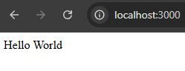
2. API Route:
Using link: http://localhost:3000/api/message
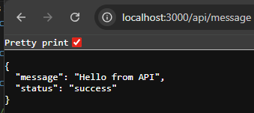

Test Using Postman:
