Laboratory 4 Digital Clock
Prelab
- simulate part 1
- draw the block diagram showing the top module design for part 2.
Clearly label DE2 hardware resources signal names for external inputs/outputs outside the box.
Clearly label submodule name, inputs, and outputs inside the box for each sub-module instance.
Clearly make the wire connections.
- complete Verilog files for part 2, and compile.

Objectives
The purpose of this laboratory is to design and implement a digital clock on DE2 board.

Part 1 digital clock with switch presetting

Circuit Block Diagram and Description
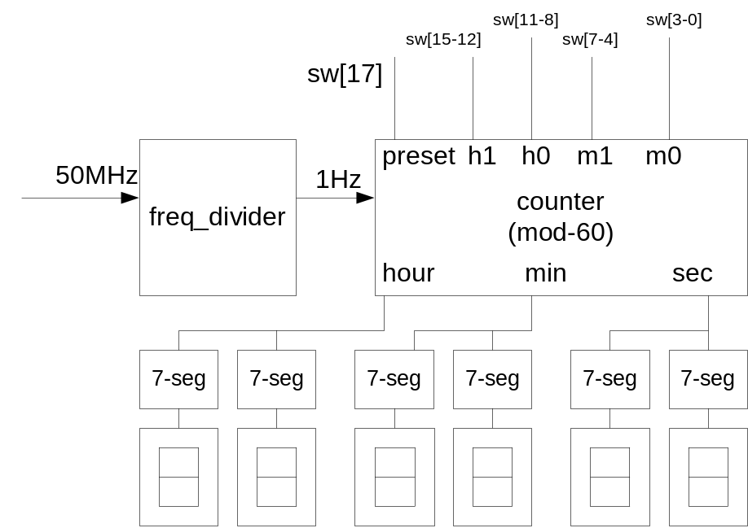

Fig.1 the diagram of digital clock

The digital clock can display the hours (00 to 23), minutes (00 to 59) and seconds (00 to 59) at the same time using six (6) 7-segment displays. The initial time can be preset by switches as follows: when SW[17]=1 (time setting mode), SW[15-0] will preset a 4-digit BCD number for initial hours and minutes, initial second is always 00; when SW[17]=0 (clock running mode), the digital clock will work normally starting with the preset hours and minutes and 0 second.

Verilog code

By now, you already have some submodules readily for use, including frequency divider clock.v for 1Hz clock generated from 50MHz on-board signal CLOCK_50 and 4 bit hex to 7 segment display hex2seg7.v (or bcd2leds.v) to display ‘0’ to ‘9’ in previous labs. These two files need to be added to your project.

Reference Verilog code for the top module is given as follows. There may be things to be fixed to make the code work as expected.

//digital clock with preset by switches

module lab4part1 ( CLOCK_50, SW,
HEX0, HEX1, HEX2, HEX3, HEX4, HEX5, HEX6, HEX7);

input CLOCK_50; // 50MHz clock
input [17:0] SW;
// SW[17]=1 time setting mode
// 0 clock running mode
//When SW[17]=1, SW[15:12] for hour1, SW[11:8] for hour0, setting 2-digit hr
// When SW[17]=1, SW[7:4] for minute1, SW[3:0] for minute0, setting 2-digit min
// second1, second0 are 00, setting 2-digit sec
output [0:6] HEX0, HEX1, HEX2, HEX3, HEX4, HEX5, HEX6, HEX7;
// HEX5 HEX4 for hour
// HEX3 HEX2 for minute
// HEX1 HEX0 for second

reg [3:0] hex_h1, hex_h0, _m1, temp_m0, temp_s1, temp_s0;

clock1Hz M0 (CLOCK_50, 25000000, clock_1Hz);
// generate 1Hz clock

bcd2seg7 hour1 (temp_h1, HEX5);
bcd2seg7 hour0(temp_h0, HEX4);
bcd2seg7 minute1(temp_m1, HEX3);
bcd2seg7 minute0(temp_m0, HEX2);
bin2seg7 second1(temp_s1, HEX1);
bin2seg7 second0(temp_s0, HEX0);
assign HEX6=7'b1111111;
assign HEX7=7'b1111111;

always @ (posedge clock_1Hz)
begin
if(SW[17])
begin
temp_h1=SW[15:12];
temp_h0=SW[11:8];
temp_m1=SW[7:4];
temp_m0=SW[3:0];
end
else
begin
temp_s0=temp_s0+1;
if (temp_s0 == 10)
begin
temp_s0 = 0;
temp_s1 = temp_s1+1;

if (temp_s1 == 6)
begin
temp_s1 = 0;
temp_m0 =temp_m0+1;
if (temp_m0 ==10)
begin
temp_m0 = 0;
temp_m1 = temp_m1+1;
if(temp_m1 == 6)
begin
temp_m1 = 0;
temp_h0 = temp_h0+1;
if((temp_h1 <= 1) && (temp_h0 == 10))
begin
temp_h0 =0;
temp_h1 = temp_h1+1;
end
else if (temp_h1==2 && temp_h0==4)
begin
temp_h0 =0;
temp_h1 =0;
end

end
end
end
end
end
end
endmodule

Implementation
- _______Create a new project lab4part1, with top module lab4part1, and source file name lab4part1.v, and add clock.v and seg7.v to your project.
- _______Write Verilog files (lab4part1.v) required by the above description.
3)_________Debug the codes as needed. Fix both syntax and logical errors if any.
- _______Download DE2_pin_assignments.qsf from altera website.
- _______In Quartus II, select assignments → import assignments, choose DE2_pin_assignments.qsf in the file box.
- _______Compile your design.
- _______Tools→ programmer, download the circuit into FPGA, and test the functionality.
- _______Make a record of the test result.

Part II. Hierarchical Design
Use two-digit BCD counter with different mod numbers. Each counter has preset control. When it is active, the counter is in setting mode and it will load preset inputs as state. Otherwise, the counter runs in the clock mode.

module BCD2Counter(clk, modN, preset, Q0, Q,Cout); //4 bit 2-digit BCD counter with modN, and preset
//control and Q0 starting point
input clk;
input [5:0] modN; // 6bit mod number :mod-60 counter for min, sec, and mod-24 counter for hr
input preset; //high active preset
input [7:0] Q0;// to set initial value
output [7:0] Q; // 2 bcds
output reg Cout; // carry out

reg [3:0] bcd1;// high digit
reg [3:0] bcd0;// high digit

assign Q={bcd1,bcd0};// asseumble to 2 bcd outputs

always @(posedge clk, posedge preset)
if (preset) // setting mode
begin
bcd1<=Q0[7:4]; // presetting mode
bcd0<=Q0[3:0];
end
else if ((10*bcd1+bcd0)<modN-1) // clcok mode
if (bcd0<9)
begin
bcd0<=bcd0+1;// add 1 to bcd0 only
Cout<=0;
end
else //bcd0 reset to 0, try adding 1 to bcd1
begin
bcd0<=0;
bcd1<=bcd1+1;
Cout<=0;
end
else
begin
bcd0=0;
bcd1=0;
Cout=1;
end
endmodule

In the top module include something as follows
//example to set 12:34:56 as starting time.
//in the lab setting the hour and minute of current time using 16 switches and secs into 0
// as in lab4 part 1
assign Q0Sec=8'b01010110;// 56
assign Q0Min=8'b00110100; // 34
assign Q0Hr= 8'b00010010;// 12

clock U1(CLOCK_50, 25000000,clk1Hz); // 1Hz clock generated from 50MHz signal
hex2seg7 U2(Q[3:0],HEX0);
hex2seg7 U3(Q[7:4],HEX1);
hex2seg7 U7(Q[11:8],HEX2);
hex2seg7 U8(Q[15:12],HEX3);
hex2seg7 U9(Q[19:16],HEX4);
hex2seg7 U10(Q[23:20],HEX5);

BCD2Counter U4(clk1Hz,60,SW[0], Q0Sec,Q[7:0],clkMin);// seconds
BCD2Counter U5(clkMin,60,SW[0], Q0Min,Q[15:8],clkHr);// minutes
BCD2Counter U6(clkHr, 24,SW[0],Q0Hr,Q[23:16], clkDay); //hours

Part 3 Digital clock with pushbutton presetting

Modify your design as follows: the initial (or starting) time is preset by two pushbuttons when SW[0] is “HIGH”: one pushbutton KEY[2] is used to set hour (hour +1 whenever KEY[2] is pressed once), another pushbutton KEY[1] is used to set minute (minute+1 whenever KEY[1] is press once). When SW[0] is “LOW”, the circuit works as a normal clock (counting each second).

hint: make the following changes to part 1 Verilog code:

1)Add the following two always blocks in your part 1 Verilog code: one for hour setting, one for minute setting.

2)Replace SW[15:0] signals with h1, h0, m1, m0.

3)Change SW[17] to SW[0].

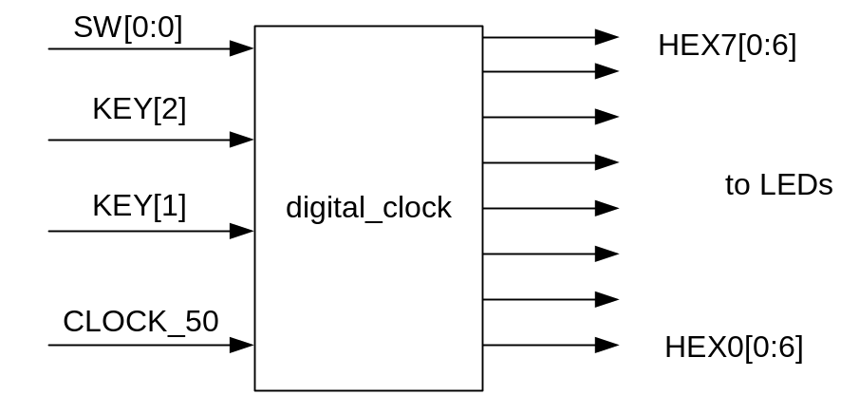

Please complete the following code for Pre_lab

module lab4_2 ( CLOCK_50, SW, KEY,

HEX0, HEX1, HEX2, HEX3, HEX4, HEX5, HEX6, HEX7)

input

output

reg [3:0] temp_h1, temp_h0, temp_m1, temp_m0, temp_s1, temp_s0;

reg [3:0] h1, h0, m1, m0;

// generate 1Hz clock by instantiating module clock

//display time on HEX7 …HEX2, HEX1, HEX0 by instantiating seg7

// set minutes

always @ (posedge KEY[1])

begin

m0 = m0+1;

if(m0==10)

begin

m0 = 0;

m1 = m1+1;

end

if(m1 == 6) m1=0;

end

// set hours

always @ (posedge KEY[2])

begin

h0 = h0+1;

if(h0==10)

begin

h0 = 0;

h1 = h1+1;

end

if(h1 == 2 && h0==4)

begin

h1=0;

h0=0;

end

end

// always block for time counter mod-60

endmodule

Implementation
- _______Create a new project, and add clock.v and seg7.v to your project.
- _______Write Verilog files (lab4_2.v) by modifying lab4_1.v.
- _______Download DE2_pin_assignments.qsf from altera website.
- _______In Quartus II, select assignments → import assignments, choose DE2_pin_assignments.qsf in the file box.
- _______Compile your design.
- _______Tools→ programmer, download the circuit into FPGA, and test the functionality.
- _______Make a record of the test result.

Part IV Optional with bonus points.
See class notes
Use two switches SW[1] SW[0] for setting/running mode control.
00=set secs
01=set mins
10=set hrs
11=running
In the setting mode, use up / down keys (KEY[0] and KEY[1]) for +1/-1 operations.
The clock frequency for continuous +1/ -1 operations (while the keys are pressed) is 10Hz. Modify the frequency division module to have 10Hz clock from 50MHz clock.

