 | {{TITLE}}
 | Document Version | 01
 | Release date | {{RELEASE_DATE}}

 | Huawei Technologies Co., Ltd. |  | 

Copyright © Huawei Technologies Co., Ltd. 2025. All Rights Reserved.
Without the written permission of the Company, no unit or individual shall excerpt or copy part or all of the contents of this document without authorization, and shall not disseminate it in any form.

Trademark Statement
and other Huawei trademarks are trademarks of Huawei Technologies Co., Ltd.
All other trademarks or registered trademarks mentioned in this document are the property of their respective owners.

Attention.
The products, services, or features you purchase are subject to Huawei's commercial contracts and clauses. All or part of the products, services, or features described in this document may not be within your purchase scope or usage scope. Unless otherwise specified in the contract, Huawei makes no express or implied representation or warranty in this document.
This document may be updated irregularly due to product version upgrade or other reasons. Unless otherwise agreed, this document is intended as a guide, and all statements, information, and recommendations in this document do not constitute a warranty of any kind, express or implied.

Huawei Technologies Co., Ltd.
Address: | Huawei Headquarters Office Building, Bantian, Longgang District, Shenzhen 518129
Website: | https://www.huawei.com
Customer service email: | support@huawei.com
Customer Service Phone: | 4008302118

Safety Statement
Vulnerability Handling Process
Huawei's regulations on product vulnerability management are subject to the Vulnerability Handling Process. For details about the process, visit the following website: https://www.huawei.com/cn/psirt/vul-response-process
If enterprise customers need to obtain vulnerability information, visit the following website:
https://securitybulletin.huawei.com/enterprise/cn/security-advisory

Contents
1 Problem Description and Impact 1
2 Root Cause Analysis 2
3 Root Cause 3
4 Trigger Condition 4
5 Workaround and Impact 5
5.1 Impact 5
5.2 Back up data before the workaround. 5
5.3 Workaround 5
5.4 Verification after the workaround 6
5.5 Rollback Operation 6
5.6 Cleanup Operation 7

Problem Description and Impact
{{PROBLEM_DESCRIPTION}}
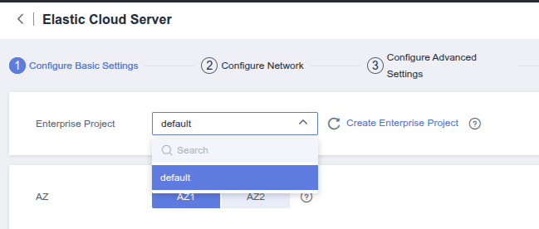

Root Cause Analysis
- {{ROOT_CAUSE_ANALYSIS}}
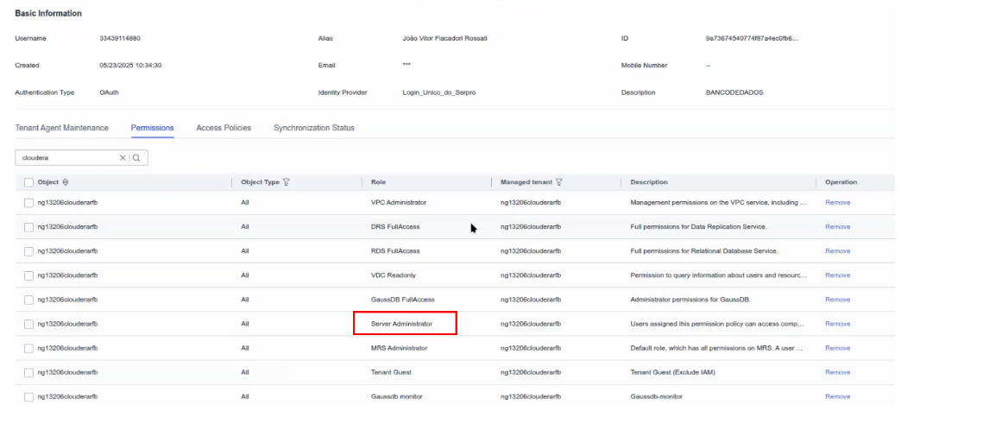

Root Cause
{{ROOT_CAUSE}}

Trigger Condition
Detailed version | {{VERSION}}
Installation Scenario | {{SCENARIO}}
Management Scale | Irrelevant to the scale of management
Trigger Condition | {{TRIGGER_CONDITION}}
{{TRIGGER_CONDITION}}

Workaround and Impact
5.1 Impact
5.2 Backing Up Data Before the Workaround
5.3 Workarounds
5.4 Verification After the Workaround
5.5 Rollback Operations
5.6 Cleaning Operations

Impact
{{IMPACT}}

Back up data before the workaround.
{{BACKUP_DATA}}

Workaround
            - {{WORKAROUND}}
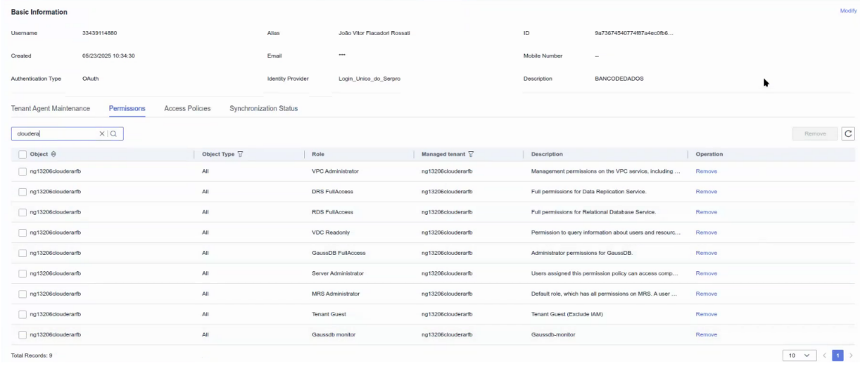

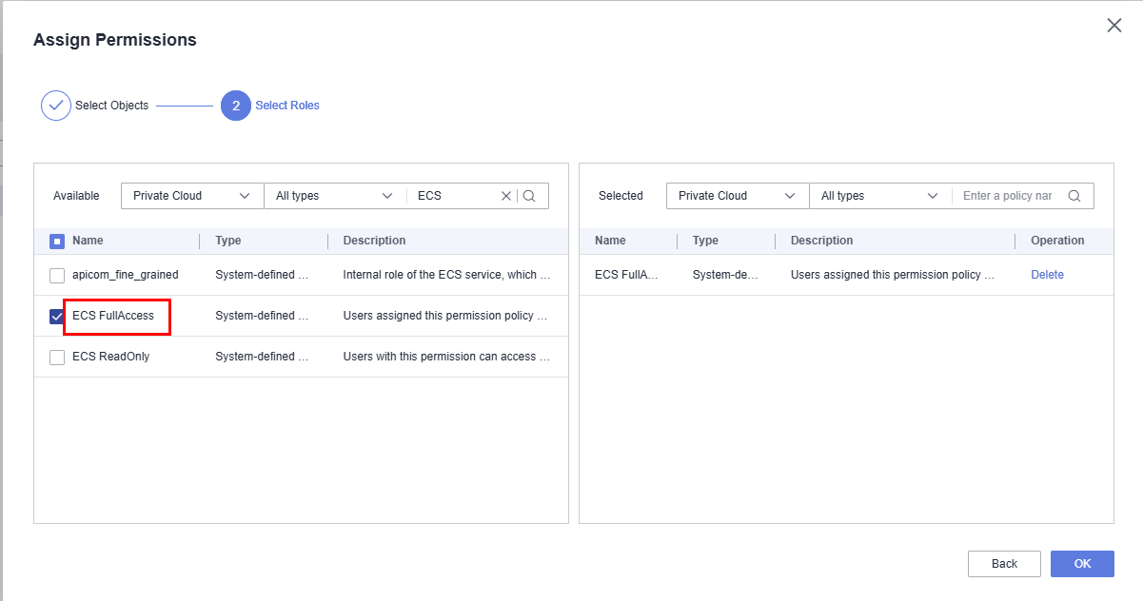

Verification after the workaround
            - {{VERIFICATION}}
----End

Rollback Operation
{{ROLLBACK}}

Cleanup Operation
{{CLEANUP}}

