 | [Analysis Report] The Enterprise Project List Is Not Displayed on the ECS Creation Page in 8.5.1 at the Brazil Site
 | Document Version | 01
 | Release date | 2025 - 08 - 13

 | Huawei Technologies Co., Ltd. |  | 

Copyright © Huawei Technologies Co., Ltd. 2025. All Rights Reserved.
Without the written permission of the Company, no unit or individual shall excerpt or copy part or all of the contents of this document without authorization, and shall not disseminate it in any form.

Trademark Statement
and other Huawei trademarks are trademarks of Huawei Technologies Co., Ltd.
All other trademarks or registered trademarks mentioned in this document are the property of their respective owners.

Attention.
The products, services, or features you purchase are subject to Huawei's commercial contracts and clauses. All or part of the products, services, or features described in this document may not be within your purchase scope or usage scope. Unless otherwise specified in the contract, Huawei makes no express or implied representation or warranty in this document.
This document may be updated irregularly due to product version upgrade or other reasons. Unless otherwise agreed, this document is intended as a guide, and all statements, information, and recommendations in this document do not constitute a warranty of any kind, express or implied.

Huawei Technologies Co., Ltd.
Address: | Huawei Headquarters Office Building, Bantian, Longgang District, Shenzhen 518129
Website: | https://www.huawei.com
Customer service email: | support@huawei.com
Customer Service Phone: | 4008302118

Safety Statement
Vulnerability Handling Process
Huawei's regulations on product vulnerability management are subject to the Vulnerability Handling Process. For details about the process, visit the following website: https://www.huawei.com/cn/psirt/vul-response-process
If enterprise customers need to obtain vulnerability information, visit the following website:
https://securitybulletin.huawei.com/enterprise/cn/security-advisory

Contents
1 Problem Description and Impact 1
2 Root Cause Analysis 2
3 Root Cause 3
4 Trigger Condition 4
5 Workaround and Impact 5
5.1 Impact 5
5.2 Back up data before the workaround. 5
5.3 Workaround 5
5.4 Verification after the workaround 6
5.5 Rollback Operation 6
5.6 Cleanup Operation 7

Problem Description and Impact
At the Brazil site of the HCS 851, the default enterprise project cannot be showed on the ECS creation page，causing ECS cannot be created.
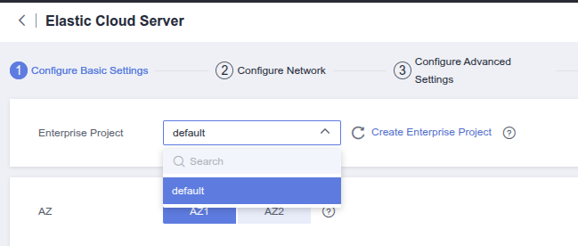

Root Cause Analysis
- Analyze the permissions of the user who cannot view the default enterprise project. Only the Server Administrator permission is granted to the user. Other users who can view the default enterprise project are granted the Tenant Administrator permission.
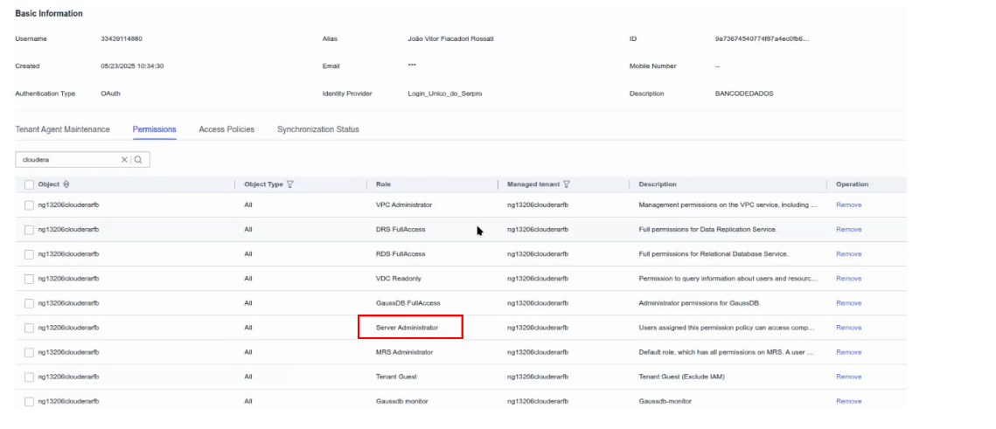
- In the 851 version, the auth_action field is added when you query an enterprise project. If this field is not passed in fine-grained authorization scenarios, the page will display enterprise projects without the permission to create ECS. After the user selects the enterprise project, the ECS cannot be provisioned. Therefore, this field is added. Only the enterprise projects with the permission are displayed on the page for creating an ECS.
- Server Administrator already exists in earlier versions and does not have the fine-grained action permission. Therefore, when the ManageOne interface is invoked to query enterprise projects, Server Administrator does not have the permission to create ECSs and does not return the enterprise project list. However, for the ECS service, this permission is the ECS administrator，and it has the permission to create ECS.

Root Cause
Optimized the fine-grained scenario in 851. When an ECS is provisioned, only the list of enterprise projects with the permission is displayed. Server Administrator is a role in non-fine-grained scenarios and does not contain the new fine-grained permission configuration items. As a result, users with the Server Administrator permission cannot query the list of enterprise projects with the permission in this scenario.

Trigger Condition
Detailed version | HCS 8.5.1
Installation Scenario | Standard Scenario
Management Scale | Irrelevant to the scale of management
Trigger Condition | Assign ECS-related permissions to a user as the Server Administrator role.

Workaround and Impact
5.1 Impact
5.2 Backing Up Data Before the Workaround
5.3 Workarounds
5.4 Verification After the Workaround
5.5 Rollback Operations
5.6 Cleaning Operations

Impact
To grant ECS FullAccess to a user, you need to modify the user group permission.
This permission is the ECS administrator permission and is included in the Server Administrator permission. When this permission and Server Administrator permission are granted at the same time, the permission does not increase. However, this permission can query the list of enterprise projects with the permission.

Back up data before the workaround.
N/A

Workaround
            - Log in to the tenant plane and find the user group associated with the user which cannot view the default enterprise project.
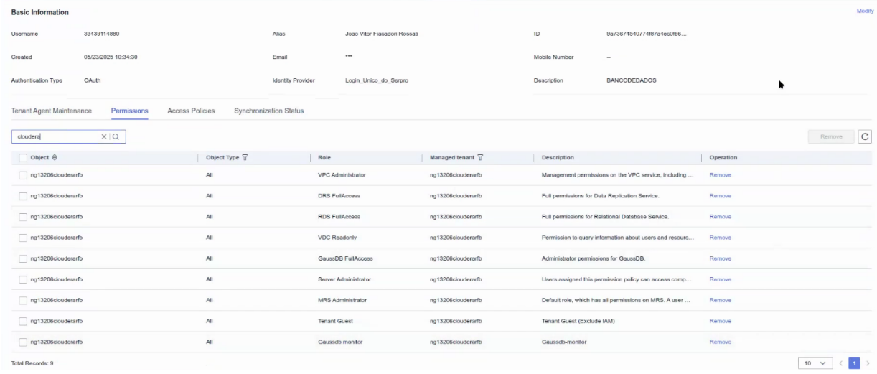
            - Adding the ECS FullAccess permission to a user group
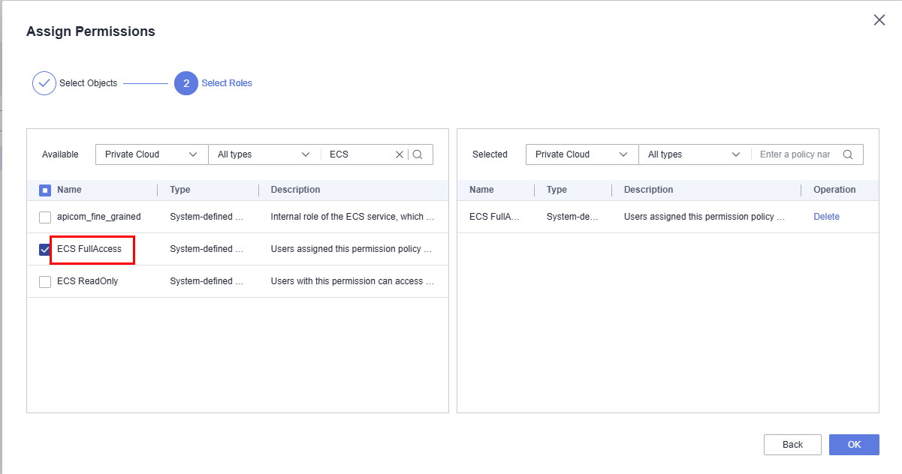
----End

Verification after the workaround
            - Log in to the tenant page again, go to the ECS page, create an ECS, and view the enterprise project list.
----End

Rollback Operation
N/A

Cleanup Operation
N/A

Problem Description and Impact
At the Brazil site of HCS 8.5.1, the default enterprise project is not displayed on the ECS creation page. This prevents users from selecting the correct enterprise project when provisioning new ECS instances.

Affected Versions
Version | Installation Scenario | Affected
HCS 8.5.1 | Standard Scenario | Yes
HCS 8.5.0 | Standard Scenario | No
HCS 8.6.0 | Standard Scenario | Fixed

Workaround
Grant ECS FullAccess permission to the user group associated with the affected user. This restores the enterprise project list on the ECS creation page.
Important: Applying this workaround modifies user group permissions. Review the impact before proceeding.
Tip: Back up the current permission configuration before making any changes. This allows a quick rollback if needed.

