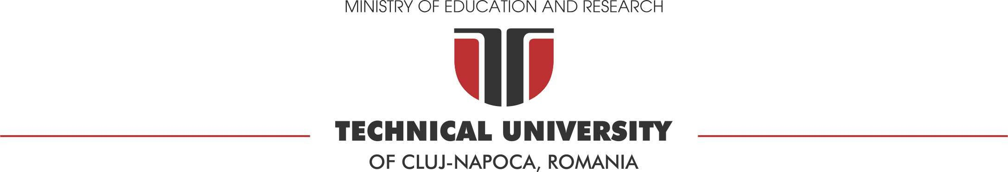

Assignment 1
Software Design

Author: Nicula Raul-Emil

Group: 30433

Faculty of Automation and Computer Science

March, 2026

Contents
1 Problem definition 2
2 Analysis phase - Use cases & requirements 2
2.1 Functional requirements 2
2.2 Use cases 2
3 Design phase 3
3.1 Architecture overview 3
3.2 Entity-relationship diagram 4
3.3 Advertisement Service 4
3.5 Design patterns 5
3.6 Class diagrams 6
3.7 Sequence diagrams 6
4 Implementation phase - Application 6
4.1 Tools and technologies 6
4.2 Application structure 6
4.3 User manual 6
5 Testing and validation 7

Problem definition

- CarKet is a web-based marketplace built with Spring Boot that helps people buy and sell cars easily. The main goal is to provide a safe platform where users can post ads for their vehicles, upload photos, and search for their next car using filters like brand or model.
- The documentation is organized into three parts: Requirements, System Design, and Implementation.
- Deliverables: I am providing the full Java source code, the HTML, CSS and js pages, and this documentation including all necessary diagrams.

Analysis phase - Use cases & requirements

Functional requirements
- User Authentication and Authorization: The system must allow users to register an account and log in using an email and password. It must also distinguish between 'Client' and 'Admin' roles to restrict access to specific features.
- Advertisement Management: Authenticated clients must be able to publish new car advertisements by providing details such as brand, model, chassis type, year, and price.
- Image Upload: The system must support uploading and storing a car image for every new advertisement published.
- Search and Filter: The system must allow all users to search for cars based on specific criteria like brand, model, or chassis type.
- Data Modification: Owners of an advertisement must be able to update the price of their listing.
- Content Deletion: The system must allow users to delete their own ads, while administrators must have the authority to delete any advertisement on the platform.

Use cases

Based on the application's implementation, the primary interactions are as follows:
- User Registration
  - Actor: Unregistered User
  - Description: The visitor provides their name, email, password, and selects a role (Client or Admin) through the registration form
  - Successful Result: A new user account is created in the database, and the user is redirected to the login page
- Authentication (Login)
  - Actor: Client(Registered User)
  - Description: The user enters their registered email and password into the login form.
  - Successful Result: The system validates the credentials and grants access to protected areas like the sale page (for Clients).
- Publish Advertisement
  - Actor: Client.
  - Description: An authenticated client fills in the car's brand, model, chassis, year, and price, and optionally uploads an image.
  - Successful Result: The system saves the car details and the image path, creating a new advertisement linked to the client.
- Search for Vehicles
  - Actor: Any User
  - Description: The user enters search criteria such as brand, model, or chassis type into the search form.
  - Successful Result: The system displays a grid of all advertisements that match the specified filters.
- Update Advertisement Price
  - Actor: Advertisement Owner
  - Description: The owner of an ad opens the details page, enters a new price in the edit modal, and submits the update.
  - Successful Result: The advertisement's price is updated in the database.
- Delete Advertisement
  - Actor: Advertisement Owner (Client) or Administrator.
  - Description: The actor selects the delete option on a specific advertisement's details page.
  - Successful Result: The advertisement is permanently removed from the system, and the user is redirected to the search page.

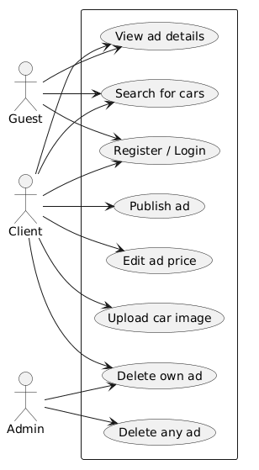

Design phase

Architecture overview
The CarKet application follows a Monolithic Client-Server architecture, specifically utilizing a Layered (n-tier) approach to separate concerns and improve maintainability. The system is divided into three major components:
- Frontend: A web-based interface built with Thymeleaf templates, CSS, and JavaScript. It handles user interactions and sends requests to the backend via standard HTTP forms or asynchronous fetch calls.
- Backend: A Spring Boot server that processes business logic, manages security through Spring Security, and coordinates data flow between the user and the database.
- Database: A PostgreSQL relational database used to persist user accounts, car details, and advertisement records.
The application uses the Model-View-Controller (MVC) design pattern to separate internal representations of information from the ways information is presented to the user:
- Model: This component consists of the data structures and business logic. It includes the database entities such as User, Car, and Advertisement, as well as the Data Access Layer that manages these objects.
- View: This is the presentation layer that displays the data to the user. It is implemented using Thymeleaf templates, which render the final HTML pages like the search results or the advertisement details.
- Controller: This layer acts as the interface between the Model and the View. It receives user input from the browser, calls the appropriate Service Layer logic, and then decides which View to display or which data to return.

Entity-relationship diagram

The CarKet application uses a relational database schema managed via Hibernate and Spring Data JPA to persist user data, vehicle information, and marketplace listings. The schema consists of the following primary tables and their relationships:
1. Users Table
-Stores the account information and access levels for all registered individuals on the platform.
-Attributes: id(primary key), email(string), password(string), role(Client or Admin)
-Relationships: Has a one-to-many relationship with the Advertisements table, as one user can publish multiple listings.

2. Cars Table
- Serves as a technical catalog for unique vehicle specifications to avoid data duplication.
-Attributes: id(primary key), brand(string), model(string), chassis(string)
-Relationships: : Has a one-to-many relationship with the Advertisements table, as multiple different ads can feature the same car model.

3. Advertisements Table
-The central table that links users to the cars they are selling, containing specific listing details.
-Attributes: id(primary key), year(int), price(int), user_id(fk referencing user), car_id(fk referencing car)
-Relationships:
Many-to-one with Users (Many ads can belong to one user).
Many-to-one with Car (Many ads can reference the same car model).
One-to-many with the Advertisement_Images collection.

4. Advertisement_Images Table
- An auxiliary table (ElementCollection) that stores the file paths for images associated with an advertisement.
-Attributes: advertisement_id(fk referencing ad), images(string)
-Relationships: This is a dependent collection linked directly to the Advertisements table.
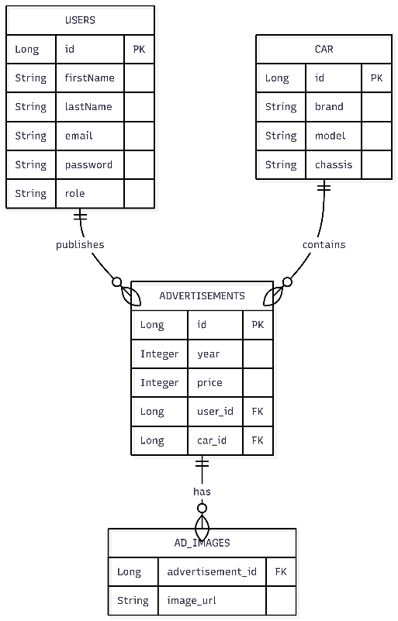

Advertisement Service

The Advertisement Service is a core backend component of the CarKet system, responsible for managing the lifecycle of car listings and enforcing business rules. It acts as an intermediary between the web controllers and the data persistence layer.
Responsibilities
- Ad Publication: It coordinates the creation of new listings by processing data from the AdRequestDTO, linking the advertisement to the correct User, and ensuring the Car entity exists or is created.
- Secured Data Modification: The component enforces security constraints by verifying that only the original owner of an advertisement (or an administrator) can delete a listing or update its price.
- Media Management: It interacts with the FileStorageService to handle the physical saving of vehicle images and stores the resulting file paths within the advertisement record.
- Data Retrieval: It provides filtered search results by communicating with the CarService to find matching vehicle models and then fetching the associated advertisements.

  - Security Configuration
The Security Configuration component is a critical infrastructure module that manages access control and identity verification across the entire CarKet platform. It sits between the client applications and the backend controllers to protect sensitive resources and data.
Functionality Provided
- Authentication Management: It defines the login process, specifying the custom login page and the logic for handling successful or failed authentication attempts.
- Role-Based Access Control (RBAC): It enforces permissions based on user roles, ensuring that only users with the CLIENT role can publish ads, while only ADMIN or the ad owner can perform deletions.
- Session Security: The component manages active user sessions, implementing a concurrency control policy that limits users to a single active session to prevent unauthorized account sharing
- Endpoint Protection: It explicitly defines which parts of the application are public (such as the search page and CSS files) and which require a verified identity (such as the sale page).
- Password Encoding: It provides a BCryptPasswordEncoder bean to ensure that user passwords are never stored or compared in plain text, maintaining high data integrity.

  - Event notification systems
The Event Notification System is a decoupled messaging module designed to handle asynchronous communication and user alerts following key platform actions. By utilizing RabbitMQ, it ensures that long-running tasks, such as sending emails, do not block the main application flow.
Functionality provided:
- Asynchronous Message Processing: It uses a RabbitTemplate to publish AdCreatedEvent and AdDeletedEvent messages to a dedicated exchange (ad.exchange) whenever a listing is published or removed.
- Decoupled Email Alerts: The NotificationService acts as a consumer, listening to specific queues (ad.created.queue and ad.deleted.queue) to trigger automated confirmation emails to users.

  - Export Strategy System
The Export Strategy System provides a flexible mechanism for users to download advertisement data in various file formats. It is built using the Strategy Design Pattern, allowing the application to support multiple export types without modifying the core retrieval logic.
Functionality provided:
- Pluggable Export Formats: The system currently supports JSON, XML, and CSV formats through specialized strategy classes
- Centralized Strategy Resolution: An ExportService manages a map of available strategies, dynamically selecting the appropriate implementation at runtime based on the user's requested format.

Design patterns

Singleton Pattern
- Category: Creational
- It ensures that a class has only one instance throughout the application lifecycle and provides a global point of access to it
- Most of the classes use it, because of the way Spring Boot works, where every Service, Repository, Bean is a singleton by default.

Proxy Pattern
- Category: Structural
- It provides a placeholder or representative for another object to control access to it, such as adding transaction management or security checks without modifying the original code.
- It is used in the Repository classes, and also, the @PreAuthorize annotation wraps the class in a proxy.

Builder Pattern
- Category: Creational
- It allows the step-by-step construction of complex objects.
- Used in UserServiceImpl

Strategy Pattern
-Category: Behavioral
-It allowed me to define a family of exporting algorithms that have their objects interchangeable
-Used in the export package

Observer Pattern
-Category: Behavioral
-Used to notify multiple classes of any change that took place
-Used in the AdvertisementServiceImpl

Broker Pattern
-Category: Architectural
-Acts as an intermediary in distributed systems, facilitating communication among various components or services.
-Used by RabbitMq

Template Method Pattern
-Export system was refactored from the Strategy to the Template method.
-Used in the AdExportTemplate

Command Pattern
-Applied to encapsulate three operations: publish, delete, edit.
-Implemented by the command interface that only has one method: execute().

Class diagrams
Class diagrams describe the static structure of the system by presenting classes, attributes, methods and relationships between classes.
This section should include one or more class diagrams illustrating the internal organization of the system components.
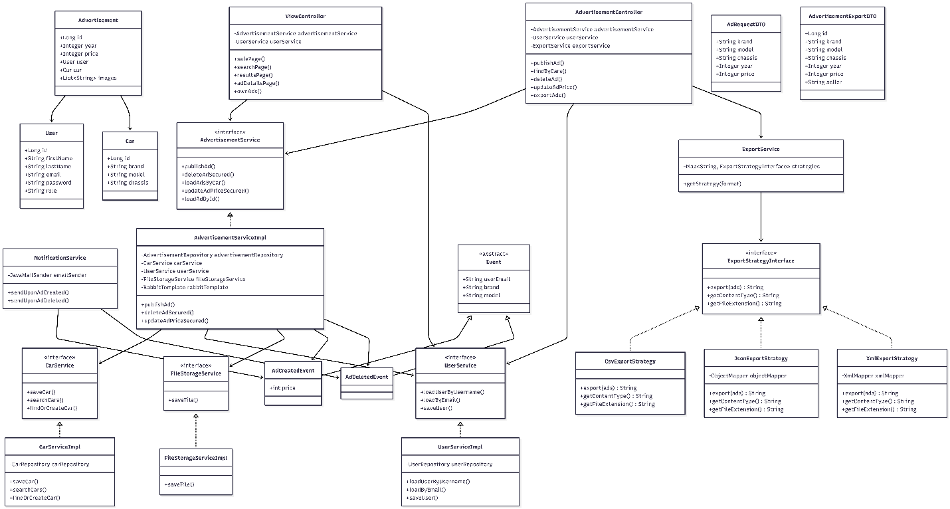

Sequence diagrams
Sequence diagrams illustrate how objects interact during the execution of a particular use case.
They show the order of method calls and message exchanges between system components.
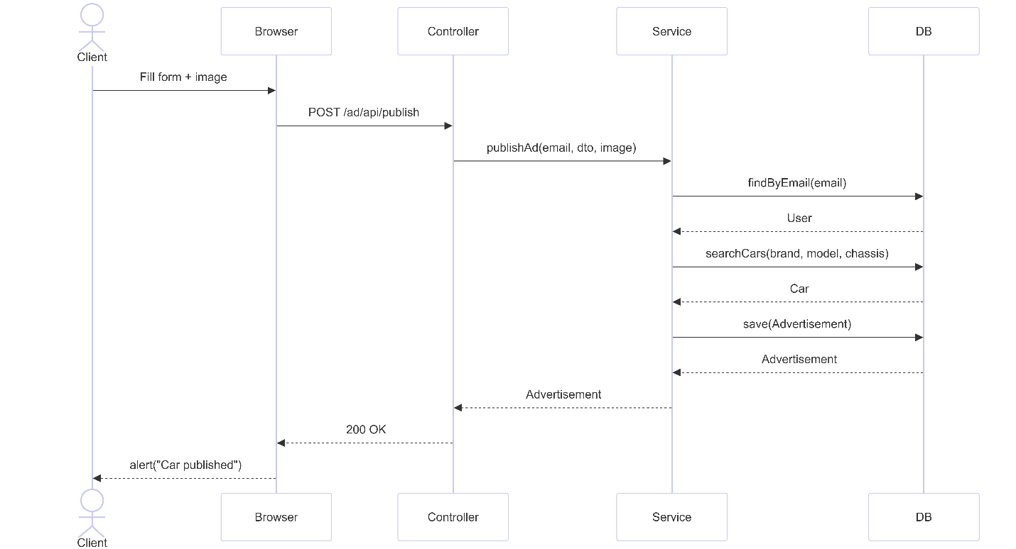

Implementation phase - Application

Tools and technologies
The CarKet application uses a unified stack of Java, Spring Boot, Thymeleaf, and PostgreSQL to create a secure and reliable web platform. This specific combination of technologies was chosen because they work together as a single, integrated ecosystem
- Programming Language: Java 17
- Database Management System: PostgreSQL
- Framework: Spring Boot 4.0.3
- Security: Spring Security
- Thymeleaf (Templates)

Application structure
The project is organized following standard Maven and Spring Boot conventions, using a layered package structure to separate concerns and improve code navigability.
The source code is divided in more packages: configurations, controllers, dto, model, repositories, services
The resources are also divided in packages: static- consists of css, js, and uploads for the ad pictures; and templates: html files.

User manual
The user is prompted on the log in page, where they have 3 choices: log in if they already have an account, register if they don’t have one, or continue as a guest, if they only want to search for cars, but not publish any ads.
After that, the user is taken on the sale page, where they have a form to fill out in order to publish the advertisement. They can change pages with the buttons on the top bar: the bill for the sale page, the magnifying glass for the search page, and the user for their own ads. Each ad can be clicked, and its details are shown, as well as 2 buttons that may or may not appear based on the role of each client. The admin and the ad owner can delete the ad, and the ad owner can edit the price.

Frontend Refactor
The Thymeleaf server-side templates were replaced with a standalone React single-page application running on port 5173. All backend communication is handled through a centralised api.js module using the Fetch API. JWT tokens are stored in localStorage and attached to every authenticated request via an Authorization header. The frontend communicates directly with the Users Microservice (port 8081) for authentication and the Cars Microservice (port 8082) for all advertisement operations.

Docker Containerization
The entire system is containerised using Docker and orchestrated with a single docker-compose.yml file at the project root. The composition defines seven services: rabbitmq, postgres-users, postgres-cars, users-microservice, cars-microservice, notifications-microservice, and frontend. Each Spring Boot service is packaged as a JAR and run inside an eclipse-temurin:17-jdk-alpine container. The two PostgreSQL instances are isolated from each other, each serving only its corresponding microservice. RabbitMQ is shared across the cars and notifications services. Service-to-service communication inside the Docker network uses Docker service names as hostnames, while browser-to-backend calls use localhost with the exposed port mappings.

Microservices Decomposition

Users Microservice (port 8081)
Responsible for user registration, authentication, and identity management. It owns its own PostgreSQL database and exposes REST endpoints for login, register, and internal user lookup by email or ID. JWT tokens are generated here and validated by all other services. Internal endpoints are protected by a shared secret header (X-Internal-Secret) to prevent unauthorized inter-service calls.
Cars Microservice (port 8082)
The core business service, responsible for managing cars and advertisements. It owns its own PostgreSQL database and communicates with the Users Microservice via HTTP to resolve user identity when publishing ads. It uses a CQRS-inspired split between AdvertisementCommandService and AdvertisementQueryService. When an ad is created or deleted, it publishes events to RabbitMQ for asynchronous processing.
Notifications Microservice
A lightweight service with no database and no REST endpoints. It listens exclusively to two RabbitMQ queues (ad.created.queue and ad.deleted.queue) and sends confirmation emails to users via Gmail SMTP when their ads are published or deleted. It has no coupling to any other microservice beyond the shared message broker.

Testing and validation
The application was tested manually, using Postman too, in order to check every api call before implementing the UI, and then, after UI was implemented, it was tested again, with every edge case I could think of.

