**Create installable setup file**

**Step: 1** Download and Install advance installer: <https://www.advancedinstaller.com/download.html>  
 You can also install license free from: <https://getintopc.com/?s=advance+installer>

**STEP : 2**

After installation, Click on **Visual Studio Application**

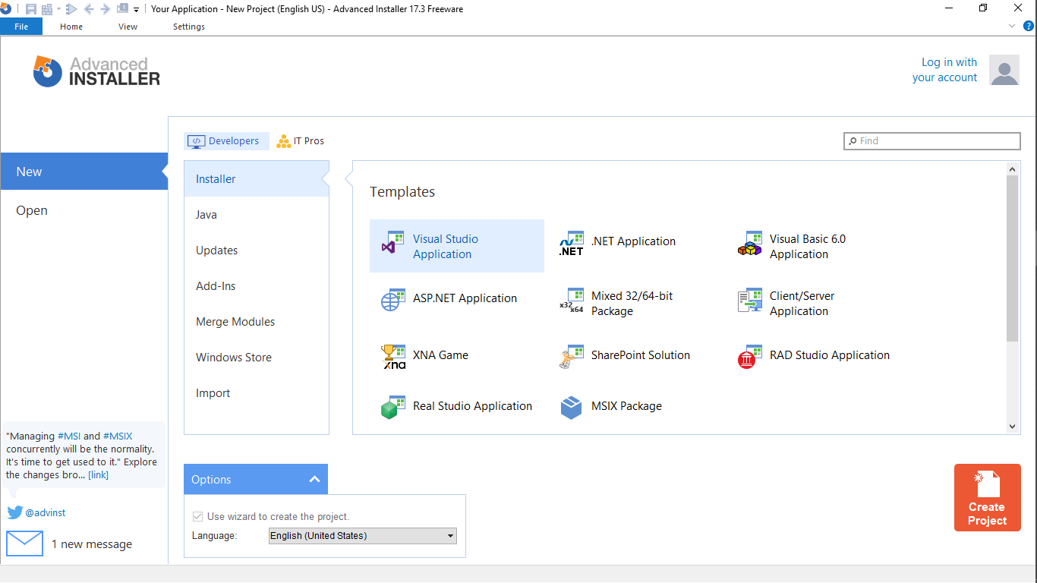

**STEP: 3**

Enter the application name and company name as follow

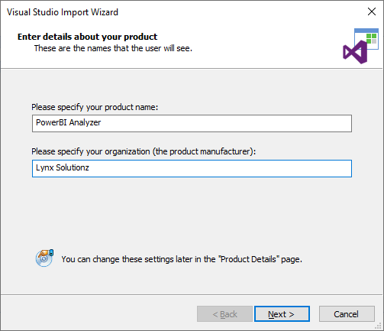

**STEP: 4**

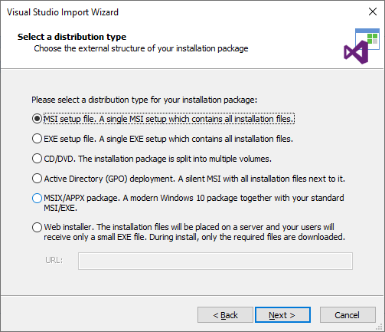

**STEP: 5**

Choose the package location

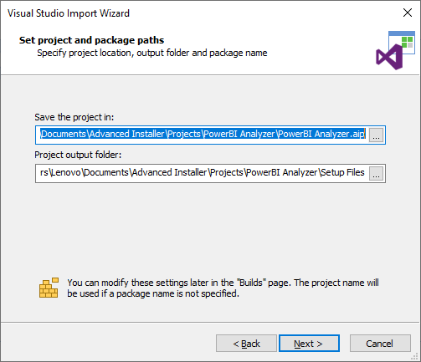

**STEP: 6**

Choose the visual studio code project (**.sln** file)  
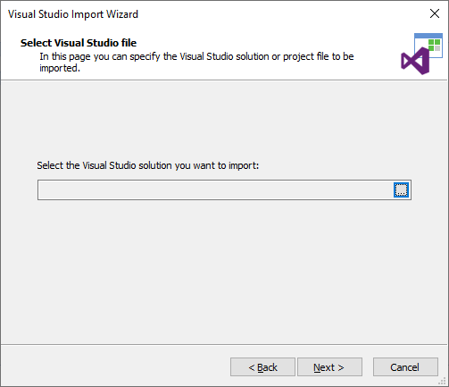

**STEP: 7**

Choose **Release** configuration and **check** build selected configuration

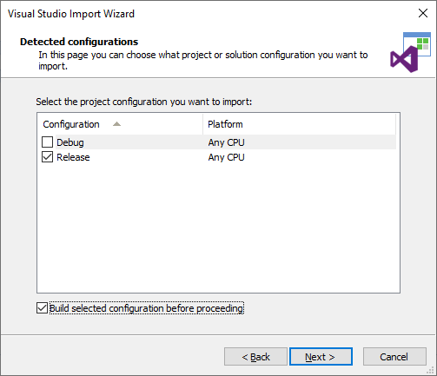

**STEP: 8**

Select all detected files

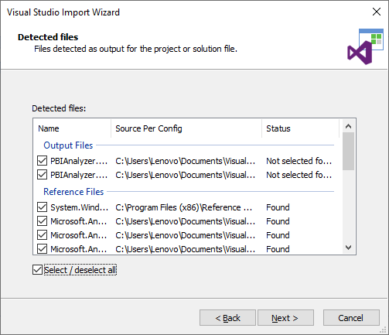

**STEP: 9**

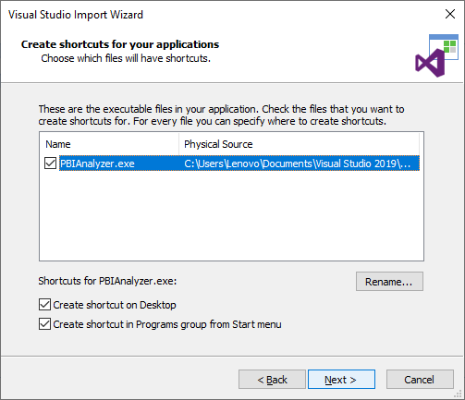

**STEP: 10**

Leave this as it as

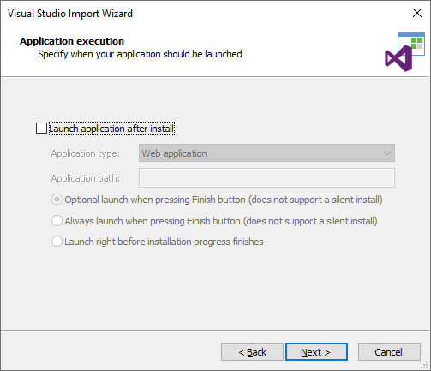

**STEP: 11**

Click on Next for next 2 windows

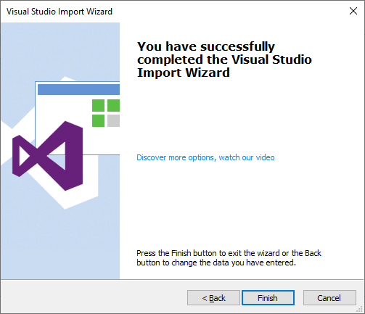

**STEP: 12**

Please see the attached video