2023 Spring CPSC240-7 Midterm Concept Test
2023-March-20: 12noon -2pm

Rules of the test

Write your answer to each question in the space immediately below each question.

You may save this file in one of the three accepted formats: doc, docx, or odt. Other formats such as pdf will be deleted.

Submission of pdf files will be deleted and a score of zero will be recorded.

Submission of links to the cloud will be deleted and a score of zero will be recorded.

The completed test with answers must be attached to an email for submission.

If you don’t have a word processor on your personal computer use Google docs to record your answers. Google docs is a good substitute for a local word processor.

Other information will appear on the last page of this test.

You need an app on your computer that will take a screenshot of open window on your desktop. A screen shot is needed for one question.

The blank option is available. To utilize the blank option key in the word “blank” where an answer would normally appear. Use of the blank option nullifies any other answer given for that question.

Proceed to the next page
1. Perform the subtraction below. Add one big endian from another big endian. As usual show your steps. Spaces are inserted to facilitate carrying and borrowing. [5]

C 7 0 A 9 2 A B
+ A 8 2 6 F 4 A F

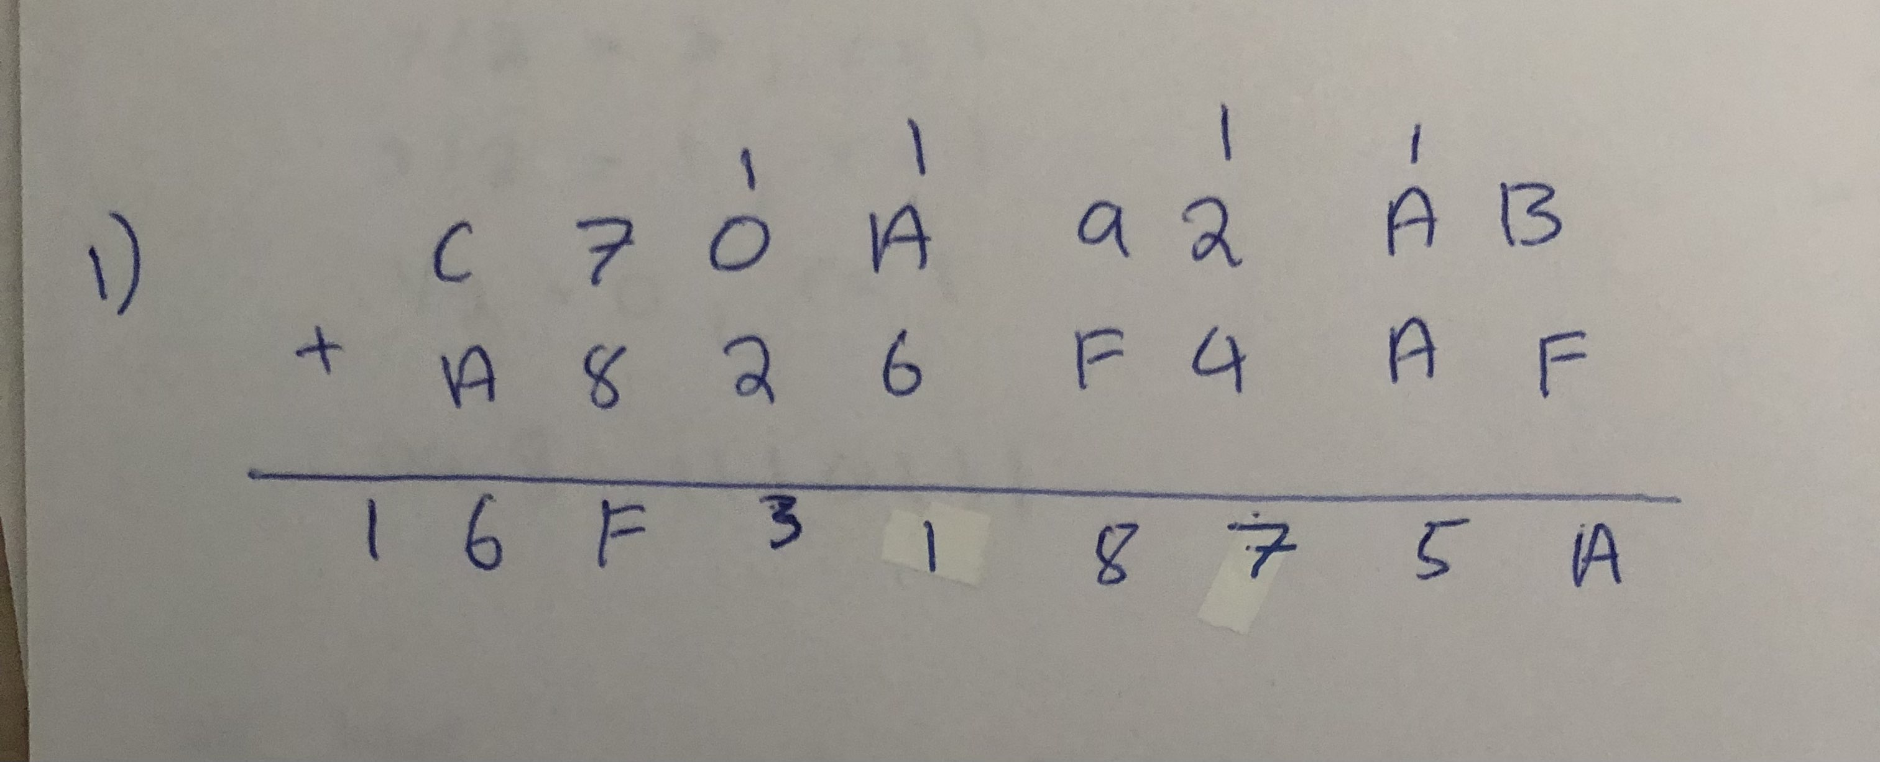

2. Suppose you are working on a game project where a group of friends will log into your computer and play a card game (maybe poker) against each other. As you near completion of the project you are thinking about putting a license on the software. What is the best choice of license for your software? [5]

General Public License(GPL3)

3. Who is the Queen of Rock music? [2]

Janic Joplin

4. Part 1: What is the title of Chris Sawyer? [4]

King of assembly

Part 2: What did he do to earn that title? (Be precise and clear.)

Assembled game called Roller Coaster Tycoon. All in assembly took 3 years only he worked on it & has a million lines of code.

5. Who is the first assembly programmer? What year did this person die? [2]

Kathleen Booth, recently passed on September 29, 2022

6. Declare an array of 40 dwords in the .bss segment. You choose a good name for the array. [5]

segment .bss

array resd 40

Make a block for an assembly program. In the block construct a loop that will place a random value in each element of the array. Here we accept all randoms including nans and normals and others.

r15, array
r14, 40
r13, 0
Loop_array:
cmp r13,r14 ;compare counter with array size(40)
je endLoop_array
rdrand r12 ;generate Dword(32bit)

mov[r15+8*r13], r12 ;store Dword in array
inc r13 ;increment index of array
jmp Loop_array

endLoop_array:

7. 67 students are waiting in the hall for the instructor to unlock the door. In the classroom there are 96 desks arranged into 8 desks in each row. In this classroom everyone crowds toward the front. The only empty chairs are in the back of the room.

How many students are in the partially filled row in the back? Make a block in assembly that will answer this question.

Assume that r10 holds 67 and r12 holds 8. Solve the problem in assembly and put the answer in r14. [5]

mov r10, 67 ; number of students waiting in the hall
mov r12, 8 ; number of desks in each row

xor rdx, rdx
div r12 ;quotient is in rax, remainder is in rdx

mov r14, rdx ; move the remainder (number of students in the partially filled row) to r14

8. Log onto the Computer Science server also known as Titan V. Enter these commands:
date
users

Make a screenshot of the output. Paste the image (probably a jpeg) into the test document directly below this line. [5]

Information: First try to log into the server as demonstrated in a lecture. If you receive a message denying you access to the server then do the following.

1Go to www.whatismyip.com and record your own IP number.

2.Send an email to the server administrator person, Mr. Gary Chang, at gchang@fullerton.edu. Say something like this: Dear Mr Chang, I need access to the ECS server for a test I am taking. Please unblock me. Here is my IP number:xxx.xxx.xxx.xxx. Mr Chang has promised to unblock everyone who needs it.

First try to log in before contacting Mr. Chang.

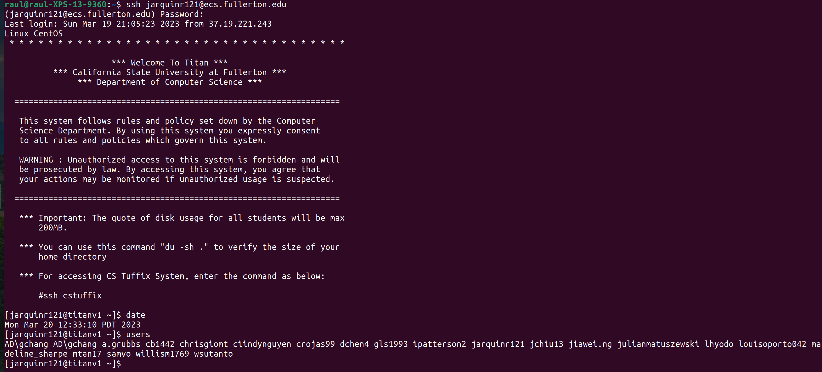
9. Part 1. Convert the decimal integer 1609 to an equivalent binary number.
Show sufficient steps to convince the grader that you know the conversion algorithm. [9]

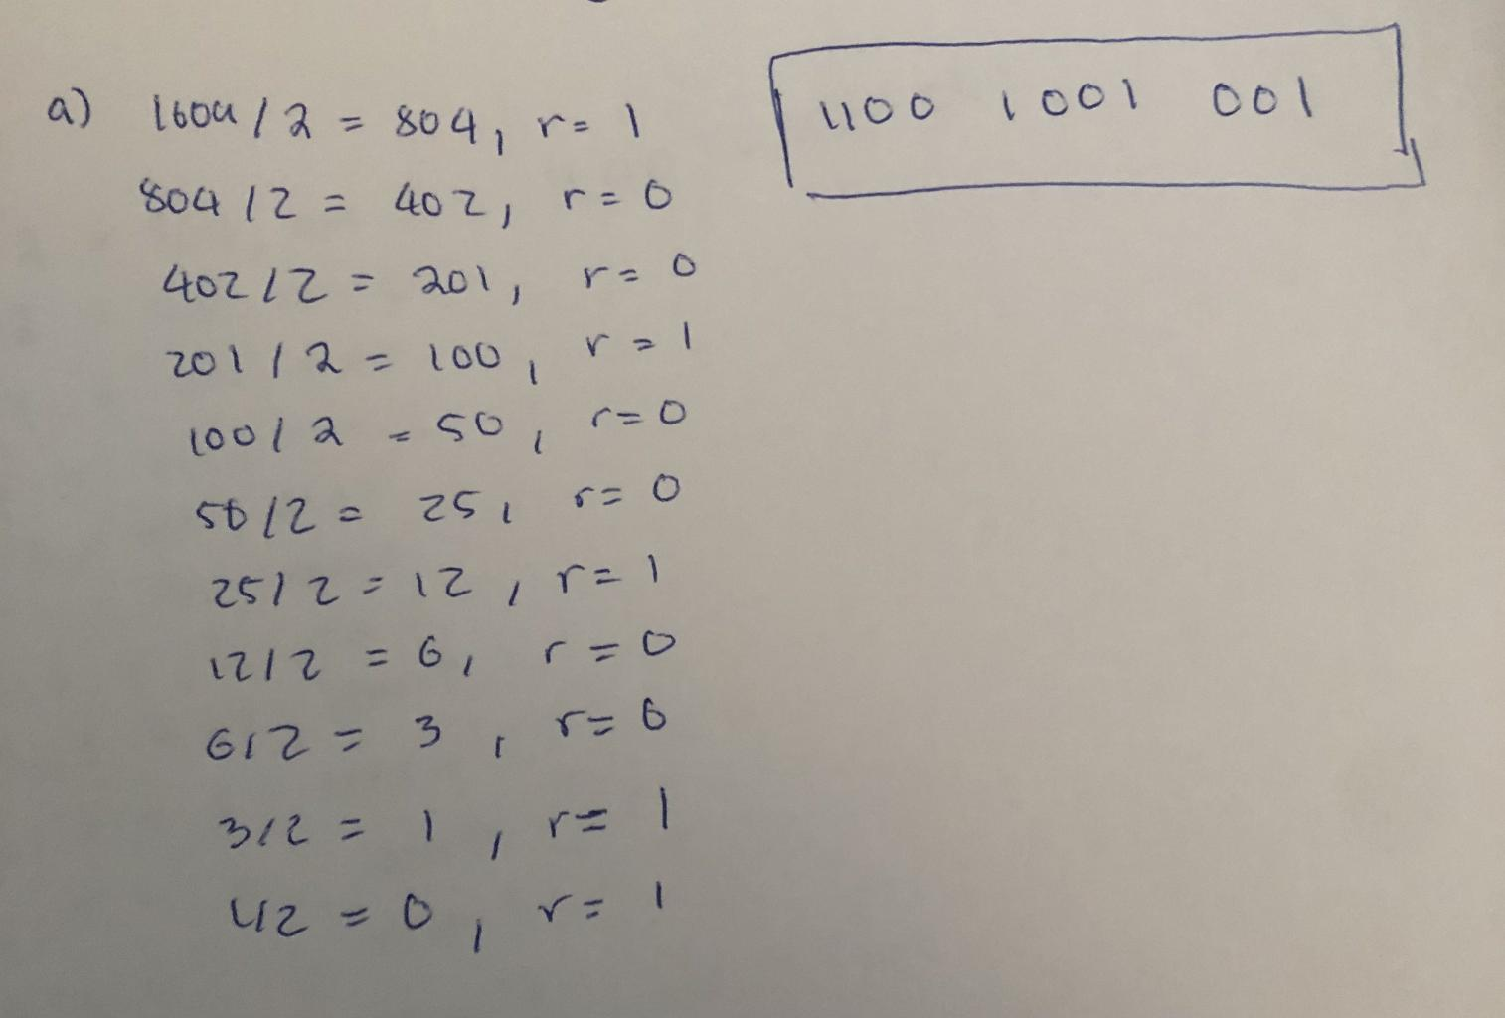

Part 2. Convert the answer of part 1 to a 32-bit hex number.

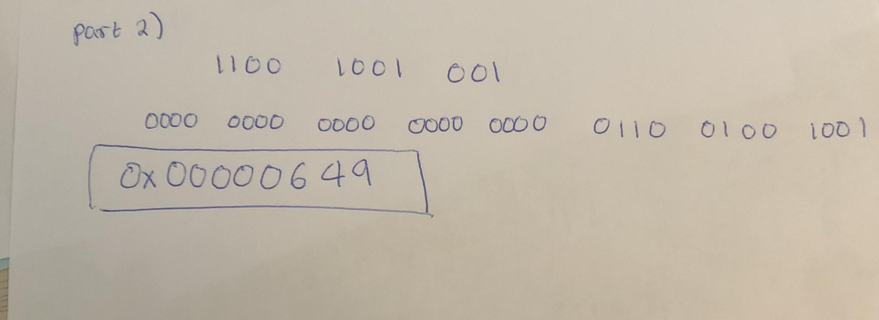
10. Convert 119.7 to a decimal float number. Show steps sufficient to convince the grader that you know how the conversion algorithm works. [9]

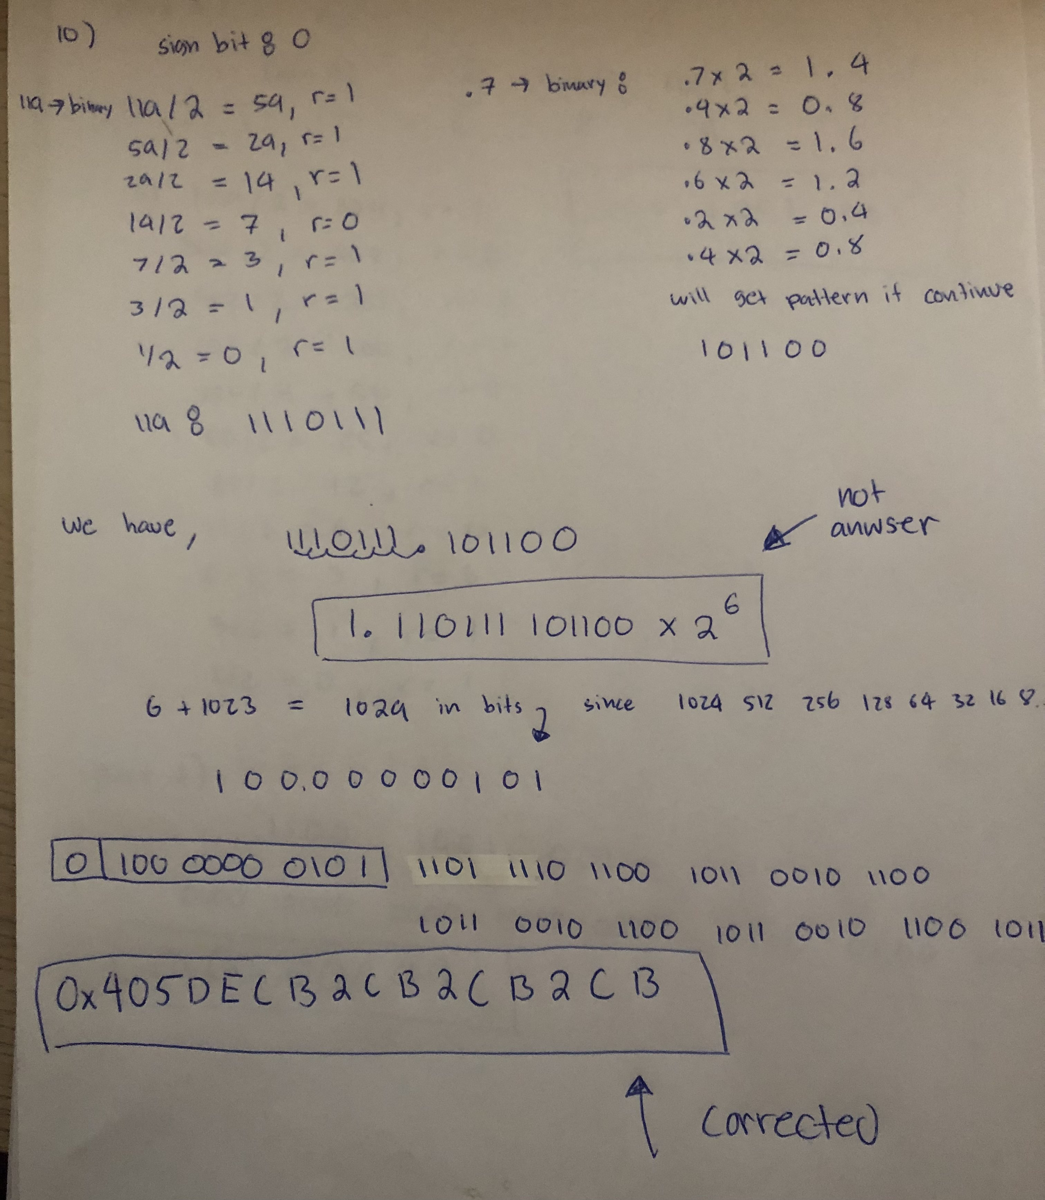

11. The register rbx contains the following data:
8 bit of junk 11 bits signed integer 45 bits of miscelleaneous

Show the block of assembly instructions that will output the signed integer in decimal. [5]

push qword 0
mov rax, 0
shl rbx, 8
shr rbx, 45
mov rdi, rbx
call printf
pop rax

12. What is stored in the frontend of any dormant AR? This question applies to dormant or sleeping ARs. [5]

stores the values of non-volatile registers that were saved when the function or procedure was suspended

13. Convert 0x3FBD E000 0000 0000 to a decimal float number. Show sufficient steps to convince me you know how to convert IEEE numbers to decimal numbers. [9]

BLANK
14. How do you compute the absolute value of the IEEE number stored in xmm0? Show the answer in assembly language (not English language). [5]

xorpd xmm0, 0x8000 0000 0000 0000

15. Suppose rcx contains the integer 58934. Show assembly instruction(s) that will convert that number to 58934.0 and store the converted number in xmm8. [5]

cvtsi2s xmm8, rcx

16. An assembly source file plans to call the function green, which has the following prototype:

double green(double,long,double,long);

In the assembly function there is a declaration of an array named wight containing 10 doubles.

The declaration looks something like this
weight dq 13.5,40.6,16.7, ….., etc

These are the values to pass to sapphire. Sapphire??? Typo.. did you mean green?
First parameter: contents of cell 0
Second parameter: contents of r12
Third parameter: contents of the last cell
Fourth parameter: contents of r15

What is the setup block for calling green? Show details. [5]

push qword 0
mov rax, 0
mov rdi, weight
mov rsi, r12
mov rdx, 10
mov rcx, r15
call green
pop rax

17. This array has been declared in C++
double a[ ] = {3.5,-7.75,-1.0,4.99,2.66,0.025}

What is the GDB command that will output all the values in the array? [5]

x/6f &a

18. What GDB command could have produced the following output? [5]

0x7fffffffde80: 0x0002 0x0000 0x0000 0x0000 0x4b40 0x004c 0x0000 0x0000
0x7fffffffde90: 0x0000 0x0000 0x0000 0x400c 0x0000 0x0000 0x0000 0x4021
0x7fffffffdea0: 0x0000 0xaaaa 0x0000 0x0000 0x0000 0x0000 0x0000 0x0000
0x7fffffffdeb0: 0x0000 0x0000 0x0000 0x0000 0x0000 0x0000 0x0000 0x0000
0x7fffffffdec0: 0x0003 0x0000 0x0000 0x0000 0x0009 0x0000 0x0000 0x0000
0x7fffffffded0: 0x0004 0x0000 0x0000 0x0000 0xfffe 0xffff 0xffff 0xffff
0x7fffffffdee0: 0xfffc 0xffff 0xffff 0xffff 0x8d00 0x0c38 0x0001 0x0000
0x7fffffffdef0: 0x0064 0x0000 0x0000 0x0000 0x0040 0x0000 0x0000 0x0000
0x7fffffffdf00: 0x0020 0x0000 0x0000 0x0000 0x0010 0x0000 0x0000 0x0000
0x7fffffffdf10: 0x0008 0x0000 0x0000 0x0000 0x9800 0xe079 0xb6c0 0xde13
0x7fffffffdf20: 0x0001 0x0000 0x0000 0x0000 0xed90 0xf7b7 0x7fff 0x0000
0x7fffffffdf30: 0xffcc

x/89xh 0x7fffffffde80

19. Here is a memory dump made during the run of a program. Separate the activation records from each other by inserting a blank line between adjacent ARs. (If you choose the blank option then record "blank".) [5]

Offset Address Value
+480 00007fff9a5122e0 0000000000000000
+472 00007fff9a5122d8 00007fff9a512380
+464 00007fff9a5122d0 0000000000401070
+456 00007fff9a5122c8 107a4d83db79292f
+448 00007fff9a5122c0 0000000000401900
+440 00007fff9a5122b8 0000000000401156
+432 00007fff9a5122b0 0000000100011c00
+424 00007fff9a5122a8 00007fff9a512388
+416 00007fff9a5122a0 00007fb3c0345b80
+408 00007fff9a512298 00007fb3c017d083

+400 00007fff9a512290 0000000000000000
+392 00007fff9a512288 0000000000000000
+384 00007fff9a512280 000000000000000a
+376 00007fff9a512278 0000000000000010
+368 00007fff9a512270 0000000000000000
+360 00007fff9a512268 0000000100401900
+352 00007fff9a512260 00007fff9a512388
+344 00007fff9a512258 00000000004011ac

+336 00007fff9a512250 00007fff9a512290
+328 00007fff9a512248 4b5c0f18727e9800
+320 00007fff9a512240 fffffffffffffff7
+312 00007fff9a512238 ffffffffffffffff
+304 00007fff9a512230 0000000000000003
+296 00007fff9a512228 0000000000000020
+288 00007fff9a512220 0000000000000000
+280 00007fff9a512218 0000000000401252

+272 00007fff9a512210 00007fff9a512250
+264 00007fff9a512208 0000000000d6a2c0
+256 00007fff9a512200 fffffffffffffffe
+248 00007fff9a5121f8 00000000004012fb

+240 00007fff9a5121f0 00007fff9a512210
+232 00007fff9a5121e8 4b5c0f18727e9800
+224 00007fff9a5121e0 0079616468747269
+216 00007fff9a5121d8 4220797070614810
+208 00007fff9a5121d0 fffffffffffffffd
+200 00007fff9a5121c8 fffffffffffffffe
+192 00007fff9a5121c0 ffffffffffffffff
+184 00007fff9a5121b8 400c000000000000
+176 00007fff9a5121b0 00000000004013d3
+168 00007fff9a5121a8 0000000000000005
+160 00007fff9a5121a0 0000000000000002
+152 00007fff9a512198 fffffffffffffffd
+144 00007fff9a512190 00007fb3c0346788
+136 00007fff9a512188 00000000004013dc

+128 00007fff9a512180 00007fff9a5121f0
+120 00007fff9a512178 0000000000401900
+112 00007fff9a512170 0000000000401900
+104 00007fff9a512168 00007fb3c0267077
+96 00007fff9a512160 000000000000001a
+88 00007fff9a512158 0000000000000191
+80 00007fff9a512150 0000000000000002
+72 00007fff9a512148 000000000000002d
+64 00007fff9a512140 000000000000005a
+56 00007fff9a512138 00000000004021fb
+48 00007fff9a512130 0000000000000246
+40 00007fff9a512128 0000000000401070
+32 00007fff9a512120 00007fff9a512380
+24 00007fff9a512118 0000000000000000
+16 00007fff9a512110 0000000000000000
+8 00007fff9a512108 0000000000000246
+0 00007fff9a512100 ffffffffffffff9d
-8 00007fff9a5120f8 000000000040182b

-16 00007fff9a5120f0 00007fff9a512180
-24 00007fff9a5120e8 00000000000001f4

//End of test. Continue to next page.
Conclusion

Record your identifying information here.

Name

Email

Cwid

Attach this document already in format doc or docx or odt to email message and send to the professor at the usual place.

holliday@fullerton.edu

In the subject line place “240-7 Midterm”

Do not send links to the cloud. Do not send pdf files.

There is no need for a message in the email itself. If you wish to send me a message with this test then write it directly in the white space in the lower half of this page.

