2023 Spring CPSC 240-7
Final Concept Test: May 10, 2023 @12m-2pm

Basic information

The time is 12:00pm to 2:00pm. Timing counts: submit this document on time.

The blank rule is in effect. Write the word “Blank” in the space for an answer and you’ll received 20% of the credit for that question. If an answer space contains both an answer and the string “Blank” then blank takes precedence.

Only three file types may be submitted, namely: .odt, .doc, or .docx. Other file types will not be read.

Do not send a link to a cloud. The returned document must be “attached” to an email sent to holliday@fullerton.edu. “Attached” does not mean “linked to”. This rule is extremely important. On page 5 of the revised Assignment 4 specification it shows what an attachment must look like. Yours must look the same.

Do not use any e-registers in any answer.

If you can’t view the diagrams in this document then you are using a Microsoft document viewer. The quick solution is to view the document in Google Docs.

1. The ACM chapter of the CS Department is planning a field trip to the Amazon warehouse in Riverside. All the members are instructed to be ready at 1pm on Tuesday at the East parking lot near the Gastronome. The number of member who appear on time is placed into r11. The president of the chapter says that they will carpool in order to save on transportation costs. This time there will be nobody sitting on someone else’s lap as in previous trips. The four-person per car rule will be enforced. The 4 is in register rsi. Your job is to help the ACM chapter president figure out how many cars are needed. Write a block of instructions that will compute how many vehicles will be need and put that answer in r12. Also, put the number of persons in the extra vehicle that may have less than the full set of 4 people into register r10.

mov rax, r11
cqo
div rsi
mov r12, rax
mov r10, rdx
;Done r12 holds quotient and r10 hold reminder

2. Convert this IEEE32 number to decimal: 0x3E6A A800

Show sufficient work to convince the grader that you really know IEEE32 numbers.
A calculator may be used, but don’t allow the calculator obscure your knowledge about IEEE numbers.

BLANK
3. Convert this decimal number to IEEE64:
[The fraction is an embedded graphic. View it in Google Docs if necessary.]
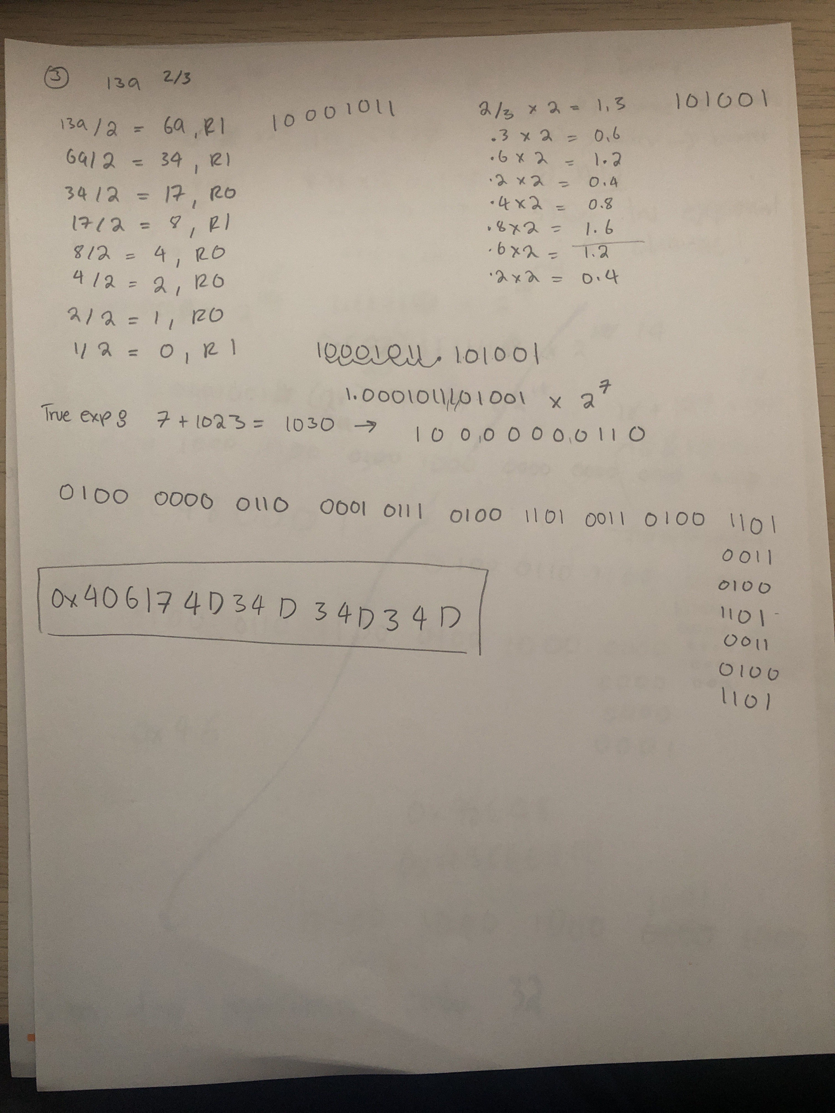
4. In the same way we honor our countries great founders we honor the heroes who made computer science a viable fun area of academic study. What is the name of the computer scientist who undertook the project to build an operating system by himself or herself? In what city was this hero located when the project started.

You need two answers.

Linus Torvalds,
Helsinki, Finland

5. Make a block of assembly instructions that will flip all the bits in r12.

mov rax, r12
mov r12, 0xFFFF FFFF FFFF FFFF
xor rax, r12

6. There is a float number in the lower 64 bits of xmm12. Show how to round that number to the nearest whole number IEEE number such that if there is a tie then the nearest even number wins. Put the rounded answer in xmm5.

BLANK

7. Create a C++ function. The prototype of the function is double getrandom(0);

When the function is called it returns a non-deterministic 64-bit random number normalized to be in the range 1.0 <= x < 2.0

Hint: C++ does not have access to non-deterministic numbers. Think about using inline assembly.

inline double getrandom()
{
double result;

asm volatile(
"call random_generator\n\t"
: "=t" (result)
:
: "rax", "rbx", "rcx", "rdx", "cc", "memory"
);

return result;
}
8.. Create a block of assembly that will count the number of ‘1’ bits in the register r9. Leave the answer in rax.

popcnt rax, r9

9. What is a GDB command that will place the number 8.5 into the qword beginning at address 0x00007ffe64ce33b8.

Follow that by using a GDB command to view the new value stored at that address.

set {double}0x00007ffe64ce33b8 = 8.5
p *(double*)0x00007ffe64ce33b8
10. Here is an array declared in segment .data.

games dq 37,93,107,60,110,87,79

What is the GDB command that will change the value in the middle number to be 999.

Follow this with the GDB command that will output only the recently changed number.

set $games[3] = 999
p/x $games[3]

//End of test. As promised the number of questions is less than 12.

If you did your best then that is all that can be asked. Continue to the next page.
Conclusion

This is like the midterm. You know what to do.

Enter your name here: Raul Jarquin Valdez

Enter your preferred email address here: jarquinr121@csu.fullerton.edu

Make sure your test document is in one of the three formats: odt, doc, docx.

Attach it to an email. Put “240-3 concepts” in the subject line.

The word is “attach” – not “link”. “Linked” documents will not be downloaded.

If you have a message for me to read, record it on this page below this paragraph. You can say anything: “Happy Birthday’, Happy Independence Day, I didn’t get anything out of this assembly class, have a nice weekend, whatever. The point is the message will be read at the time this test is graded. A message placed in the body of the email itself will soon be separated from the test document.

Come back on Monday May 15 for the best part of the whole semester.

All test questions are original. Questions are not adopted from any book publisher’s set of suggested questions. You can only blame your instructor for defects in the test.
Make sure your test document is in one of the three formats: odt, doc, docx.

Attach it to an email. Put “240-3 concepts” in the subject line.

The word is “attach” – not “link”. Get it right. Your whole grade depends on that one word “attach”.

If you have a message for me to read record it on this page below this line. You can say anthing: “Happy Birthday’, Happy Independence Day, I didn’t get anything out of this assembly class, have a nice weekend, whatever. The point is the message will be read here, but in the email itself the message is soon lost in a sea of spam.

Come back on Monday May 15 and we’ll finish this course.

