# CPSC 254 Lab 5 Group 2-2 Test Results

## R24 <Relop>

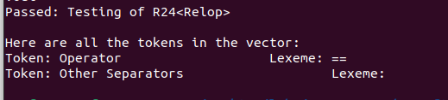

* Results: reading in from a text file, the vector of tokens contains the operator and pass this test.
* Problem: there are 2 invalidate operator forms. One is “=<”, another is “=>”.

## R22 <While>

* 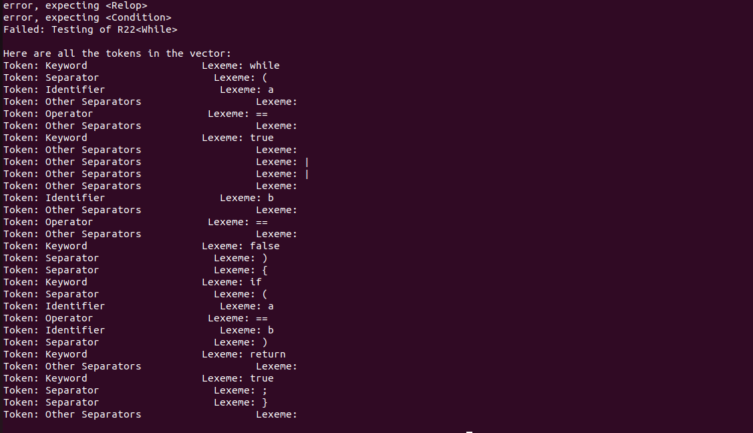Results: reading in from a text file, the vector of tokens contains two conditions and if statement inside. Testing was failed.
* Problem: there are two conditions, however, the rule of condition does support this type. And cannot figure out or operator ||.

## R18 <If>

* R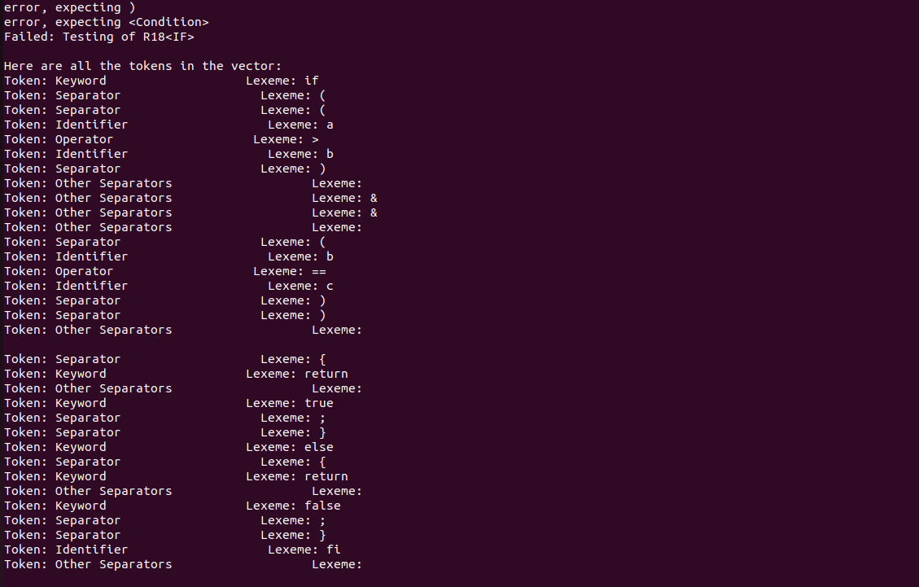esults: reading in from a text file, the vector of tokens contains two conditions and if statement inside. Testing was failed.
* Problem: there are two conditions, however, the rule of condition does support this type. And cannot figure out and operator &&.