


ER Diagram for Electronic Voting System

Module Title and Code: Introduction to Databases, UFCFTK-30-1
Submitted By: Raunak Kumar Singh
Student Number: 24071246
Orbund Id: 11281
Submitted To: Rabin Gautam

TASK 1 (30%)
Construct an ER Diagram for an Electronic Voting System

Design an ER diagram for an electronic voting system to replace the manual voting system in Nepal. Make the following assumptions:
- Voter Registration: Each voter has personal details (name, citizenship number, address).
- Election Details: The system supports multiple elections, each with a unique ID and election date.
- Candidates: Each election has multiple candidates, with details such as name and political party.
- Voting Process: Each voter can vote once per election.
- Results: The system stores the election results, including votes for each candidate.
- Security: Ensure vote confidentiality and prevent tampering.
Requirements:
- Entities: Identify entities like Voter, Election, Candidate, Vote, etc.
- Relationships: Define relationships (e.g., Voter casts Vote, Election has Candidates).
- Cardinalities: Specify cardinalities (one-to-many, many-to-many).
- Constraints: Include constraints like voter eligibility (age, citizenship) and one vote per voter.
Deliverables:
- ER Diagram: Include entities, attributes, relationships, and cardinalities. You can use any tools for creating the ER diagram (e.g., draw.io, Lucidchart, Microsoft Visio).
- Relations: Convert the ER diagram into a relational schema with primary and foreign keys.

Introduction

This task involves designing an ER diagram for an Electronic Voting System. The systems main motive is to remove the traditional voting system of Nepal with new and most effective Electronic Voting System.
The ER model represents key entities such as voters, elections, candidates, votes, and results, along their relationships and constraints.
In addition to the voting process, voter registration is also included to better reflect a real-world election system.

Entity-Relationship (ER) Diagram

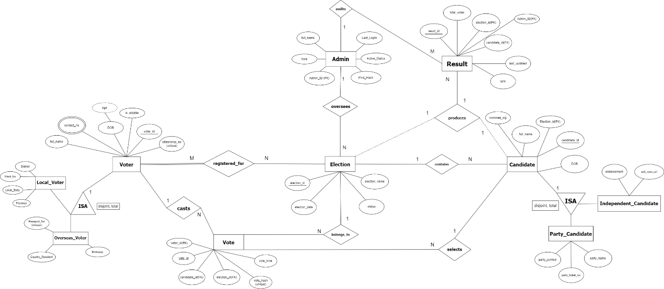
Fig: ER Diagram for Electronic Voting System (Created Using draw.io)

Entity Description
My Electronic Voting System consists of the following entities:

1.Voter: Stores information about individuals eligible to vote, including voter_id, full_name, citizenship_no, DOB, and contact_no.
2. Local_Voter: A specialization of Voter representing voters residing within the country, including attributes such as district, ward_no, local_body, and province.
3. Overseas_Voter: A specialization of Voter representing voters residing in another nation, including attributes such as passport_no, embassy, and country_resident.
4. Election: Represents elections conducted in the system designed by me, which includes election_id, election_name, election_date, and status.
5. Candidate: Represents individuals participating in elections. Each candidate is associated with a specific election and may either be a party or independent candidate.

6. Party_Candidate: A subclass of Candidate containing attributes such as party_name, party_symbol, and party_ticket_no.
7. Independent_Candidate: A subclass of Candidate representing candidates without party affiliation.
8. Vote: Represents each vote cast in the system, including vote_id, voter_id, election_id, candidate_id, vote_time, and vote_hash.
9. Result: Represents the outcome of elections, storing total_votes for each candidate along with election_id, admin_id, and candidate_id.
10. Admin: Represents system administrators responsible for managing elections and auditing the results.

Relationships
The relationship between entities is implemented as follows:

1. A voter registers for an election through the registered_for relationship, showcasing participation eligibility before voting.
2. A voter casts a vote.
3. A vote belongs to an election.
4. A vote selects a candidate.
5. An election contains multiple candidates.
6. An election produces results.
7. A candidate produces results.
8. An admin oversees elections.
9. An admin audits results.

Cardinalities
The cardinalities of the relationship in my system are as follows:

1. A voter can register for multiple elections and each election can have multiple voters. (M: N)
2. One voter can cast multiple votes. (1: N)
3. Each vote belongs to one election. (N: 1)
4. Each vote selects one candidate. (N: 1)
5. One election contains multiple candidates. (1: N)
6. One election produces multiple results. (1: N)
7. Each candidate produces one result per election. (1: 1)
8. One admin oversees multiple elections. (1: N)
9. One admin audit multiple result. (1: M)

Constraints
My system enforces the following constraints:

1. A voter can vote only once per election. This is enforced using a unique constraint on the combination of voter_id and election_id in the Vote entity.
2. Each voter must have a unique citizenship number.
3. A voter must be at least 18 years old to be eligible to vote.
4. Only voters registered for an election are allowed to cast a vote in that election.
5. Vote confidentiality is maintained using a vote_hash to prevent tempering.
6. Foreign key constraints ensure referential integrity between related entities.

ISA (Specialisation) Explanation
My system uses specialisation (ISA) to represent different categories of Voters and Candidates.

The Voter entity is divided into:
1. Local_Voter
2. Overseas_Voter
This specialisation is disjoint and total, meaning each voter belongs to exactly one category.
Similarly, the Candidate entity is divided into:
1. Party_Candidate
2. Independent_Candidate
This allows the system to distinguish candidates based on their political affiliation and improved data organisation.

Relational Schema
The ER diagram is converted into the following relational schema.

VOTER (
voter_id PRIMARY KEY,
full_name,
citizenship_no UNIQUE,
DOB,
contact_no,
is_eligible
)

LOCAL_VOTER (
voter_id PRIMARY KEY,
district,
ward_no,
province,
Local_body,
FOREIGN KEY (voter_id) REFERENCES VOTER (voter_id)
)

OVERSEAS_VOTER (
voter_id PRIMARY KEY,
passport_no UNIQUE,
embassy,
country_resident,
FOREIGN KEY (voter_id) REFERENCES VOTER (voter_id)
)

ELECTION (
election_id PRIMARY KEY,
election_name,
election_date,
status
)

CANDIDATE (
candidate_id PRIMARY KEY,
election_id,
full_name,
nominee_sig,
DOB,
FOREIGN KEY (election_id) REFERENCES ELECTION (election_id)
)

PARTY_CANDIDATE (
candidate_id PRIMARY KEY,
party_name,
party_symbol,
party_ticket_no,
FOREIGN KEY (candidate_id) REFERENCES CANDIDATE (candidate_id)
)

INDEPENDENT_CANDIDATE (
candidate_id PRIMARY KEY,
endorsement,
self_nom_ref,
FOREIGN KEY (candidate_id) REFERENCES CANDIDATE (candidate_id)
)

VOTE (
vote_id PRIMARY KEY,
voter_id,
election_id,
candidate_id,
vote_time,
vote_hash UNIQUE,
FOREIGN KEY (voter_id) REFERENCES VOTER (voter_id),
FOREIGN KEY (election_id) REFERENCES ELECTION (election_id),
FOREIGN KEY (candidate_id) REFERENCES CANDIDATE (candidate_id),
UNIQUE (voter_id, election_id)
)

RESULT (
result_id PRIMARY KEY,
election_id,
candidate_id,
admin_id,
total_votes,
last_updated,
rank,
FOREIGN KEY (election_id) REFERENCES ELECTION (election_id),
FOREIGN KEY (candidate_id) REFERENCES CANDIDATE (candidate_id),
FOREIGN KEY (admin_id) REFERENCES ADMIN (admin_id)
)
ADMIN (
admin_id PRIMARY KEY,
role,
pwd_hash,
active_status,
last_login,
full_name
)
MANAGES (
admin_id,
election_id,
PRIMARY KEY (admin_id, election_id),
FOREIGN KEY (admin_id) REFERENCES ADMIN (admin_id),
FOREIGN KEY (election_id) REFERENCES ELECTION (election_id)
)

REGISTERED_FOR (
voter_id,
election_id,
PRIMARY KEY (voter_id, election_id),
FOREIGN KEY (voter_id) REFERENCES VOTER (voter_id),
FOREIGN KEY (election_id) REFERENCES ELECTION (election_id)
)

Conclusion
In conclusion, the ER Diagram successfully models an Electronic Voting System by adding up all the required entities, relationship, and constraints.
The inclusion of voter registration enhances the realism of my system, while constraints ensure data safety and integrity.
The Relational Schema implemented from the ER Diagram provides solid foundation for the system in real world DB Environment.

Tools and Technologies Used:

1. Draw.io
I used draw.io to bring my imagination of Electronic Voting System into visual representation using ER Diagram method.

