



Flight & Airline Database System (SQL + Python)

Module Title and Code: Introduction to Databases, UFCFTK-30-1
Submitted By: Raunak Kumar Singh Student Number: 24071246
Orbund Id: 11281
Submitted To: Rabin Gautam

TASK 2 (30%)

1. Consider the following FLIGHT table given below:

id | source | destination | aid | fare | discount | capacity
RA230 | Kathmandu | Delhi | 1 | 50000 |  | 200
AI215 | Delhi | Kathmandu | 2 | 60000 | 5000 | 300
3L046 | Kathmandu | Abu Dhabi | 3 | 70000 |  | 300
RA416 | Kathmandu | Kuala Lumpur | 1 | 55000 | 2000 | 180
H9891 | Kuala Lumpur | Kathmandu | 4 | 65000 | 3000 | 250

Similarly consider the following AIRLINES table given below:

id | name | country | founded_year | fleet_size
1 | Air Nepal | Nepal | 1990 | 20
2 | Air India | India | 1932 | 150
3 | Etihad Airways | UAE | 2003 | 120
4 | Malaysia Airlines | Malaysia | 1947 | 80

- Write SQL syntax to create database with name TRACKER and the given tables: FLIGHT and AIRLINES. The aid column must refer to id of AIRLINES table.
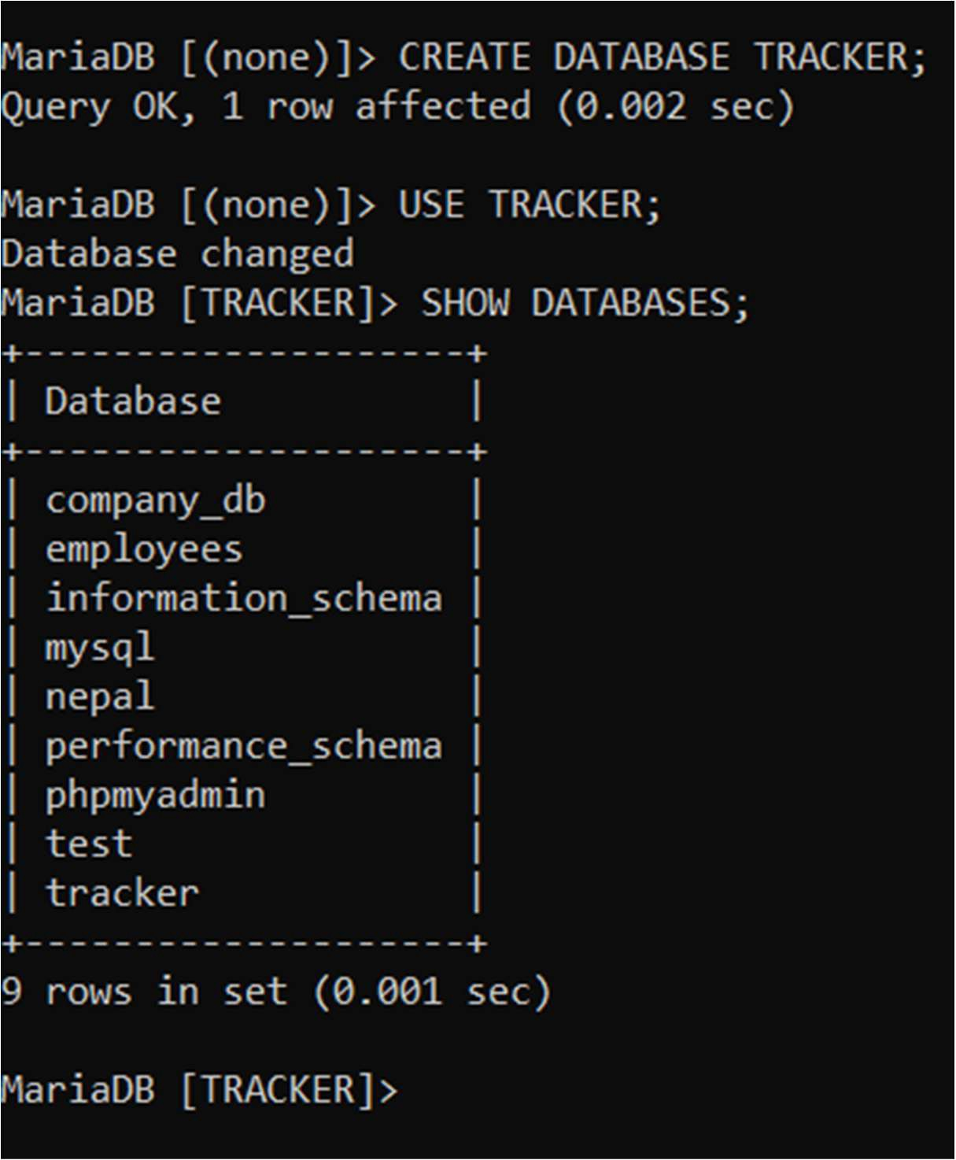
Answer:

Firstly, the database TRACKER was created.

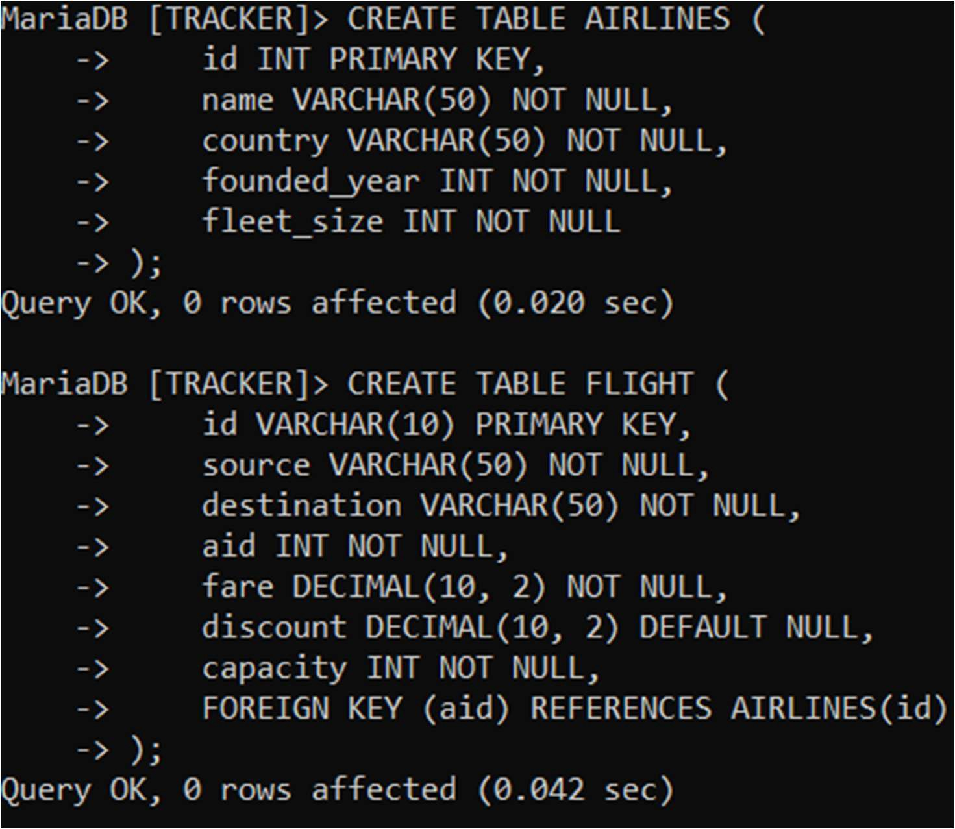

After that, the AIRLINES table was created first, then I created Flight table which ensures foreign key referencing (aid – AIRLINES.id).

At the beginning, I started the XAMPP Server to run MYSQL in my own local system. After that, I opened SQLyog and connected it to the localhost database server.
Then, I went back to XAMPP Server and used its terminal to access MYSQL by running the command “mysql -u root -p”.
After the connection was achieved, I created a database named TRACKER as per the question.
Now at first, I created the table for AIRLINES. Then, I created the table for FLIGHT and added a foreign key in it so that the aid column will refer to the id column in the AIRLINES table.

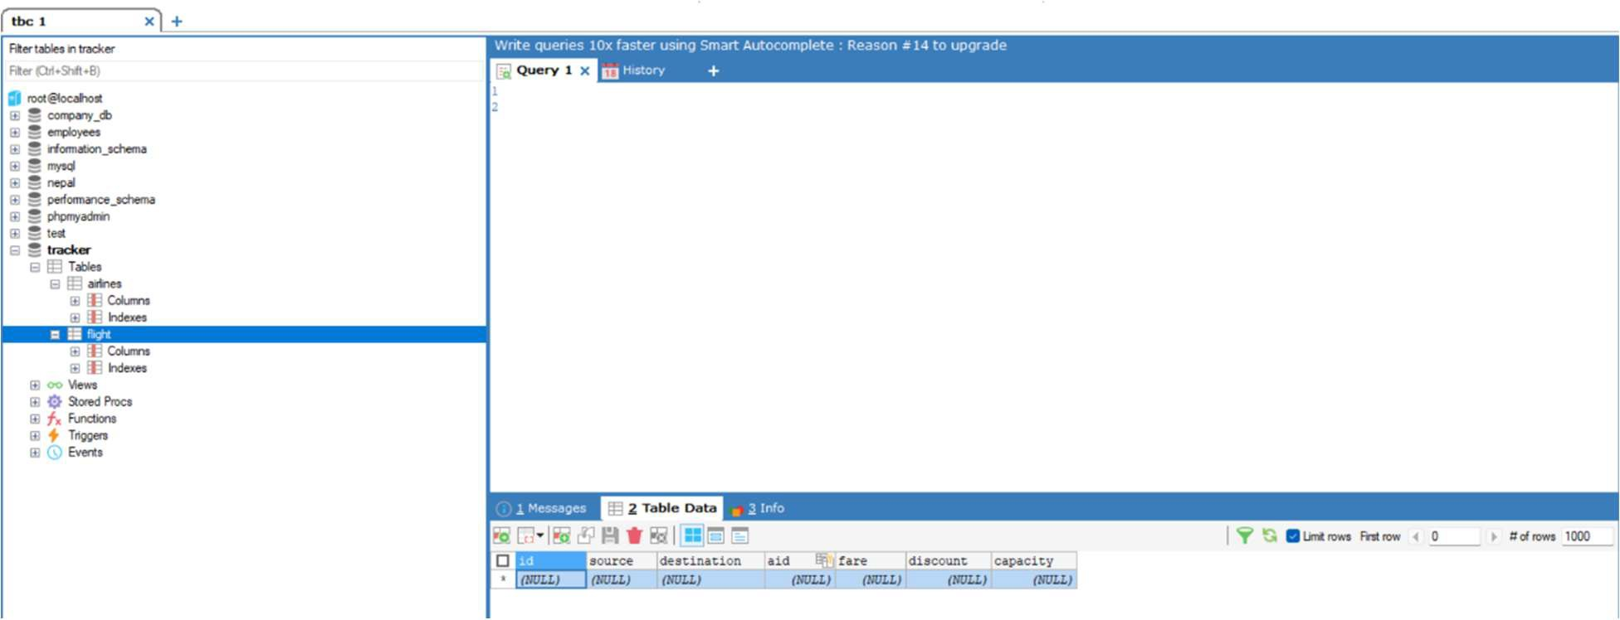
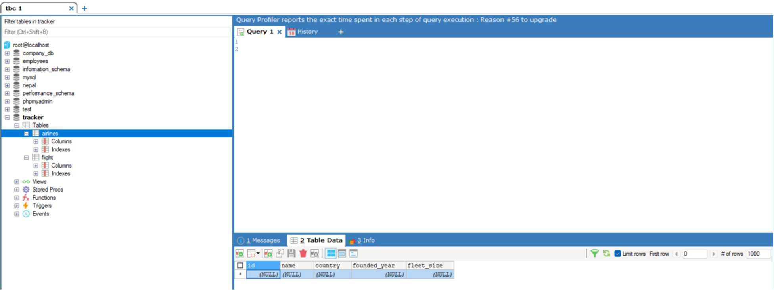

At first both tables were empty.

- Connect this database: TRACKER with Python and create a Python script that inserts at least 5 rows with random data into the FLIGHT and AIRLINES table.
Answer:

The TRACKER database was connected using Python in Jupyter Notebook (via VS Code).

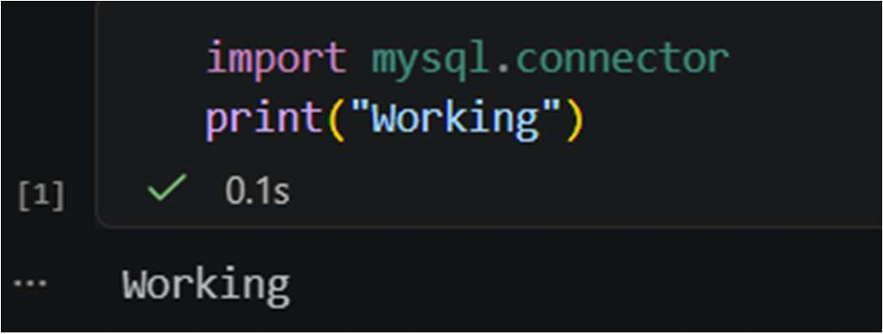
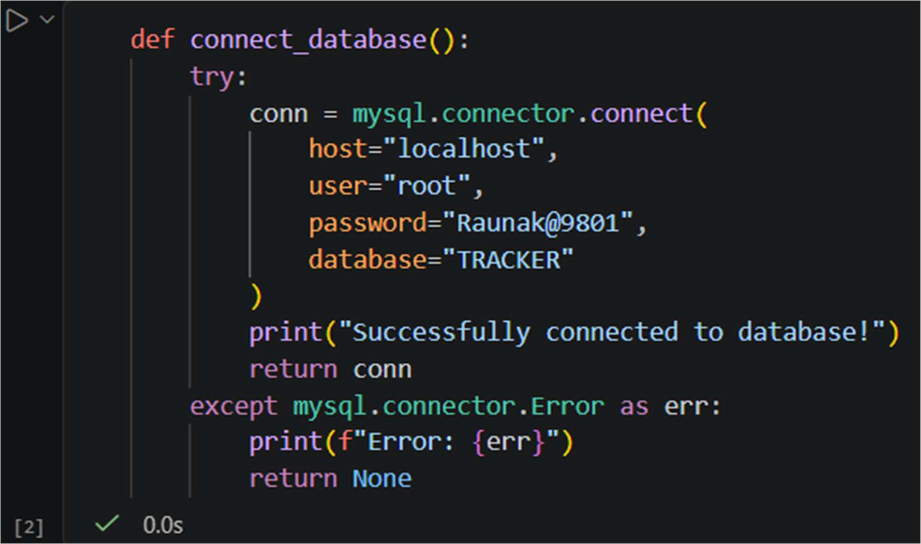

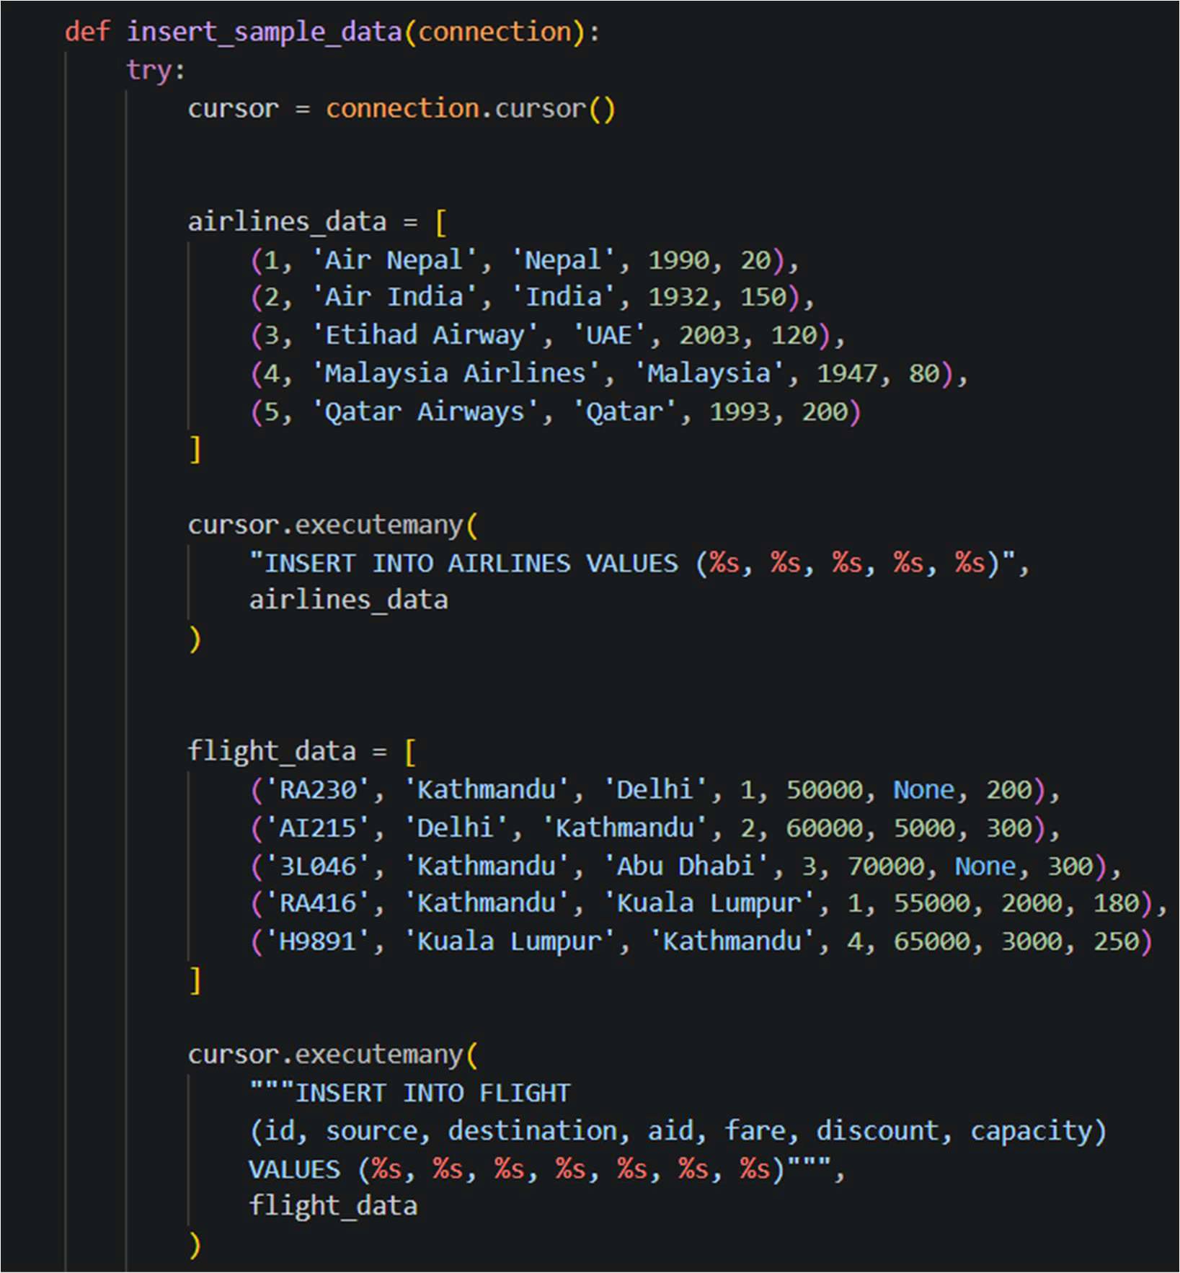
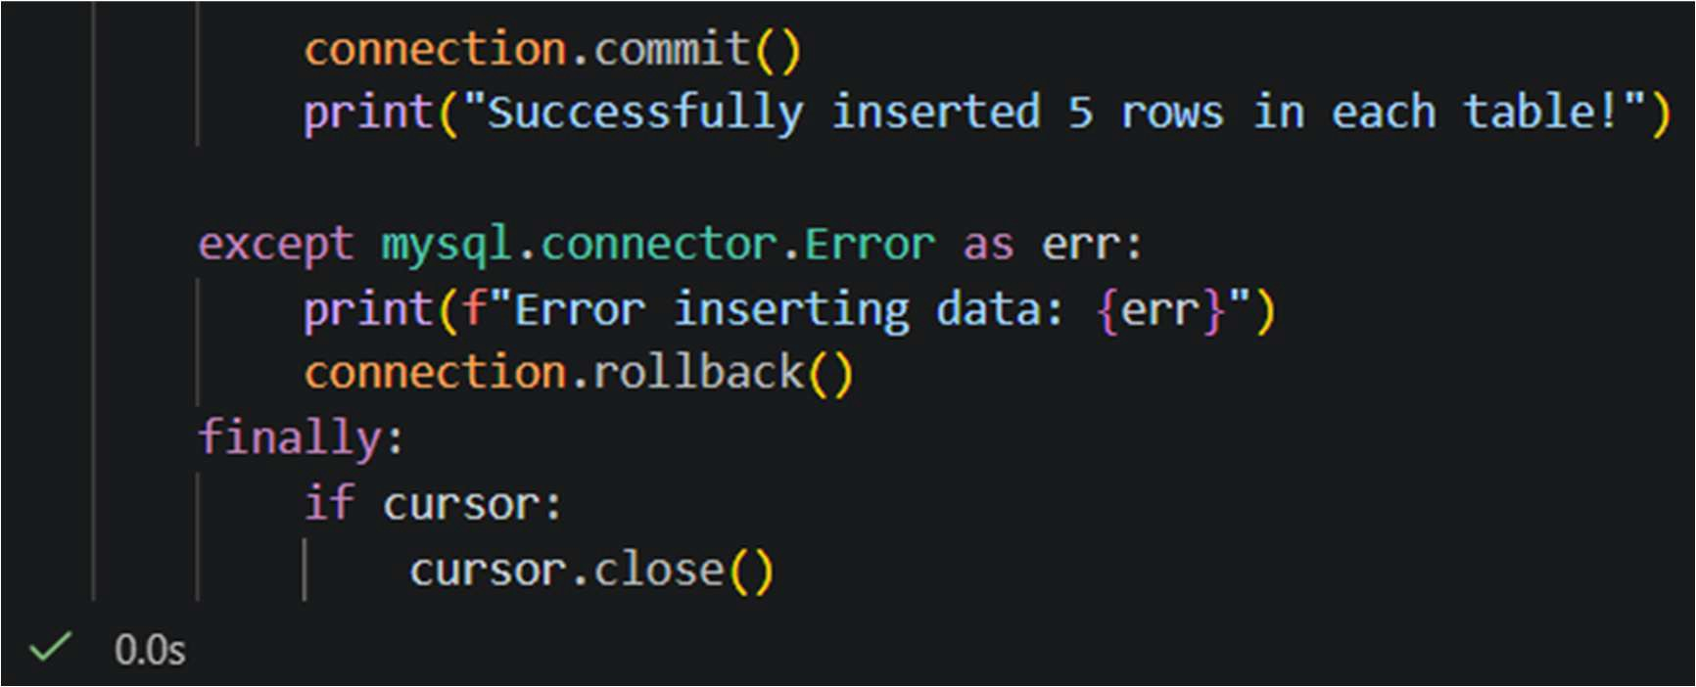

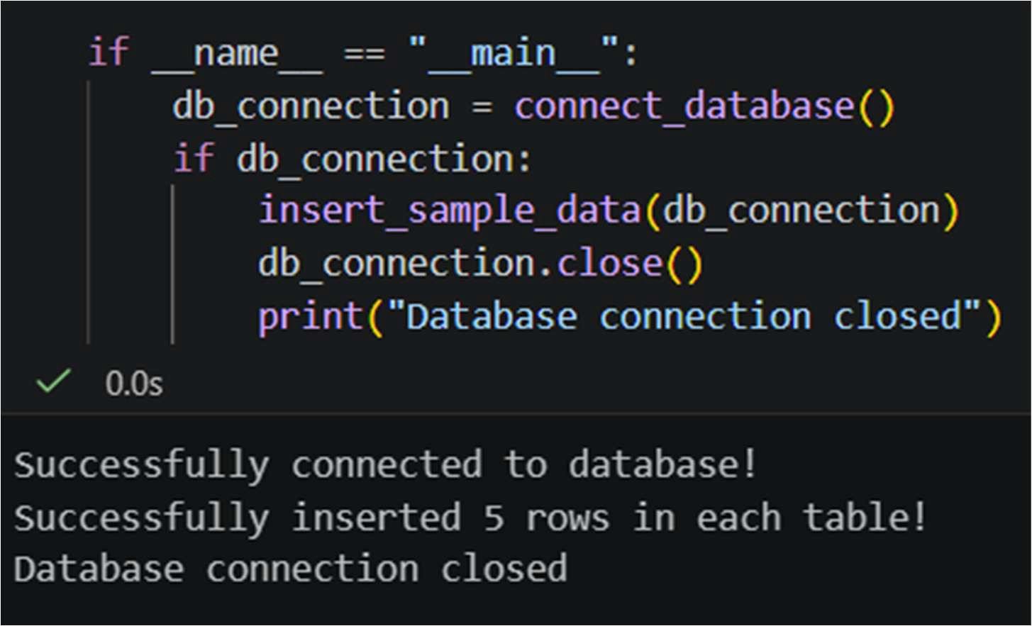

After implementing the script, the data was successfully added.

To verify the implementation of the queries, SQLyog was used to view the tables.

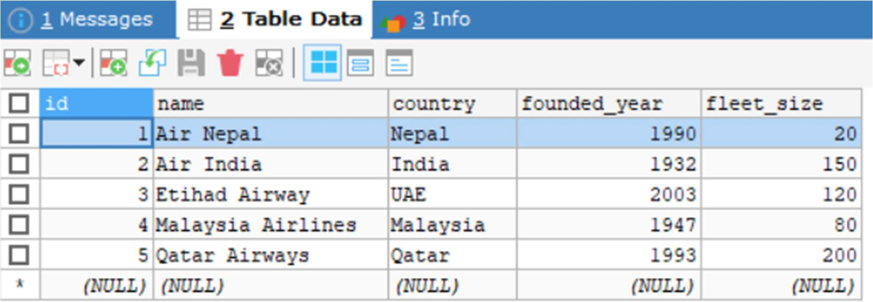
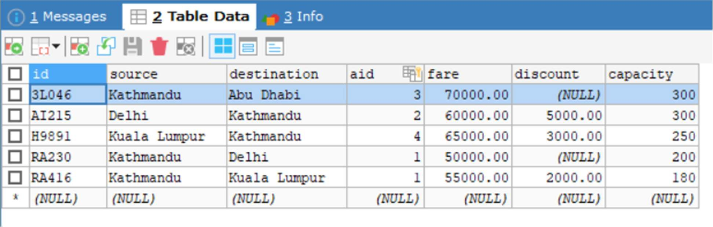
For this task, I connected the TRACKER database with Python using Jupyter Notebook within VS Code.
At first, I installed and imported the required Python Library (PyMySQL) to make the connection between python and MySQL. Then, I wrote the connection code using the host, username, password, and database name.
Next, I created a python code to insert at least five records into both the AIRLINES and FLIGHT tables. I used SQL INSERT inside the python code and implemented them through the connection built within the system.
After inserting data, I committed the changes to make sure the records were saved properly in the system.
For verification, I opened SQLyog and refreshed my current data base and after that all the data were inserted into the tables in the TRACKER database.

For Q-3, I used XAMPP Server and its terminal to access MySQL and SQLyog to run the following queries. I implemented different SQL commands according to the respective questions to retrieve, update, and filter data.

- Execute the following using SQLyog or any alternatives DBMS:

  - SQL query to list all the flights of source to destination on which flight is capable to hold maximum passengers.
Answer:
SELECT source, destination, MAX (capacity) AS maximum FROM FLIGHT
GROUP BY source, destination ORDER BY maximum DESC;

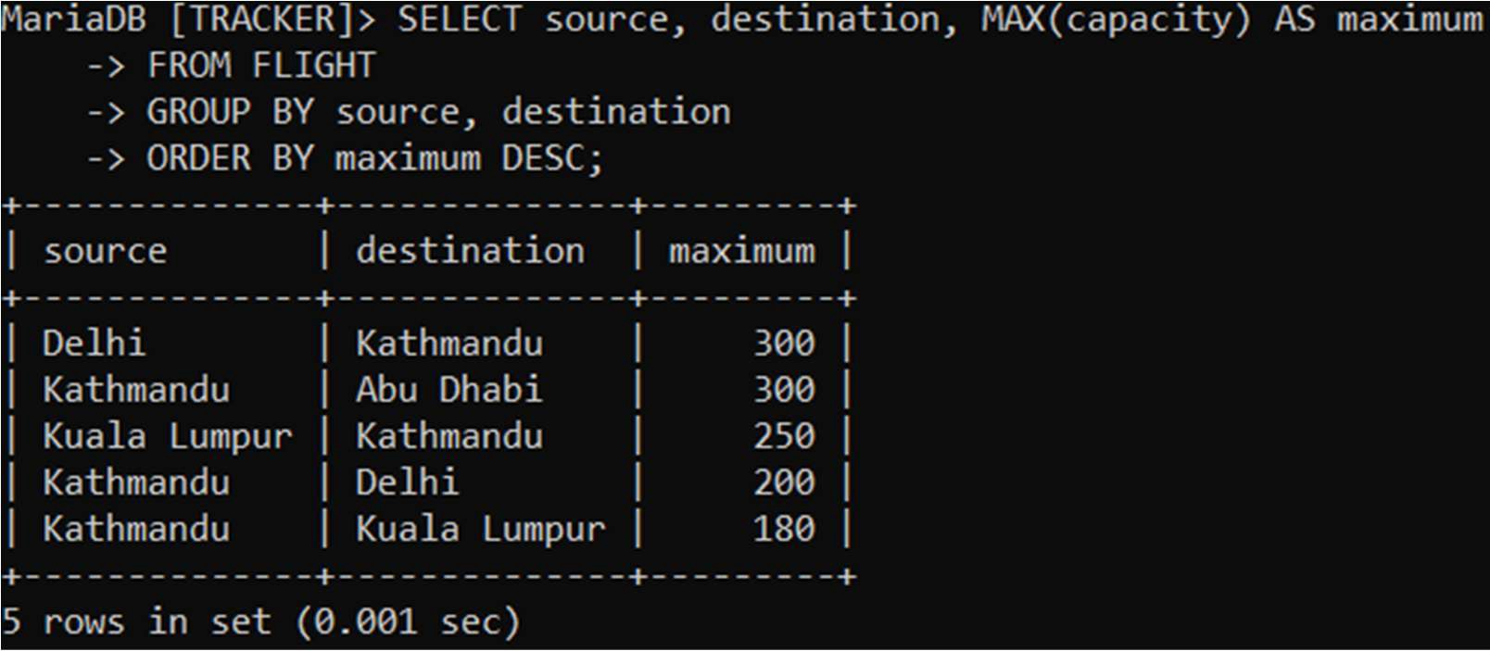

This query obtains the data of the flights between each source and destination with the maximum passenger capacity.

  - SQL query to retrieve the total flights that don’t take off from Kathmandu.
Answer:
SELECT COUNT (*) AS noFlightKTM
FROM FLIGHT WHERE source! = 'Kathmandu';

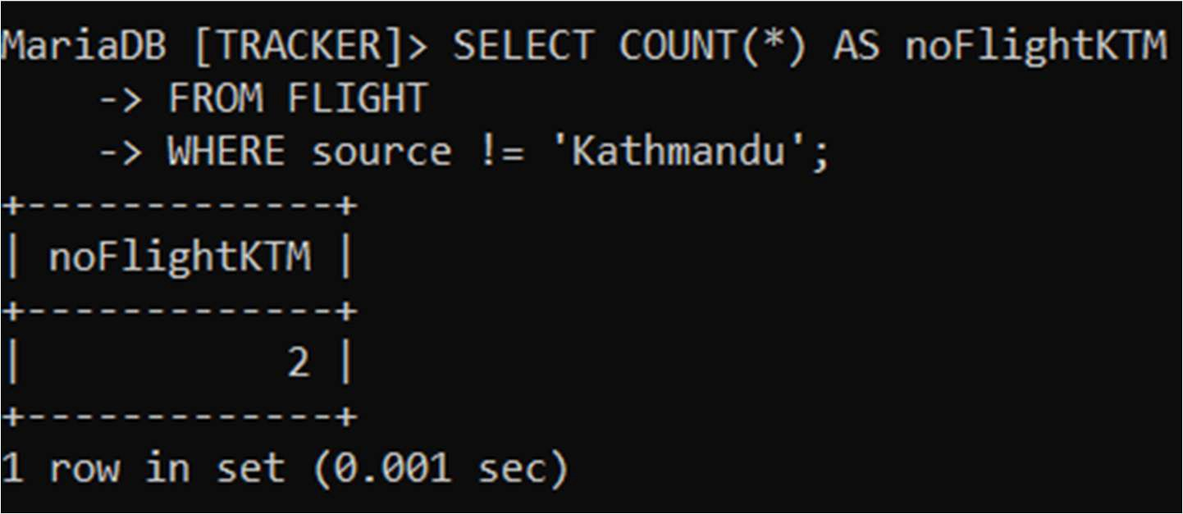

This query counts the total number of flights that do not depart from Kathmandu.

  - SQL syntax to update the fare of all flights by 2% to those flights either capacity is more than 250 or take off from Kathmandu.
Answer:
Current Data:
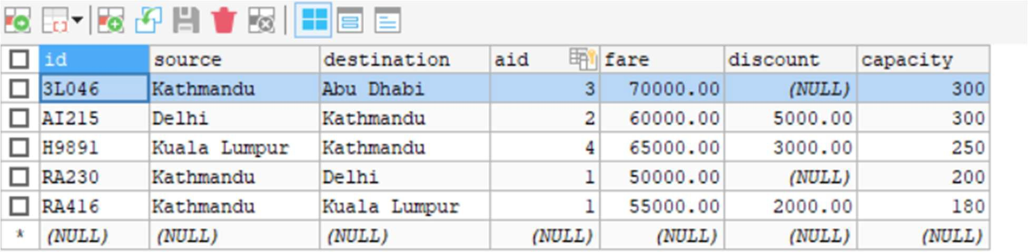

UPDATE FLIGHT
SET fare = fare * 1.02 WHERE capacity > 250
OR source = 'Kathmandu';

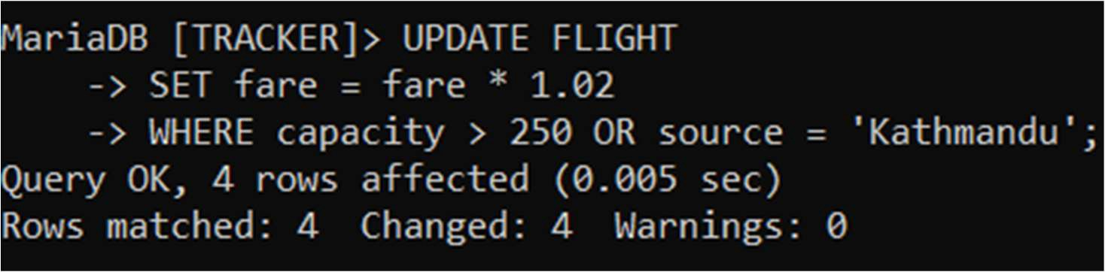

The query appends the fare by 2% for selected flights.

After Modification:
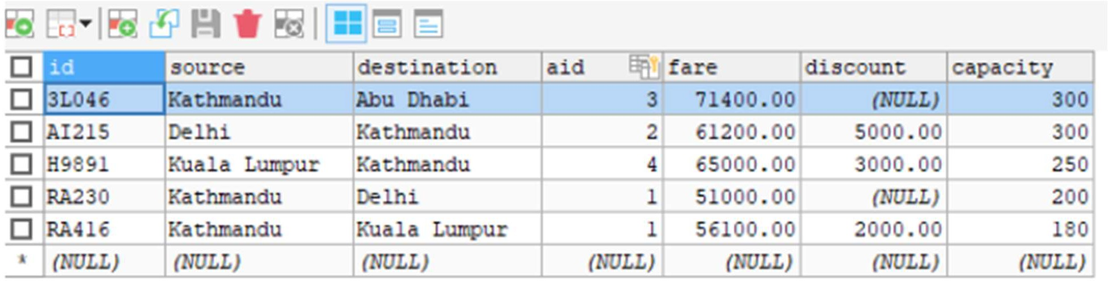
Multiple Times:
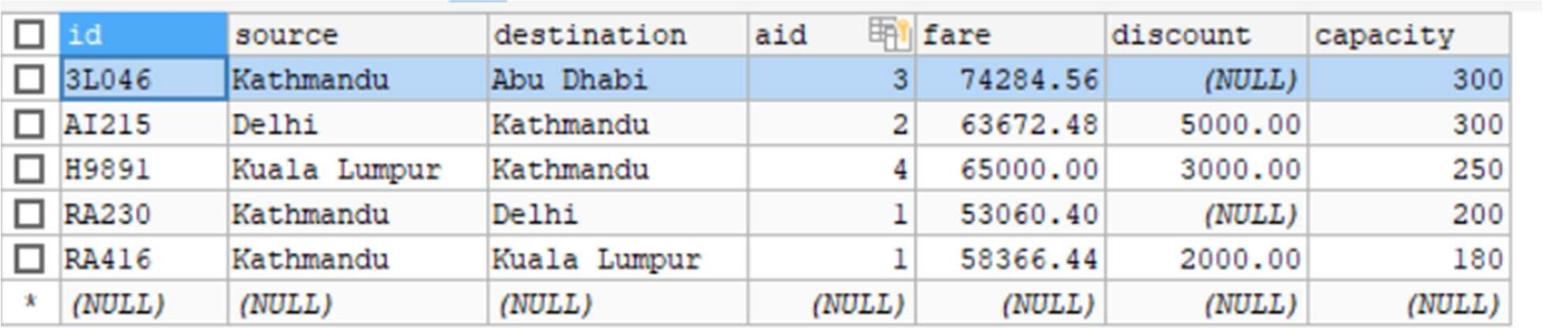

When the query was implemented multiple times, different O/P was observed because each execution increased the fare again by 2% on the already updated value.

Therefore, the query should be implemented only once to maintain appropriate results.

  - SQL query to find the fare and capacity of all flights whose discount is not available with destination having at least 5 characters.
Answer:
SELECT fare, capacity FROM FLIGHT
WHERE discount IS NULL AND CHAR_LENGTH (destination) >= 5;

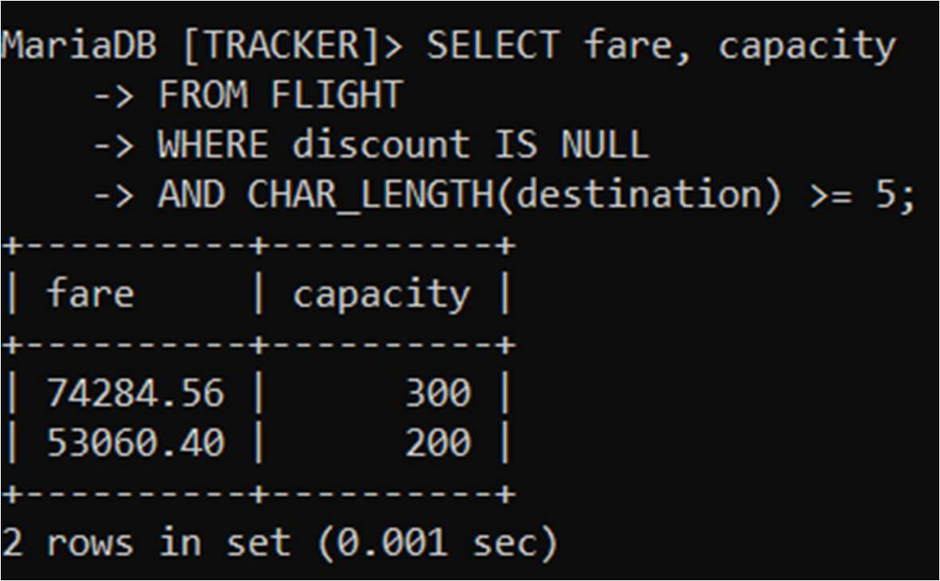
This query gets the fare and capacity of flights where no discount is given and the destination name has at least 5 characters.

Tools and Technologies Used:

- XAMPP Server
I used XAMPP Server to run a local server environment in order to manage the database in the system. I also used its terminal to perform certain SQL task like connecting it to Localhost and many more.

- SQLyog
I used SQLyog to work on the database i.e. create tables, and run certain SQL queries to check and manage the data in the database.

- VS Code
I used VS Code to work on the coding part precisely to build connection between the database and the python. SQL part was also coded here for the record.

- Jupyter Notebook (VS Code)
I used Jupyter Notebook within VS Code to write and execute python scripts precisely to build the connection with the database and inserting data into the database of the system.

