



User Creation and Privilege Management

Module Title and Code: Introduction to Databases, UFCFTK-30-1
Submitted By: Raunak Kumar Singh Student Number: 24071246
Orbund Id: 11281
Submitted To: Rabin Gautam

TASK 3 (20%)
Creating Users and Granting Privileges (Based on Task 2 Tables)

Write SQL commands to:
- Create a user data_analyst with the password Analyst@123.
Answer:
CREATE USER 'data_analyst'@'%' IDENTIFIED BY 'Analyst@123';
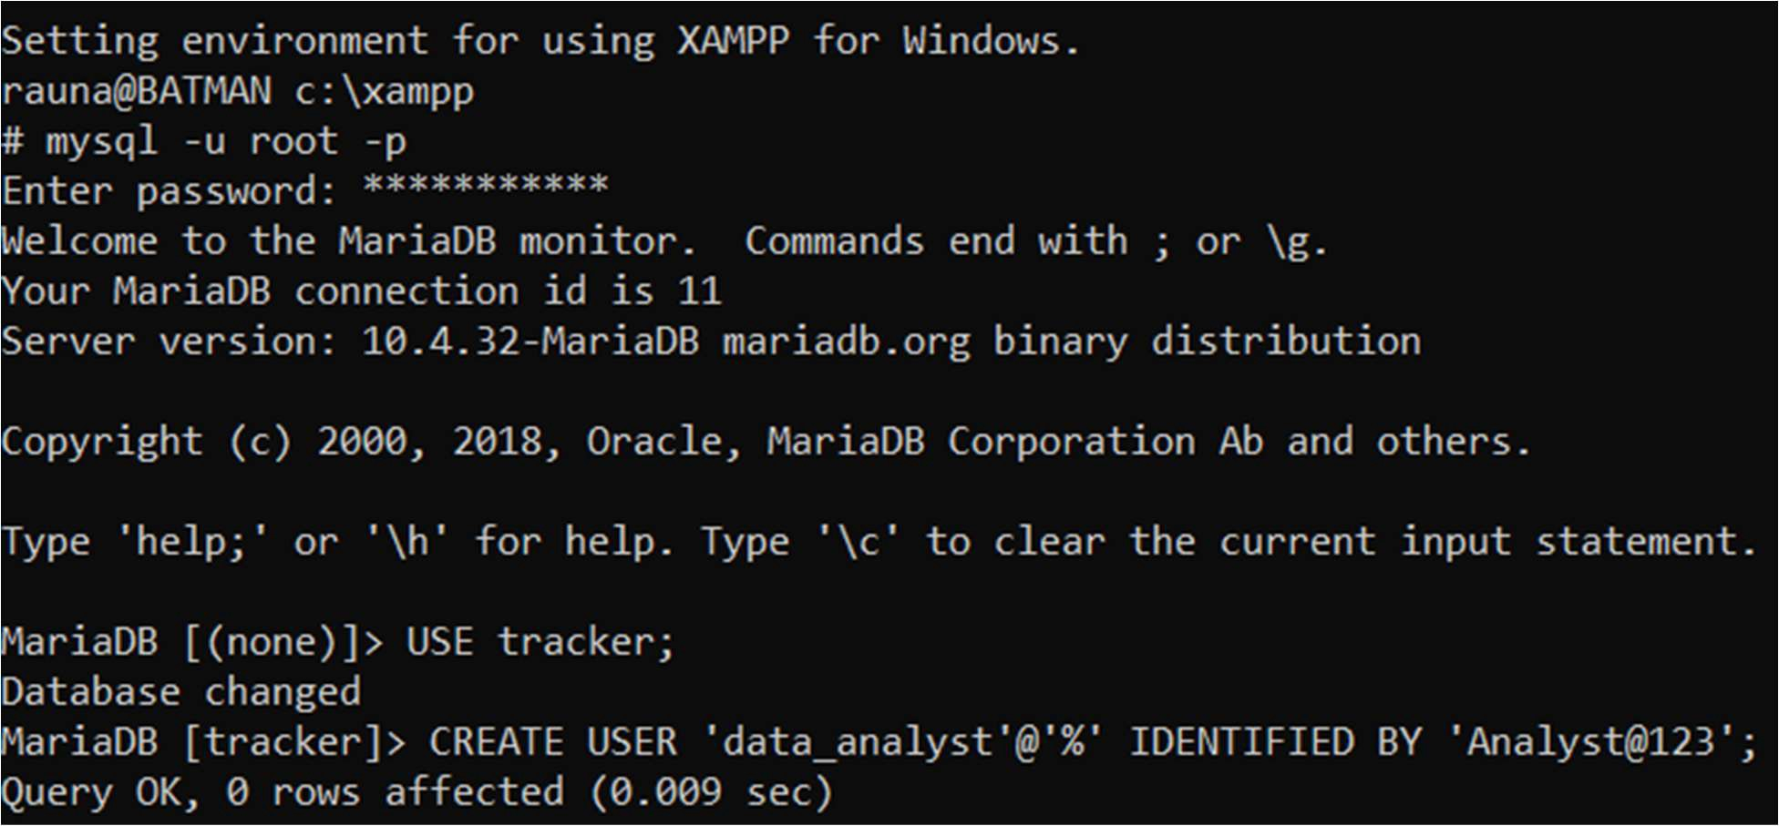

In this task, a new user named data_analyst was implemented to the system with a secure password.
This user can access the database depending on the permission approved later in following tasks.

- Grant the user data_analyst SELECT privileges on all tables in the TRACKER database.
Answer:
GRANT SELECT ON TRACKER.* TO 'data_analyst'@'%';
In this task, the user was granted permission to view the data from all the tables i.e. AIRLINES and FLIGHT inside the TRACKER database.
However, no any modifications power was approved at this stage of the task.

- Grant the user data_analyst INSERT privileges only on the FLIGHT table in the TRACKER database.
Answer:

GRANT INSERT ON TRACKER.FLIGHT TO
'data_analyst'@'%';

In this task, the user was granted the permission to add new records, but only in the table named FLIGHT.
Other table i.e. AIRLINES remains restricted for the data modifications or insertion.

- Revoke the INSERT privilege from the FLIGHT table. Answer:

REVOKE INSERT ON TRACKER.FLIGHT FROM
'data_analyst'@'%';

In this task, the previously assigned INSERT permission was removed.
This shows that how access rights can be adjusted according to the required condition.

Proof of Execution:
To confirm that everything worked correctly, the following tasks were performed:

- Checking if user exists:
SELECT User, Host FROM mysql.user WHERE User = 'data_analyst';
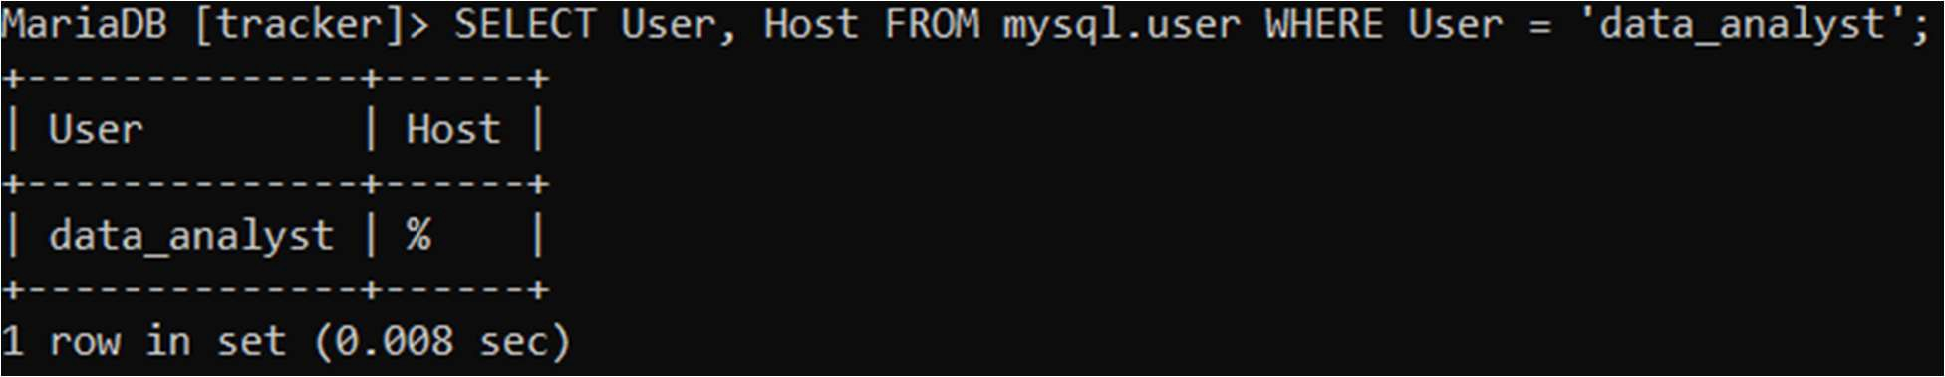
- Checking granted privileges:
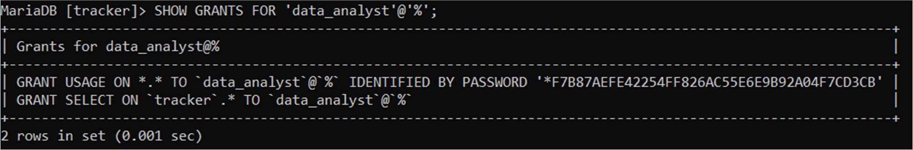
SHOW GRANTS FOR 'data_analyst'@'%';
These queries ensured that the user exists and that the correct permission were applied.

Tools and Technologies Used:

1.XAMPP Server
I used XAMPP Server to run a local MySQL environment on my system. I used its terminal to connect to localhost and perform all the required SQL Tasks, including creating users, assigning privileges, and executing verification queries.

