


Spark SQL Queries and Data Analysis

Module Title and Code: Introduction to Databases, UFCFTK-30-1
Submitted By: Raunak Kumar Singh
Student Number: 24071246
Orbund Id: 11281
Submitted To: Rabin Gautam

TASK 1 SparkSQL (40%)

Spark SQL is an effective tool for querying both structured and semi-structured data using SQL queries. In Task 3, you will utilize Spark SQL to execute a set of queries on a provided dataset, which can be found in the supplementary files on Blackboard. The queries must be executed using Python and Spark SQL. You may use either Spark's SQL-like API or native SQL commands within the Spark environment to perform the queries. Finally, submit a Jupyter notebook containing the code and clearly displayed query results. Below is the list of queries you need to complete.

Answer:
To handle the large employees_updated.csv dataset effectively, I used Google Colab.

- Installing the core engine: PySpark (Google Colab)
At first, I installed PySpark Library using the pip command in Google Colab. The O/P shows that it was already satisfied, so no extra installation was required.

- Uploading Dataset: employees_updated.csv

Now, I uploaded employees_updated.csv into the Colab environment. The upload was successful as the file name and size are displayed after running the command.

- Creating Spark Session: “SparkSQL”
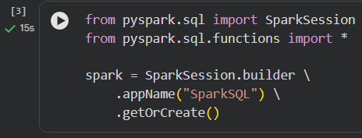
Once the library was installed in Step:1, I established the SparkSession. In my case, it works as the bridge between my Python Script and Spark Engine. I named my session as “SparkSQL” to keep my project organized and ensure that all my SQL Commands had a dedicated place to ruin itself.

- Loading Dataset and Displaying Data
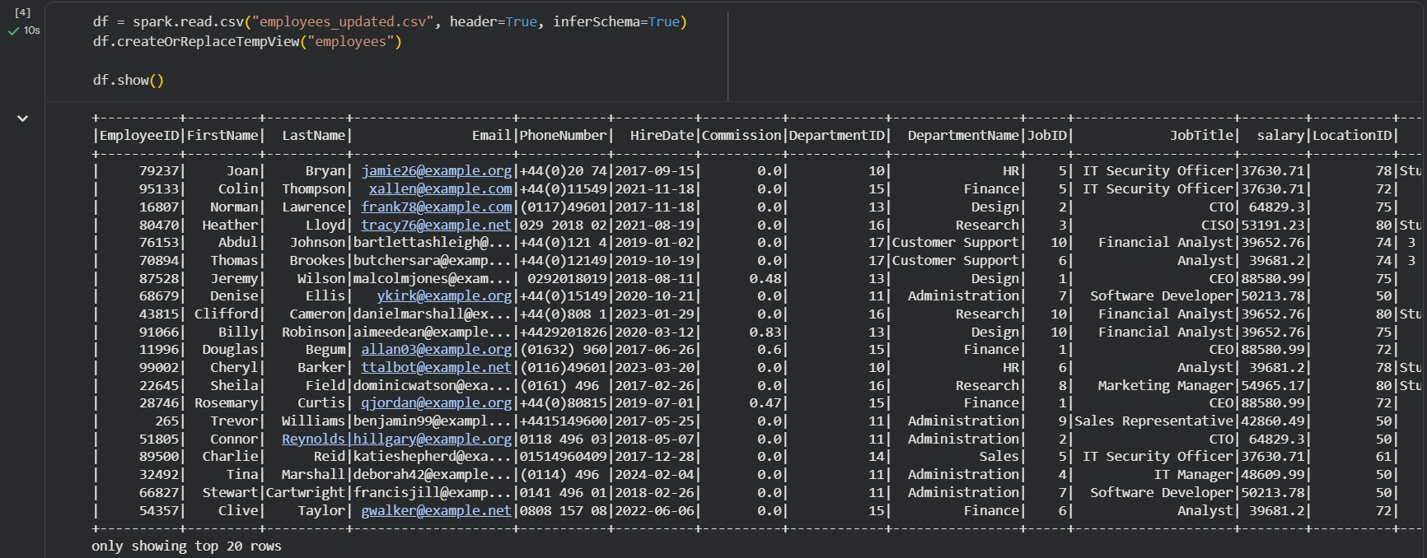
In my last step for the environment setup, I used createOrReplaceTempView(“employees”). This command helps me to turn dataset into Virtual Table.
I also made sure to set inferSchema=True, it allows Spark to get the data-types automatically.

- How many employees were hired in the year 2021?
Answer:
I wanted to filter the data of employees which were hired in the year 2021.I applied the YEAR () function to the HireDate Column to get the record of the hired employees in the year 2021.
Result: The query revealed that 6,828 employees were hired in the year 2021.

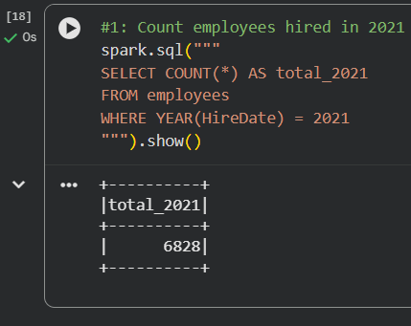
Query 1:
spark.sql ("""
SELECT COUNT (*) AS total_2021
FROM employees
WHERE YEAR(HireDate) = 2021
"""). show ()

- Which employees work in a department that is in a physical address with the word ‘close’?
Answer:
I used the LIKE operator with wildcards “%close%”. I also used LOWER () function to PhysicalAddress Column in order to avoid case sensitive issue i.e. Close and close is treated equally and wasn’t missed.
Result: The result displayed the list of employees with word “close” i.e. PhysicalAddress – 168 River Close alongside with their FirstName and LastName.

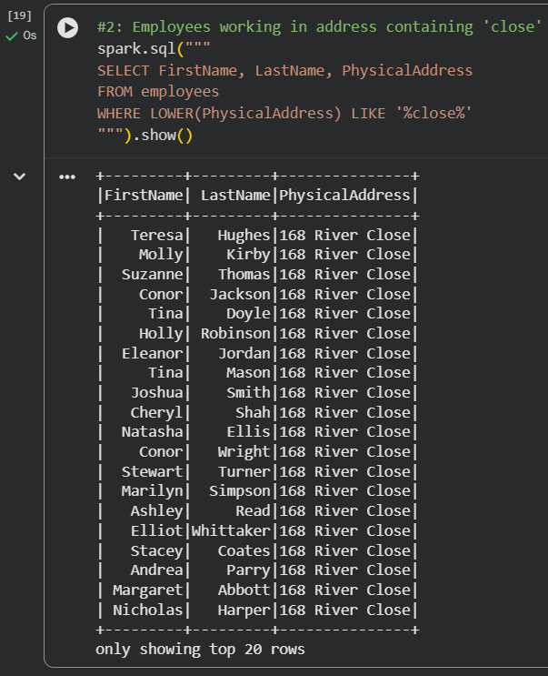
Query 2:
spark.sql ("""
SELECT FirstName, LastName, PhysicalAddress
FROM employees
WHERE LOWER(PhysicalAddress) LIKE '%close%'
"""). show ()

- Which job title costs the company more money?
Answer:
I wanted to see which role was the most paid for the company, so I grouped everything by JobTitle and summed up the salaries. After this, I sorted the list from Highest to Lowest.
Result: The CEO position takes the top spot, costing the company a total of roughly 449,548,524.
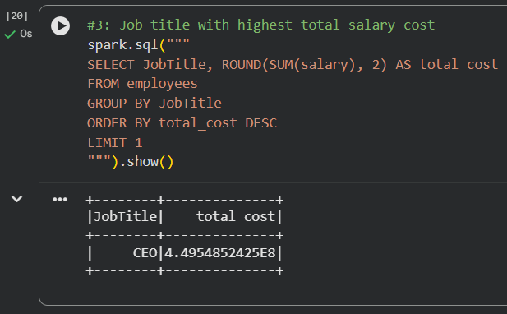
Query 3:
spark.sql ("""
SELECT JobTitle, ROUND (SUM (salary), 2) AS total_cost
FROM employees
GROUP BY JobTitle
ORDER BY total_cost DESC
LIMIT 1
"""). show ()
- Calculate the total salary that each employee is going to receive at the end of the month after commission.
Answer:
I calculated the final month payout by adding the Salary and Commission columns together. I used a COALESCE function to treat any empty commission as Zero, which prevented the calculation errors.
Result: For example; Joan Bryan’s total is 37,630.71 similarly Abdul Johnson’s is 39652.76.

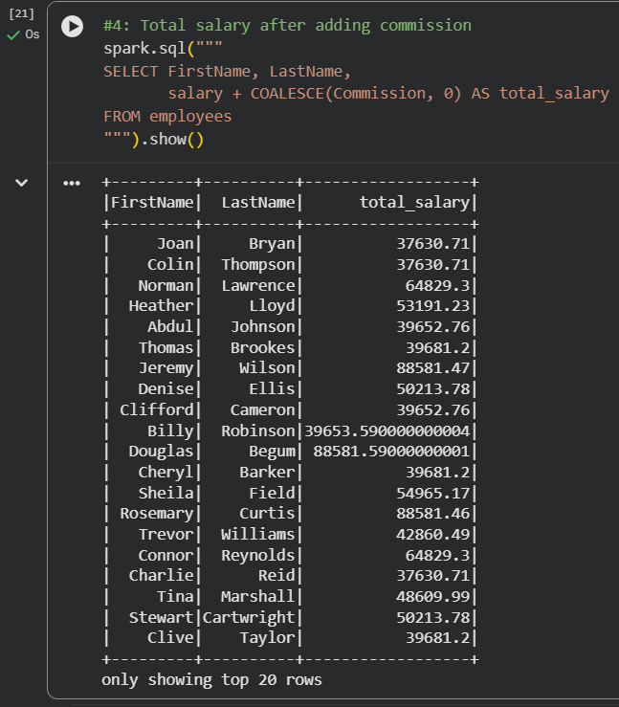

Query 4:
spark.sql ("""
SELECT FirstName, LastName,
salary + COALESCE (Commission, 0) AS total_salary
FROM employees
"""). show ()

- In which date of the month does ABC hire most employees?
Answer:
I separated down the HireDate to look only at the day of the month using the DAY () function. By grouping these days and counting them, I could see which date saw the greatest number of activities for hiring.
Result: The 5th of the month is the most hiring day of the month for HR, with the record of 1,733 hires on that day.
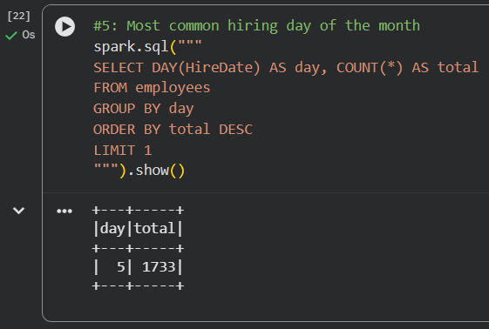
Query 5:
spark.sql ("""
SELECT DAY(HireDate) AS day, COUNT (*) AS total
FROM employees
GROUP BY day
ORDER BY total DESC
LIMIT 1
"""). show ()
- Which department has the highest number of employees?
Answer:
I ran a count on the total number of employees after grouping the data by DepartmentName.
Result: The Finance department holds largest in the company with total employees of 6,369.
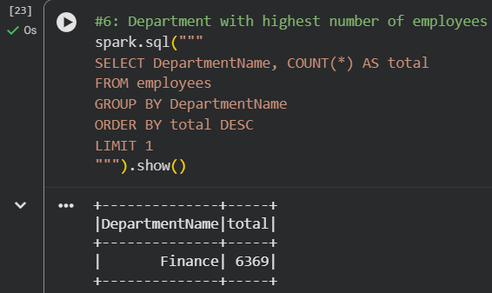
Query 6:
spark.sql ("""
SELECT DepartmentName, COUNT (*) AS total
FROM employees
GROUP BY DepartmentName
ORDER BY total DESC
LIMIT 1
"""). show ()

- What is the average salary for employees in each department?
Answer:
I calculated the mean salary for each department using the AVG () function and rounded the numbers to two decimal places for better O/P.
Result: Salaries were fairly balanced among all the departments. For example,
HR at 52,299.61 and Marketing at 51,804.88.
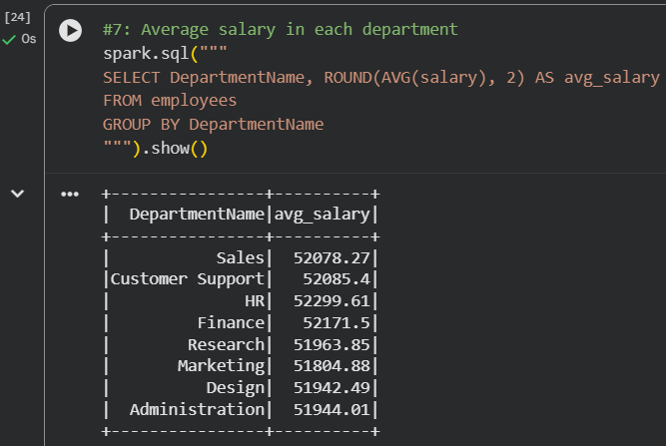
Query 7:
spark.sql (“““
SELECT DepartmentName, ROUND (AVG (salary),2)
AS avg_salary
FROM employees
GROUP BY DepartmentName
”””). show ()
- How many employees have been with the company for more than 5 years?
Answer:
To find employees with over 5 years of service in the company, I used months_between () to compare the current_date () against their original HireDate, looking for the employees with more than 60 months of service.
Result: A mass total of 29,853 employees has completed their 5 years tenure in this company as a veteran’s.
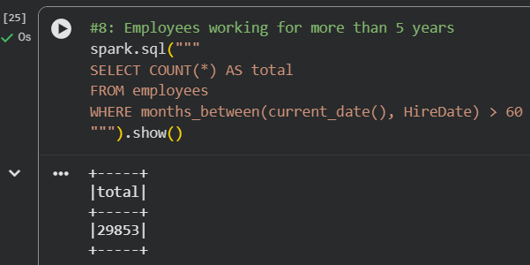
Query 8:
spark.sql (“““
SELECT COUNT (*) AS total
FROM employees
WHERE months_between (current_date (), HireDate) > 60
”””). show ()

- What is the total commission paid to employees in each department?
Answer:
I grouped the data by DepartmentName and summed all the individual commission payout using the SUM () function.
Result: HR is leading with a total commission of 631.88 and after that Finance holds the second position with total of 629.72.
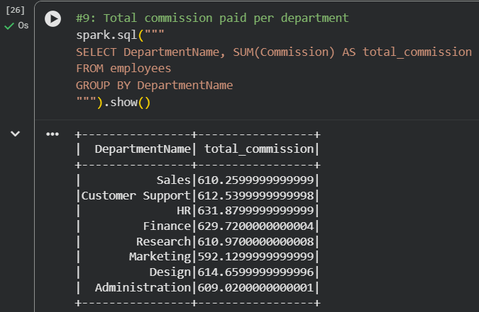
Query 9:
spark.sql (“““
SELECT DepartmentName, SUM (Commission)
AS total_commission
FROM employees
GROUP BY DepartmentName
”””). show ()

- Which employee has the highest salary after commission?
Answer:
I did a final calculation of Salary + Commission for every employee, then sorted the entire employees_updated.csv to find the highest value.
Result: Dorothy Haynes is the highest paid employee in the company with the total of 88581.99.
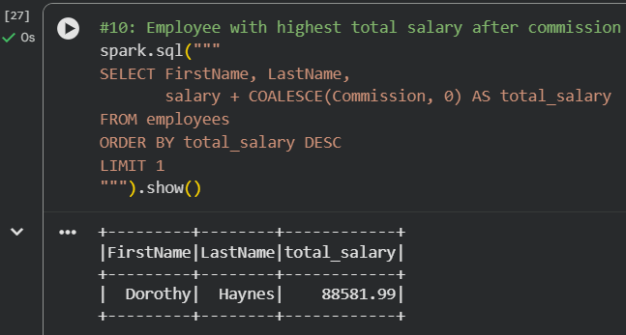
Query 10:
spark.sql (“““
SELECT FirstName, LastName, salary + COALESCE (Commission, 0)
AS total_salary
FROM employees
ORDER BY total_salary DESC
LIMIT 1
”””). show ()
Tools and Technology Used:

1. Google Colab
I used Google Colab to run my Spark SQL session and then execute my python scripts get the required outputs. My SQL commands were executed in Google Colab and all the questions were answered.

2. MS Word
I used MS Word to present my answer in more detailed and systemic way. MS Word contains all the queries, outputs, screenshots, etc.

