


Query Optimization

Module Title and Code: Introduction to Databases, UFCFTK-30-1
Submitted By: Raunak Kumar Singh
Student Number: 24071246
Orbund Id: 11281
Submitted To: Rabin Gautam

You are a database administrator for a social media platform. The platform has a large user base, and users frequently post status updates, comment on posts, and like other users' content. The posts table stores user posts, and the comments table stores comments on these posts. The marketing team requests a report showing the top 10 most commented posts in the last 30 days, including the number of comments for each post. The query needs to join the posts and comments tables, filter the results by the created_at timestamp, and order the posts by the number of comments. After executing the query, you notice that the performance is slower than expected, especially when the comments table has grown substantially.

1. What are the possible reasons for the query's slow performance when joining the posts and comments tables?
Answer:
The query is slow mainly because the database is doing extra work than required task during processing the data.
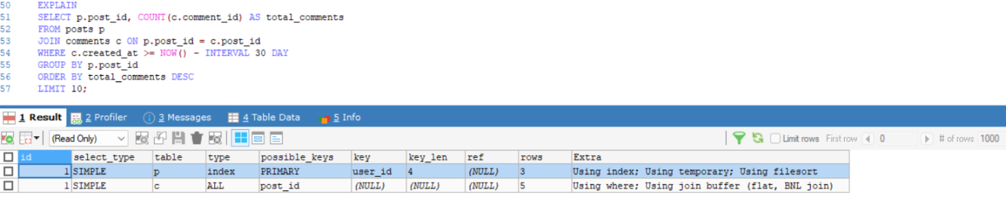

From the given O/P, it can be seen that for the comments table the value type = ALL and key = Null are shown. This means that DB is performing a Full Table Scan, where it checks every row in the comments table instead of using an index. Imagine if the table becomes larger the time for full table scan will increase and it will slow down the query.
Another issue is the join operation. The O/P shows “USING JOIN BUFFER (FLAT, BNL JOIN)”, which simply means a block nested loop join is being used. This type of joint is not very effective because the database repeatedly compares rows from both the tables, which increases the processing time.
The EXPLAIN output also shows “USING TEMPORARY” and “USING FILESORT” for the posts table. This means the database is creating a temporary table and sorting the data manually when applying GROUP BY and ORDER BY. These extra occupies the memory and slows down the query.
Also, the query identifies data using the created_at column for last 30 days. Since no index is being used for this column, the DB has to check each row one by one, which directly slows down the query.

2. How would you optimize the query to speed up the join between the posts and comments tables?
Answer:
To improve the performance of the query, the main aim was to reduce the unnecessary extra work, stop full table scan and make the join more efficient.

1. We are making an index on the comments table:
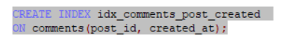
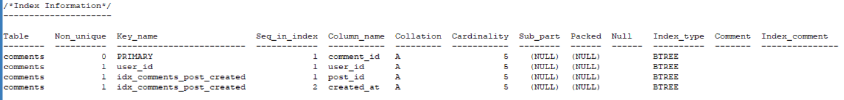
This index is essential because it matches the two most important part of query i.e. post_id and created_at. Now instead of checking whole dataset it will directly go to the necessary record.

2. We are slightly adjusting the query now:
After the indexing part, the query is slightly adjusted so that it starts from the comments table. Since this table is filtered by date, it reduces the no. of rows that need to be joined with the posts table.
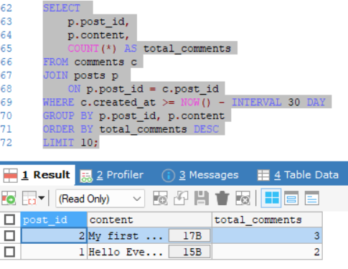

3. We tested query again using EXPLAIN command:
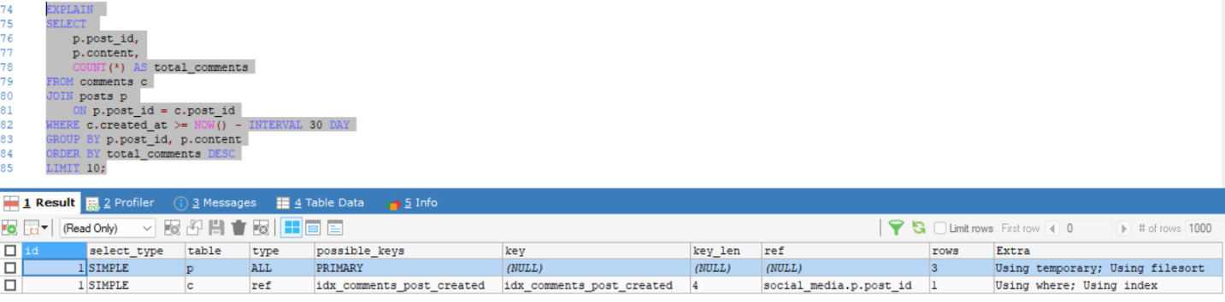
The query was tested again using EXPLAIN command, the DB was now using type = ref instead of scanning the whole table unlike before.
Lastly, we eradicated the full table scan and implemented indexing which made the query faster and more effective.

3. Would it be beneficial to cache the results of this query for frequently requested reports? If so, how would you implement caching in this scenario?
Answer:
Yes, caching would definitely be useful for this query, especially because it is used for reports that people ask again and again.
In case of this query, it really does a lot of work like joining two tables i.e. comments and posts, filters the data of around 30 days, and group and sort the results. All of these works take time, it’s natural that query will be slow due to increase in the comments. If someone keeps on asking the report, it doesn’t make sense to run whole query again and again.

We used both SQL_N0_CACHE and Normal Query:
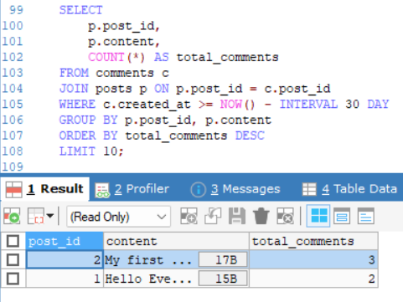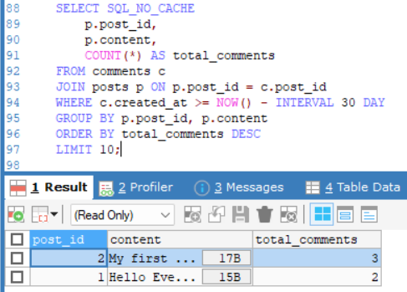
From my own practical test, I ran both the queries. When SQL_N0_CACHE is used, the dataset has to execute all the queries from the scratch every time, which normally takes longer time. When it was removed, the DB can reuse the results, make the queries faster and more effective.
Caching can be implemented using tools like Redis or Memcached to store the results temporarily, or maybe storing results in another table and updating it time by time.
However, caching needs to be managed carefully because the data can become outdated when comments are added in the posts. This can be handled by setting an expiry time or refreshing the cache regularly.
At last, caching reduces the workload on the DB and improvises the performance of frequently asked reports.

Tools and Technology Used:

1. SQLyog
I used SQLyog to create database and then implement the required queries. I also extracted the Task3_24071246.sql from it to prove that it was done in SQLyog.

2. MS Word
I used MS Word to present my answer in more detailed and systemic way. MS Word contains all the queries, outputs, screenshots, etc.

