Student Study Habit Pattern Mining
Project Report
Date: December 11, 2025
Submitted by:
Aditya
Khasim
Santhosh
Bharath
Ronack

1. Executive Summary
This project analyzes student study habits to predict academic performance using Machine Learning. It groups students into behavioral "personas" (Clustering) and predicts exam scores (Regression). The solution is deployed as an interactive Streamlit Web Application.

2. Methodology & Architecture
The system processes raw student data through a pipeline of imputation, encoding, and scaling before feeding it into Random Forest and K-Means models.

2.1 Data Pipeline & Application Flow
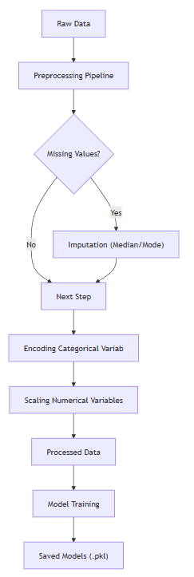
Figure 1: Data Processing Pipeline

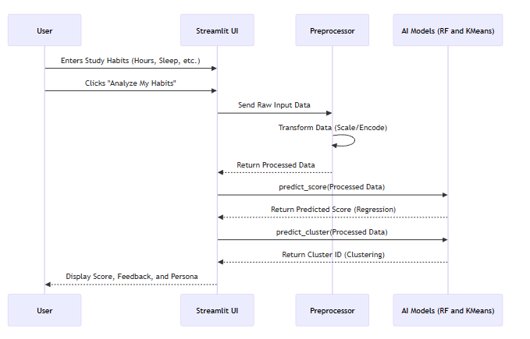
Figure 2 : User Application Flow

3. Application Demonstration
The following screenshots demonstrate the working application.

Application Home Page
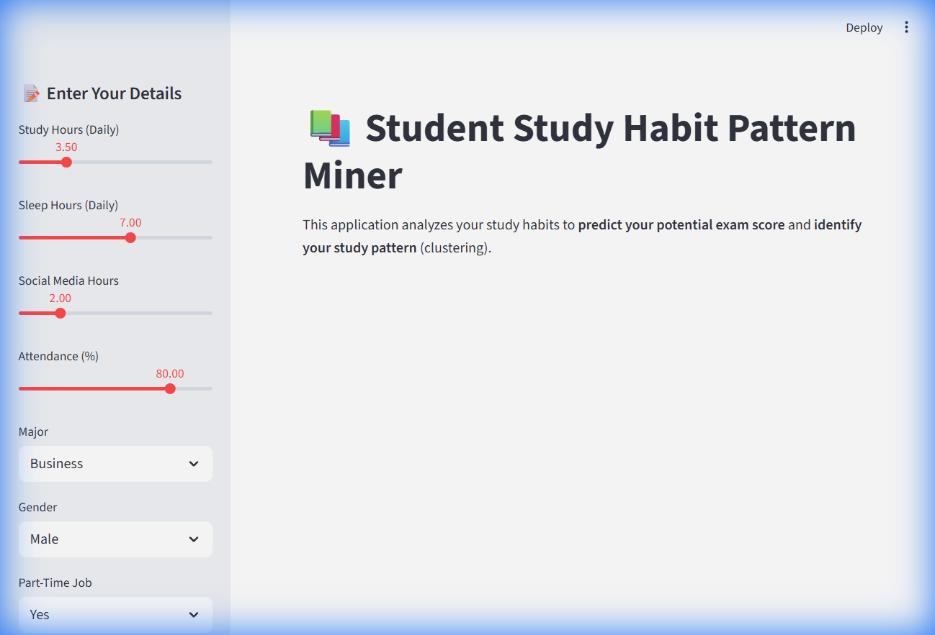
Figure 2: Application Home Page

Prediction Results
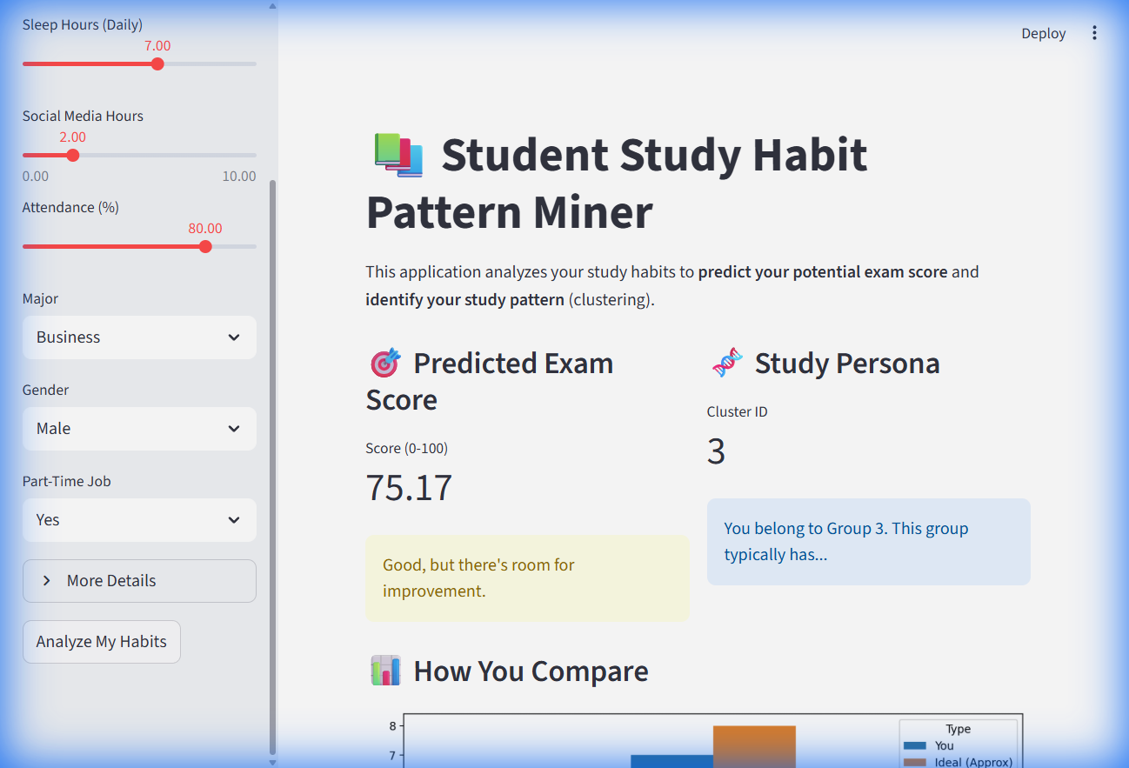
Figure 3: Prediction Results

Comparative Analytics
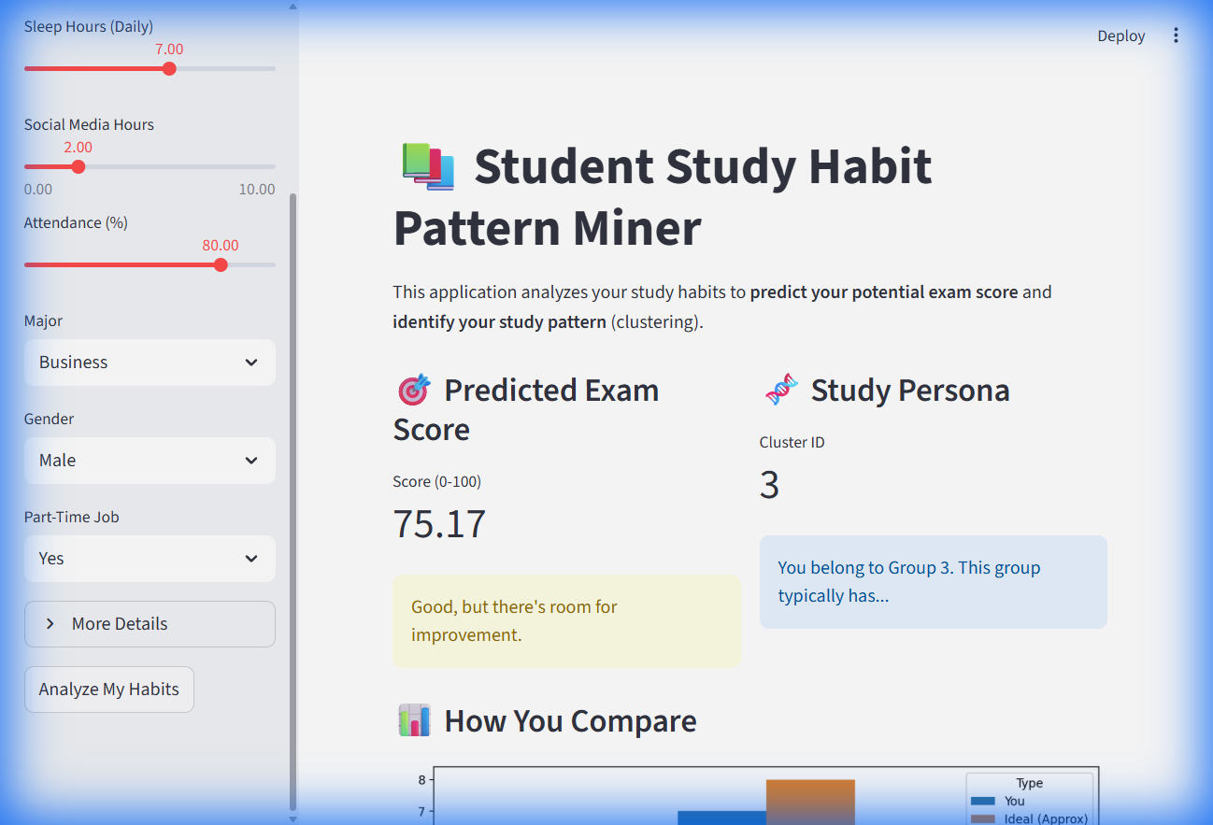
Figure 4: Comparative Analytics

4. Conclusion
The project successfully demonstrates the use of AI in educational analytics. The web application provides actionable insights to students, helping them optimize their study habits.

