**Task Description#1**

* Zero-shot: Prompt AI to write a function that checks whether a given year is a leap year.

PROMPT :

write a python function which takes input as a year and checks whether the given year is leap year check all the conditions of leap year.

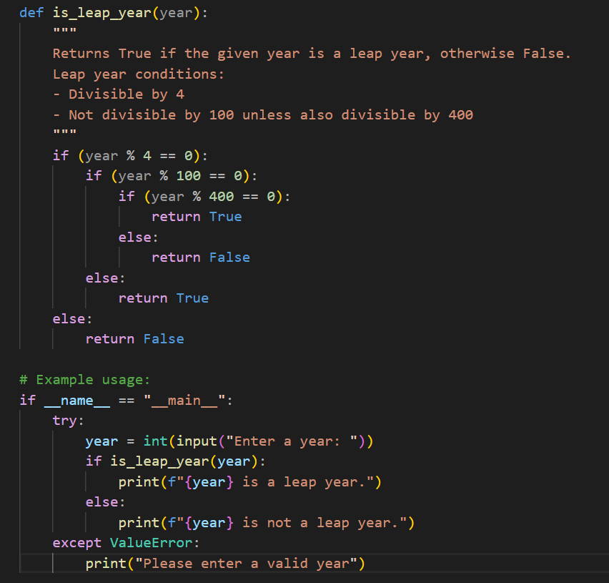

**Task Description#2**

* One-shot: Give one input-output example to guide AI in writing a function that converts centimeters to inches.

PROMPT:

write a function in python to convert centimeteres to inches.

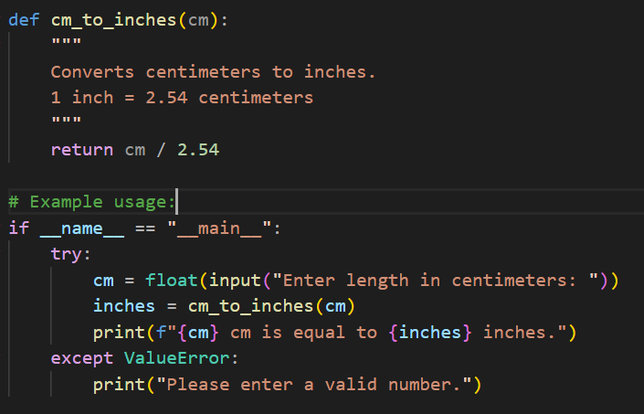

**Task Description#3**

* Few-shot: Provide 2–3 examples to generate a function that formats full names as “Last, First”.

PROMPT:

write a python function which takes full name as input and gives output as "last, first"  
example input :raju gandhi output : gandhi raju,  
input ravi kiran output : kiran ravi

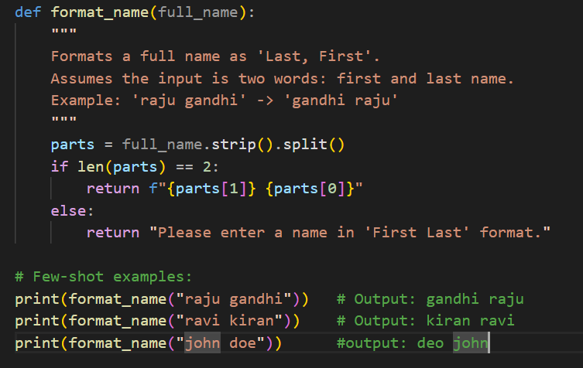

**Task Description#4**

* Compare zero-shot and few-shot prompts for writing a function that counts the number of vowels in a string.

PROMPT:

ZERO_SHOT: Python function for counting number of vowels in a string

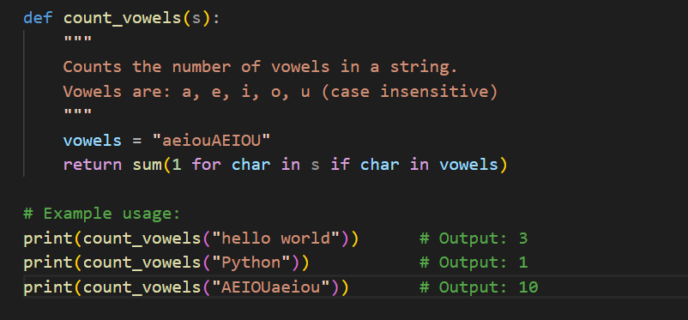

Few_shot: write a python function to count the number of vowels in a string  
example: input: hello output: 2  
input: rakesh kumar output: 4

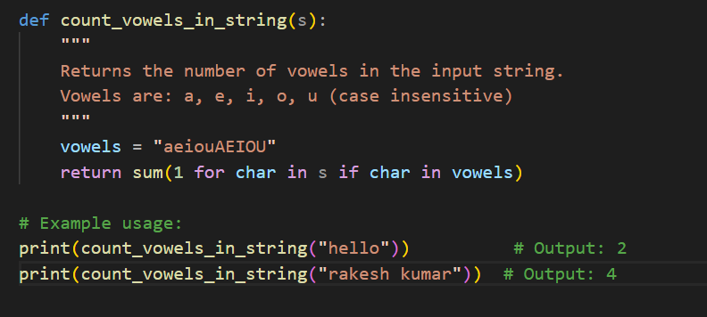

**Task Description#5**

* Use few-shot prompting to generate a function that reads a .txt file and returns the number of lines.

PROMPT:

generate a function that reads a .txt file and returns the number of lines  
example if file has 2 lines then return 2

