**package connection;**

**import org.bson.Document;**

**import com.mongodb.client.FindIterable;**

**import com.mongodb.client.MongoClient;**

**import com.mongodb.client.MongoClients;**

**import com.mongodb.client.MongoCollection;**

**import com.mongodb.client.MongoDatabase;**

**import com.mongodb.client.MongoIterable;**

**public class collection_two {**

**public static void main(String[] args) {**

**// Creating a Mongo client**

**MongoClient mongoClient = MongoClients.create("mongodb://localhost:27017");**

**MongoDatabase database = mongoClient.getDatabase("myDb");**

**MongoCollection<Document> collection = database.getCollection("products");**

**Document priceRangeQuery = new Document("price", new Document("$gte", 700).append("$lte", 900));**

**FindIterable<Document> products = collection.find(priceRangeQuery);**

**for (Document product : products) {**

**System.out.println(product.toJson());**

**}**

**}**

**}**

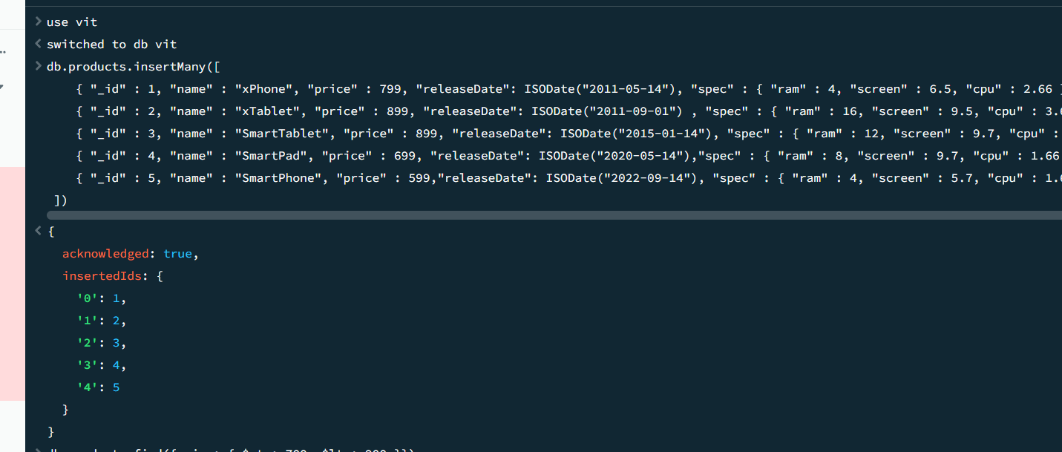 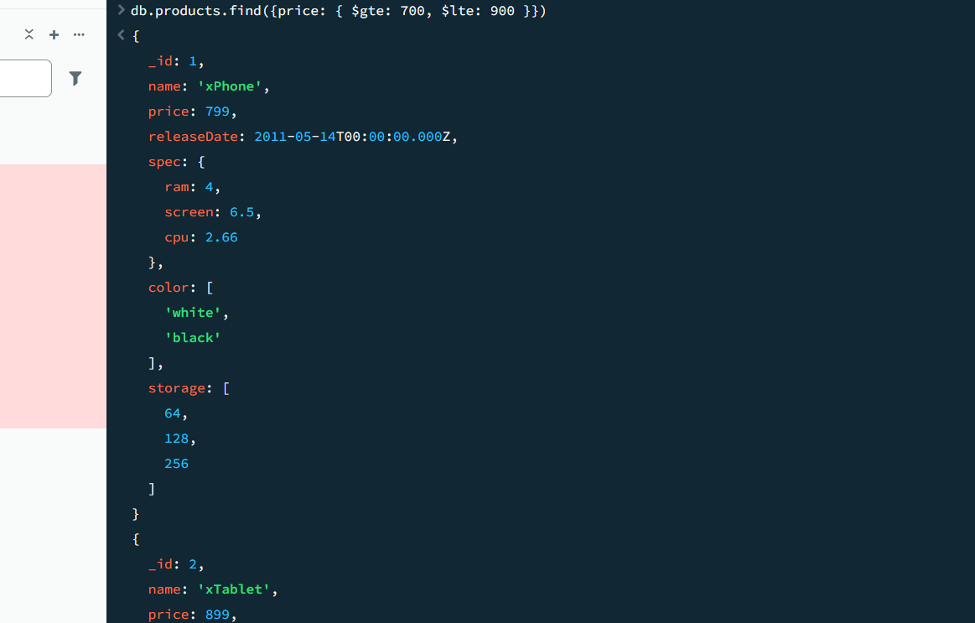

package connection;

import java.util.Arrays;

import org.bson.Document;

import com.mongodb.client.AggregateIterable;

import com.mongodb.client.FindIterable;

import com.mongodb.client.MongoClient;

import com.mongodb.client.MongoClients;

import com.mongodb.client.MongoCollection;

import com.mongodb.client.MongoDatabase;

import com.mongodb.client.MongoIterable;

public class collection_two {

public static void main(String[] args) {

// Creating a Mongo client

MongoClient mongoClient = MongoClients.create("mongodb://localhost:27017");

MongoDatabase database = mongoClient.getDatabase("myDb");

MongoCollection<Document> collection = database.getCollection("products");

AggregateIterable<Document> result = collection.aggregate(Arrays.asList(

new Document("$match", new Document("price", new Document("$ne", null))), // filter documents where price is not null

new Document("$group", new Document("_id", null)

.append("totalPrice", new Document("$sum", "$price"))

.append("count", new Document("$sum", 1)))

));

for (Document doc : result) {

System.out.println("Total Price: " + doc.getInteger("totalPrice"));

System.out.println("Count: " + doc.getInteger("count"));

}

}

}

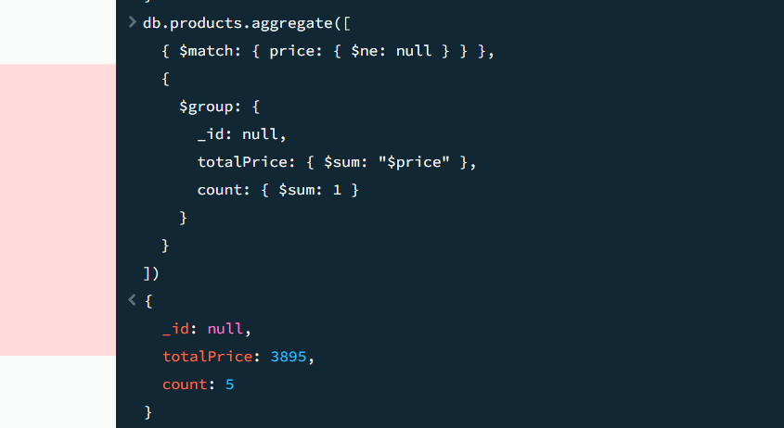

**package** connection;

**import** java.util.Arrays;

**import** org.bson.Document;

**import** com.mongodb.client.AggregateIterable;

**import** com.mongodb.client.FindIterable;

**import** com.mongodb.client.MongoClient;

**import** com.mongodb.client.MongoClients;

**import** com.mongodb.client.MongoCollection;

**import** com.mongodb.client.MongoDatabase;

**import** com.mongodb.client.MongoIterable;

**public** **class** collection_two {

**public** **static** **void** main(String[] args) {

// Creating a Mongo client

MongoClient mongoClient = MongoClients.*create*("mongodb://localhost:27017");

MongoDatabase database = mongoClient.getDatabase("myDb");

MongoCollection<Document> collection = database.getCollection("sales");

AggregateIterable<Document> result = collection.aggregate(Arrays.*asList*(

**new** Document("$sort", **new** Document("item", 1).append("price", -1)),

**new** Document("$group", **new** Document("_id", "$item")

.append("maxPrice", **new** Document("$first", "$price"))

.append("document", **new** Document("$first", "$$ROOT"))),

**new** Document("$replaceRoot", **new** Document("newRoot", "$document"))

));

**for** (Document doc : result) {

System.***out***.println(doc.toJson());

}

}

}