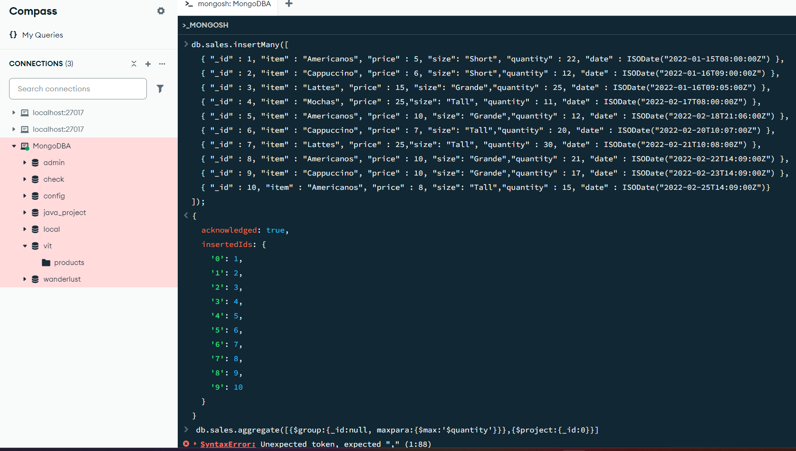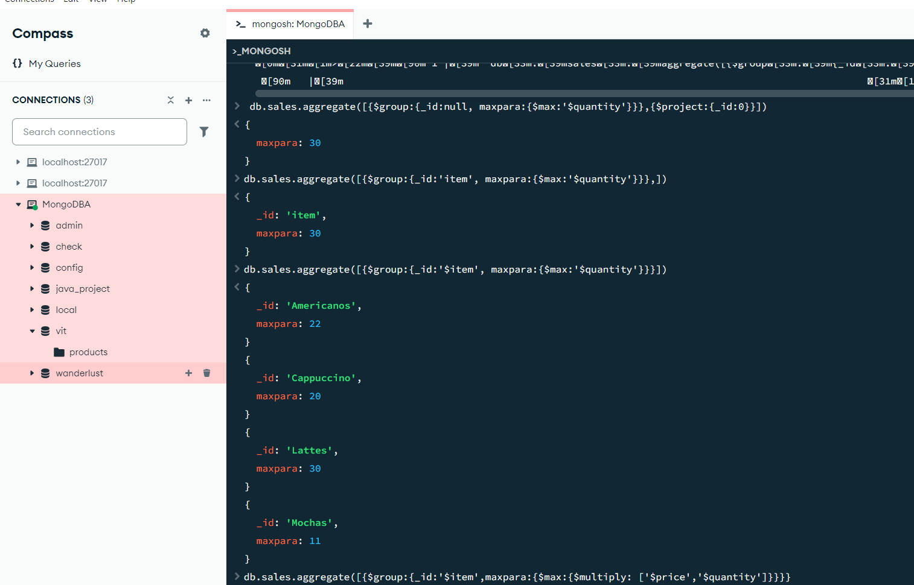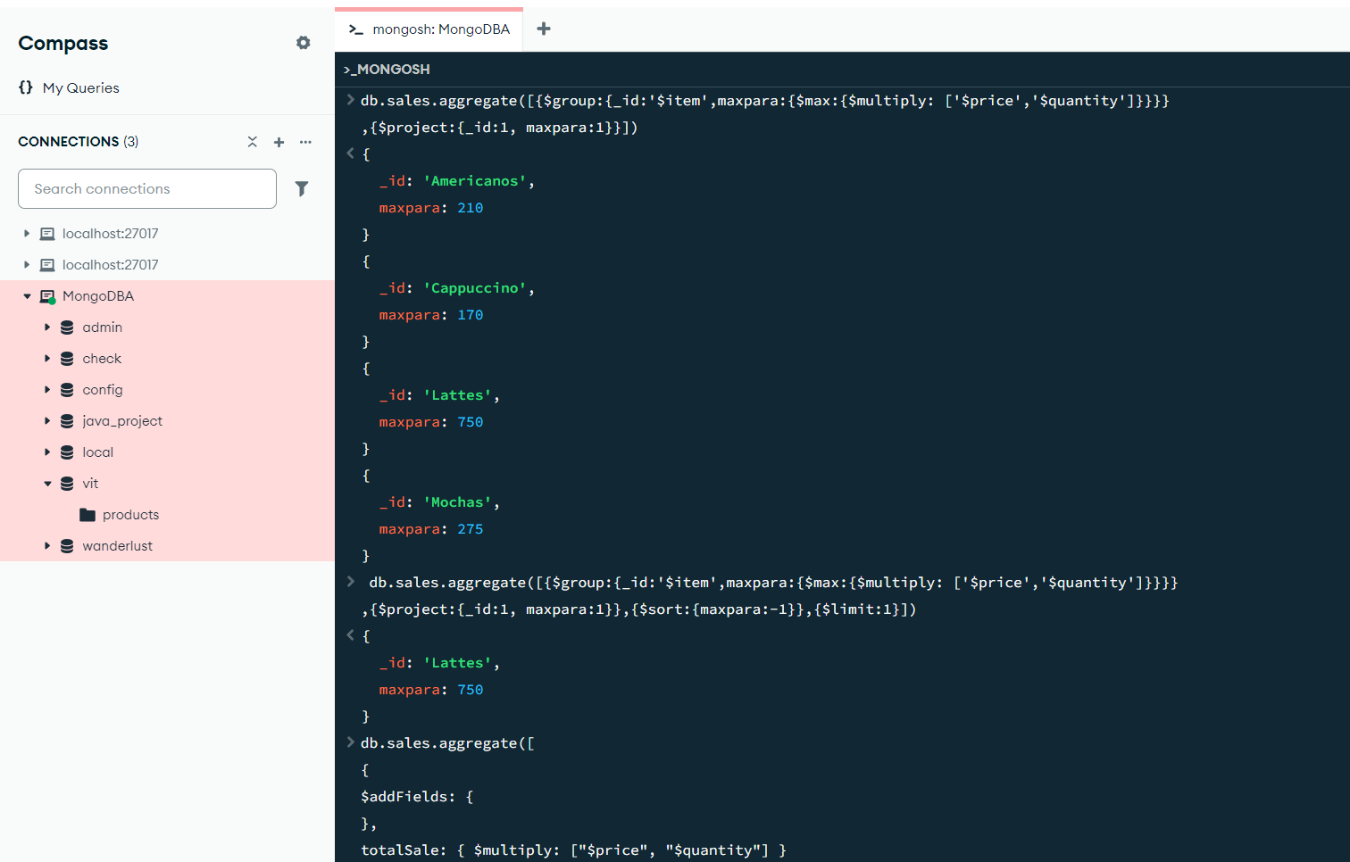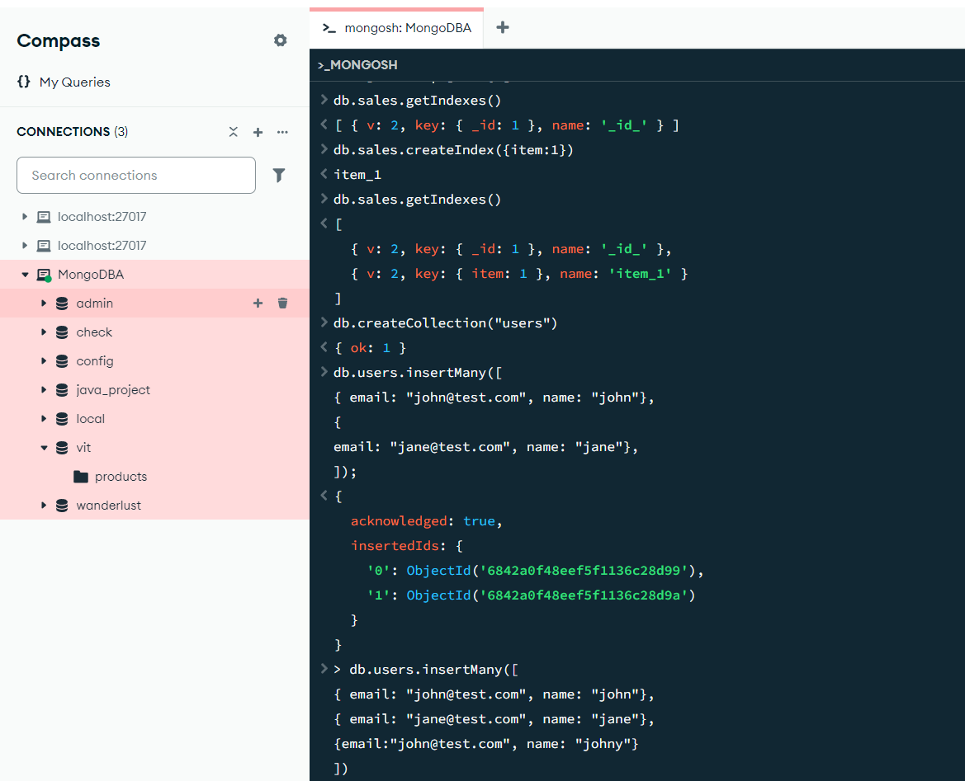

package connection;

import com.mongodb.MongoClient;

import com.mongodb.MongoCredential;

import com.mongodb.client.MongoDatabase;

public class mongoDB { public static void main(String[] args) {

try {

MongoClient db = new MongoClient("localhost", 27017);

MongoCredential credential;

credential = MongoCredential .createCredential(

"GFGUser",

"mongoDb",

"password".toCharArray());

System.out.println( "Successfully Connected" + " to the database");

MongoDatabase database = db.getDatabase("mongoDb");

System.out.println("Credentials are: " + credential); }

catch (Exception e) {

System.out.println( "Connection establishment failed");

System.out.println(e);

}

}

}