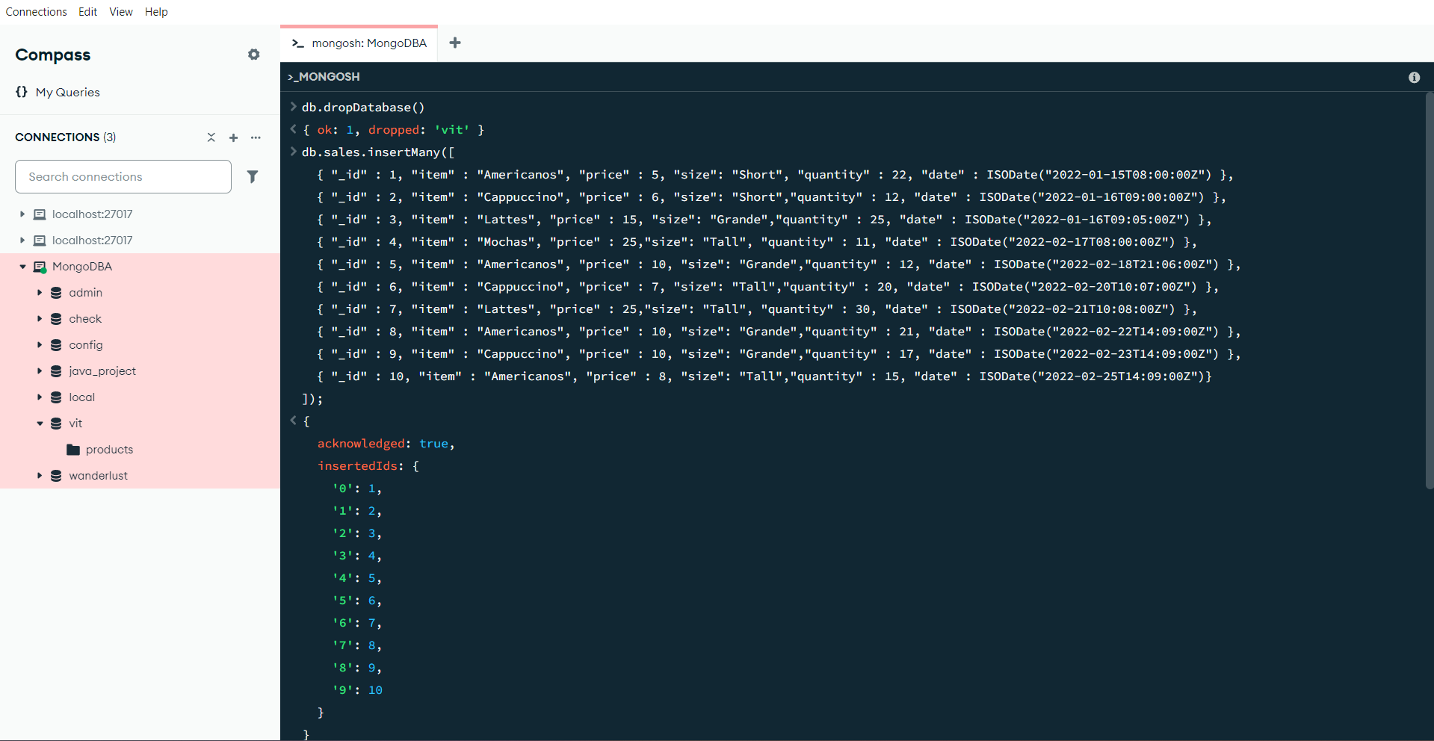

1. **Find the total revenue (price × quantity) for each item, sorted from highest to lowest.**

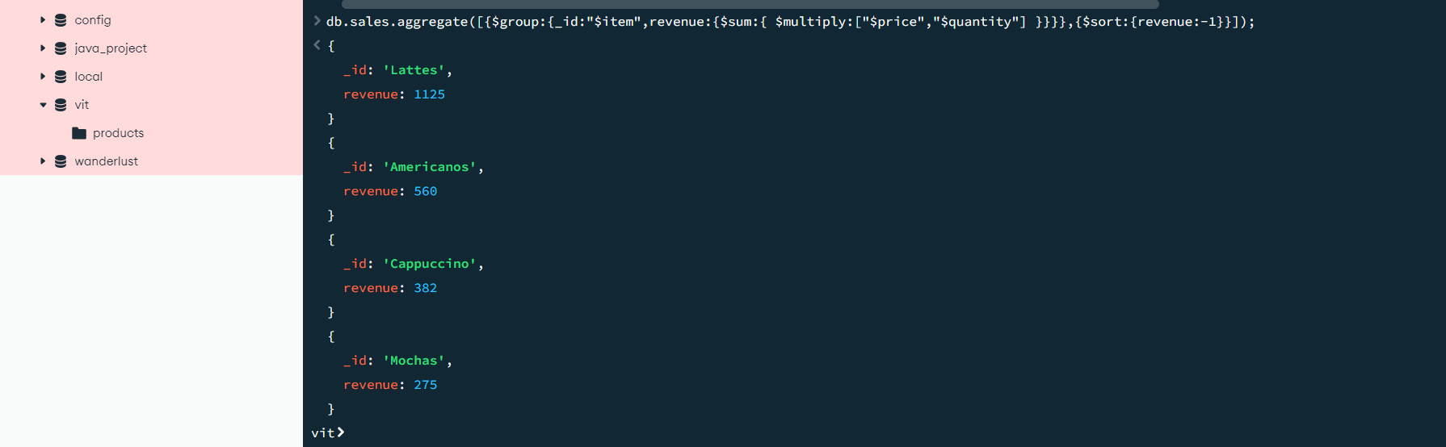

**2. Calculate the total quantity sold per month in 2022.**

**3. Find all items where price is greater than 10 and size is not 'Short'.**

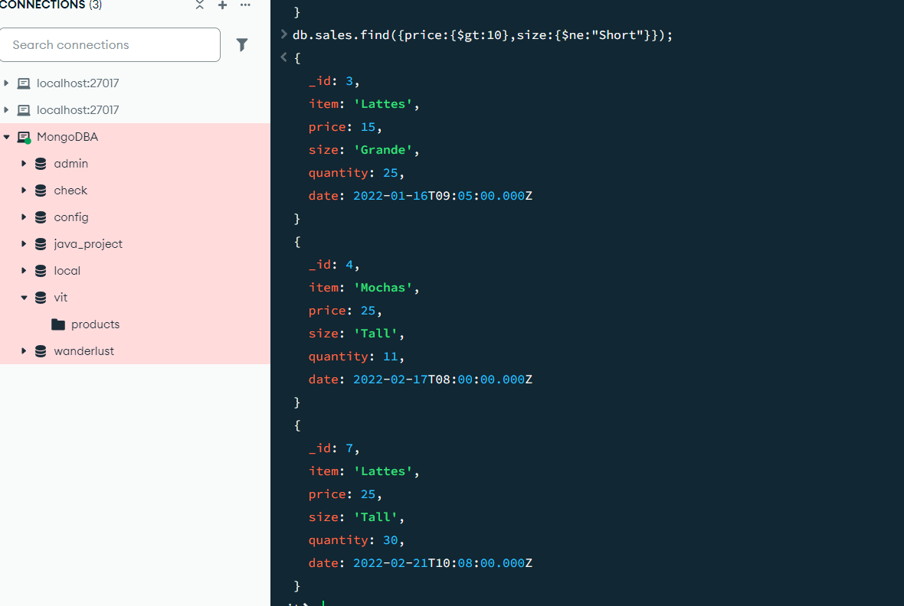

**4. Get all Cappuccino sales with quantity between 10 and 20**

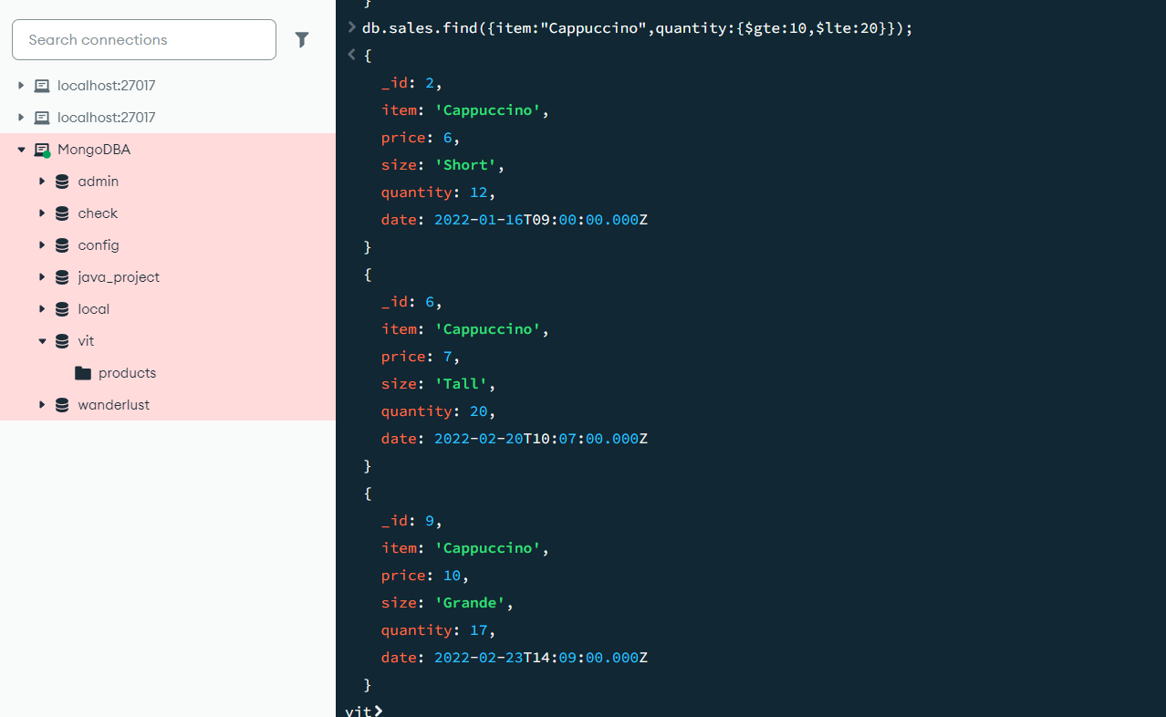

**5. Query to find items where the item name starts with "A".**

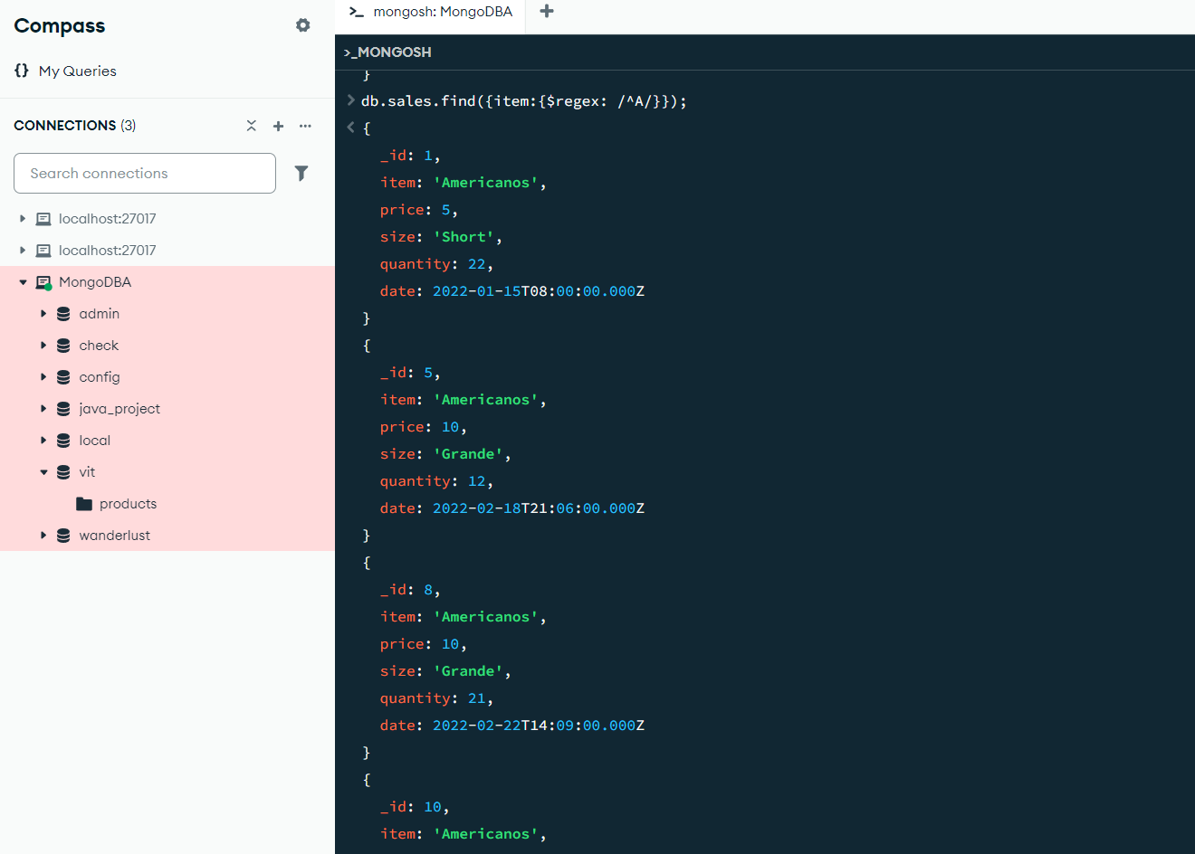

**6. Find all records that do not have the field size.**



**7.** **List all items sold in February 2022.**

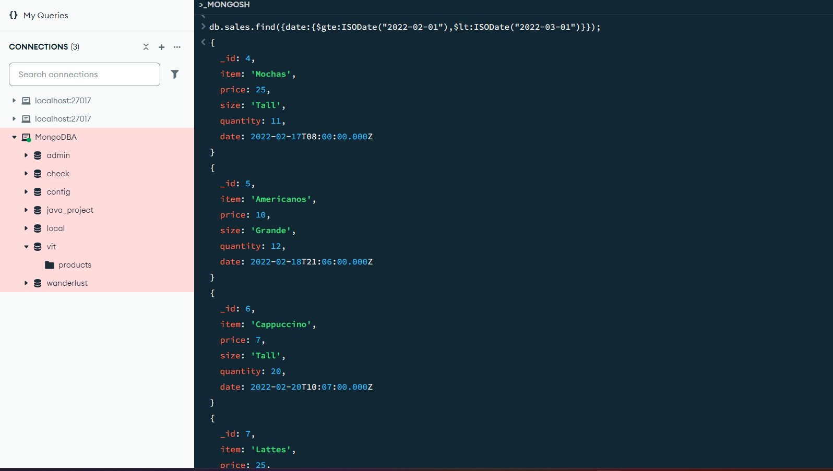

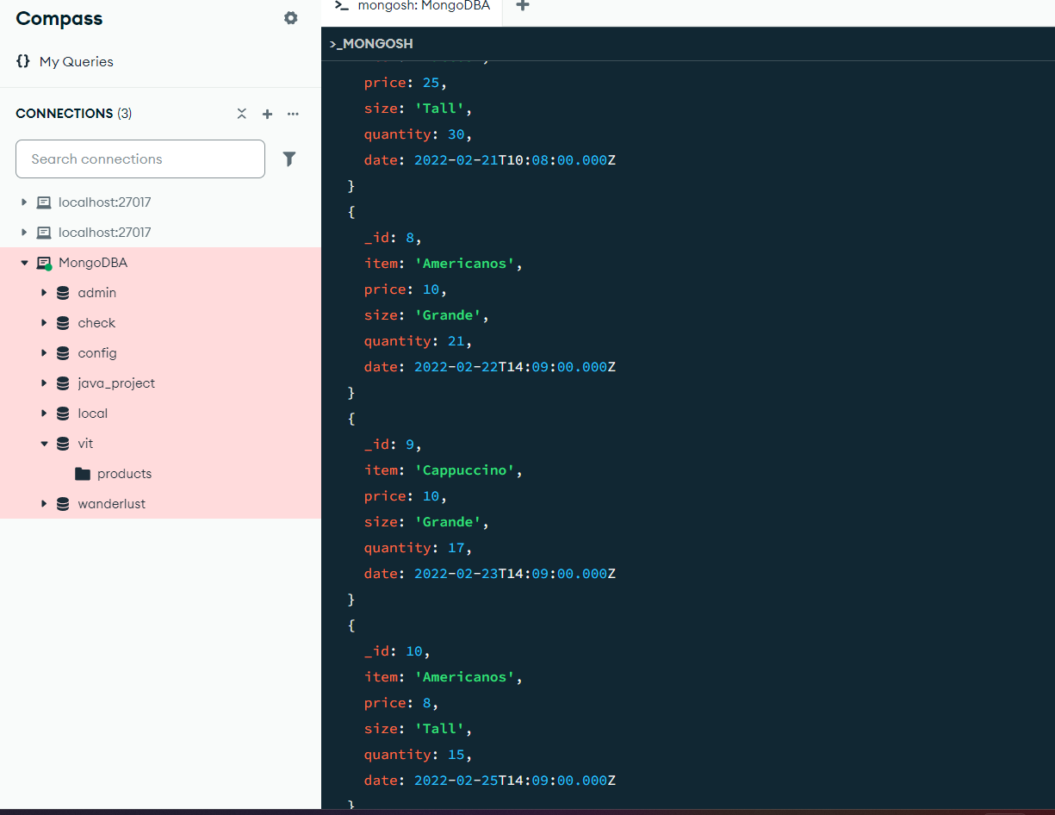

**8. Find all sales that are either "Grande" or "Tall" but not "Americanos".**

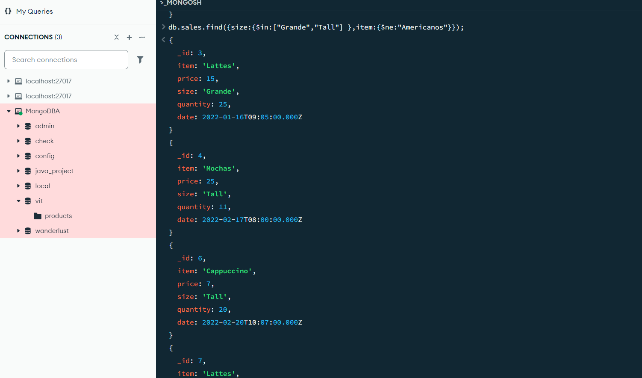

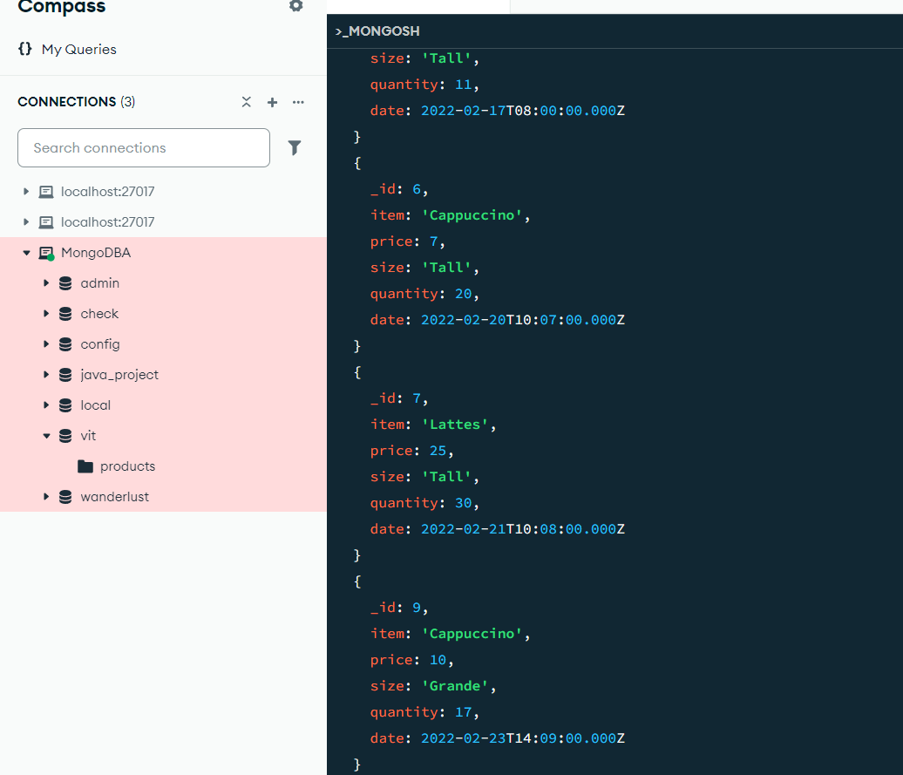

**9. Find sales where the quantity is more than twice the price.**

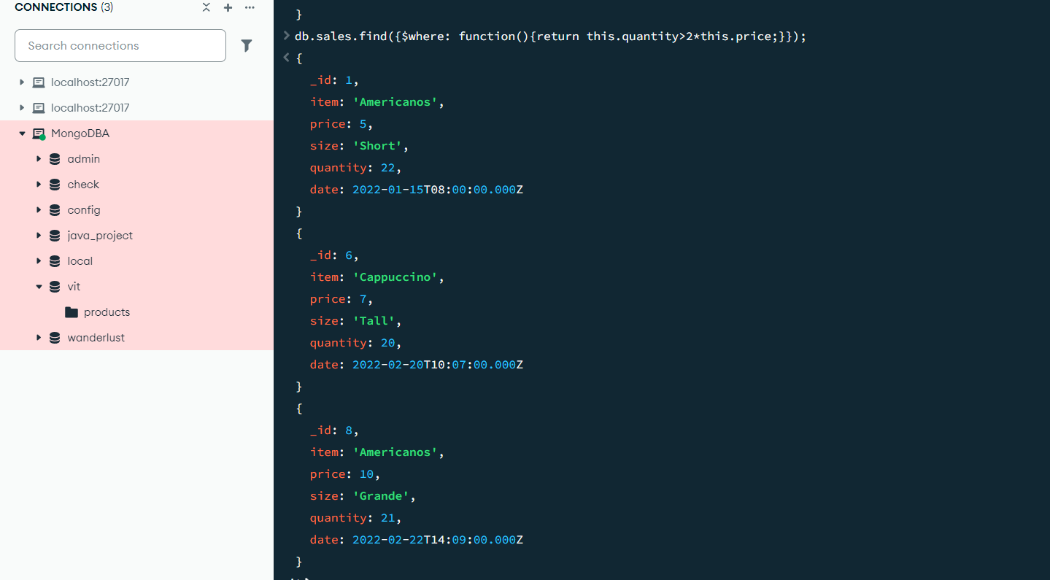

**10. Find all sales where the price is greater than the average price of their respective size.**

**11. Find Sales Where the Day of Week Matches Quantity's Last Digit [Filter sales where the day of the week (0=Sunday, 1=Monday, etc.) matches the last digit of quantity]**

**12. Find Sales Where the Month is Prime and Quantity is Odd [Filter sales where the month (1-12) is a prime number (2,3,5,7,11) AND quantity is odd]**

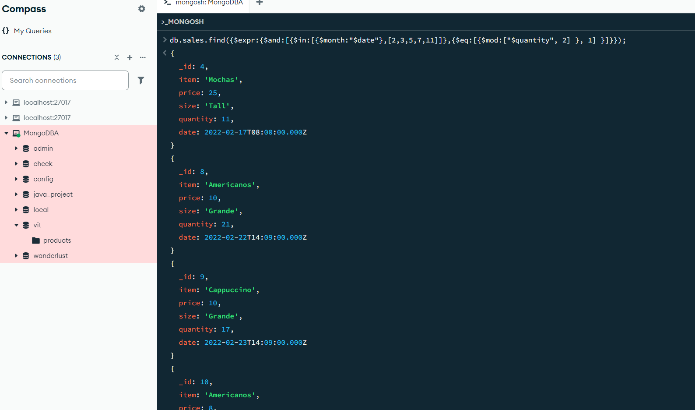

**13. Find Sales with "Suspicious Quantities" (Divisible by 5 or 7) [Filter sales where quantity is divisible by 5 or 7]**

