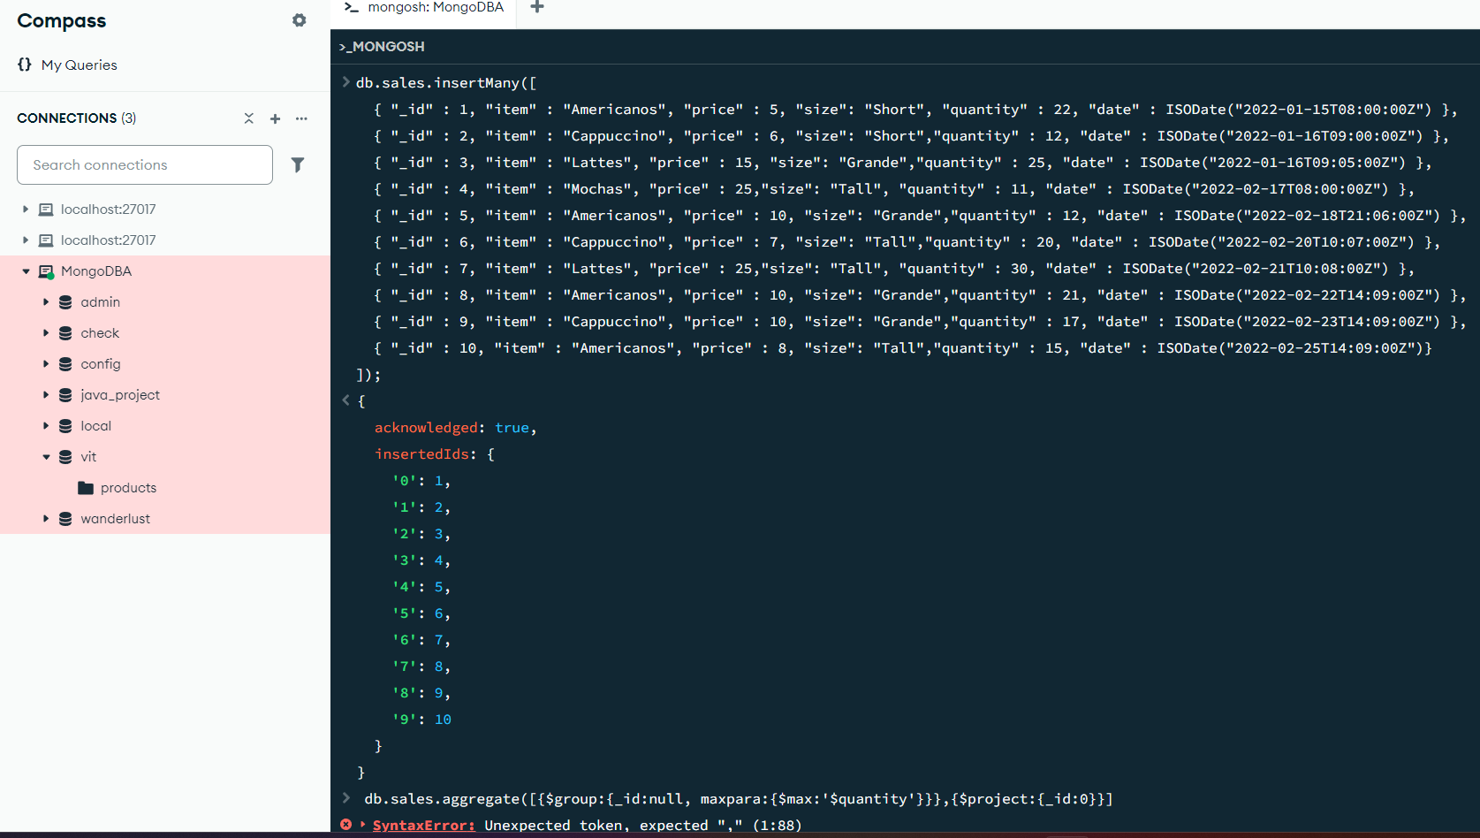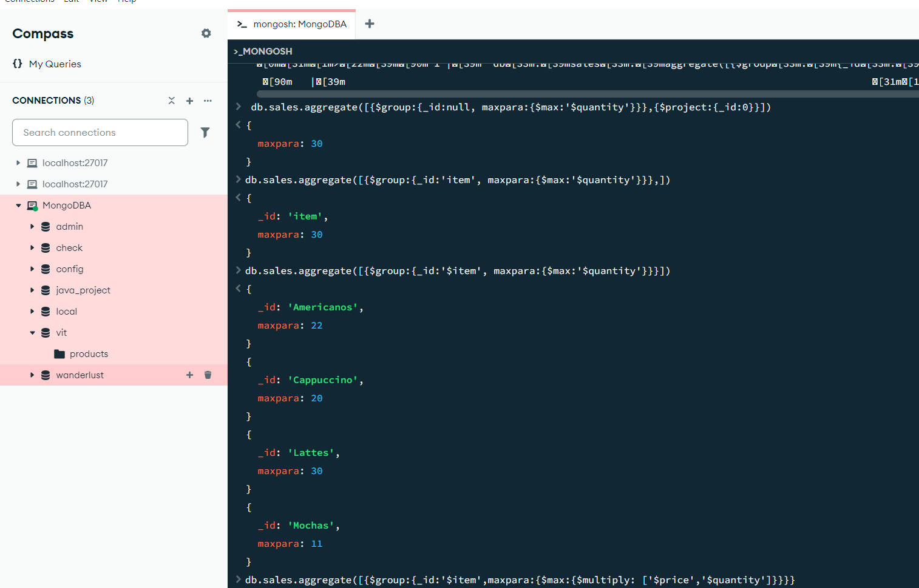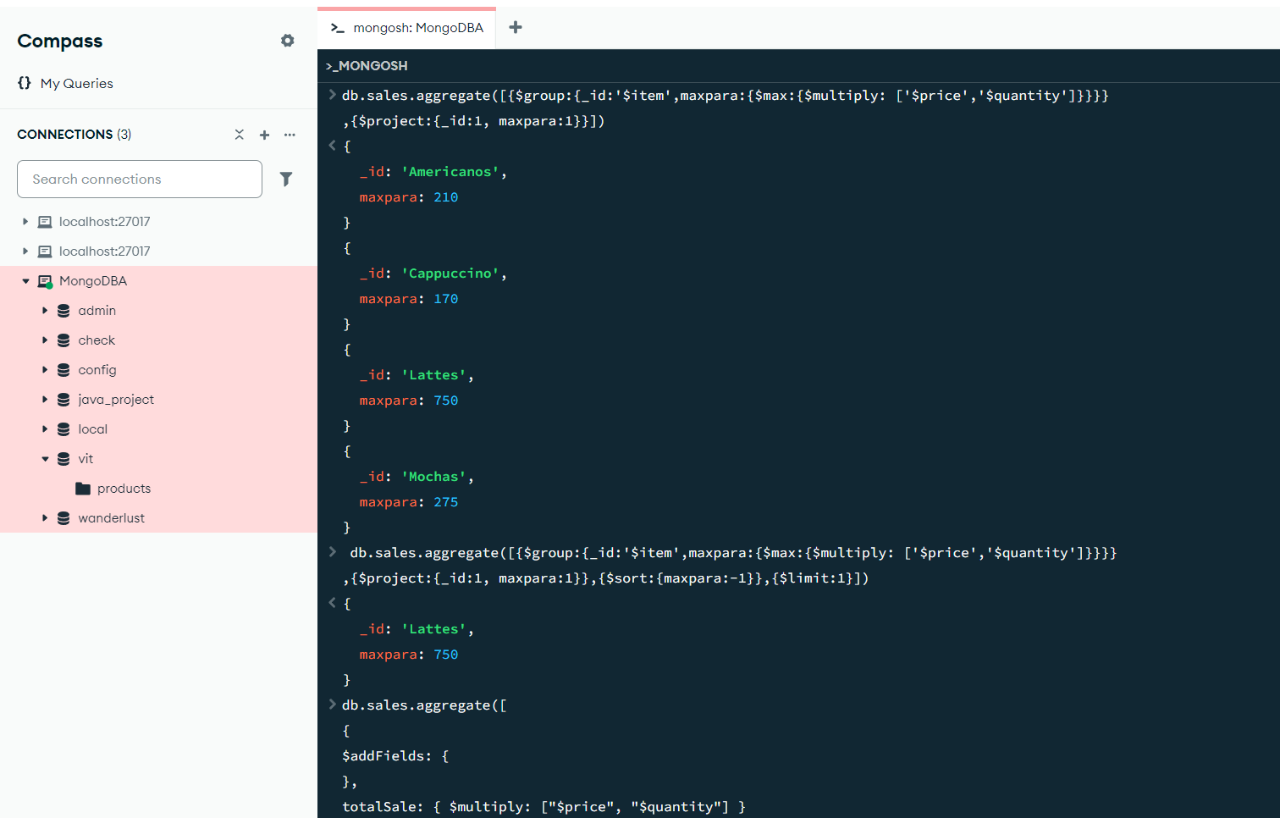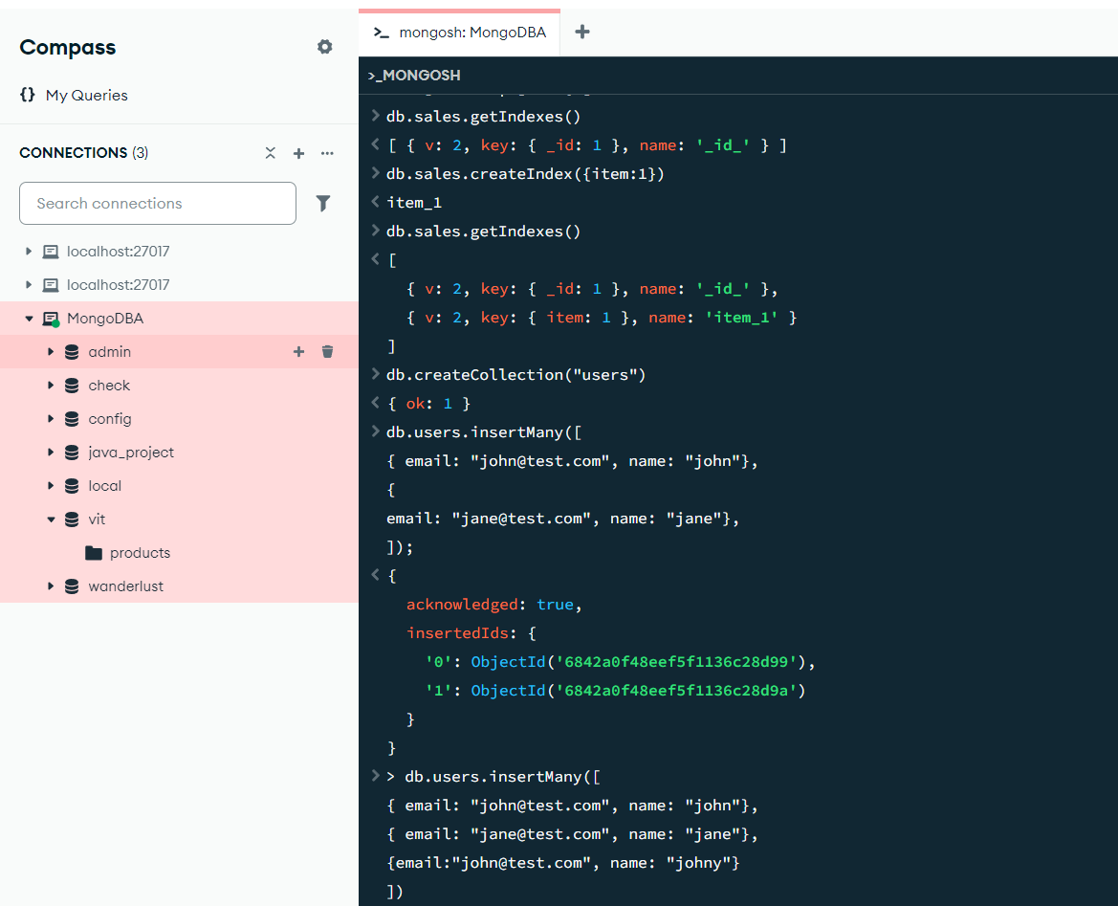

package connection;
import com.mongodb.MongoClient;
import com.mongodb.MongoCredential;
import com.mongodb.client.MongoDatabase;
public class mongoDB { public static void main(String[] args) {
try {
MongoClient db = new MongoClient("localhost", 27017);
MongoCredential credential;
credential = MongoCredential .createCredential(
"GFGUser",
"mongoDb",
"password".toCharArray());

System.out.println( "Successfully Connected" + " to the database");
MongoDatabase database = db.getDatabase("mongoDb");
System.out.println("Credentials are: " + credential); }
catch (Exception e) {
System.out.println( "Connection establishment failed");
System.out.println(e);
}
}
}

