"C:\Program Files\MongoDB\Server\7.0\bin\mongod.exe" --replSet myReplSet --dbpath C:\data\d0 --port 27017 --bind_ip localhost
"C:\Program Files\MongoDB\Server\7.0\bin\mongod.exe" --replSet myReplSet --dbpath C:\data\d1 --port 27017 --bind_ip localhost
"C:\Program Files\MongoDB\Server\7.0\bin\mongod.exe" --replSet myReplSet --dbpath C:\data\d2--port 27017 --bind_ip localhost

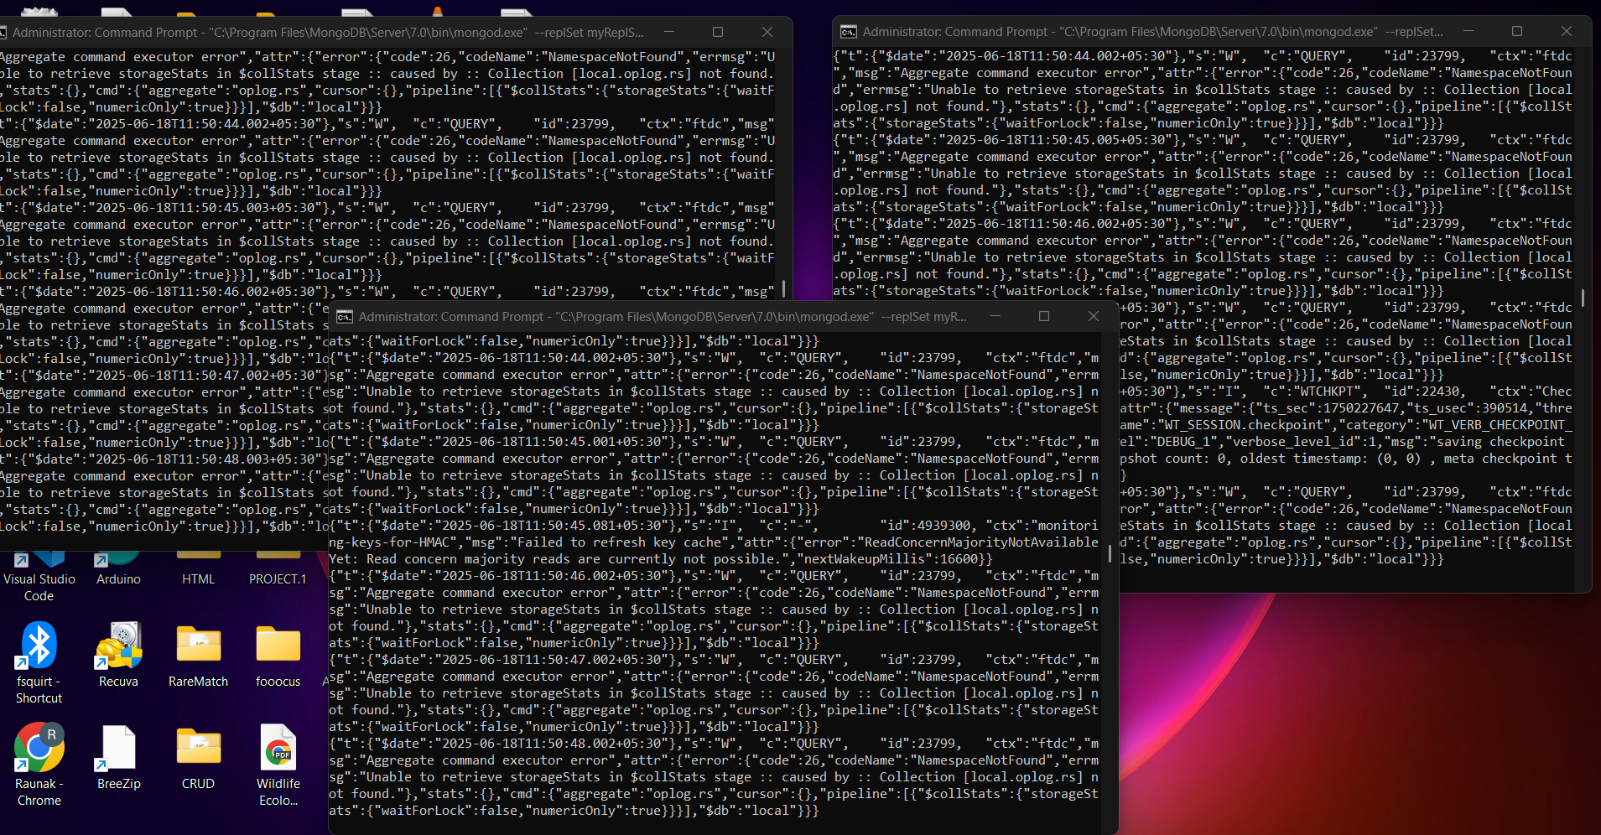

rs.initiate({
_id: "myReplSet",
members: [
{ _id: 0, host: "localhost:27017" },
{ _id: 1, host: "localhost:27018" },
{ _id: 2, host: "localhost:27019" }
]
})
