E-commerce Sales Analysis Report (2024–2025)

1. Data Pipeline & Architecture
Raw transactional data was ingested into a MySQL environment utilizing an ETL (Extract, Transform, Load) workflow. Key transformations included header sanitization (snake_case conversion), whitespace normalization, and temporal type-casting of order_date. A single-table schema (sales2024_25) was optimized to ensure query performance for complex aggregations.

2. Objective
To analyze sales performance, profitability, discount impact, and customer purchasing behavior using transactional data from 2024–2025.

3. Monthly Revenue Analysis
Revenue remains relatively stable across months with minor fluctuations. Peak performance is observed in mid-year and year-end periods. A sharp drop in October 2025 is due to incomplete data (only 3 active days), not an actual decline in business performance.

4. Sales Performance
Revenue is evenly distributed across categories, indicating a diversified product portfolio. No single category dominates the business. Product-level analysis shows revenue is spread across multiple products, reducing dependency on any single item.

5. Profitability Analysis
All categories are profitable with margins ranging from approximately 14% to 15%. This indicates a consistent pricing strategy across the business. Differences in total profit are primarily driven by sales volume rather than margin efficiency.

6. Discount Impact Analysis
Discount levels are consistent across categories (~9.5% to 10.6%), indicating a standardized discount strategy. Correlation analysis shows a very weak negative relationship between discount and profit, suggesting that discounts are not the primary driver of profitability.

7. Regional Analysis
The North region leads in revenue due to both higher order volume and higher average order value. The South region shows relatively lower performance across metrics. Overall, regional performance is balanced.

8. Payment Method Analysis
Payment mode usage is evenly distributed across all methods. Revenue and profit contributions are also similar, indicating that payment method does not significantly influence customer spending behavior.

9. City-Level Analysis
Revenue is evenly distributed across top cities, with Bangalore leading marginally. This indicates strong geographic diversification and reduced dependency on any single market.

10. Customer Behavior Analysis
The average order value is approximately ₹106,733, indicating high-value transactions. This suggests that customers are either purchasing premium products or buying multiple items per order.

11. Profit Distribution
Profit distribution is positively skewed, where most transactions generate moderate profit, and a small number of high-profit transactions drive overall profitability.
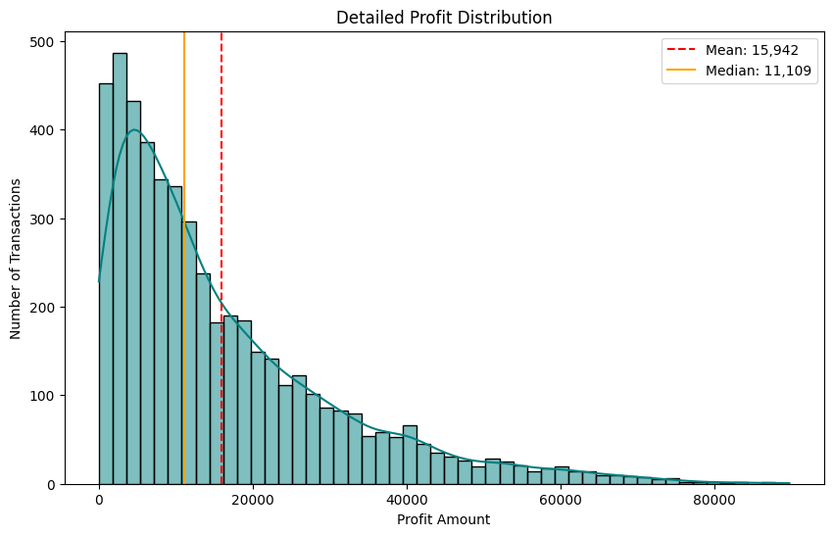

12. Correlation Analysis
Sales and profit have a strong positive correlation (~0.85), indicating that revenue growth directly drives profit. Discount has a very weak negative correlation with profit, suggesting minimal impact. Quantity shows moderate correlation with both sales and profit.
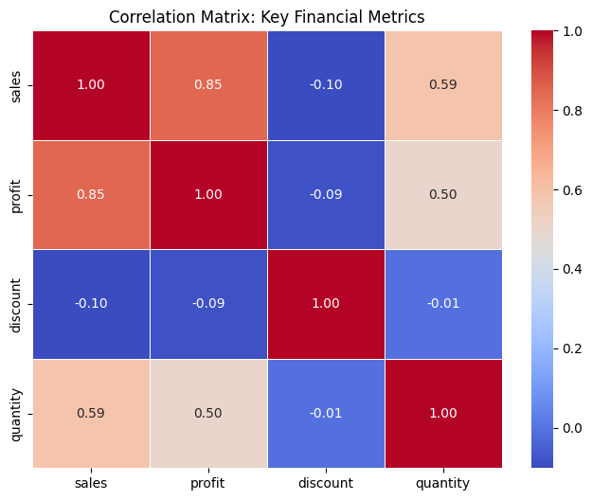

13. Conclusion
The business demonstrates stable performance with diversified revenue sources across categories, regions, and cities. Profitability is driven primarily by sales volume and high-value transactions rather than discount strategies. The company maintains a consistent pricing and discount model, resulting in uniform performance across segments.

