Research Progress Report
Exact-Statistics Anchoring for Generator-Based Heterogeneous Federated Learning under Long-Tailed Data
Why rare classes vanish from GeFL-F, and how Ours-A brings them back
Submitted by: [Student Name] · [Roll No.]
Supervisor: [Professor Name]
[Department], [Institute]
October 2026

Summary
- Problem: under long-tailed clients GeFL-F loses 21–25 points; rare classes are almost never predicted.
- Cause: FedAvg shrinks the generator's class rows for classes that fewer than half of the clients have.
- Our architecture (Ours-A): class identity from the exact class mean, fake features corrected to exact class statistics, consensus labels, client-prior loss.
Result (3 seeds, same seeds and splits for every method) | GeFL-F | Ours-A | Gain
MNIST, long tail (balanced accuracy) | 75.25 | 94.82 | +19.6
FashionMNIST, long tail | 58.47 | 79.67 | +21.2
CIFAR-10, long tail | 33.74 | 44.38 | +10.6
SVHN, long tail | 50.49 | 54.41 | +3.9
MNIST, 100 clients, long tail | 75.98 | 94.30 | +18.3
Paper's balanced setting vs the best of its 10 methods | — | above on MNIST (10/50/100 clients) and CIFAR-10; level on FMNIST; below on SVHN

1. The baseline: GeFL-F and the full lifecycle of its data

1.1 Setting and notation
- Clients. K clients (K = 10, 50 or 100). Client k holds private data D_k and a classifier head of architecture a(k), one of G = 10 CNNs (CNN-1 … CNN-10), assigned contiguously (K/10 clients per architecture).
- Data. MNIST, FashionMNIST and SVHN use a 10% fraction of the training set (6,000 / 6,000 / 7,326 images); CIFAR-10 uses 50% (25,000). In the paper's setting the data are split IID across clients. Test sets are the full balanced test sets.
- Models. One shared feature extractor φ, one shared conditional generator G(h | y), and K private heads h_k.
- Metric. The paper's best_mean_acc: each architecture's test accuracy at its best round, averaged over the 10 architectures. Under the long tail we report balanced accuracy at the final round, and tail recall (mean recall of the four rarest classes).
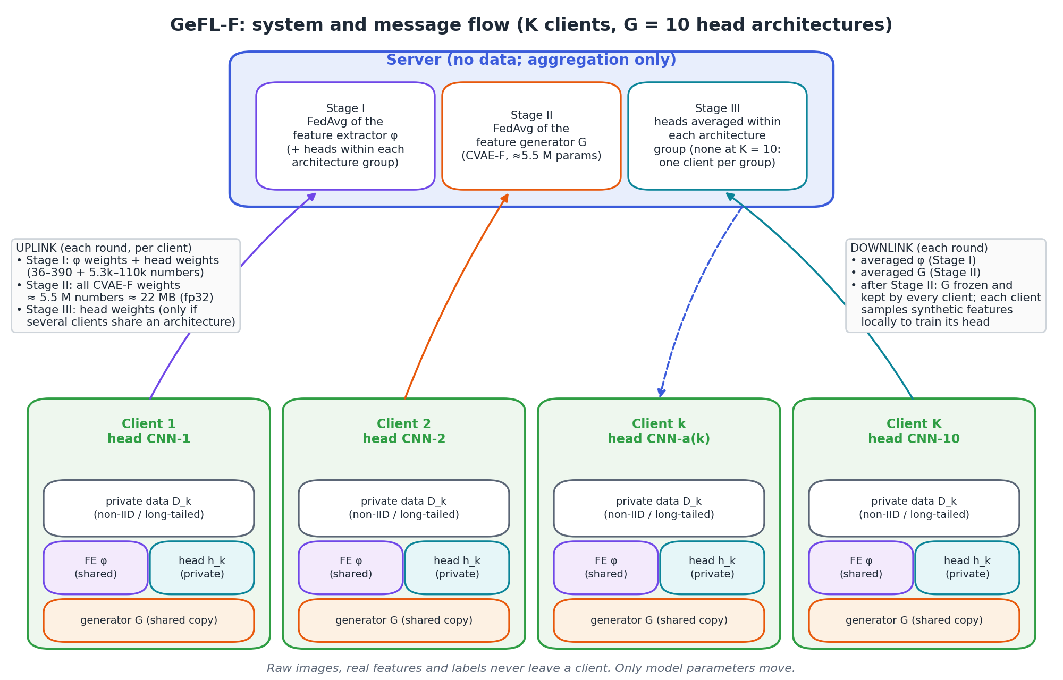
Figure 1. GeFL-F system view: what is local, what is shared, and which messages travel in each stage.

1.2 Model architectures and tensor shapes
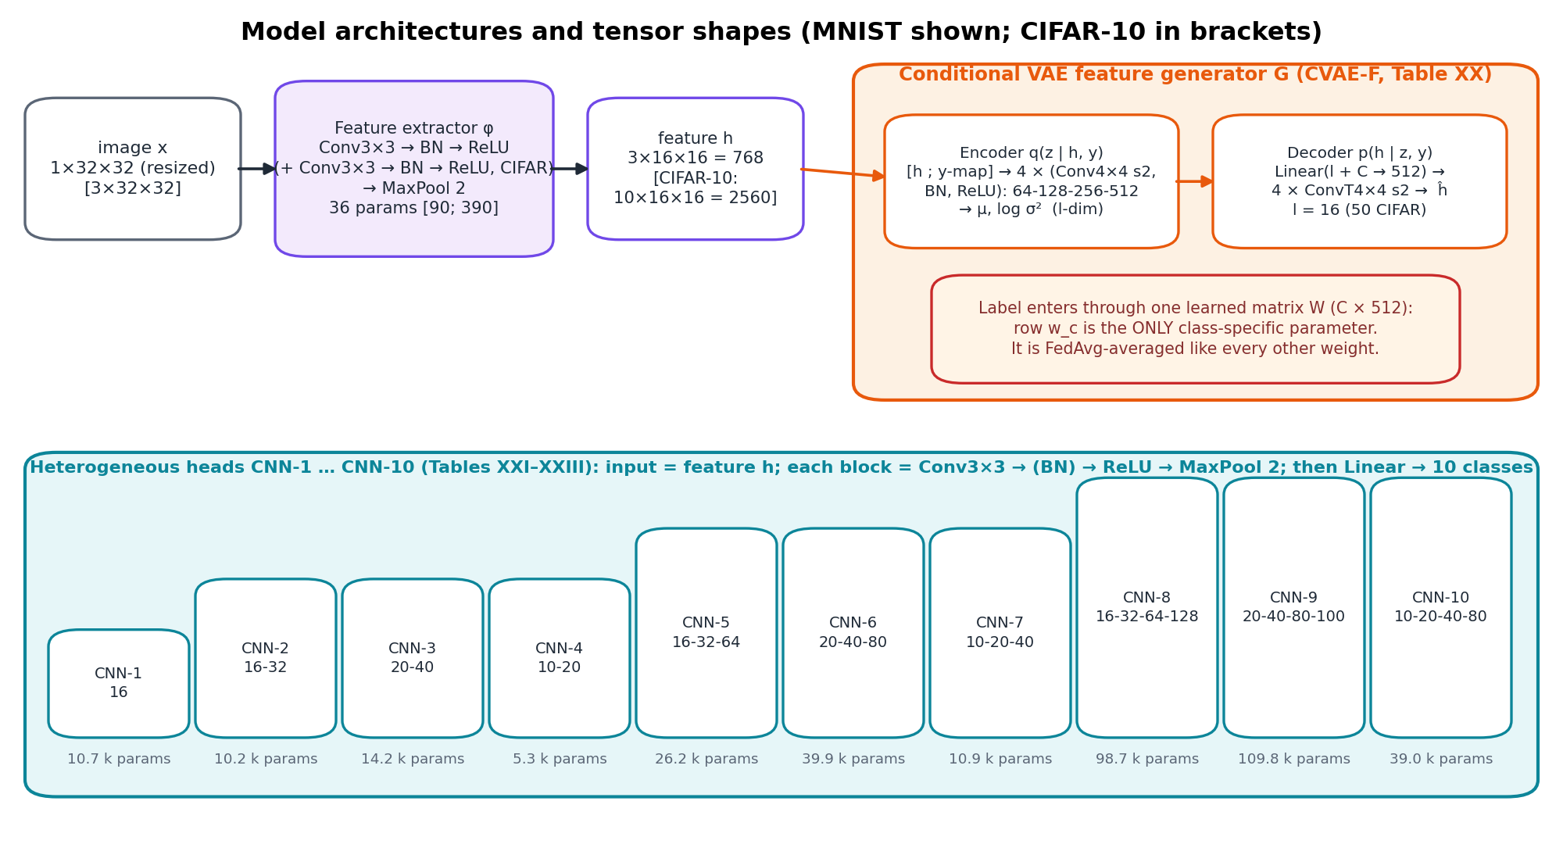
Figure 2. Architectures. The CVAE-F's label projection W (C × 512) holds the only class-specific parameters; this matters in Part 2.
Model | Input | Output | Parameters | Shared?
Feature extractor φ (Table XIV) | image resized to 1×32×32 (MNIST, FMNIST) / 3×32×32 | feature h: 3×16×16 = 768 (MNIST, FMNIST, SVHN); CIFAR-10 10×16×16 = 2,560 | 36 / 90 / 390 | yes (FedAvg in Stage I, then frozen)
Generator G, CVAE-F (Table XX) | h (+ label map) → z (l = 16; 50 for CIFAR-10) | ĥ, same shape as h | ≈ 5.5 M | yes (FedAvg in Stage II, then frozen)
Heads CNN-1 … CNN-10 (Tables XXI–XXIII) | feature h | 10 logits | 5.3 k – 109.8 k | no (averaged only within an architecture group)

1.3 Lifecycle: three sequential stages
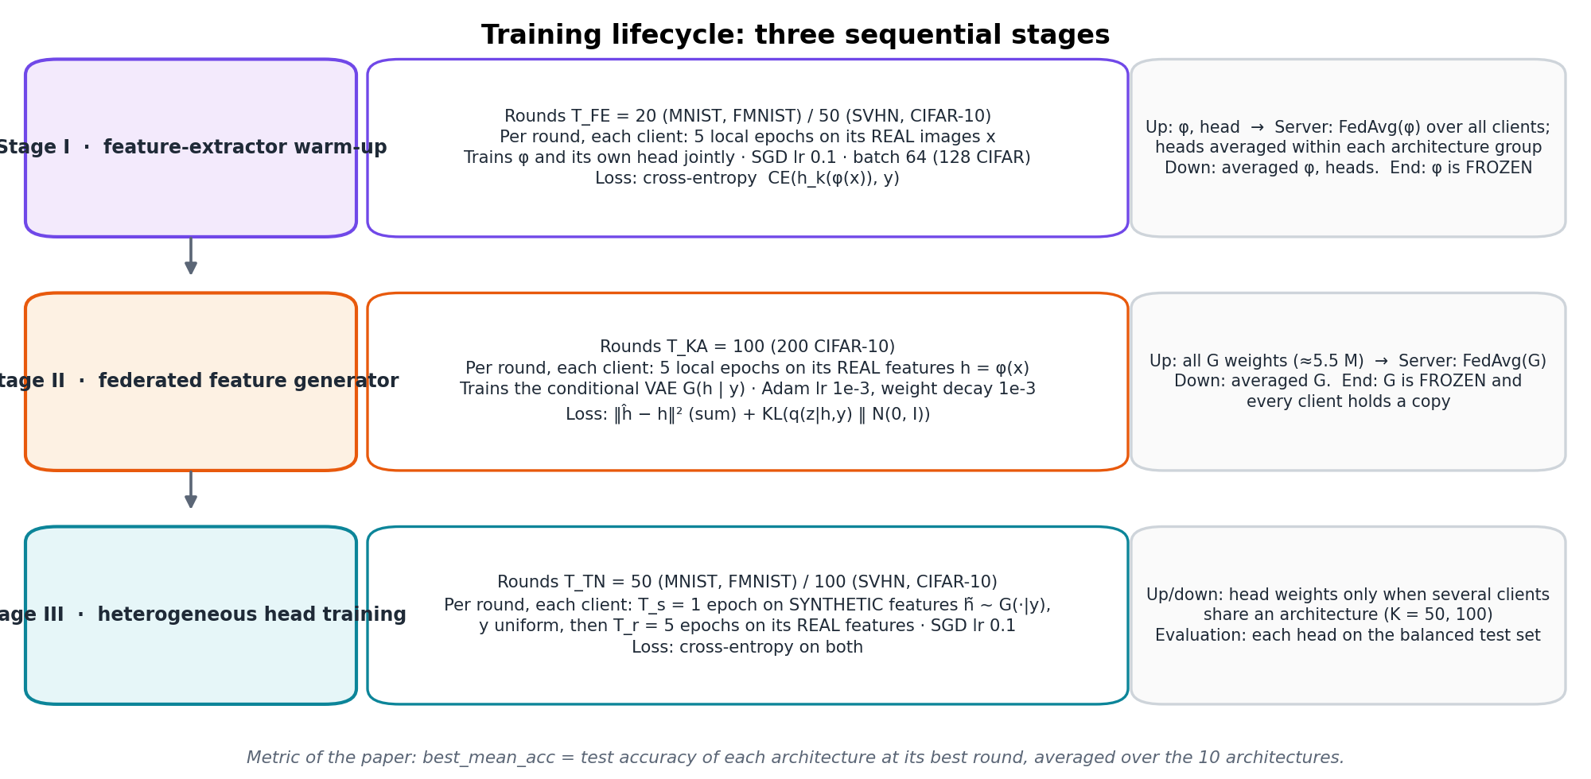
Figure 3. The three stages, with rounds, local epochs, data, optimiser and loss of each.

Stage I: feature-extractor warm-up (T_FE = 20 rounds; 50 for SVHN and CIFAR-10)
- Local data: the client's real images x with labels y.
- Local training: 5 epochs per round; φ and the client's head trained jointly; SGD, learning rate 0.1, batch 64 (128 for CIFAR-10); loss = cross-entropy CE(h_k(φ(x)), y).
- Uplink: φ's weights (36–390 numbers) and the head's weights (5.3 k–110 k numbers).
- Aggregation: φ is averaged over all clients (FedAvg, equation below); heads are averaged within each architecture group.
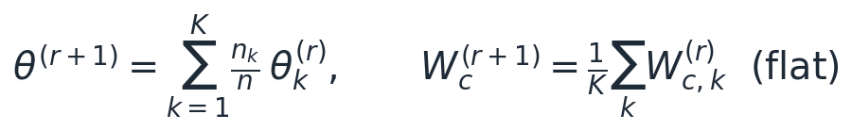 (1)
- Downlink: the averaged φ and heads. At the end of Stage I, φ is frozen for the rest of training.

Stage II: federated feature generator (T_KA = 100 rounds; 200 for CIFAR-10)
- Local data: real features h = φ(x) of the client's own images, with their labels.
- Local training: 5 epochs per round of the conditional VAE, Adam with learning rate 10⁻³ and coupled weight decay 10⁻³, batch 64. The loss is the evidence lower bound:
(2)
- The label enters the decoder through W^T e_y, i.e. the class-c row w_c of the label projection: these C × 512 numbers are the generator's only class-specific parameters.
- Uplink: every generator weight, about 5.5 million numbers (≈ 22 MB at fp32) per client per round, ≈ 2.2 GB per client over Stage II.
- Aggregation: FedAvg of all weights, including W (equation 1). Downlink: the averaged generator. At the end of Stage II, G is frozen and every client keeps a copy.

Stage III: heterogeneous head training (T_TN = 50 rounds; 100 for SVHN and CIFAR-10)
- Synthetic phase: T_s = 1 epoch on generated features h̃ = G(z, y), with y drawn uniformly over the 10 classes and z ~ N(0, I), sampled locally from the client's own copy of G; loss CE(h_k(h̃), y).
- Real phase: T_r = 5 epochs on the client's real features φ(x); loss CE(h_k(φ(x)), y); SGD, learning rate 0.1.
- Uplink and aggregation: head weights, averaged within an architecture group only when several clients share an architecture (K = 50, 100). At K = 10 each architecture has one client, and nothing is exchanged in this stage.
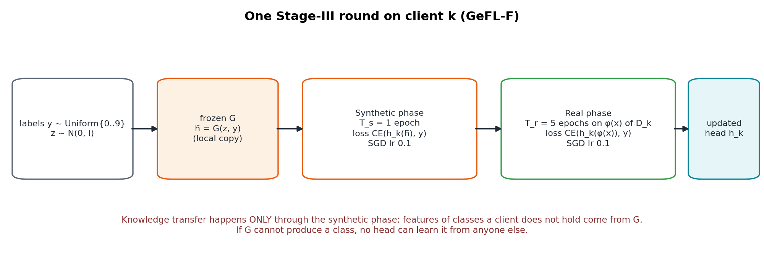
Figure 4. One Stage-III round. Classes a client does not hold reach its head only through the generator.

1.4 Communication summary
Stage | Uplink per client per round | Server operation | Downlink
I | φ (36–390) + head (5.3 k–110 k numbers) | FedAvg(φ); heads within groups | averaged φ, heads
II | all generator weights, ≈ 5.5 M numbers (≈ 22 MB) | FedAvg(G) | averaged G
III | head weights (only if an architecture has several clients) | average within architecture groups | averaged heads

Privacy: images, features and labels never leave a client; only model weights move (same as FedAvg).

1.5 Validation of our reproduction
Setting | Paper | Authors' code | Ours
MNIST IID, K = 10 (best_mean_acc) | 95.47 | 96.07 | 96.02 ± 0.04
MNIST IID, K = 50 | 95.04 | – | 95.16
MNIST IID, K = 100 | 94.63 | – | 94.61
FashionMNIST IID, K = 10 | 83.14 | – | 82.67 ± 0.31
MNIST long tail, seed 0 (final balanced accuracy) | – | 75.84 | 73.92

Our GeFL-F matches the paper within 0.5 points in the balanced setting.

2. The problem: rare classes vanish under long-tailed clients

2.1 The long-tailed federation
Class sizes n_c ∝ IF^{c/(C−1)}, IF = 100 (MNIST: 24 to ≈2,400 samples). Client shares: Dirichlet(0.5). Test sets balanced.
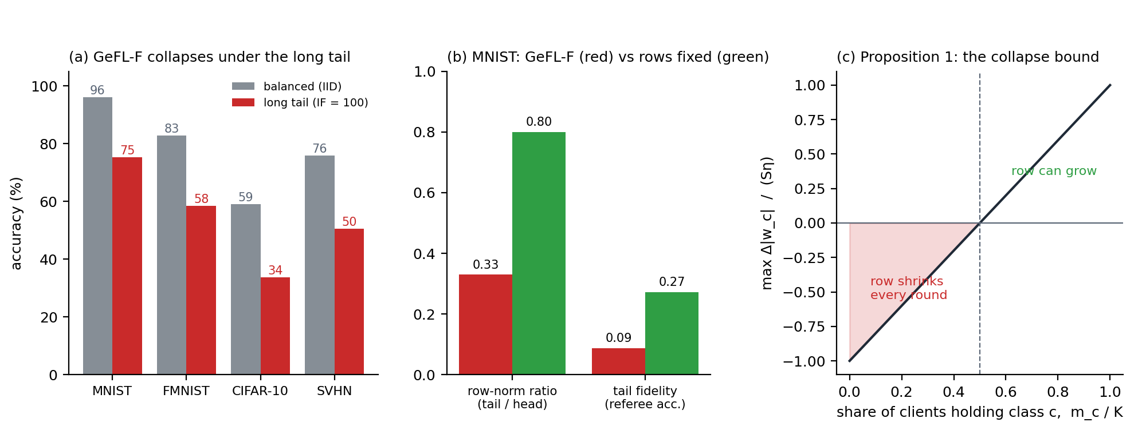
Figure 5. (a) GeFL-F's accuracy under the long tail. (b) Its tail classes' conditioning rows and fidelity. (c) The collapse bound of Proposition 1.

2.2 Diagnosis: the conditioning-row recursion
A client without class c gets only the weight-decay gradient on row w_c. Adam turns this into a fixed step toward zero. Holders (m_c of K) push up, non-holders push down, and FedAvg averages:
(approximate bound)
So every class held by fewer than half of the clients loses its row every round, and its fake features become class-agnostic.

2.3 Evidence
Measurement (IF = 100, Dir 0.5, K = 10) | MNIST | FashionMNIST | SVHN
Tail-to-head row-norm ratio, GeFL-F | 0.33 | 0.22 | 0.18–0.49
Same, with non-holders excluded from the average (HWA) | 0.80 | 1.01 | 0.96–1.05
Tail fidelity of GeFL-F's generator (referee accuracy on synthetic tail features) | 8.8 % | 19.6 % | –
GeFL-F balanced accuracy: IID → long tail | 96.0 → 75.3 | 82.8 → 58.5 | 75.8 → 50.5

Ratio far below 1 under the long tail, and restored when non-holders are removed from the average.

2.4 Why this breaks knowledge transfer
A head trained on fake features is only as good on real data as the fake features are close to real ones (TV distance). For rare classes this gap is large:
(3)

3. The research journey: every approach we tested
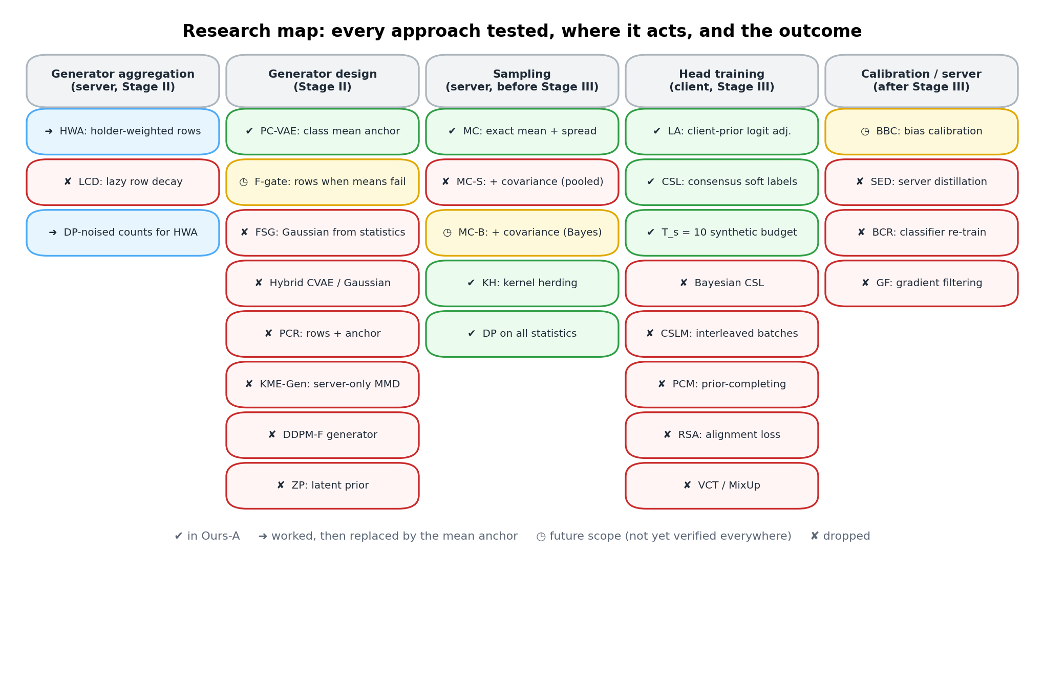
Figure 6. Research map. Green: kept in the final method. Red: tested and dropped on the evidence.

3.1 Repairing the generator's aggregation

HWA: holder-weighted aggregation (kept)
Where: server, Stage II, class rows only. How: weight each client's row by its effective sample count (Cui et al., CVPR 2019); non-holders get weight 0:
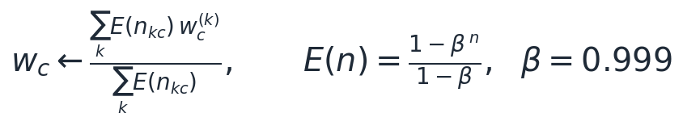 (4)
Result: +9.0 / +11.2 / +3.4 / +6.0 (MNIST / FMNIST / CIFAR-10 / SVHN, long tail); row ratio back to 0.80–1.05. Later replaced in Ours-A by the mean anchor, which has no class rows at all.

LCD: lazy conditioning decay (dropped)
Where: clients, Stage II. How: update and decay only rows of classes present in the batch. Result: 78.6 vs 79.1 for HWA; adds nothing.

3.2 Training the heads

LA: logit adjustment with the client's own prior (kept; established technique)
Where: each client, real-data phase. How: Menon et al. (ICLR 2021) with the client's own private prior π_k:
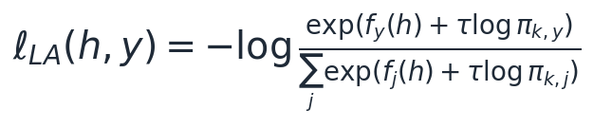 (5)
Result: +3.6 to +6.3 on all four datasets. Needed because the 5 real epochs pull each head back to its own skew. No effect in IID.

CSL: consensus soft labels on synthetic features (kept)
Where: synthetic phase; clients send only prediction sums on a shared fake pool. How: target = mix of the label and the average prediction of all architectures (FedMD, FedDF):
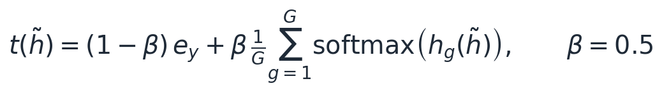 (6)
Result: +2.5 MNIST long tail; +0.5 to +0.8 IID. β = 0.5 better than β = 1.

T_s = 10: a larger synthetic budget (kept)
Why (Proposition 5): more fake training helps only when the generator is faithful (low label bias b).
(Proposition 5)
Result: with the anchored generator +1.7 (MNIST long tail) and +3.9 at K = 100; with the original generator −0.05, as predicted.
Dropped head-side idea | Placement and model | Result | Why it failed
Bayesian CSL | Replace the fixed mixture by a Bayes posterior under symmetric generator noise, fidelity ρ̂ estimated from ensemble agreement | 83.16 vs 84.22 (FMNIST IID, p = 0.004); 87.3 vs 90.5 (MNIST LT) | ρ̂ is circular: heads trained on the generator agree with it (ρ̂ → 0.999), so the target collapses to the hard label
CSLM | Interleave consensus-labelled synthetic features into every real batch | SVHN LT 49.9 vs 62.4 | Mixes the client-prior logit adjustment with balanced synthetic labels in one batch
PCM | Fill each real batch's missing classes with synthetic samples | FMNIST LT 59.6 vs 65.2 (with LA) | Needs faithful tail features, which do not exist before the generator is fixed
RSA | Align head embeddings of synthetic and real features on held classes | synthetic–real gap grew on unheld classes | Fits the alignment to the held classes only
VCT / MixUp | Mix real features with consensus-labelled synthetic partners (VCT) or with each other (MixUp) | CIFAR-10 IID: VCT 60.29, MixUp 59.98, neither 60.93; LT tail recall +10 with VCT | Feature-space mixing does not regularise past the frozen extractor (Part 5.4)

3.3 Server-side corrections
Approach | Placement and model | Result | Verdict
SED: server-side ensemble distillation | Server distils the heads' ensemble into each head on fresh synthetic features | FMNIST IID 81.69 → 80.96; LT 70.65 → 71.30 | Dropped: bounded by equation 3; the ensemble's knowledge reaches heads only as faithfully as the generator allows
BCR: balanced classifier re-training | Server re-fits each head's last layer on balanced synthetic features (CReFF-like) | 62.0 vs 65.2 for LA (FMNIST LT, quick) | Dropped: weaker than LA
GF: gradient filtering | Filter conflicting synthetic gradients | 58.5 vs GeFL-F 58.8 | Dropped: no effect
BBC: balanced bias calibration (Saerens et al., 2002) | Fit C logit offsets per head on balanced fake features | +0.35 to +1.4 under the long tail (MNIST/FMNIST) | Future scope: not yet run on all datasets

3.4 Alternative generators
Generator | Placement and model | Result | Verdict and reason
FSG: Gaussian from exact statistics | Server builds N(m_c, Σ_pooled) from secure-aggregated sums; no generator training | MNIST LT 87.0; CIFAR-10 LT 44.2; SVHN LT 44.2 < GeFL-F 50.5 | Dropped: its Bayes head is LDA (eq. 8), which reaches only 21 % on SVHN pixels
Hybrid CVAE / Gaussian | Mixture of the two generators | 87.1 vs 87.9 (full schedule; the quick pass had favoured it) | Dropped
KME-Gen | Generator trained only at the server, by MMD to exact kernel embeddings | MNIST 89.9, FMNIST 75.1 (+15 over GeFL-F) at 1/3000 of the communication | Dropped as main method; noted as an efficient variant
DDPM-F (paper's diffusion generator) | Our components on the paper's best feature generator | SVHN IID 70.37 vs DDPM GeFL-F 69.77 (p = 0.10); far below 76–77 with CVAE | Dropped: slow (hours per seed) and weaker here
ZP: ex-post latent prior | Fit z ~ N(m, S) to the encoder means (exact sums) | PC + ZP 91.69 vs PC + MC 92.31 | Dropped: MC fixes the same issue better
PCR: class rows + mean anchor | Both conditioning signals in one decoder | Ties Ours-A on MNIST/FMNIST; SVHN LT 60.9 vs 65.6 for rows alone | Dropped: the anchor under-disperses samples where means are uninformative

(8)

3.5 Moment correction
MC (kept in Ours-A). Moves each fake class onto its exact mean and spread with the smallest change (Proposition 3): +1.6 MNIST, +1.6 FMNIST over the plain anchored generator.
Covariance version (MC-S / MC-B): future scope. Helps FMNIST and SVHN but not yet complete on every dataset (Part 7).

4. The final architecture: Ours-A

4.1 Where each part comes from
Part of Ours-A | Source (research paper) | What we use from it
Class sums sent safely | Bonawitz et al., Practical Secure Aggregation, ACM CCS 2017 | server gets only the total over clients
Class mean as class identity | Tan et al., FedProto, AAAI 2022 | class prototypes (means) as shared knowledge
Moment fix (MC) | Optimal transport, scalar case (Olkin and Pukelsheim 1982) | smallest change that gives the exact mean and spread
Fingerprint selection (KH) | Chen, Welling and Smola, Kernel Herding, UAI 2010; Gretton et al., MMD, JMLR 2012 | pick samples whose average fingerprint matches the class
Client-prior loss (LA) | Menon et al., Logit Adjustment, ICLR 2021; Zhang et al., FedLC, ICML 2022 | loss that undoes a client's own class skew
Consensus labels (CSL) | Li and Wang, FedMD, 2019; Lin et al., FedDF, NeurIPS 2020 | average prediction of different models as soft label

The single idea
FedAvg estimates class information and, under a long tail, the estimate collapses.
Secure aggregation adds up class sums exactly. Ours-A takes class information from these exact sums.

4.2 Architecture
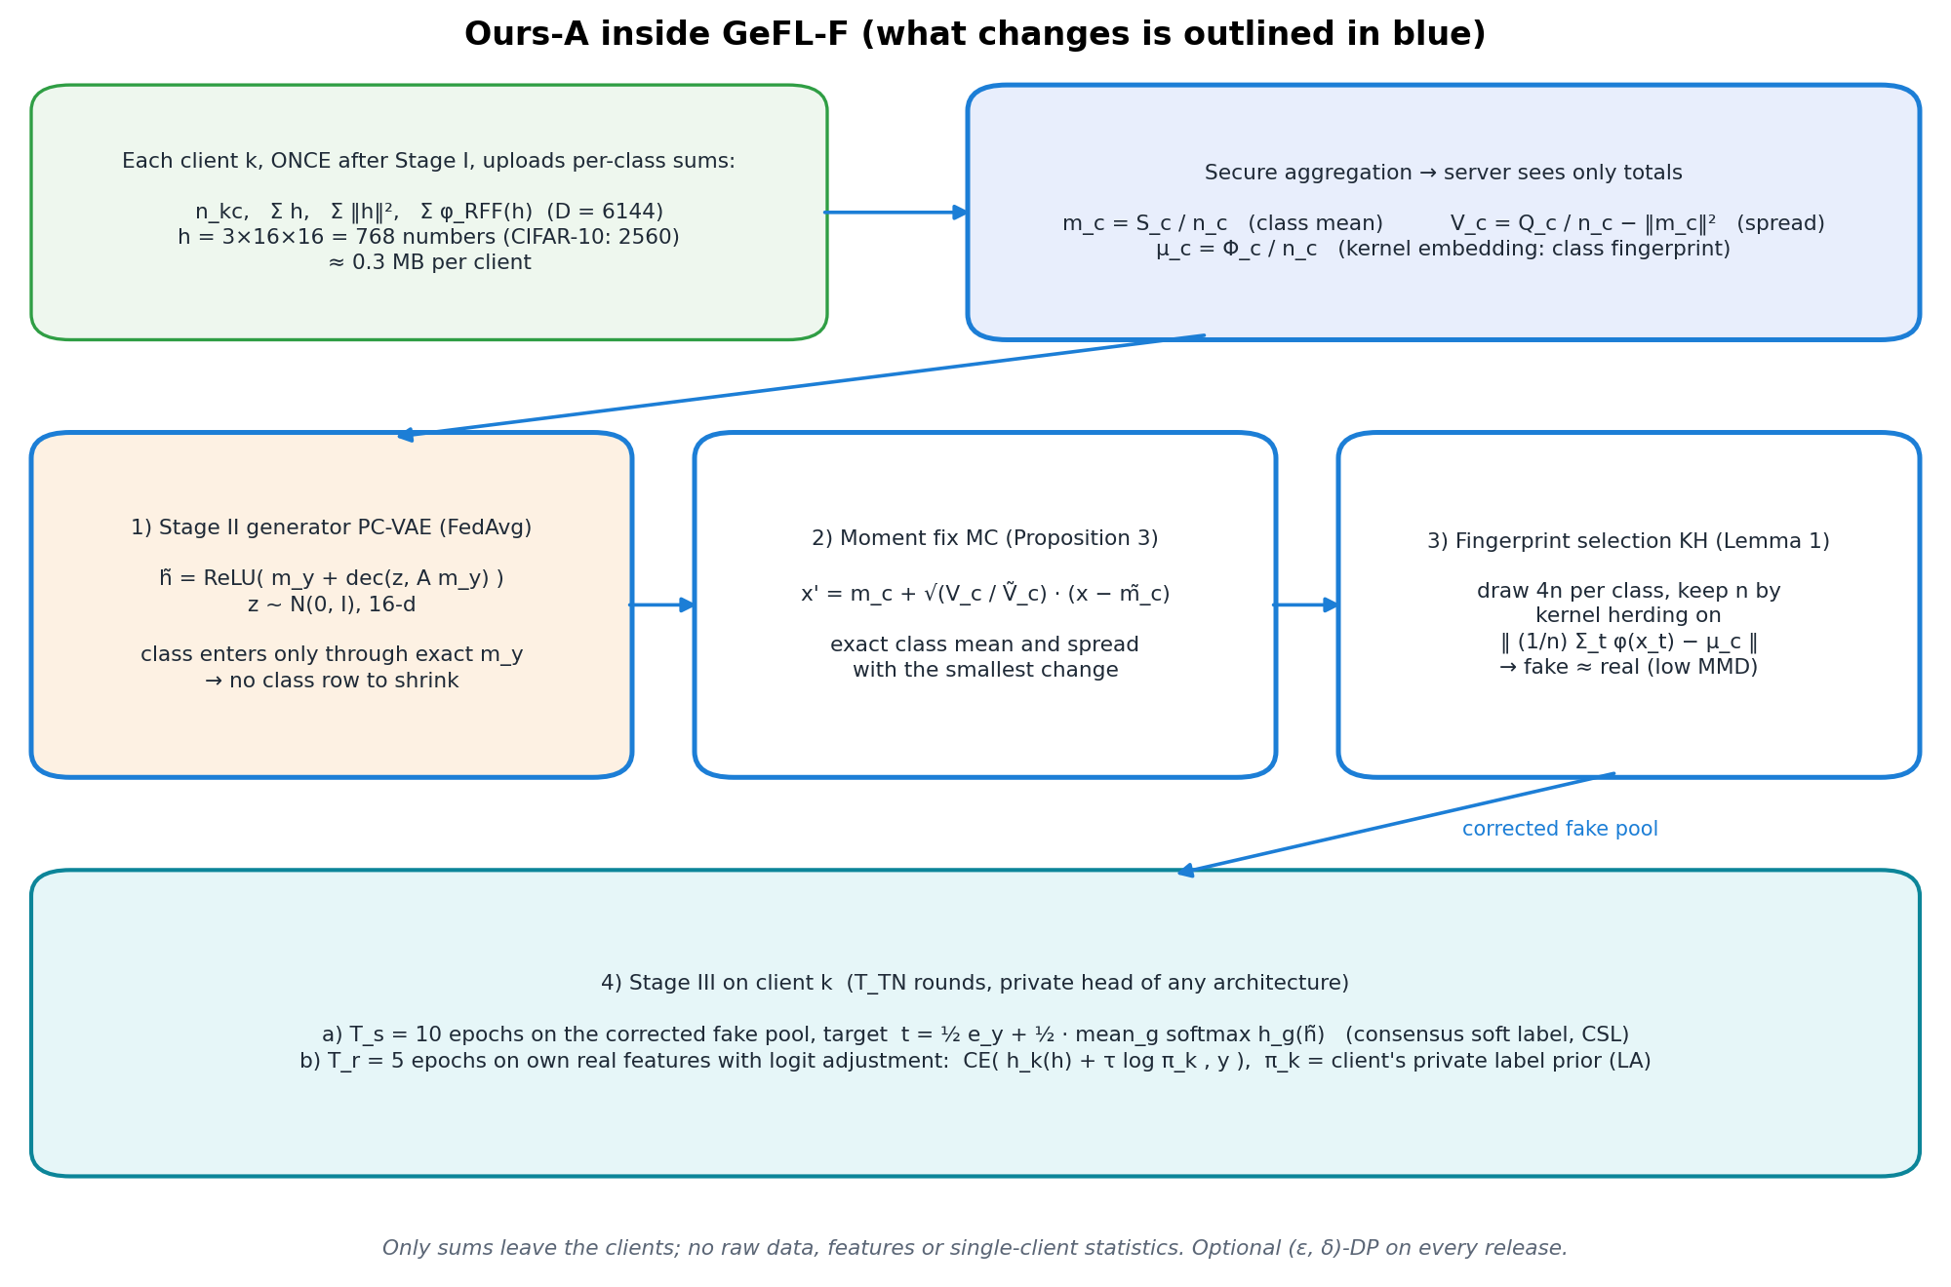
Figure 7. Ours-A inside GeFL-F. Blue: what changes. Everything new comes from class sums added up by secure aggregation.

4.3 Mathematical model

Step 1: class statistics (one upload per client, after Stage I)
Each client sends per-class counts, feature sums, sums of squared norms and sums of 6,144 random features. The server adds them:
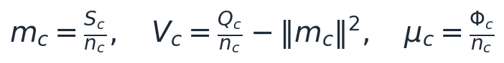 (9)

Step 2: class identity from the exact class mean (PC-VAE)
The generator learns only the difference from the class mean; it has no class-specific weight that FedAvg could shrink:
(10)

Step 3: moment fix (MC)
Proposition 3. Of all maps that give class c its exact mean and spread, this one changes the samples the least:
(11)

Step 4: fingerprint selection (kernel herding)
Draw 4n candidates per class, keep the n whose average fingerprint best matches μ_c. Lemma 1: the head's real-vs-fake error gap is bounded by this mismatch (MMD):
(12)

Step 5: heads
10 epochs on the corrected fake features with consensus labels (eq. 6), then 5 epochs on real features with the client-prior loss (eq. 5).

4.4 What Ours-A adds to communication
Release | Size | When | Protection
Class counts, sums of h and of ‖h‖², sums of random features | ≈ 0.3 MB per client | once, after Stage I | secure aggregation; optional (ε, δ)-DP
Consensus labels: prediction sums on a shared fake pool | ≈ 24 KB per fake epoch | each Stage-III round | sums only; no real data
Generator, extractor, heads | as in GeFL-F | as in GeFL-F | unchanged

For formal privacy, features are clipped and each release gets Gaussian noise (zero-concentrated DP):
(13)

5. Results

5.1 Protocol
All runs follow the paper's appendix: the same models, optimisers, rounds and data fractions; 3 seeds; each seed fixes the split and the initialisation for every method, so comparisons are paired; p-values come from paired t-tests. Local runs used one laptop GPU; heavy runs used Kaggle T4 × 2 sessions.

5.2 Main result: long-tailed clients
Method (IF = 100, Dir 0.5, K = 10; balanced accuracy) | MNIST | FashionMNIST | CIFAR-10 | SVHN
GeFL-F (Kang et al., 2025) | 75.25 | 58.47 | 33.74 | 50.49
GeFL-F + logit adjustment (≈ FedLC) | 78.92 | 64.78 | 37.30 | 56.44
+ HWA (count-anchored rows) + LA | 87.89 | 76.02 | 40.73 | 62.45
+ HWA + LA + consensus labels | 90.40 | 76.60 | 42.10 | –
Gaussian generator from exact statistics (FSG) + LA | 87.04 | 73.60 | 44.17 | 44.23
Ours-A | 94.82 | 79.67 | 44.38 | 54.41
oracle: Ours-A's heads, last layer re-fit on pooled real data | 94.93 | 81.55 | 50.64 | 59.13

Tail recall: 51.9 → 91.1 (MNIST), 35.4 → 73.6 (FashionMNIST). SVHN is the weak case (Part 5.7).
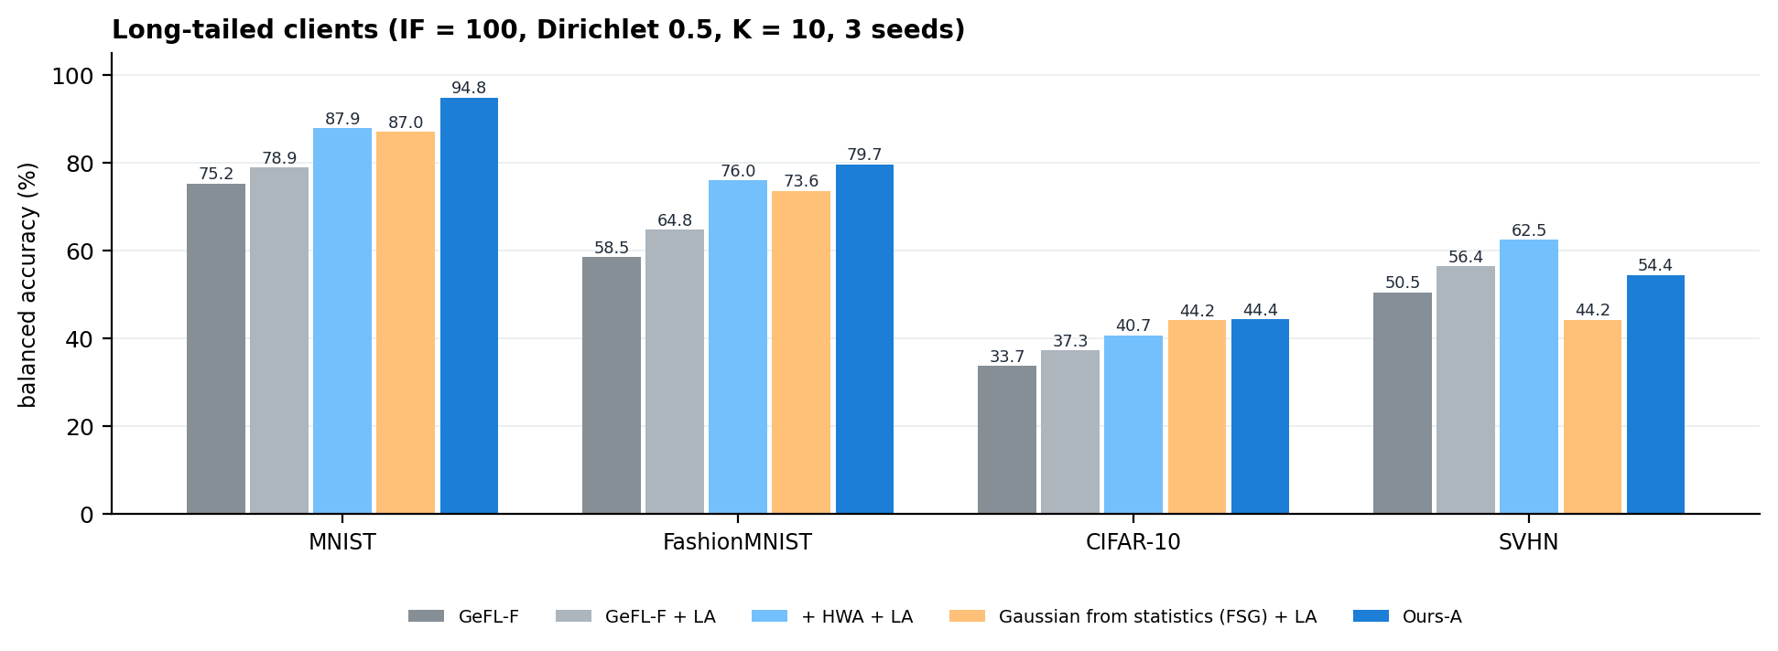
Figure 8. Long-tailed clients: Ours-A against GeFL-F and the strongest alternatives.

5.3 The paper's own balanced setting, against all ten of its methods
best_mean_acc, IID | GeFL-F (paper) | Best of the paper's ten methods | Our GeFL-F | Ours-A | Ours-A − best
MNIST, K = 10 | 95.47 | 96.44 (GeFL, DDPM) | 96.01 | 97.62 | +1.18
MNIST, K = 50 | 95.04 | 95.04 (GeFL-F, CVAE-F) | 95.43 | 96.93 | +1.89
MNIST, K = 100 | 94.63 | 94.63 (GeFL-F, CVAE-F) | 94.88 | 96.77 | +2.14
FashionMNIST, K = 10 | 83.14 | 84.28 (GeFL-F, DDPM-F) | 82.76 | 83.96 | −0.32
FashionMNIST, K = 50 | 82.21 | 82.96 (GeFL-F, DDPM-F) | 81.50 | 82.96 | ±0.00
CIFAR-10, K = 10 | 55.86 | 59.36 (GeFL, DDPM) | 59.10 | 60.93 | +1.57
SVHN, K = 10 | 76.26 | 76.26 (GeFL-F, CVAE-F) | 75.82 | 74.38 | −1.88

Above the best of the paper's 10 methods on MNIST (all client counts) and CIFAR-10; level on FashionMNIST; below on SVHN.
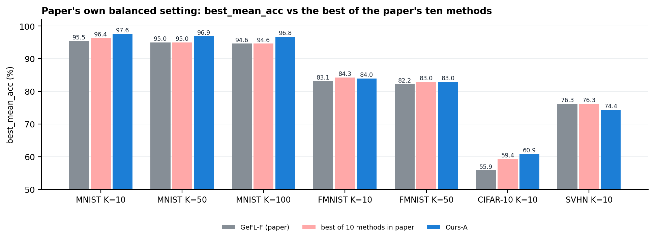
Figure 9. The paper's balanced setting: Ours-A against the paper's GeFL-F and the best of its ten methods.

5.4 Data augmentation (paper's Table IV), and why MixUp does not transfer
CIFAR-10, IID, K = 10 | Accuracy
FedAvg / + MixUp / + CutMix / + AugMix / + AutoAugment (paper) | 55.65 / 60.07 / 58.95 / 53.96 / 56.99
Image-space GeFL + MixUp / + CutMix / + AugMix / + AutoAugment (paper) | 62.67 / 61.66 / 56.47 / 59.97
Ours-A, no augmentation | 60.93
Ours-A + feature-space MixUp (our run, same seeds) | 59.98
Ours-A + VCT (our MixUp variant) | 60.29

Ours-A beats 7 of 9 without augmentation. The two higher ones train full models on raw images; in GeFL-F the extractor is frozen, and feature-space MixUp lowered our accuracy (59.98 vs 60.93).

5.5 More clients, and formal privacy
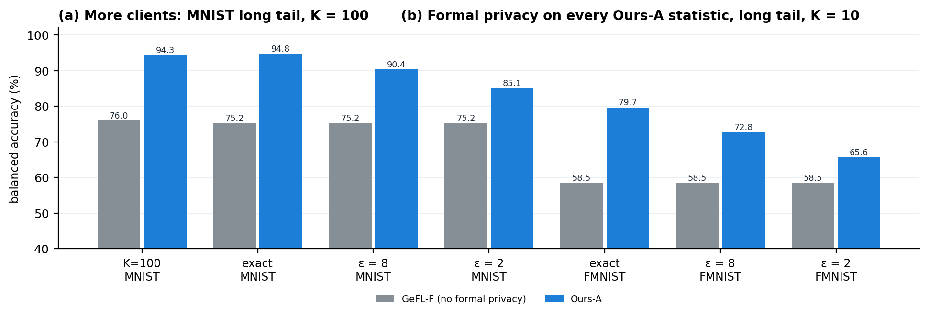
Figure 10. (a) 100 clients, MNIST long tail. (b) Ours-A with every statistic made (ε, 10⁻⁵)-differentially private.
Setting | GeFL-F | HWA + LA | FSG + LA | Ours-A
MNIST long tail, K = 100 | 75.98 | 83.07 | 86.05 | 94.30

Only −0.5 from 10 to 100 clients (the CVAE with HWA loses 4.8): no class weights to estimate from shrinking client data.
Long tail, K = 10 | GeFL-F (no formal guarantee) | Ours-A exact | Ours-A, ε = 8 | Ours-A, ε = 2
MNIST | 75.25 | 94.82 | 90.36 | 85.06
FashionMNIST | 58.47 | 79.67 | 72.77 | 65.59

Privacy costs 4.5–6.9 points at ε = 8 and 9.8–14.1 at ε = 2, mostly on the rarest classes; still +7 to +15 over GeFL-F.

5.6 What each component contributes
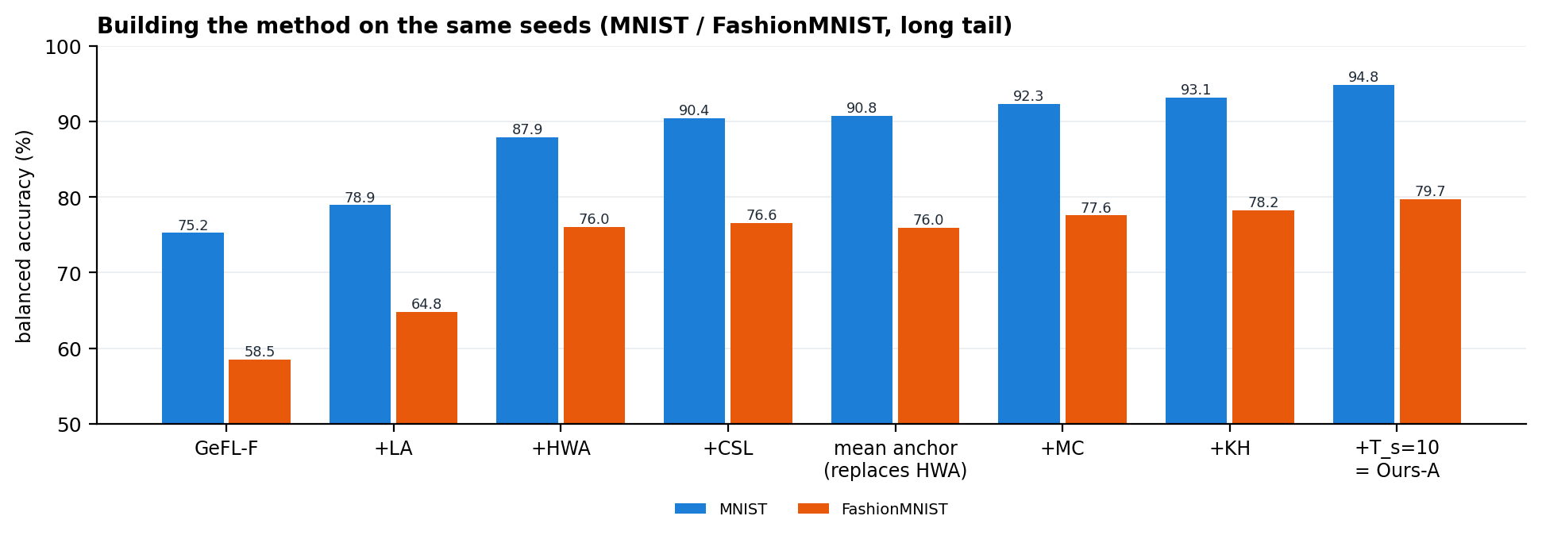
Figure 11. Adding components one at a time on the same seeds (long tail).
Each step adds on the same seeds. Kernel herding helped in all 9 paired tests (p = 0.004).

5.7 The weak case: SVHN
SVHN | GeFL-F | + HWA + LA | Ours-A
long tail, balanced accuracy | 50.49 | 62.45 | 54.41
balanced setting, best_mean_acc | 75.82 | 75.64 | 74.38

SVHN's class means are almost identical (nearest-mean accuracy 12 %, chance 10 %), so a mean-anchored generator cannot separate its classes. Fixing this is future scope (Part 7).

5.8 Mechanism measurements
Quantity (long tail) | GeFL-F | Ours-A
Tail fidelity (referee accuracy on synthetic tail features), MNIST / FMNIST | 10.3 / 19.9 % | 88.6 / 78.7 %
Tail spread relative to real data, raw → after correction and herding | – | 0.39–0.49 → 0.93–0.98
IID fidelity vs the referee's accuracy on real data (FMNIST) | – | 0.837 vs 0.839

After the fixes, fake features are as hard as real ones, not artificially clean.

6. Why it works, and its limits
- Removes the cause: the generator has no class-specific weight, so FedAvg cannot shrink rare classes (holds at 100 clients).
- Smallest correction: the moment fix changes fake features as little as possible (Proposition 3).
- Targets the transfer error: fingerprint selection reduces the term that bounds real-data error (Lemma 1).
- Same protocol and privacy model as GeFL-F: one small extra upload of class sums; formal DP possible.

Limitations
- SVHN: class means carry no class information, so Ours-A is below GeFL-F in the balanced setting (74.4 vs 75.8).
- Balanced data: gains are +1 to +2 points; the method is built for imbalance.
- The frozen feature extractor limits every method (CIFAR-10 oracle ≈ 51 under the long tail).
- On CIFAR-10 and SVHN, 10 fake epochs give a higher peak but a lower final accuracy than 1.

7. Future scope
Next step | Why | Early evidence
Automatic switch: class rows (HWA) when class means are weak | fix SVHN | SVHN long tail 54.4 → 65.6
Covariance correction (MC-S / MC-B) | use exact class covariance, not only spread | FMNIST: 79.7 → 81.6 (long tail), 84.0 → 85.8 (balanced)
Calibration of each head (BBC) | remove leftover bias toward common classes | +0.3 to +1.4 under the long tail
Leave-one-out ablation of Ours-A | prove each part is needed | running
50 / 100 clients on SVHN and CIFAR-10; FMNIST at 100 | complete the paper's grid | running
Paper's other FL baselines under the long tail | complete comparisons | running

Appendix A. Proofs
Proposition 1. A non-holder's gradient on w_c is λw_c. Adam's update is η·m̂/√v̂, and for a constant-sign gradient m̂/√v̂ → sign(w_c), so each step moves |w_c| by η toward zero. A holder's normalised step is at most η in magnitude. With weights m_c/K for holders and 1 − m_c/K for non-holders, the averaged change is at most (2m_c/K − 1)Sη. ∎
Proposition 3. With Y = T(X), E‖Y − X‖² = V_c + Ṽ_c + ‖m_c − m̃_c‖² − 2E⟨Y − m_c, X − m̃_c⟩. By Cauchy–Schwarz the last term is at most √(V_c Ṽ_c), with equality if and only if Y − m_c = √(V_c/Ṽ_c)(X − m̃_c). ∎
Proposition 5. With w = λn_s/(n_r + λn_s), the error becomes σ²(1 − w)/n_r + w²b², a convex parabola minimised at w* = σ²/(2n_rb²). The optimum is clipped to the feasible range, so the optimal synthetic share is non-increasing in b and reaches its maximum as b → 0. ∎
Lemma 1 is the standard RKHS bound: |E_G ℓ − E_P ℓ| = |⟨ℓ, μ_G − μ_P⟩| ≤ ‖ℓ‖·MMD(G, P).

Appendix B. Hyperparameters and experiment inventory
Dataset | Fraction / train size | Batch | T_FE / T_KA / T_TN | Latent l | Feature h
MNIST | 0.1 / 6,000 | 64 | 20 / 100 / 50 | 16 | 3×16×16
FashionMNIST | 0.1 / 6,000 | 64 | 20 / 100 / 50 | 16 | 3×16×16
SVHN | 0.1 / 7,326 | 64 | 50 / 100 / 100 | 16 | 3×16×16
CIFAR-10 | 0.5 / 25,000 | 128 | 50 / 200 / 100 | 50 | 10×16×16

Ours-A settings: 6,144 random Fourier features; herding pool 4n; consensus weight β = 0.5; LA temperature τ = 1; T_s = 10, T_r = 5.
Experiment series | Question answered
F01, F10, E20 (local) | Main long-tail comparison and the first anchored generator
E16, E21, E22 (local) | Synthetic budget (Proposition 5); 100 clients
E24, E25 (local) | Kernel herding, KME-Gen, the anchored stack
E26, E27, E29, E31, E32 (local) | Formal DP; IID at 50/100 clients; hybrid
K01–K04 (Kaggle) | CIFAR-10 and SVHN baselines; regimes, privacy, ablations; client scaling; diffusion generator
K08, K10, K11, K13 (Kaggle) | Ours-A on CIFAR-10 and SVHN; hybrid; VCT vs MixUp

All code, logs and per-seed results are in the project repository, and every number in this report can be regenerated from the logged runs.

