Age Verification Using Transfer Learning
Project By: Raunak Batavia, Raj Bedara, Archie Tuscano

Abstract: In this ever-changing world of digitalization, we have come up with an age verification software that predicts the age of the user just by looking at an image to categorize the age of a person in a bracket of 6 years. The algorithm gives a general estimation of the person’s age which can be deployed on various platforms for age verification of the user for different applications.

Introduction:
The idea for this project came from the fact that in this every changing digital world, its not uncommon for young people to venture into dark places without supervision. The world is more connected now than ever before and its not always a positive. The advantages of internet and social media do come with its downsides and so keeping these in mind, we came up with this idea to tackle one of the issues that have propped up due to this connectivity. Our algorithm looks at an image of the person and categorizes it in a bucket of age. The reason we have come up with the idea of bucketing the age is to tackle the inaccuracy that we encountered while testing the algorithm to get a rough estimate of the age which can be further analyzed by additional checkpoints if flagged. This saves enormous amounts of time which otherwise would require analysis of each individual case.

Methodology:

Face Augmentation:
The algorithm has been trained on data used from UTK face (2017) which contains 24000 images which are classified based on age, race and gender. Since our algorithm only depends on the age and no racial and gender biases are accounted for, the other two data points are redundant. The images are run through MediaPipe algorithm to detect just the face in an image and box them. The rest of the image is just noise and so is thrown out. This greatly improves the efficiency of the program and saves computational power and time. The images are 0 padded while the bounding box is further increased by 25% to include further facial features that the MediaPipe may have ignored. This 25% was selected after multiple iterations to be the most optimal hyperparameter. A further checkpoint of image boundary was added so that the bounding box doesn’t exceed the raw image. Once the face is bound, we categorize the images in different ages. Since UTK face has a range of ages 1 to 116, we have 116 folders each containing images of people belonging to that age group.
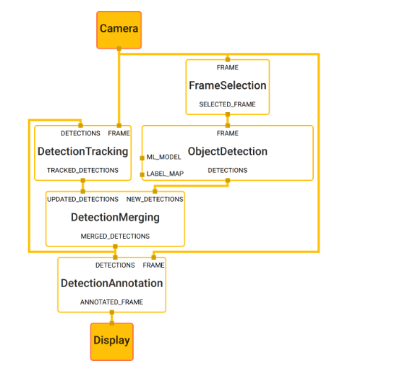
Fig 1:Explains how MediaPipe framework works for face detection. This image is taken from the paper titled MediaPipe: A Framework for Building Perception Pipelines authored by Camillo Lugaresi

ML Algorithm:
Now that the image has been categorized and the faces bound, we select our algorithm. We selected ResNet34 as the perfect algorithm to train our dataset on because of 2 reasons. ResNet is trained on ImageNet. ImageNet is a massive, organized database of over 14 million labeled images across thousands of categories, crucial in deep learning as a standard benchmark for training and testing computer vision models, especially for tasks like image classification, leading to breakthroughs and enabling powerful pre-trained models used in transfer learning for everything from autonomous cars to medical imaging. Models trained on ImageNet learn rich visual features, which can then be adapted (transferred) to other, smaller image recognition tasks, saving massive training time and data. On further analysis we used ResNet34 to be a good middle ground for transfer learning and ResNet18 was too light while ResNet50 felt heavy for our computational limitations. Since ResNet is trained on 224x224 images, we resize our input dataset to these parameters. Using the same resolution ensures optimal transfer learning and stable convergence. The image is normalized on mean = [0.485, 0.456, 0.406] std = [0.229, 0.224, 0.225] as the ImageNet is trained on these parameters.
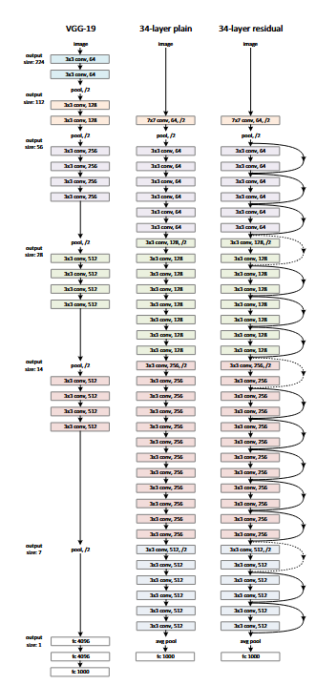
Fig 2:ResNet34 algorithm framework taken from paper titled Deep Residual Learning for Image Recognition authored by He, Kaiming

Training:
The dataset was split into 80% training,10% validation and 10% test datasets. The program was trained in 2 phases.

Phase 1:
The first phase of the dataset training was done on raw ResNet34 where the backbone was frozen with the weights only being updated on the final Fully Connected layer with a learning rate of 0.001.
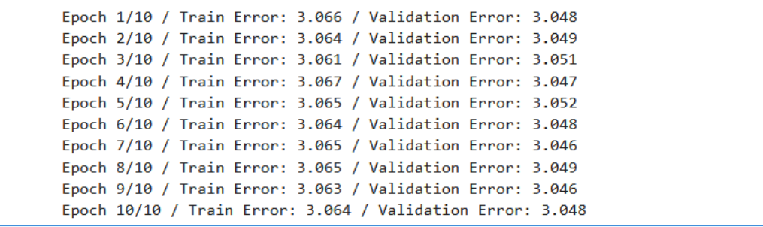
The figure above shows our results for the classification on just raw ResNet34 architecture. The error seems huge, and it is expected intuitively as well.ImageNet contains images of different categories (e.g. -dogs, cats etc.) which are redundant for our application which needs different features (e.g. wrinkles, white hair, skin tightness etc.) so even though the results aren’t bad, they can improve.

Phase 2:
In this phase of learning we unfreeze the 4th layer of ResNet to extract the features needed which differentiate the age. Features such as wrinkles, hair type, hair volume, skin tightness, eye bags etc. at a learning rate of 0.00001. After training, we got the following results.
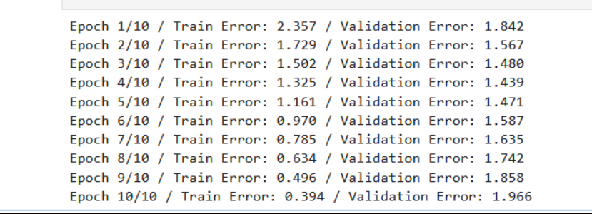
Here we notice something rather interesting. After the 4th epoch, we see the validation error increasing which is a textbook example of overfitting. And this result makes sense because UKT face is a very small data set with a lot of noise and we haven’t accounted for racial and gender biases. So, we run the training again but this time we only run it for 5 epochs.
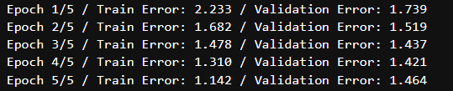
Thus after 5 epochs we got the above results, which is pretty good for the dataset limitations we have.

PS:
Earlier the idea was for the project to be a regression problem using MAE(Mean absolute error) where the algorithm predicts the age of a person but due to dataset, computational and ResNet limitations, the error was too high to ignore.
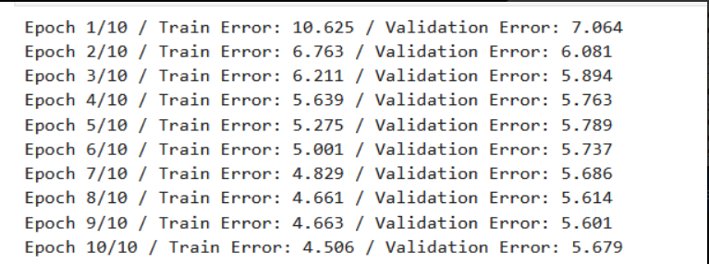
Thus we decided to bucket the ages (classification) for a better result and 6 bucket size was chosen to check the 18-age limit as this is what prioritized our project vision. An Adam optimizer was used with cross entropy loss.

Testing:
After this result we ran the test dataset. The test results were as follows:
Test Loss: 1.4912
Test Accuracy: 0.4485
Thus the model shows a good accuracy of 44.85% which is pretty reasonable for our dataset and limitations.
To better understand we have the following confusion matrix:
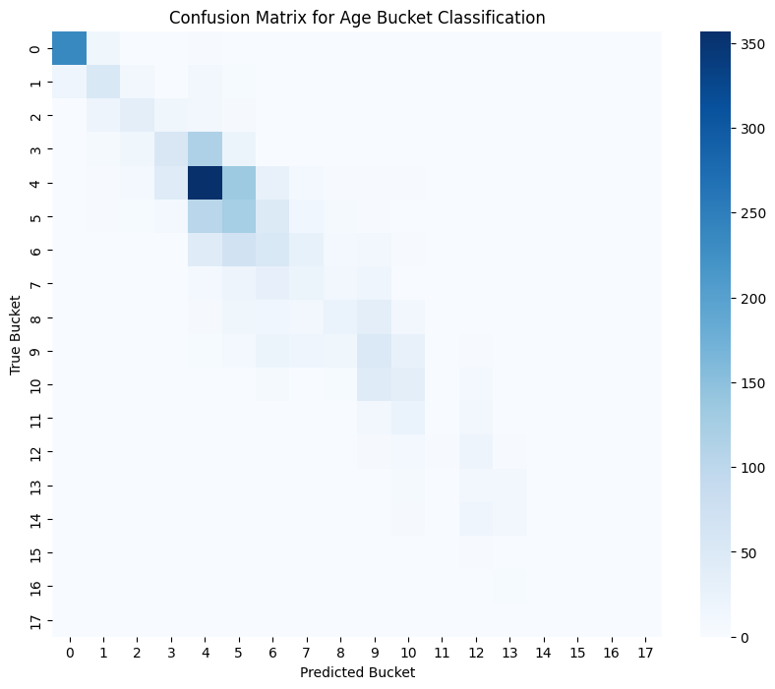
This is the raw confusion matrix. It shows strong diagonal dominance, indicating accurate bucket predictions. Most errors occur between neighboring buckets, which is expected due to natural age similarity. Crucially, extreme misclassifications (e.g., child predicted as senior) are rare, demonstrating strong age grouping capability. The model performs slightly weaker in older age buckets due to dataset imbalance. And this also coincides with real world observations. Predicting age with just vision often varies on teenage years where it depends on individual cases, weather, environmental patterns, genetics, work background(office vs manual labor) etc. thus our prediction mostly being in neighbor buckets is a very good result. The most difficult ages to predict are teenage years and old ages which also happens in our algorithm.
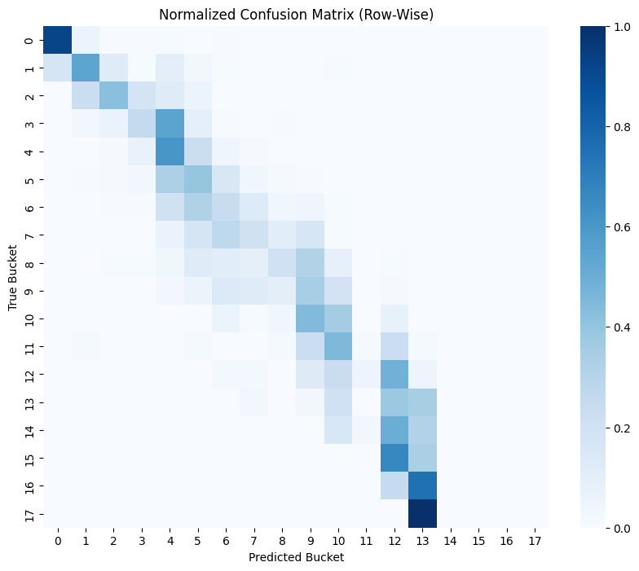

The normalized confusion matrix highlights bucket-wise accuracy. Early age buckets show the strongest performance, with over 70–80% accuracy in many cases. Middle-aged buckets display moderate confusion with adjacent categories due to natural visual similarity. Older age buckets show reduced accuracy, largely due to dataset imbalance. Overall, the model demonstrates reliable performance for practical applications such as underage detection.

Real World Testing:
After the training we ran this algorithm through pictures of our group members and some pictures of family and friends to see how it excels in real world data.
The data processing steps were the same and then the algorithm is run through the saved weights we got from the training and these were the results:
Harsh iamge.jpeg → Bucket: 2 → Age range: 12-17
Harsh image .jpeg → Bucket: 4 → Age range: 24-29
IMG-20230219-WA0000.jpg → Bucket: 4 → Age range: 24-29
IMG-20230417-WA0000.jpg → Bucket: 4 → Age range: 24-29
IMG-20250704-WA0028.jpg → Bucket: 4 → Age range: 24-29
IMG-20250920-WA0000.jpg → Bucket: 0 → Age range: 0-5
IMG-20251129-WA0019.jpg → Bucket: 1 → Age range: 6-11
IMG-20251129-WA0020.jpg → Bucket: 4 → Age range: 24-29
photo 1 Age26.png → Bucket: 4 → Age range: 24-29
photo 2 Age 26.jpg → Bucket: 2 → Age range: 12-17
photo 3 Age26.jpg → Bucket: 4 → Age range: 24-29
photo 4 Age26.jpg → Bucket: 3 → Age range: 18-23
photo 5 Age26.jpg → Bucket: 2 → Age range: 12-17
photo 6 Age26.jpg → Bucket: 4 → Age range: 24-29
photo 7 Age26.jpg → Bucket: 4 → Age range: 24-29
photo 8 Age26.jpg → Bucket: 3 → Age range: 18-23
Photo Age25(2).jpeg → Bucket: 2 → Age range: 12-17
Photo Age25.jpeg → Bucket: 4 → Age range: 24-29
Photo Age25(2).jpeg → Bucket: 8 → Age range: 48-53

In this results the only outliers were on : Photo Age25(2).jpeg, Photo Age25(2).jpeg, photo 2 Age 26.jpg, photo 4 Age26.jpg, photo 5 Age26.jpg, photo 8 Age26.jpg. One interesting observation was that in these images the lighting was off or the face had accessories like glasses. This was an interesting because one way that we feel we can tackle this is by making anchor boxes on accessories(Not part of face) and just train the UKT face on facial features so that these accessories are not looked as a part of facial feature at a specific age.

Limitations:
Some of the limitations that we faced during this project were:
- Low resolution, noisy dataset from UTK face
- Computational Limitations. Even though we used GPU for our training, it was computationally heavy.
- The algorithm was run on a really small dataset of real world images. A wider range of data would further help us fine tune our algorithm for a higher accuracy
- No accounting for Racial and gender biases, environmental factors, genetics and generational shifts in aging patterns.
- On further research we found that Age-GAN is a better model for age detection which accounts for racial and ethnic biases

Real world Applications:
This algorithm can be deployed in the real world for a number of applications:
- At bars and restaurants to flag underage entry
- On social media platforms to catch child predators lurking around young groups
- Can be deployed on adult websites to tackle child pornography and exploitation
- Targeted ads which are age appropriate
- On road to detect underage driving
These are some of the places we feel this algorithm will do wonders in order to make the internet a safer place for minors.

Future work:
The algorithm can be further fine tuned to not only detect age but also look at the evolution of how every generation is aging differently. This can help further research studies on how our ever changing technological advancements in food, medicine, comforts etc. are changing the way generations are aging.
The algorithm can also be integrated in personalized web cams and camera check points to detect whether the content/ place is age appropriate. Although it wont be 100% accurate but just a simple flag can facilitate a personalized check by a real human for a 100% catch which otherwise would require a very high number of checks for human interventions.

References:
- Lugaresi, Camillo, et al. "Mediapipe: A framework for building perception pipelines." arXiv preprint arXiv:1906.08172 (2019).
- Krizhevsky, Alex, Ilya Sutskever, and Geoffrey E. Hinton. "Imagenet classification with deep convolutional neural networks." Advances in neural information processing systems 25 (2012).
- He, Kaiming, et al. "Deep residual learning for image recognition." Proceedings of the IEEE conference on computer vision and pattern recognition. 2016
- https://medium.com/@skillcate/age-detection-model-using-cnn-a-complete-guide-7b10ad717c60. We used this guide to understand the confusion matrix and understand the reason for outliers.
- https://www.kaggle.com/datasets/jangedoo/utkface-new

Member Contributions:Raunak Batavia:34%
Raj Bedara:33%
Archie Tuscano:33%

