# Task Manager

# Created on June 11, 2020

1. **Introduction:**

This project basically is a Task Manager Application. Task Manager is used in almost all companies to manage the list of tasks. Goal of this website is to organize user tasks and control tasks for each user.

This project is very beneficial for any company and organization. Example: In every company, we have list of tasks to be done. So, we can see what tasks are done and what are the remaining to prevent redundancy.

Features:

1. Login Page.
2. List all the tasks.
3. Add tasks to be done.
4. Remove tasks if done.
5. **Design and Implementation:**

In this project, I moved from one step to the next.

1. Creating login page.
2. Creating front end of task manager.
3. Creating cards.
4. Creating edit and create task.
5. Creating edit task.
6. Once the basic structure was ready then applied a bit of CSS.
7. In the end created a final layout.
8. Added tooltips on edit and delete on taskbar
9. Made some little creative changes.

**Few Modules used:**

BrowserModule: **BrowserModule** provides services that are essential to launch and run a **browser** app. **BrowserModule** also re-exports CommonModule from @**angular**/common , which means that components in the AppModule **module** also have access to the **Angular** directives every app needs, such as NgIf and NgFor .

NgModule: **The purpose of a NgModule is to declare each thing you create in Angular, and group them together** (like Java packages or PHP / C# namespaces).

AppRoutingModule: To implement routing.

HttpClientModule: To use API.

HTTP_INTERCEPTORS: A multi-provider token that represents the array of registered **[HttpInterceptor](https://angular.io/api/common/http/HttpInterceptor)** objects.

ActivatedRoute: To get the current route

Params: To get parameters associated with a route

Router: To get router object.

**ScreenShot:**



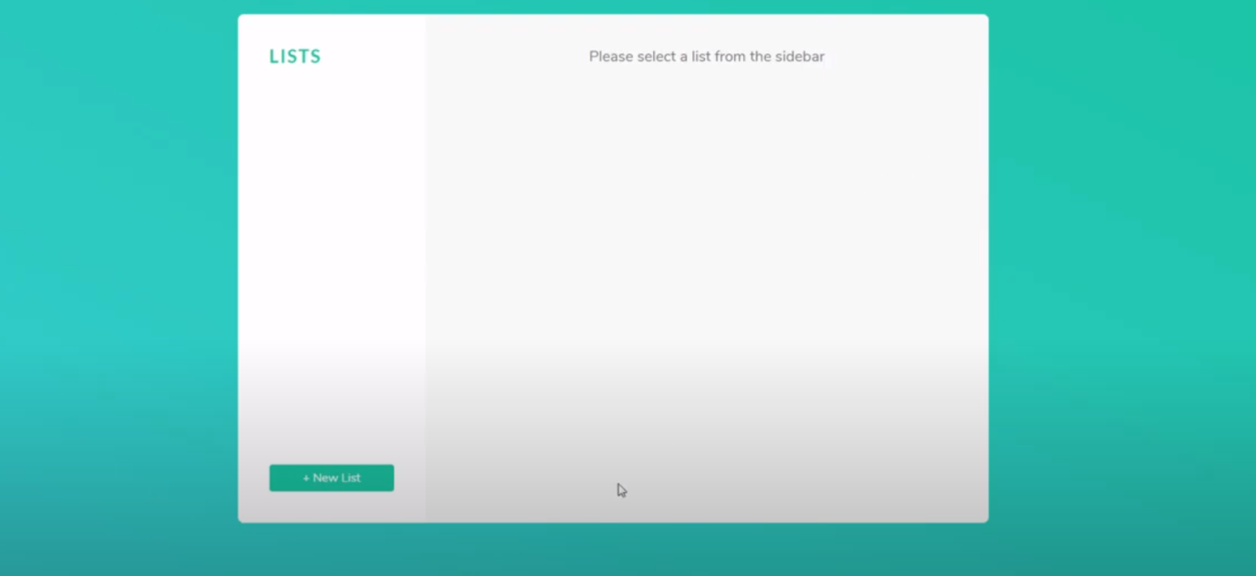

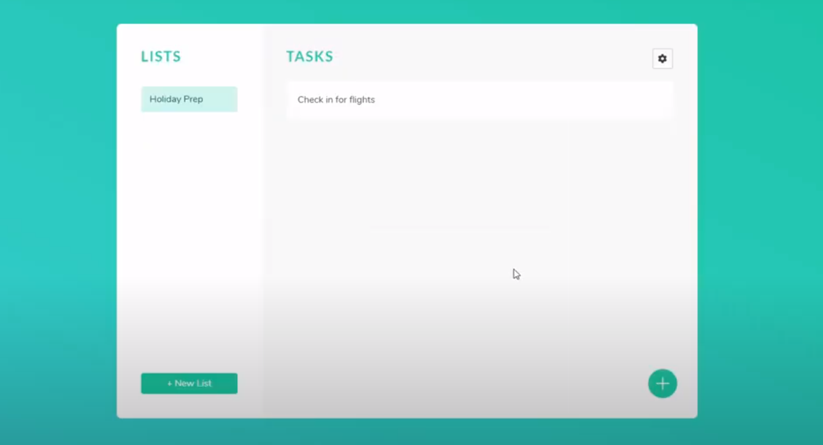

1. **Conclusion:**
   1. This project helped to learn efficient and clean use of angular and angularjs that how it helps a lot. But even a little mixup can cause a drama in your web page.
   2. Better understood Angular.
   3. Shortcoming is that it is not working website. It is just a design. Currently does not have a persistent storage.
   4. I would have used calendar API instead of bare list as it would have strengthened my core skills.
   5. Would try to create it from scratch and without use of Angular.
2. **References:**

One of my friends created a website like this and this website is inspired from that website.

* http://appointmentsystem.atwebpages.com/