**Task_Manager_Application**

1. **Introduction:**

This project basically is a Task Manager Application. Task Manager is used in almost all companies to manage the list of tasks. Goal of this website is to organize user tasks and control tasks for each user.

This project is very beneficial for any company and organization. Example: In every company, we have list of tasks to be done. So, we can see what tasks are done and what are the remaining to prevent redundancy.

Features:

1. Login Page.
2. List all the tasks.
3. Add tasks to be done.
4. Remove tasks if done.
5. **Wireframe Design:**

List 1

List 2

Add New List

TASK 1

TASK 2

1. **Flow Information:**

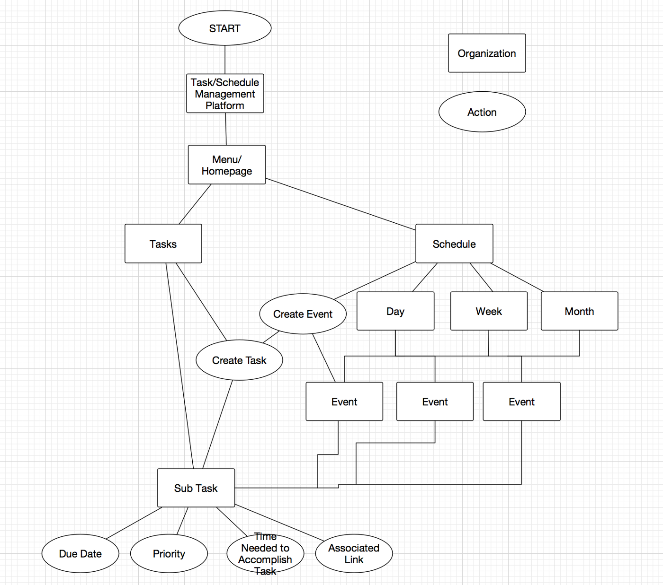

1. **REFERENCES:**
2. https://medium.com/@weschler/p7-wireframe-prototype-task-management-tool-8a5566a4e78a
3. https://todoist.com/
4. http://www.toodledo.com/
5. https://www.any.do/
6. https://habitica.com/static/home