How to install python and packages?

1. First open <https://www.python.org/downloads/> in the browser.
2. Download the python.

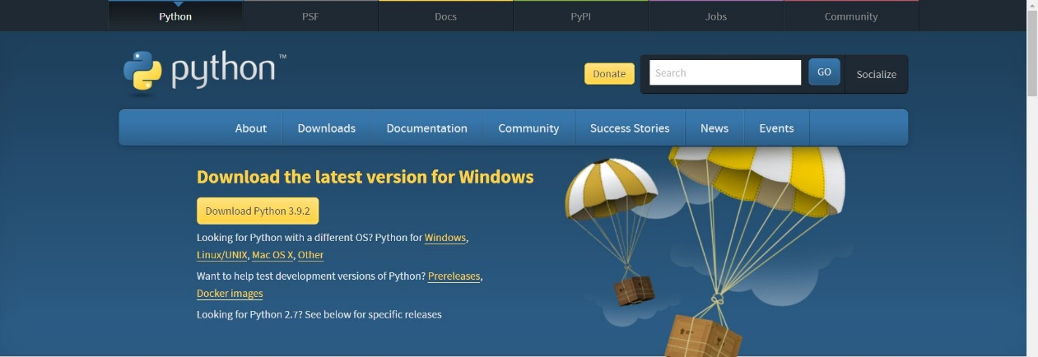

1. Run the .exe which got downloaded.

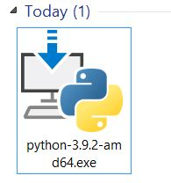

1. Make sure to select the check box of the path.
2. Click on Install.

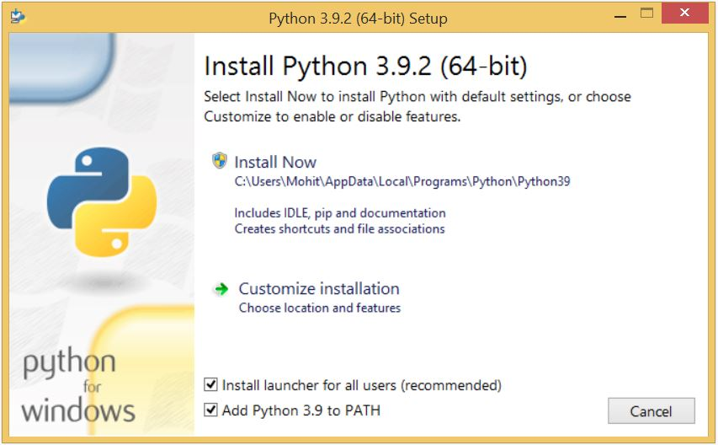

1. Wait until it’s getting install and then click on close button.
2. Open command as an administrator.

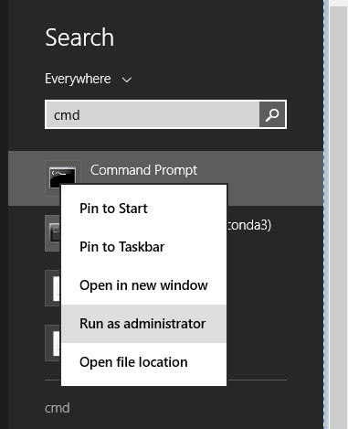

1. Type the following command one by one.
   * pip3 install selenium
   * pip3 install pyperclip
   * pip3 install pyautogui
2. Now change the id and password in the “config.json” in the config folder.