
Department of Computer Engineering and Technology
MINI PROJECT REPORT
Computer Networks Laboratory
(CSE20110)
Laboratory Continuous Assessment 3

DISTRIBUTED CHAT APPLICATION WITH LEADER ELECTION

Submitted by
Sr. No. | Student Name | PRN
1 | Chinmay Kulkarni | 1262242392
2 | Raunak Yadav | 1262242203
3 | Prit Jain | 1262242385

Group No : 3 Panel H Batch 1
Third Year B.Tech. Computer Engineering and Technology
Under the guidance of
Deepak Prashar Sir
Academic Year 2026–2027
Submission Date : 31/10/26

Department of Computer Engineering and Technology
CERTIFICATE

This is to certify that the mini-project entitled “Distributed Chat Application with Leader Election” has been carried out by the following students of Third Year B.Tech. Computer Engineering and Technology under my guidance during academic year 2026–2027.
Student Name | PRN
Chinmay Kulkarni | 1262242392
Raunak Yadav | 1262242203
Prit Jain | 1262242385

The report is submitted towards the mini-project component of Laboratory Continuous Assessment 3 for the Computer Networks Laboratory course.

Faculty Signature : ____________________
Deepak Prashar Sir
(Project Guide and Course Faculty)
Date : 31/10/26 Place: Pune

Acknowledgement
We thank the faculty of the Department of Computer Engineering and Technology, MIT World Peace University, for providing the academic environment in which this Computer Networks Laboratory mini-project was completed. We also acknowledge the documentation and software resources used during implementation and testing. The group takes responsibility for the implementation details and results described in this report.
Group No : 3

Abstract
The Distributed Chat Application with Leader Election is a network-based messaging system developed using Python, TCP sockets, and multithreading. Three interconnected chat servers allow users connected to different servers to exchange public and private messages. Heartbeat-based failure detection and the Bully algorithm elect a leader among available servers. A global user directory supports user discovery and cross-server message routing. A browser dashboard, built using HTML, CSS, JavaScript, and a FastAPI/Uvicorn gateway, provides chat functionality and visibility into server health and leader status. The project demonstrates TCP communication, concurrency, leader election, failure detection, replicated state, and client reconnection. End-to-end testing confirmed the principal messaging, directory, dashboard, election, and recovery features in the tested scenarios.
Keywords: Distributed systems, TCP sockets, Bully algorithm, leader election, heartbeat monitoring, WebSocket

Table of Contents
Acknowledgement
Abstract
1 Introduction and Project Objectives
2 Proposed Design and Requirements
3 Implementation and Technical Working
4 Testing and Results
5 Discussion and Conclusion
References
AI Usage Declaration
Appendices

List of Figures
Figure 2.1 Packet Tracer network topology

List of Tables
Table 1.1 Objectives and verification
Table 2.1 Tools and requirements
Table 2.2 Example addressing scheme
Table 2.3 Server ports
Table 4.1 Test plan and results

1 Introduction and Project Objectives

1.1 Introduction and Background
A conventional chat application often relies on one central server, which can become a single point of failure. A distributed design uses multiple servers that cooperate to provide messaging and shared user information. This project applies TCP socket communication, multithreading, heartbeat monitoring, and leader election to a three-server cluster. A browser dashboard is provided through a web gateway that bridges WebSocket connections to the TCP backend [1]–[4].

1.2 Problem Statement
The project enables users connected to different chat servers to communicate through a unified service while detecting server failures and selecting a new coordinator when required.

1.3 Scope
The implementation covers three Python chat servers, terminal and browser access, public and private messaging, a replicated in-memory user directory, heartbeat-based peer monitoring, Bully leader election, and browser reconnection. Cisco Packet Tracer illustrates the network topology but does not execute the custom Python application.

1.4 Objectives
ID | Objective | Verification
O1 | Implement a multi-server TCP chat application | Startup and connection tests
O2 | Support global and private cross-server messaging | Global/private message tests
O3 | Maintain a cluster-wide user directory | User listing and cleanup
O4 | Detect failures and elect a leader | Stop/restart tests
O5 | Provide browser access and reconnection | Dashboard/reconnection tests

2 Proposed Design and Requirements

2.1 Architecture and Network Topology
The system contains three chat servers, three example client PCs, a web gateway, and Ethernet switches. Each client uses a browser to access the dashboard. The gateway bridges browser WebSocket traffic to the TCP chat servers. Peer channels carry heartbeat, election, registry, and message-routing traffic.
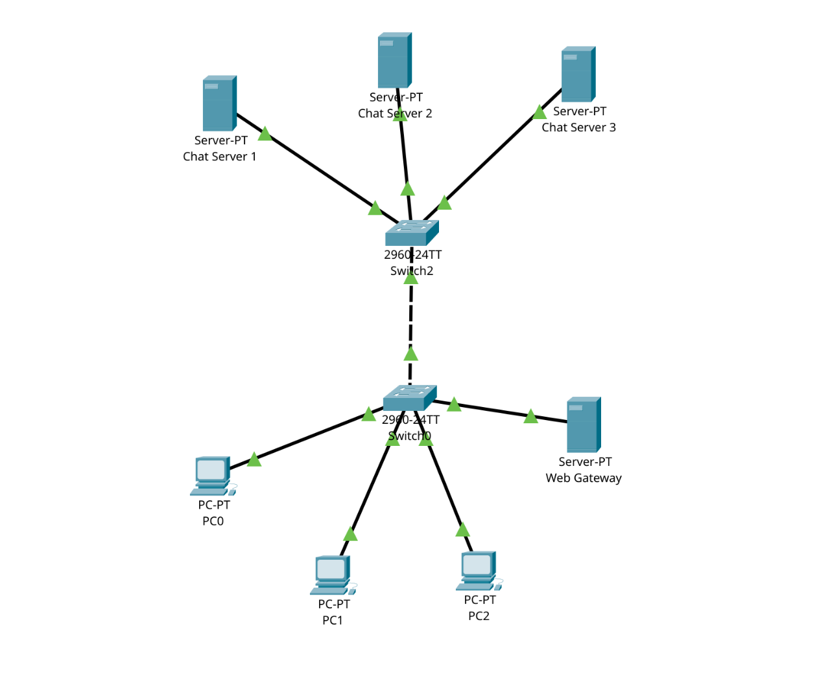
Figure 2.1. Packet Tracer network topology for the distributed chat application.

2.2 Tools and System Requirements
Tool | Specification | Purpose
Python | Python 3.x | Chat servers and terminal client
TCP sockets/threading | Python standard library | Communication and concurrency
FastAPI/Uvicorn | Project dependencies | WebSocket gateway
HTML/CSS/JavaScript | Browser technologies | Dashboard interface
Linux/Fedora | Development environment | Run application
Cisco Packet Tracer | Topology simulator | Visualize devices and links

2.3 Addressing and Protocol Selection
The following IP addresses are illustrative for the diagram and may differ from runtime configuration.

Device | Example IP | Role
Web Gateway | 192.168.1.10/24 | WebSocket endpoint, example port 8000
Chat Server 1 | 192.168.1.11/24 | Client port 5001; peer port 6001
Chat Server 2 | 192.168.1.12/24 | Client port 5002; peer port 6002
Chat Server 3 | 192.168.1.13/24 | Client port 5003; peer port 6003
Client PCs | 192.168.1.21–23/24 | Browser clients

TCP provides reliable, ordered byte-stream communication. Newline-delimited messages frame application protocol records. Browsers use WebSockets to communicate with the gateway because browser JavaScript does not directly open raw TCP sockets.

3 Implementation and Technical Working

3.1 Methodology
The implementation was developed in stages: a basic TCP chat service was extended to support multiple servers, peer message forwarding, heartbeat monitoring, Bully leader election, a replicated user directory, cross-server private messaging, and a browser gateway. The dashboard was then integrated with connection recovery and cluster-status displays.

3.2 Configuration or Code Implementation
Python sockets handle client-facing and peer-facing communication. Threads allow servers to handle clients while heartbeat and election tasks run in the background. Each server maintains local connections and a replica of the global user directory. The FastAPI/Uvicorn gateway bridges browser WebSockets to the TCP backend.
Server | Client port | Peer port
Server 1 (ID 1) | 5001 | 6001
Server 2 (ID 2) | 5002 | 6002
Server 3 (ID 3) | 5003 | 6003

3.3 Protocols and Technical Working
For global messaging, the originating server delivers the message locally and forwards it to peer servers, which deliver it to their local clients without forwarding it indefinitely. For private messaging, the sender server searches its local directory replica and routes the message to the recipient server. The leader coordinates registry changes but is not contacted for every private message.
Heartbeat monitoring uses an approximate one-second interval and a five-second timeout. A non-responsive peer is marked as suspected down. The Bully algorithm uses ELECTION, OK, and COORDINATOR messages; the highest-ID live server is expected to become leader. Active local users can be synchronized after a leadership change.

3.4 Execution Procedure
- Create and activate a Python virtual environment.
- Install dependencies: python -m pip install -r requirements.txt
- Start servers in separate terminals: python server_final.py 1, python server_final.py 2, and python server_final.py 3.
- Start the gateway: python -m uvicorn web_gateway:app --host 127.0.0.1 --port 8000
- Open the dashboard in a browser and connect users with distinct usernames.
- Test global chat, direct messages, user listing, leader status, and reconnection by stopping a server.
The gateway command assumes dependencies are installed and the terminal is in the project directory. Use the host address appropriate to the environment for access from another computer.

4 Testing and Results

4.1 Test Plan
The project was tested end-to-end using multiple server processes and client sessions. The table summarizes principal tests and observed behavior reported during development.
ID | Test | Expected result | Observed result | Status
T1 | Start all servers | All available | All three operated in testing | Pass
T2 | Inspect leader with all live | Server 3 leads | Server 3 led when all were available | Pass
T3 | Global message across servers | Remote users receive it | Cross-server messaging worked | Pass
T4 | Private message to remote user | Correct recipient receives it | Private messaging worked | Pass
T5 | List global users | Users across servers shown | Global directory was visible | Pass
T6 | Stop Server 3; Server 2 alive | Server 2 can lead | Failover tested | Pass
T7 | Restart Server 3 | Server 3 can reclaim leadership | Recovery behavior worked | Pass
T8 | Stop server hosting users | Registrations removed | Registry cleanup tested | Pass
T9 | Stop connected server | Browser attempts reconnection | Recovery behavior tested | Pass

4.2 Results and Execution Evidence
Figure 2.1 illustrates the proposed LAN arrangement. End-to-end testing confirmed that principal messaging, leader-election, directory, dashboard, and reconnection functions worked in the tested scenarios. Packet Tracer is used for visual topology representation; Python processes run separately.

4.3 Objective Achievement
Objective | Evidence | Outcome
O1 | T1 | Achieved
O2 | T3–T4 | Achieved
O3 | T5, T8 | Achieved in tested scenarios
O4 | T2, T6–T7 | Achieved in tested scenarios
O5 | T9 and dashboard use | Achieved in tested scenarios

5 Discussion and Conclusion

5.1 Discussion and Comparative Analysis
Compared with a single-server chat application, this design distributes client connections across multiple servers and can elect a new coordinator when the current leader fails. The leader coordinates directory changes, while servers use replicated information to route private messages directly. Directory updates still depend on coordination and peer communication.

5.2 Advantages and Applications
- Supports public and private communication across multiple servers.
- Demonstrates heartbeat-based failure detection and Bully leader election.
- Maintains replicated user-directory information for routing.
- Provides a browser dashboard for chat and cluster monitoring.
- Offers a practical educational example of TCP networking and distributed coordination.

5.3 Limitations
- The global directory is stored in memory rather than a persistent database.
- Messages are not guaranteed to survive server failures or disconnections.
- Existing TCP sessions are not migrated automatically.
- Heartbeat timeouts can falsely suspect a server during temporary network problems.
- Authentication, encryption, and production-scale security are not implemented.

5.4 Challenges and Troubleshooting
Issue | Cause or diagnosis | Solution and verification
Browser reconnection stalled | A failed WebSocket attempt was not closed before retry. | Updated retry handling to close the failed connection; recovery was tested.
Status appeared stale briefly | Heartbeat, election, registry updates, and UI refresh are asynchronous. | Allow detection/election to complete and inspect logs.
Limited Ethernet interfaces | Packet Tracer Server-PT has limited physical ports. | Connect devices through switches; TCP ports are software ports.

5.5 Future Scope
Future improvements include persistent message history, stronger directory consistency, secure authentication, encrypted communication, load balancing, improved failure detection, and restoration of conversation history after reconnection. Deployment across separate machines could evaluate real network delays and additional failure scenarios.

5.6 Conclusion
The Distributed Chat Application with Leader Election demonstrates how multiple TCP servers cooperate to provide public and private messaging, maintain shared user information, and respond to failures. Heartbeat monitoring detects unresponsive nodes, the Bully algorithm elects a coordinator, and replicated directory information supports cross-server routing. The browser dashboard improves usability and makes system events easier to observe. The project meets its main educational objectives and provides a foundation for improvements in persistence, security, consistency, and scalability.

References
[1] Python Software Foundation, “socket — Low-level networking interface.” https://docs.python.org/3/library/socket.html (accessed 18 Oct. 2026).
[2] Python Software Foundation, “threading — Thread-based parallelism.” https://docs.python.org/3/library/threading.html (accessed 18 Oct. 2026).
[3] FastAPI, “WebSockets.” https://fastapi.tiangolo.com/advanced/websockets/ (accessed 18 Oct. 2026).
[4] Uvicorn, “Uvicorn documentation.” https://www.uvicorn.org/ (accessed 18 Oct. 2026).
[5] MDN Web Docs, “The WebSocket API.” https://developer.mozilla.org/en-US/docs/Web/API/WebSockets_API (accessed 18 Oct. 2026).
[6] Cisco Networking Academy, “Cisco Packet Tracer.”

AI Usage Declaration
AI assistance was used to help organize and edit the report and explain relevant networking concepts. The project description and testing summary were checked against the group implementation and reported end-to-end tests. The group takes responsibility for the accuracy of the final submission.
Declaration: We take responsibility for the accuracy of this report and understand the submitted implementation and results. Sources and assistance used have been acknowledged.
Student Name | PRN | Signature
Chinmay Kulkarni | 1262242392
Raunak Yadav | 1262242203
Prit Jain | 1262242385

Individual Contributions
Complete the table with the actual contributions of each group member.
Student | Work completed | Evidence or deliverable
Raunak Yadav | Ideation of Project, Server & Client backend logic | ____________________________
Chinmay Kulkarni | UI design, Testing,Report | ____________________________
Prit Jain | PPT | ____________________________

