REACT HandsOnLAB - 9

In this hands-on lab, you will learn how to:
- Use map() method of ES6
- Apply arrow functions of ES6
- Implement Destructuring features of ES6

Create a React Application named “cricketapp” with the following components:

PlayersData.js

export const players = [
{ name: 'Jack', score: 50 },
{ name: 'Michael', score: 70 },
{ name: 'John', score: 40 },
{ name: 'Ann', score: 61 },
{ name: 'Elisabeth', score: 61 },
{ name: 'Sachin', score: 95 },
{ name: 'Dhoni', score: 100 },
{ name: 'Virat', score: 84 },
{ name: 'Jadeja', score: 64 },
{ name: 'Raina', score: 75 },
{ name: 'Rohit', score: 80 }
];

// Arrays for merging
const T20Players = ['First Player', 'Second Player', 'Third Player'];
const RanjiTrophyPlayers = ['Fourth Player', 'Fifth Player', 'Sixth Player'];
// Merge the two arrays using the spread operator
export const IndianPlayers = [...T20Players, ...RanjiTrophyPlayers];
// Another array for destructuring example
export const IndianTeam = ['Sachin1', 'Dhoni2', 'Virat3', 'Rohit4', 'Yuvraj5', 'Raina6'];

App.js

import React from 'react';
import './App.css';

import { players, IndianPlayers, IndianTeam } from './playersData';
import ListofPlayers from './components/ListofPlayers';
import Scorebelow70 from './components/Scorebelow70';
import { OddPlayers, EvenPlayers } from './components/TeamPlayers';
import ListofIndianPlayers from './components/ListofIndianPlayers';
function App() {
// Set flag to true or false to see different outputs
const flag = true;
if (flag) {
return (
<div className="App">
<h1>List of Players</h1>
<ListofPlayers players={players} />
<hr />
<h1>List of Players having Scores Less than 70</h1>
<Scorebelow70 players={players} />
</div>
);
} else {
return (
<div className="App">
<h1>Odd Players</h1>
{OddPlayers(IndianTeam)}
<hr />
<h1>Even Players</h1>
{EvenPlayers(IndianTeam)}
<hr />
<h1>List of Indian Players Merged:</h1>
<ListofIndianPlayers IndianPlayers={IndianPlayers} />
</div>
);
}
}
export default App;

Components/ListofIndianPlayers.js

import React from 'react';
function ListofIndianPlayers({ IndianPlayers }) {
return (
<div>
{IndianPlayers.map((player, index) => (
<li key={index}>Mr. {player}</li>
))}
</div>
);
}
export default ListofIndianPlayers;

Components/ListofPlayers.js

import React from 'react';
function ListofPlayers({ players }) {
return (
<div>
{players.map((player, index) => (
<li key={index}>
Mr. {player.name} {player.score}
</li>
))}
</div>
);
}
export default ListofPlayers;

Compoenents/Scorebelow70.js

import React from 'react';
function Scorebelow70({ players }) {
// Filter players with score <= 70 and then map to display them
const playersBelow70 = players
.filter(player => player.score <= 70)
.map((player, index) => (
<li key={index}>
Mr. {player.name} {player.score}
</li>
));
return <div>{playersBelow70}</div>;
}
export default Scorebelow70;

Compoents/TeamPlayers.js

import React from 'react';
export function OddPlayers([first, , third, , fifth]) {
return (
<div>
<li>First: {first}</li>
<li>Third: {third}</li>
<li>Fifth: {fifth}</li>
</div>
);
}
export function EvenPlayers([, second, , fourth, , sixth]) {
return (
<div>
<li>Second: {second}</li>
<li>Fourth: {fourth}</li>
<li>Sixth: {sixth}</li>
</div>
);
}

With Flag == True

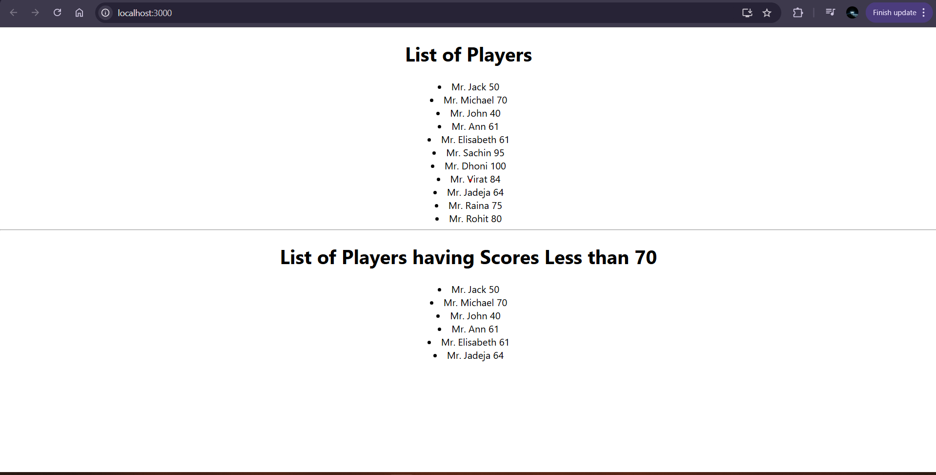
With Flag == Flase

