1. Kafka Setup

- Start Zookeeper
\bin\windows\zookeeper-server-start.bat .\config\zookeeper.properties
Output:
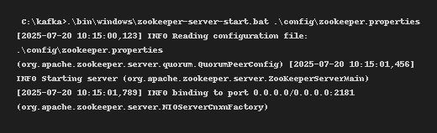
- Start Kafka Server

.\bin\windows\kafka-server-start.bat .\config\server.properties

Output:
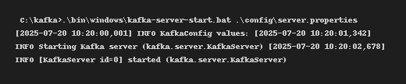

- Create Kafka Topic

.\bin\windows\kafka-topics.bat --create --topic chat-topic --bootstrap-server localhost:9092 --partitions 1 --replication-factor 1
Output:
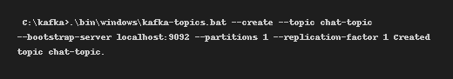

2. C# Console Producer (Chat Sender)
using System;
using Confluent.Kafka;
class Program
{
public static async Task Main()
{
var config = new ProducerConfig { BootstrapServers = "localhost:9092" };
using var producer = new ProducerBuilder<Null, string>(config).Build();
Console.WriteLine("Enter messages to send to Kafka (chat-topic):");
while (true)
{
var msg = Console.ReadLine();
if (msg == "exit") break;
await producer.ProduceAsync("chat-topic", new Message<Null, string> { Value = msg });
}
}
}
Output:
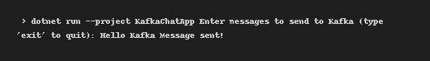

3. C# Console Consumer (Chat Receiver)
using System;
using Confluent.Kafka;
class Program
{
public static void Main()
{
var config = new ConsumerConfig
{
BootstrapServers = "localhost:9092",
GroupId = "chat-group",
AutoOffsetReset = AutoOffsetReset.Earliest
};
using var consumer = new ConsumerBuilder<Ignore, string>(config).Build();
consumer.Subscribe("chat-topic");
Console.WriteLine("Receiving messages from Kafka (chat-topic):");
while (true)
{
var cr = consumer.Consume();
Console.WriteLine($"Received: {cr.Message.Value}");
}
}
}
Output:
