REACT HandsOnLAB - 5

In this hands-on lab, you will learn how to:
- Style a react component
- Define styles using the CSS Module
- Apply styles to components using className and style properties

File Structure:
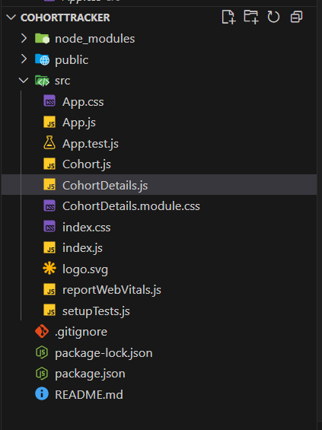

CohortDetails.module.css

.box {
width: 300px;
display: inline-block;
margin: 10px;
padding: 10px 20px;
border: 1px solid black;
border-radius: 10px;
}
.dt {
font-weight: 500;
}

CohortDetails.js
import style from "./CohortDetails.module.css";
function CohortDetails(props) {
const isOngoing = props.cohort.currentStatus === "Ongoing";
const headingStyle = {
color: isOngoing ? "green" : "blue",
};

return (
<div className={style.box}>
<h3 style = {headingStyle}>
{props.cohort.cohortCode} -<span>{props.cohort.technology}</span>
</h3>
<dl>
<dt className={style.dt}>Started On</dt>
<dd>{props.cohort.startDate}</dd>
<dt className={style.dt}>Current Status</dt>
<dd>{props.cohort.currentStatus}</dd>
<dt className={style.dt}>Coach</dt>
<dd>{props.cohort.coachName}</dd>
<dt className={style.dt}>Trainer</dt>
<dd>{props.cohort.trainerName}</dd>
</dl>
</div>
);
}
export default CohortDetails;

App.js

import './App.css';
import { CohortsData} from './Cohort'
import CohortDetails from './CohortDetails';
function App() {

return (
<div>
<h1>Cohorts Details</h1>
{CohortsData.map(cohort => <CohortDetails cohort={cohort}/>)}
</div>
);
}
export default App;

