TASK 4 – ADVANCED ANALYTICS & STATISTICAL MODELING
Sample Superstore Dataset | 8,827 records | 790 customers

1. Objective
Apply descriptive statistics, hypothesis testing, confidence intervals, time-series analysis, customer segmentation using K-Means clustering, and a basic predictive model to derive business insights.

2. Dataset Overview
The dataset contains 8,827 transaction records and 790 unique customers. The analysis uses Order Date, Sales, Quantity, Discount, Profit, customer attributes, product attributes, region and shipping information.

3. Descriptive Statistics
Metric | Mean | Median | Std Dev | Min | Max | Skewness
Sales | 92.8649 | 40.8800 | 114.0451 | 0.4440 | 498.2600 | 1.6850
Quantity | 3.6086 | 3.0000 | 2.1293 | 1.0000 | 14.0000 | 1.3503
Discount | 0.1576 | 0.2000 | 0.2115 | 0.0000 | 0.8000 | 1.6878
Profit | 11.1986 | 7.4376 | 49.0661 | -1181.2824 | 240.8595 | -4.7133
Sales and Quantity are positively skewed. Profit is strongly negatively skewed because a small number of orders have very large losses. Therefore, mean values should be interpreted together with medians.

4. Hypothesis Testing
A) Independent two-sample Welch t-test
H0: Mean Sales of Consumer and Corporate segments are equal.
H1: The means are different.
Consumer mean sales = 94.62; Corporate mean sales = 91.02.
t = 1.3064, p-value = 0.1915.
Decision at α = 0.05: Fail to reject H0. The dataset does not provide statistically significant evidence that average order-line Sales differ between Consumer and Corporate segments.
B) Chi-square test of independence: Region vs Category
χ² = 2.9217, df = 6, p-value = 0.8186. Decision at α = 0.05: Fail to reject H0. Region and Category do not show a statistically significant association in this dataset.

5. Confidence Intervals
95% CI for mean Sales: [90.49, 95.24]
95% CI for mean Profit: [10.17, 12.22]

6. Time-Series Analysis
Order Date was converted to monthly time-series format. A 3-month moving average was used as a simple forecasting method. The forecast is recursive: each future month uses the latest three observed/forecast values.
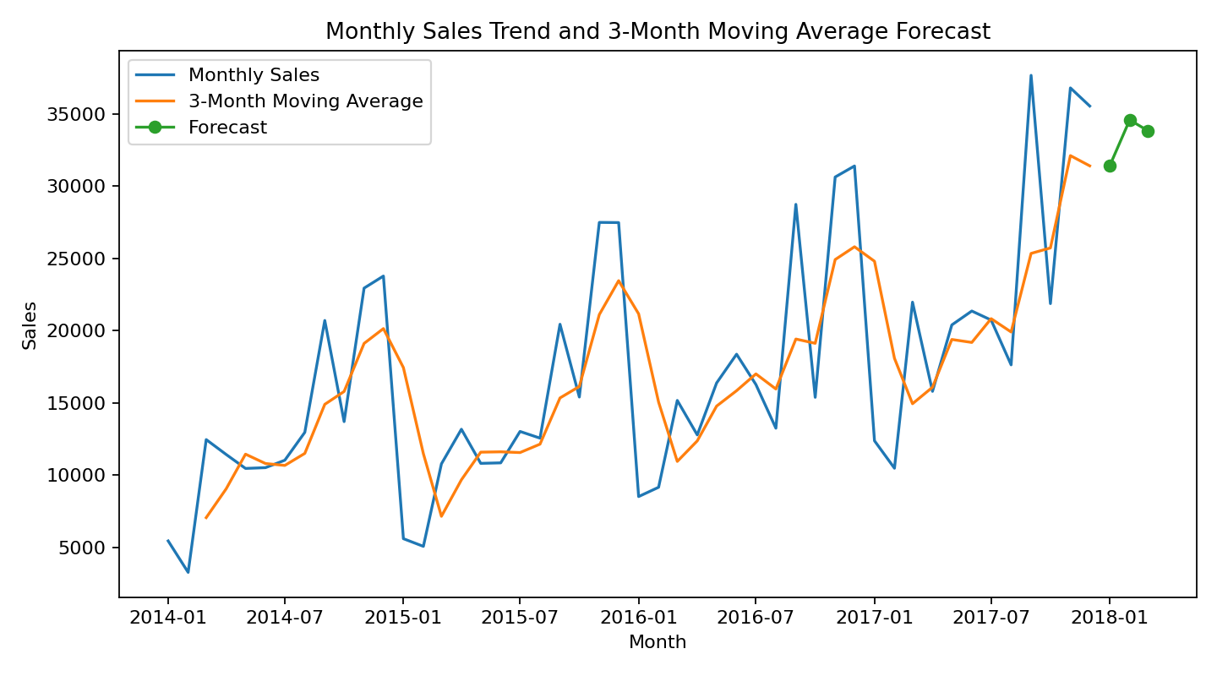
Next three estimated monthly Sales values: 31,397.30, 34,575.31, 33,836.43
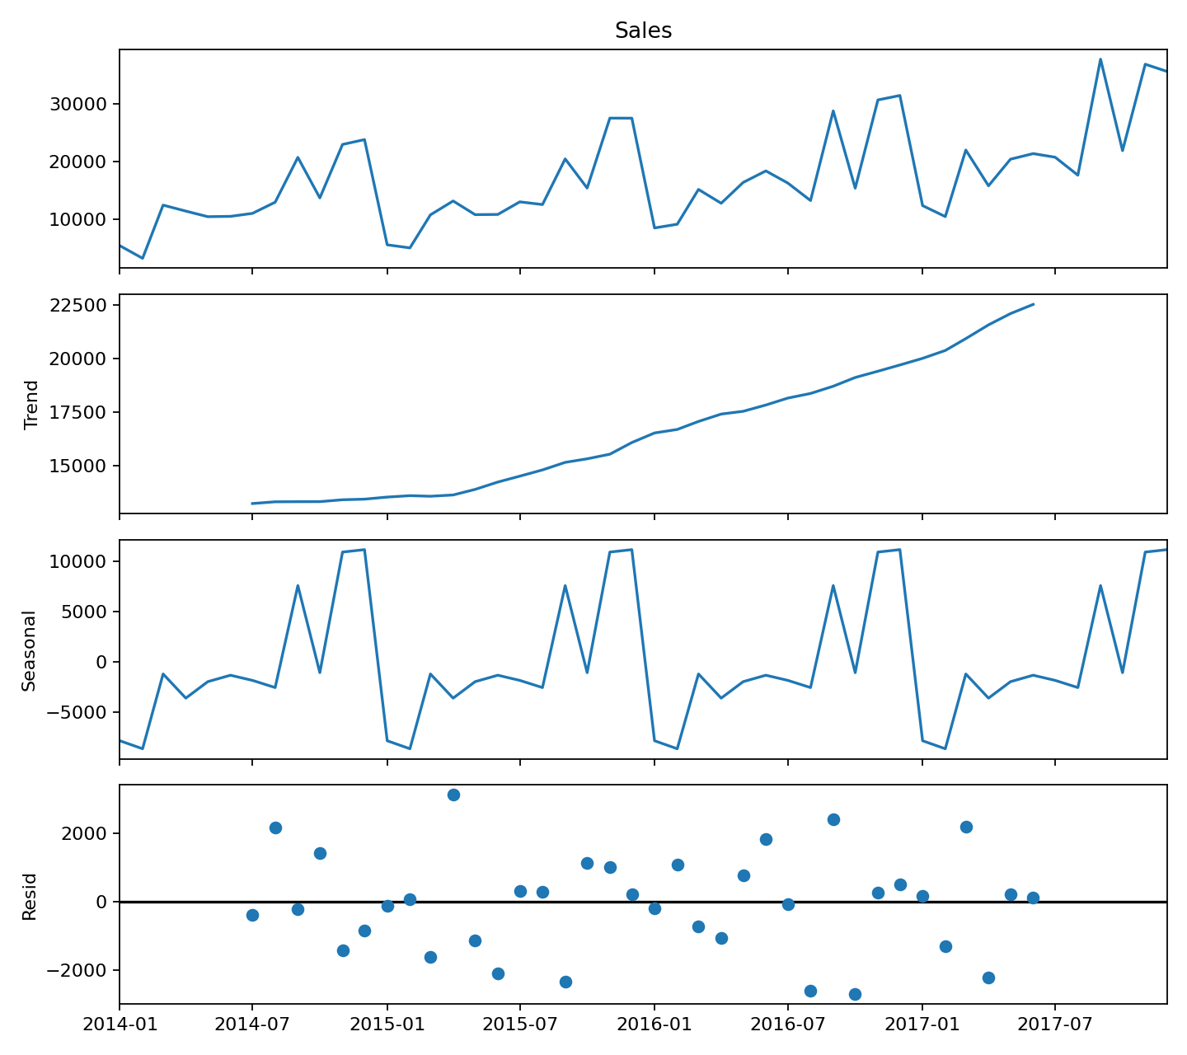

7. Customer Segmentation using K-Means
RFM features were created at customer level: Recency (days since last order), Frequency (unique orders), and Monetary (total Sales). Features were standardized using StandardScaler and clustered with K-Means using 4 clusters. Silhouette score = 0.326.
Cluster | Segment | Customers | Avg Recency | Avg Frequency | Avg Monetary
0 | Regular Customers | 262 | 105.50 | 4.21 | 554.94
1 | High-Value Customers | 113 | 83.70 | 9.58 | 2150.37
2 | Loyal / Frequent Customers | 306 | 86.30 | 7.02 | 1189.69
3 | At-Risk / Inactive Customers | 109 | 569.50 | 3.61 | 617.32
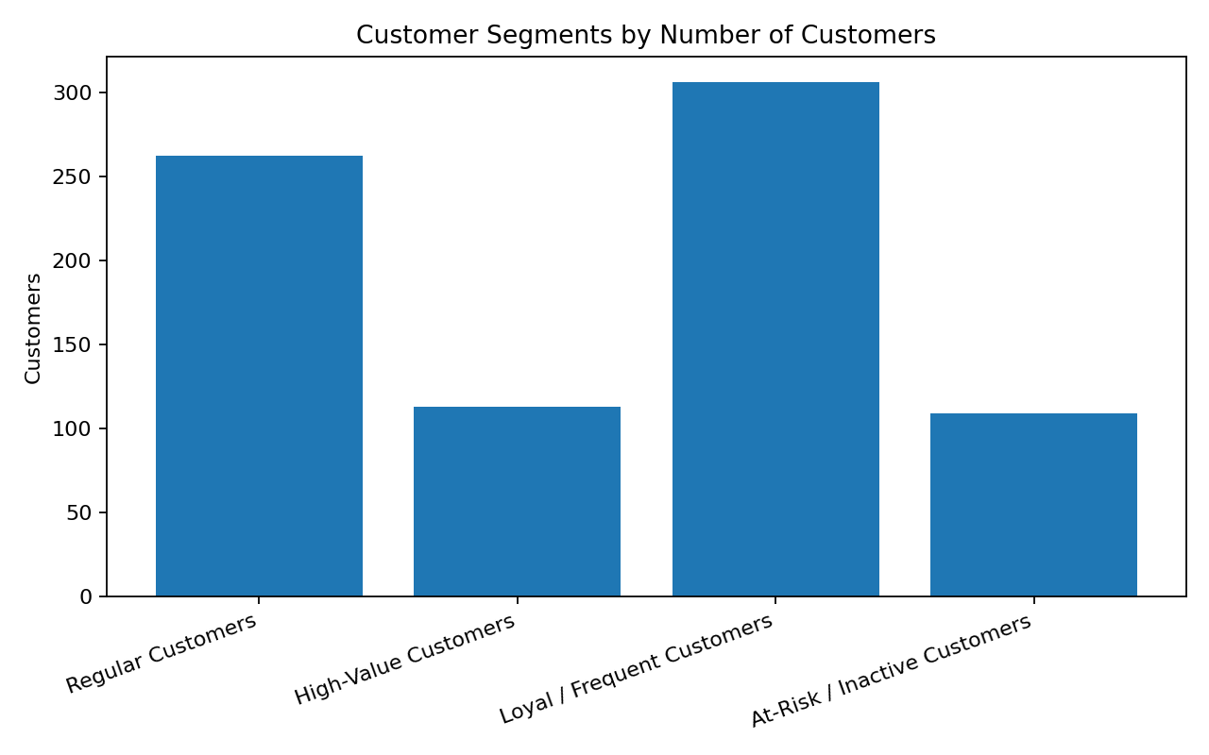
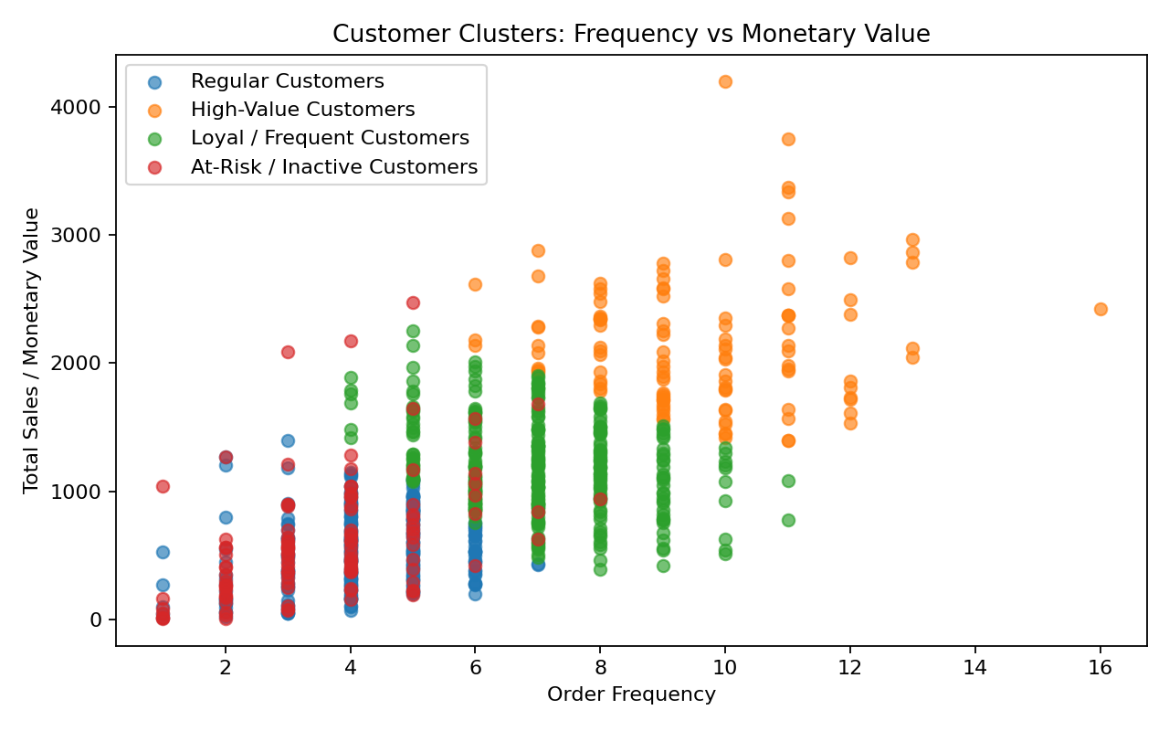

Cluster Recommendations
High-Value Customers: Protect with VIP offers, premium bundles, early access and personalized retention campaigns.
Loyal / Frequent Customers: Encourage cross-selling, repeat purchases and loyalty rewards.
Regular Customers: Use targeted promotions and product recommendations to increase frequency and basket size.
At-Risk / Inactive Customers: Run win-back campaigns, reminders and personalized discounts based on prior purchases.

8. Basic Predictive Modeling
A Linear Regression model was built to predict Sales using Quantity, Discount, Region, Category, Sub-Category, Segment and Ship Mode. The data was split into 80% training and 20% testing data. Categorical variables were one-hot encoded.
R² = 0.389
RMSE = 89.99
MAE = 62.17
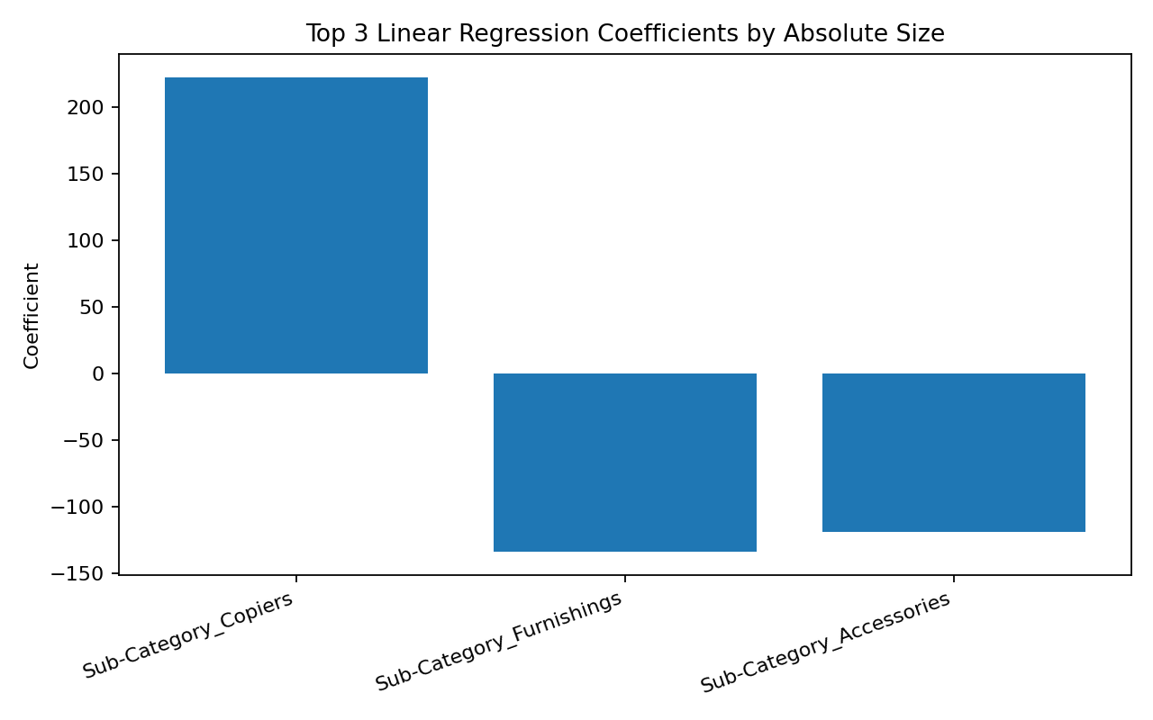
Top 3 model features by absolute coefficient:
Sub-Category_Copiers: coefficient 222.05
Sub-Category_Furnishings: coefficient -133.32
Sub-Category_Accessories: coefficient -118.46

9. Business Insights
Average order-line Sales is 92.86, while the median is 40.88, showing a right-skewed sales distribution.
Average Profit is 11.20; the large negative skew indicates that a small number of transactions create unusually large losses.
The Consumer vs Corporate Sales comparison was not statistically significant at the 5% level.
Region and Category were not statistically significantly associated based on the chi-square test.
Customer segmentation reveals a clearly inactive/high-recency group that is suitable for win-back campaigns.
The high-value cluster should receive retention and premium cross-sell attention because it has the strongest monetary value.
The simple regression explains about 38.9% of the variance in Sales on the held-out test set, so it is useful as a baseline rather than a final production model.

10. Conclusion
Task 4 is completed using statistical analysis, hypothesis testing, confidence intervals, time-series forecasting, K-Means customer segmentation and a baseline predictive model. The results can be extended with advanced forecasting (ARIMA/Prophet), hyperparameter tuning, cross-validation and classification models when a suitable business target such as churn is available.

11. Deliverables
The accompanying folder contains the analysis notebook, Excel workbook, statistical tables, monthly forecast, customer cluster assignments, model feature importance and charts.

