RAUNAQ DEY 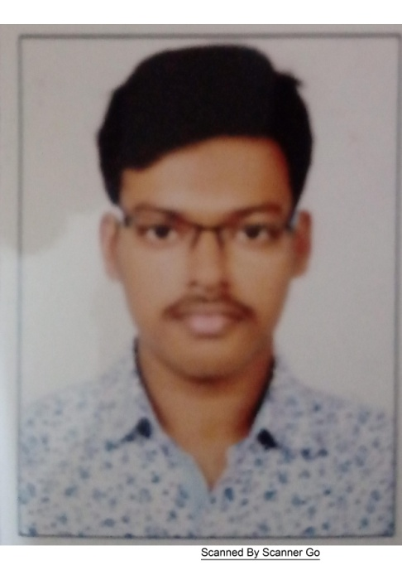

**9748038141**

Email: [raunaqdey97@gmail.com](mailto:raunaqdey97@gmail.com)

# CAREER OBJECTIVES:

In pursuit of a career that recognizes & appreciates my technical acumen & ability.

# KEY SKILLS:

* Communication and Collaboration Tools: Social Media
* Office Suites**:** Microsoft Office (MS-Word, MS- Excel, Powerpoint)
* Programming Languages - C, C++. All are at basic suites
* Web Frontend – HTML
* Operating Systems – Windows 7, 10

# Professional Qualification**:**

Studying Masters of Computer Application at 5th Semester from Narula Institute of Technology, Agarpara, Kolkata.

# Educational Qualification:

|  |  |  |  |
| --- | --- | --- | --- |
| **Standard** | **Board** | **School/College** | **Passing Year** |
| Secondary Education | ICSE () | St. Xavier’s Institution | 2017 |
| Higher Secondary Education | CBSE () | Kalyani Public School | 2019 |
| Graduation | MAKAUT | Narula Institute of Technology | 2022 |

**STRENGTHS:**

* Visionary
* Practical decision making
* Creative
* Self-motivated
* Result oriented

# CORE BELIEFS:

* Life long Learner
* Commitment and dedication as core values
* Hard work and optimism for superior performance

# PERSONAL DETAILS:

* Date of Birth: 8th August 2000.
* Language Proficiency : English, Hindi, Bengali
* Marital Status: Single.
* Address : 97/3 East Kodalia 4th Road, New Barrackpur, North 24 Parganas, West Bengal - 700 131

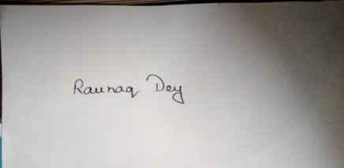

Raunaq Dey

-----------------------------