## 

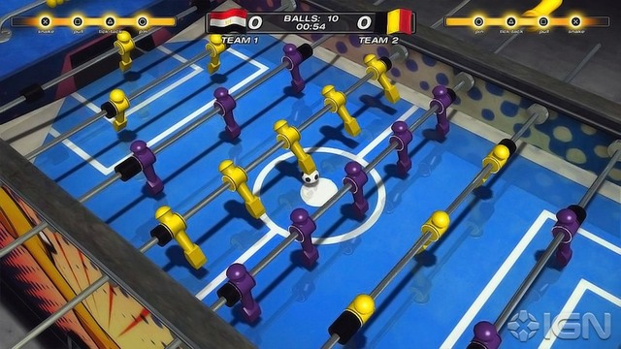

Autonomous Foosball Bot

# Project designed by:

1. Arkya Chatterjee ([arkya.chat@gmail.com](mailto:arkya.chat@gmail.com), 9433001363)
2. Raunaque Patra ([rpatra1997@gmail.com](mailto:rpatra1997@gmail.com), 8335873103)
3. Srijit Dutta ([srijitdutta04@](mailto:srijit04@yahoo.co.uk)gmail.com, 9987582312)
4. Arunavo Mondal (arunavomondal97@gmail.com, 8828494843)

# Overview and Motivation

An autonomous foosball bot provides a challenging and entertaining scenario of “man v/s machine” in a game of foosball. It provides an opportunity to the relatively experienced player to play against a formidable opponent without having to search for a human challenger. At present, there are no such machines available in mass production. So our team would like to develop a working prototype of such a device.

Our final product would look something like this: <https://youtu.be/m6C4SOxfNGQ>

**Problem Statement**

To make a working prototype of a foosball playing bot, that controls the four rods on one side of a foosball table, which will be able to play autonomously against a human competitor.

**Theory of implementation**

We plan to use an array of IR LEDs and sensors, to map the entire foosball table on a pair of coordinate axes. The position of the ball at any given time is located using this coordinate mapping. The nearest “player” then tries to kick the ball in the direction of the opponent’s goal. Once this functionality is implemented, we plan to streamline the algorithm to develop coordination between the different rows of players.

# Goals

1. To develop a working prototype for an arcade style foosball bot
2. To understand the working of stepper motors, and linear actuators
3. To create the AI for the robot

# Basic Components

* Foosball Table (will borrow one)
* Array of 225 IR LED + phototransistor pairs (Rs 2000)
* Comparators [LM 339] (Rs 128)
* Digital de-mux [74HC5414] (Rs 90)
* Analog multiplexer [CD4067] (price not available)
* V3006 servo motor x4 (Rs 1600)
* NEMA 17 stepper motors x4 (Rs 3165)
* DRV8825 motor driver for stepper motor (Rs 880)
* Belts , ramps ,pulleys (Rs 2250)
* Arduino Mega (Rs 700)
* Wires, nuts and bolts (Rs 100)
* DC adaptor

Total price (approx) = Rs 10,913

# Milestones

## Purchase mechanical components (including linear actuators, servo motors) (Week 0)

## Form a working mechanical structure (Week 1)

## Get the electronic circuits running (Week 2)

## Implement AI for the basic functionality (Week 3)

## Try to develop coordination between the different “players” (Weeks 4 and 5)

P.S.: Week 6 is going to be a buffer week, for debugging purposes, and for finalising the working prototype