**Digital Design and Computer Organization Laboratory**

**UE23CS251A**

**3rd Semester, Academic Year 2024-25**

Date: 17-09-2024

|  |  |  |
| --- | --- | --- |
| Name: Arunkumar R | SRN:PES1UG24CS802 | Section  A |

**Course Title: DIGITAL DESIGN AND COMPUTER ORGANISATION**

**Course Code: UE23CS251A**

**Semester: 3**

**Credits: 5**

**Course Type: Core**

**Experiential Learning: Banana Problem statement (after unit1)**

# 1. PROBLEM STATEMENT Design Specification

In this problem, you are to design the combinational circuit that controls the ceiling light in downstairs hallway at your home

There are three wall switches: one at the front door (A), one at the back door (B) and one in the family room (C)

When you walk in the front door, the ceiling lights are off, the switch A is ON and both the B and C switches are OFF

From these initial conditions, changing the position of any switch should turn the lights on; changing the position of any switch (again) should turn the lights off, etc.

# Karnaugh Map(K-map):

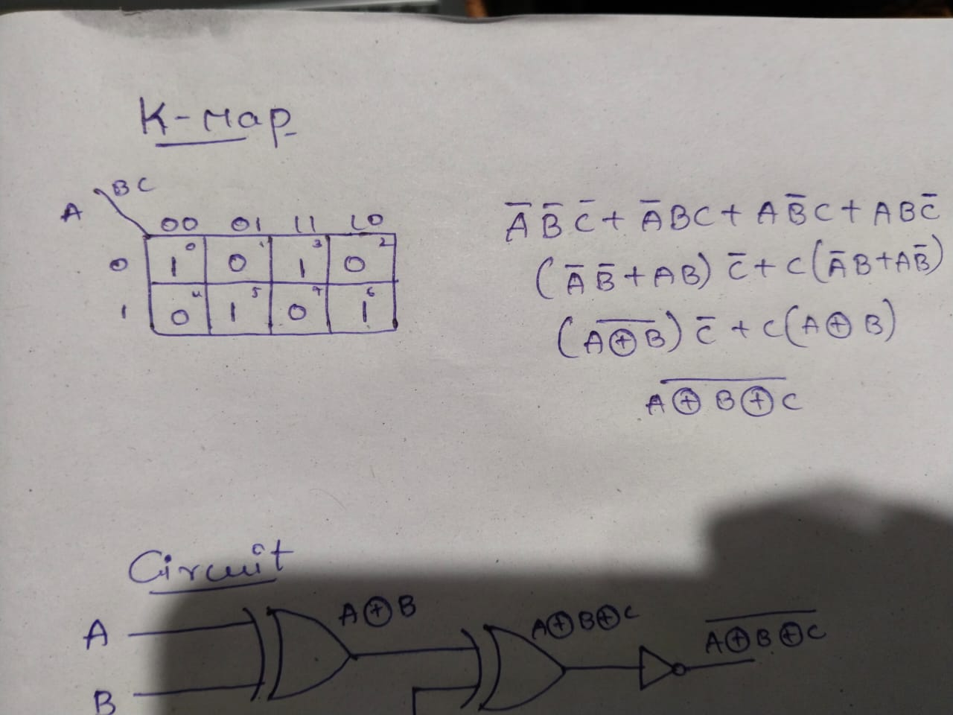

1. 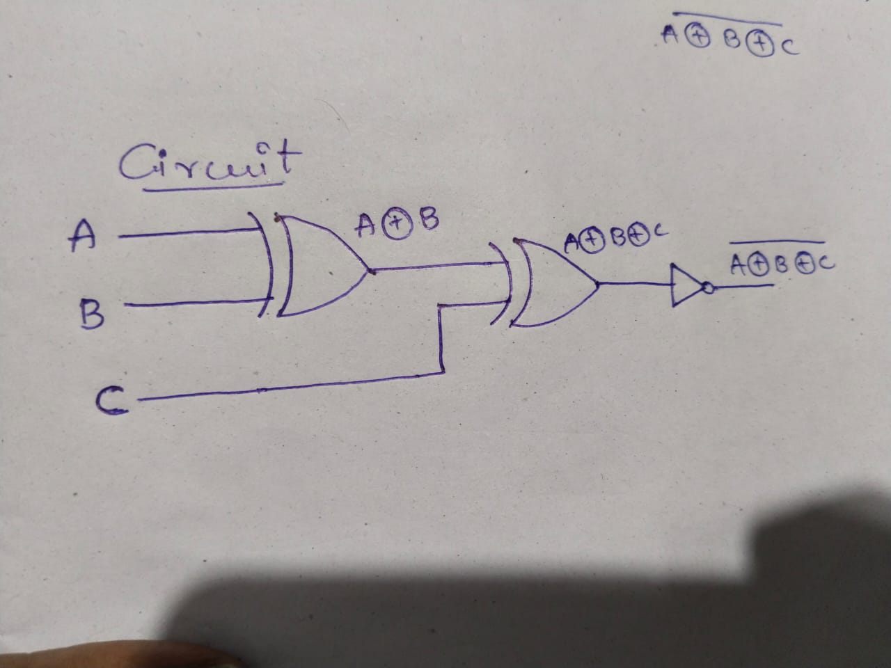**Combinational Circuit:**
2. Verilog Code for the derived Circuit and Test Bench

.v file

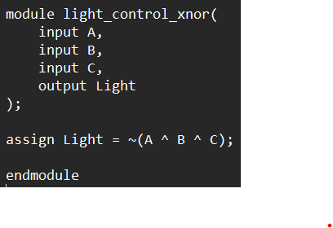t

Test bench file

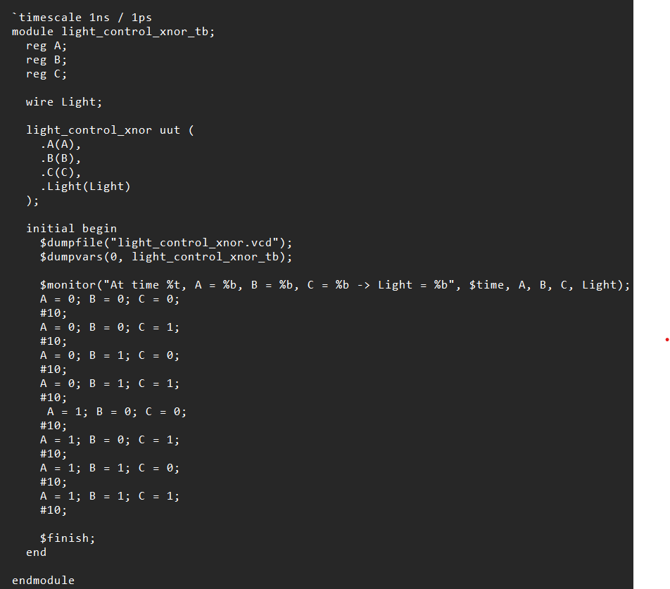

VVP output

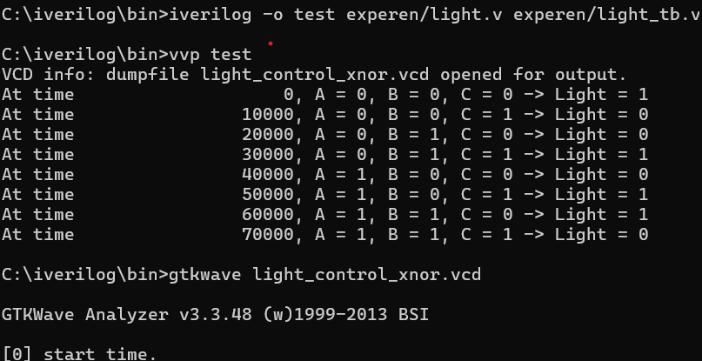

1. Waveform to illustrate the working of the derived Circuit

