Gamification and Learning Environments

Protocol for a Systematic Literature Review

(V1.1, 2016)

**Maria Rauschenberger**

University of Applied Sciences Emden/Leer, Emden, Germany

maria.rauschenberger@hs-emden-leer.de)

**Andreas Willems**

(University of Applied Sciences Emden/Leer, Emden, Germany

andreaswillems666@gmail.com)

**Menno Ternieden**

(University of Applied Sciences Emden/Leer, Emden, Germany

Menno.Ternieden@hs-emden-leer.de)

**Jörg Thomaschewski**

(University of Applied Sciences Emden/Leer, Emden, Germany

Joerg.Thomaschewski@hs-emden-leer.de)

Supplement of the paper:

Rauschenberger, M., Willems, A. , Ternieden, M. & Thomaschewski, J. (2018). Towards the use of gamification frameworks in learning environments. *Jl. of Interactive Learning Research*,. *(Accepted*)

1. **Objectives**

*Gamification* is a concept used for increasing motivation and engagement in various applications. It can be defined as the use of game elements in non-game contexts. Applying game elements in education is especially desired to engage and motivate students. Contemporary and future students grow up as digital natives and therefore, are accustomed to a wide variety of multimedia applications. To improve the learning experience and the effect of learning is the goal of gamification in the field of education.

Our main goal is to find out whether frameworks for *gamification* in learning environments exist, which game elements they feature and whether they are evaluated. Therefore, we conduct a Systematic Literature Review (SLR) following the guideline from Kitchenham and Charters (Kitchenham & Charters, 2007).

This research protocol is a supplement of the paper “Towards the use of gamification frameworks in learning environments“ and in press (to be published in: [JILR](https://www.aace.org/pubs/jilr/) 2018).

1. **Research Questions**

The following research Questions set the scope of the SLR:

1. Which frameworks exist for gamification in learning environments?

The term framework is used for a collection of ideas and rules as it provides a broad approach to more concrete embodiments. Only if it is necessary for the understanding the terms model, platform or process will be used. Second, each framework is examined whether an evaluation (e.g. case study) was carried out.

1. Which game elements are used in the frameworks?

Regarding this RQ, all game elements (former patterns) from the extracted data are collected and aggregated to investigate which game elements are applied.

1. Can recommendations of game elements for learning environment be derived?

The goal of this RQ is to provide advice to improve learning environments with the concept of *gamification* through game elements.

1. **Search Space**

The strategy that will be used to search for primary studies including search terms and resources to be searched. Resources include digital libraries, specific journals, and conference proceedings. An initial mapping study can help determine an appropriate strategy.

**Search terms:** gamification AND learning AND (framework OR model OR pattern)

**Resources:** ACM Digital Library and IEEE Xplore (as well-known literature databases in the area of computer science and user experience)

1. **Search Criteria**

Selection criteria is used to determine which studies are included in, or excluded from, a systematic review. It is usually helpful to pilot the selection criteria on a subset of primary studies.

* International articles written in English
* Available in full text
* Published after 2014 (to evaluate possible established game elements)
* Only related to the topic of gamification (no false positive results)

1. **Study selection procedures.**

The protocol should describe how the selection criteria will be applied e.g. how many assessors will evaluate each prospective primary study, and how disagreements among assessors will be resolved.

1. Classification be title, keywords and abstract; full text in doubt
2. Content analysis to exclude merely related articles (mentioning of the term gamification in different contexts)
3. Include articles that present a self-made, comprehensive framework
4. **Study quality assessment checklists and procedures.**

The researchers should develop quality checklists to assess the individual studies. The purpose of the quality assessment will guide the development of checklists.

Only include articles, that positively meet the following criteria:

1. Does the search result present a new unique framework?
2. Does the search result extend an existing framework?
3. Does the search result apply or evaluate a framework?

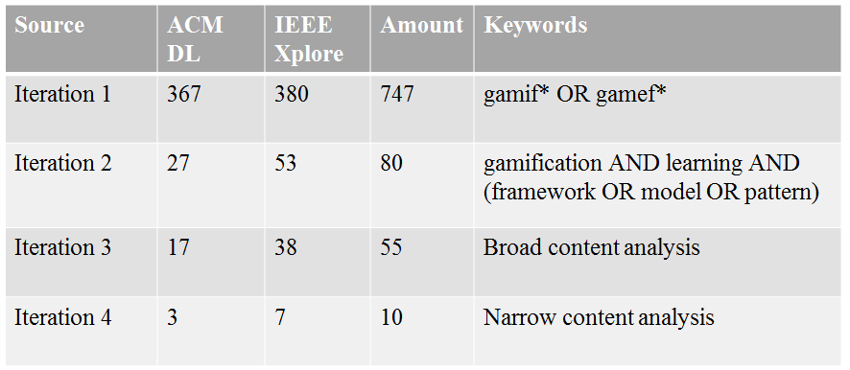

Fig. 1 Overview search process

1. **Data extraction strategy.**

This defines how the information required from each primary study will be obtained. If the data require manipulation or assumptions and inferences to be made, the protocol should specify an appropriate validation process.

* Analysis of the presented framework to obtain the used game elements and, if existing, their effect on the results
* Statistical summary of the elements

1. **Synthesis of the extracted data.**

This defines the synthesis strategy. This should clarify whether or not a formal meta-analysis is intended and if so what techniques will be used.

No formal meta-analysis. Discussion of the results regarding to the type and frequency of game elements.

# References

Rauschenberger, M., Willems, A. , Ternieden, M. & Thomaschewski, J. (2018). Towards the use of gamification frameworks in learning environments. *Jl. of Interactive Learning Research*,. *(Accepted*)

Kitchenham, B., & Charters, S. (2007). Guidelines for performing Systematic Literature Reviews in Software Engineering. *Engineering*, *2*, 1051.