Synchronous and Blocking
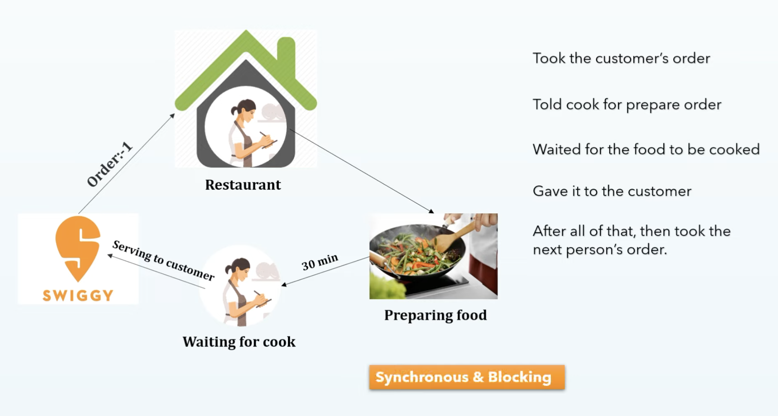

Asynchronous and Non-Blocking

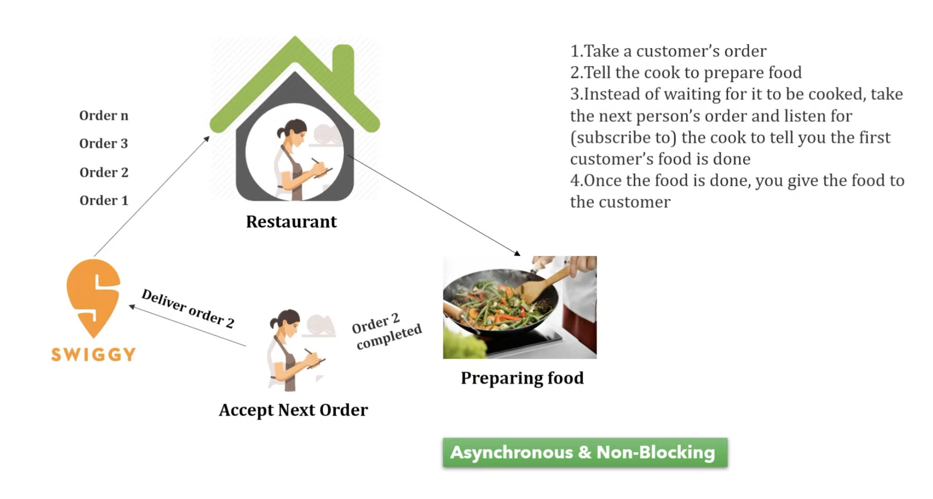

Reactive Stream Workflow (Architecture):
1. The Subscriber invoke subscribe method and pass the subscribe instance as input to Publisher and Publisher going to send the subscription event to Subscriber confirming that your subscription is successful.
2. Subscriber call request(n) from Subscription interface to get the data from Publisher.
3. Publisher send data stream to Subscriber by invoking onNext(data) method, if Publisher return 10 record then in this case Publisher will fire 10 times of onNext(data) events.
4. Once all the record recieved to Subscriber then Publisher will invoke onComplete() method to confirming hey Subscriber I have done my Job, your execution is successful, if there is any errors then publisher will fire onError() event.
5. There is option to Subscriber to ask limited number of data from Publisher, example let say Publisher have 10 items and you want to fetch 2 items then Subscriber can control that, that is Data Backpressure in Reactive Programing.
