CISCO NSO
End-to-End Acceptance Test Procedure Document
Executive Summary & Demonstration Report
Telangana Fiber Grid Corporation Ltd. (T-FIBER)
Government of Telangana
Environment: 172.28.2.17 | LSA Deployment (CFS / RFS)
JULY 2026

Contents
1. Purpose
2. What This Means for the Business
3. Test Environment
4. Executive Test Results Summary
5. Detailed Test Cases
5.1 CLI-Based Test Cases (Test Case 1 – 6)
5.2 UI / Web Portal-Based Test Cases (Test Case 7 – 19)
6. Document Acceptance

1. Purpose
This report confirms that the Cisco NSO (Network Services Orchestrator) platform has been installed, configured, and verified end-to-end. NSO is the automation system that allows the network team to set up and manage customer internet/fibre connections without manual, device-by-device configuration.
A complete acceptance test was carried out — from confirming the system is running, through submitting a real customer service order, to confirming the physical field device was activated and the order could be safely removed. The test suite was extended to also validate RFS cluster resilience under simulated node failover conditions. Every check passed.

2. What This Means for the Business
- Faster service activation: New customer fibre connections can be provisioned automatically instead of manually configured on each device.
- Reduced human error: Standardized, repeatable automation reduces the risk of misconfiguration in the field.
- Full traceability: Every order is logged and visible in the web dashboard for audit and support purposes.
- Safe operations: The system can also cleanly reverse (delete) an order, confirming rollback safety before this goes into full production use.
- Proven resilience: Service orders remain visible and consistent even when individual RFS cluster nodes are locked out for maintenance or failover, confirming High Availability works as designed.

3. Test Environment
The table below summarizes the environment used to conduct this acceptance test.
Component | Role | IP Address / Identifier
CFS (Customer Facing Service) | Central orchestration node used for order submission & verification | 172.28.2.17
RFS (Resource Facing Service) Web Portal | Field-facing service node used for order verification | 172.28.2.18
RFS-18 | RFS Cluster Node (Leader in normal operation) | Cluster Node ID: RFS-18
RFS-19 | RFS Cluster Node (Follower in normal operation) | Cluster Node ID: RFS-19
RFS-20 | RFS Cluster Node (Follower in normal operation) | Cluster Node ID: RFS-20
Tejas EMS | Third-party Element Management System for OLT field device verification | Integrated via NBI
Deployment Model | LSA (Layered Service Architecture) — CFS/RFS | —

4. Executive Test Results Summary
The table below summarizes each verification step performed and its outcome. Full technical evidence (screenshots) for each step is provided in Section 5.
# | Checkpoint | What It Confirms | Result
1 | System Health Check | Confirmed the orchestration platform (NSO) is running and available. | PASS
2 | Administrator Access | Confirmed authorized staff can securely log in to the system. | PASS
3 | Network Device Connectivity | Confirmed the platform can reach and communicate with field network devices (OLTs). | PASS
4 | Automation Package Check | Confirmed the provisioning automation package is correctly installed and active. | PASS
5 | Service Order Submission | A real customer service order (fibre connection setup) was submitted for processing. | PASS
6 | Order Processing | The order was processed and committed successfully with no errors. | PASS
7 | Web Portal Verification | The committed order was confirmed visible in both business and network-facing web dashboards. | PASS
8 | Audit Log Verification | System logs correctly recorded the full transaction for traceability. | PASS
9 | Field Device Provisioning | Confirmed the physical field device (OLT) was actually configured to activate service. | PASS
10 | Delete | Confirmed the system can cleanly remove a service order, proving safe rollback capability. | PASS

5. Detailed Test Cases
This section presents each verification step as a formal test case, including its purpose, procedure, expected result, and supporting evidence — in the same order the demonstration was walked through live. CLI-based test cases are presented first, followed by UI / web-portal-based test cases.

5.1 CLI-Based Test Cases

Test Case 1: NSO System Health Check
Description: | Verify that the Cisco NSO orchestration platform is installed, running, and reporting a healthy status.
Why This Step: | Before any provisioning activity can be trusted, the platform itself must be confirmed to be up and running. This is the baseline check that all subsequent tests depend on.
Procedure: | 1. Login to the NSO server via SSH.  2. Run the command 'ncs --status' (or equivalent NSO status command).  3. Verify the output reports the service as running and displays the installed version.
Expected Result: | NSO reports status as running/live, with version details displayed and no errors.
Result: | ☐ OK ☐ Not OK
Evidence / Logs: | 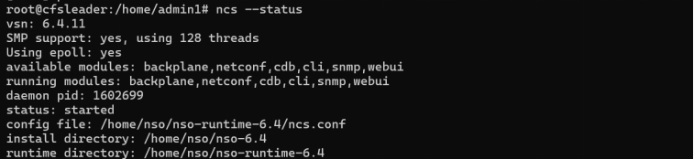  NSO status check confirming the platform is running.

Test Case 2: Administrator Access (CLI Login)
Description: | Verify that an authorized administrator can securely log in to the NSO Command Line Interface (CLI).
Why This Step: | Confirms that access to the orchestration platform is restricted to authenticated, authorized personnel, which is a basic security and operational-control requirement before any configuration is performed.
Procedure: | 1. Connect to the NSO CLI via SSH using administrator credentials.  2. Enter the username and password when prompted.  3. Verify successful login and that the CLI prompt is presented with the expected privilege level.
Expected Result: | Administrator is able to log in to the NSO CLI without error and is presented with the operational prompt.
Result: | ☐ OK ☐ Not OK
Evidence / Logs: | 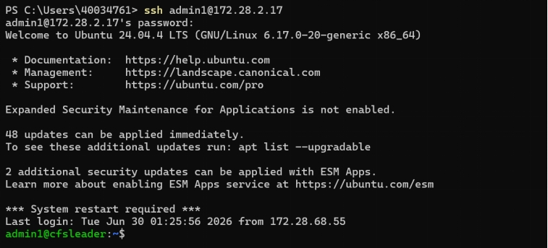  Administrator logging into the NSO CLI.

Test Case 3: Network Device Connectivity Check
Description: | Verify that NSO can reach and communicate with the field network devices (OLTs) that it is expected to manage.
Why This Step: | Automated provisioning is only possible if NSO has live, working connectivity to the physical devices in the field. This step proves the prerequisite network path exists before any service is pushed.
Procedure: | 1. From the NSO CLI, run the device list/connectivity check command (e.g. 'show devices list' or 'connect').  2. Verify that the OLT devices appear with a reachable/connected status.
Expected Result: | All configured OLT devices are listed with a reachable/connected status and no connectivity errors.
Result: | ☐ OK ☐ Not OK
Evidence / Logs: | 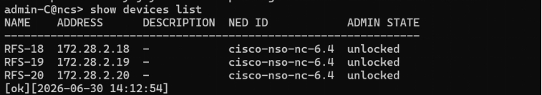  Device connectivity list confirming reachable network devices.

Test Case 4: Automation Package Verification
Description: | Verify that the service provisioning automation package (RFS/CFS service package) is correctly installed and active on NSO.
Why This Step: | The service package is the automation logic that translates a customer order into device configuration. If it is not loaded and operational, no service orders can be processed, regardless of platform health.
Procedure: | 1. From the NSO CLI, run 'show packages package oper-status' (or equivalent).  2. Verify that the relevant service package(s) are listed with an 'up' / operational status.
Expected Result: | The service automation package is listed as loaded and operational (up), with no load errors reported.
Result: | ☐ OK ☐ Not OK
Evidence / Logs: | 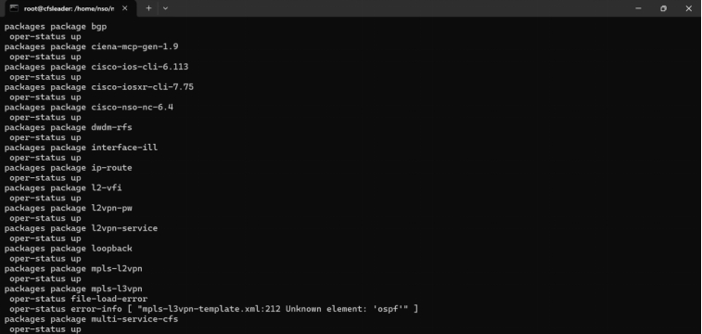  Service package operational status — confirmed active.

Test Case 5: Service Order Submission & Commit (CLI)
Description: | Submit a real customer service order (fibre connection setup, including device, package, VLAN, and bandwidth profile details) through the NSO CLI and commit it.
Why This Step: | This is the core function under test: proving that a real, end-to-end customer order can be accepted and processed by the automation platform, not just a synthetic/sample transaction.
Procedure: | 1. From the NSO CLI, create the service instance with the required customer parameters (device, package, VLAN, bandwidth profile).  2. Validate the configuration.  3. Commit the transaction.
Expected Result: | The service order commits successfully with no validation or commit errors.
Result: | ☐ OK ☐ Not OK
Evidence / Logs: | 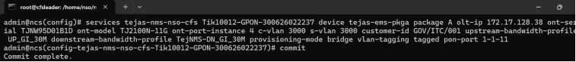  Confirmation that the order committed successfully.

Test Case 6: Service Order Deletion via CLI (Rollback Verification)
Description: | Delete the previously committed service order through the NSO CLI to confirm safe rollback capability.
Why This Step: | Provisioning is only safe to use in production if it can also be cleanly reversed — for cancellations, corrections, or churn — without leaving the platform or the field device in an inconsistent state.
Procedure: | 1. From the NSO CLI, locate the previously committed service instance.  2. Issue the delete/no command against the service instance.  3. Commit the transaction and verify no errors are returned.
Expected Result: | The service order is removed successfully with no errors, and the transaction commits cleanly.
Result: | ☐ OK ☐ Not OK
Evidence / Logs: | 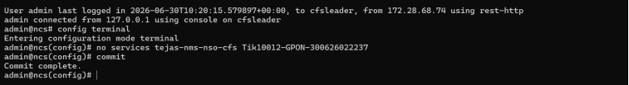  Confirmation that the committed order was successfully deleted.

5.2 UI / Web Portal-Based Test Cases

Test Case 7: RFS Cluster Node State Verification — Normal Operation
Description: | Verify the RFS cluster node roles and lock states under normal operating conditions: RFS-18 configured as Leader, RFS-19 and RFS-20 configured as Followers, all nodes Unlocked.
Why This Step: | Confirms the High Availability (HA) cluster is healthy and correctly formed before service-order testing begins, so that any subsequent result can be attributed to the automation logic rather than an unhealthy cluster.
Procedure: | 1. Login to the NSO cluster management view.  2. Check the role of each RFS node (RFS-18, RFS-19, RFS-20).  3. Check the administrative lock state of each node.  4. Confirm RFS-18 is Leader and RFS-19/RFS-20 are Followers, and all nodes show Unlocked.
Expected Result: | RFS-18 is shown as Leader; RFS-19 and RFS-20 are shown as Followers; all three nodes are in the Unlocked state.
Result: | ☐ OK ☐ Not OK
Evidence / Logs: | 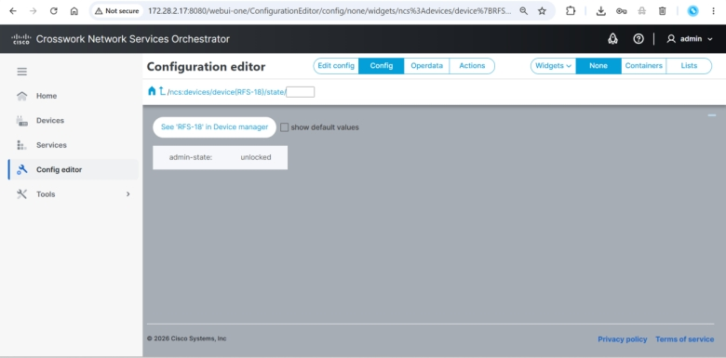  RFS-18 confirmed as Leader — Unlocked.  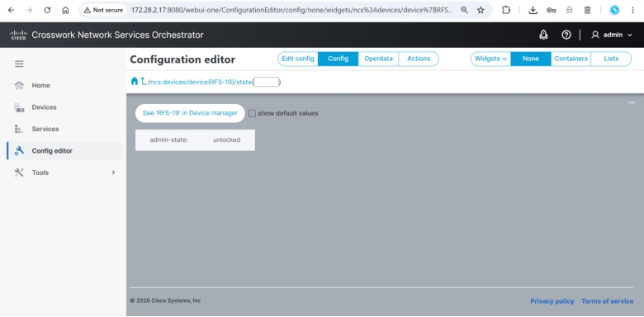  RFS-19 confirmed as Follower — Unlocked.  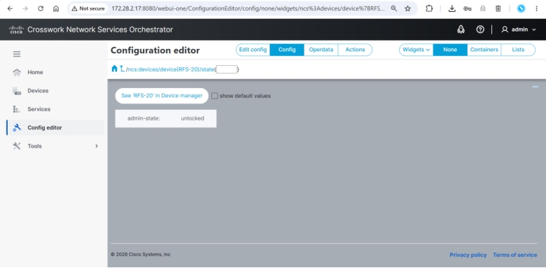  RFS-20 confirmed as Follower — Unlocked.  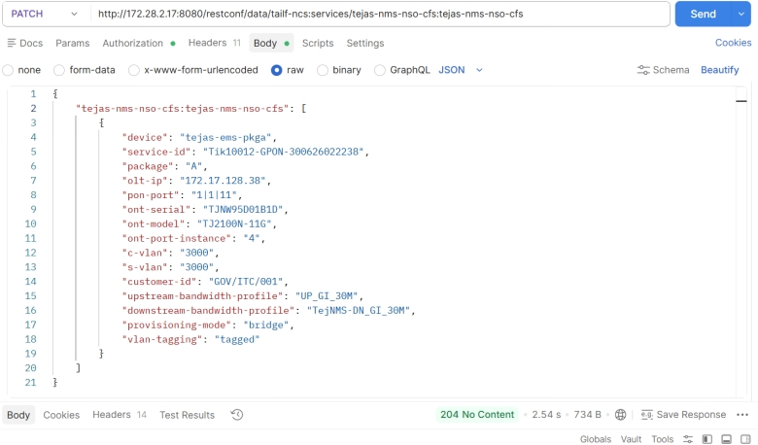  Cluster-wide node status summary — all nodes Unlocked.

Test Case 8: CFS Web Portal — Service Order Verification
Description: | Verify that the committed service order is visible in the CFS (Customer Facing Service) web portal at 172.28.2.17 by searching for the Service ID.
Why This Step: | Confirms that the order processed by automation is correctly reflected in the business-facing system of record, which is what customer service and billing teams rely on.
Procedure: | 1. Login to the CFS web portal (172.28.2.17).  2. Search for the committed order using its Service ID.  3. Confirm the order details match what was submitted.
Expected Result: | The committed service order is found in CFS, with details matching the submitted order.
Result: | ☐ OK ☐ Not OK
Evidence / Logs: | 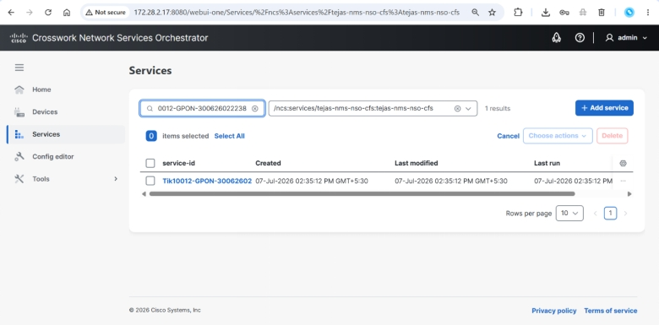  Committed service order confirmed visible in CFS by Service ID.

Test Case 9: RFS Web Portal — Service Order Verification
Description: | Verify that the committed service order is also visible in the RFS (Resource Facing Service) web portal at 172.28.2.18 by searching for the Service ID.
Why This Step: | Confirms that the order has correctly propagated from the business layer (CFS) down to the network resource layer (RFS), proving the CFS/RFS orchestration chain is working end-to-end.
Procedure: | 1. Login to the RFS web portal (172.28.2.18).  2. Search for the committed order using its Service ID.  3. Confirm the order details match what was submitted in CFS.
Expected Result: | The committed service order is found in RFS, consistent with the CFS record.
Result: | ☐ OK ☐ Not OK
Evidence / Logs: | 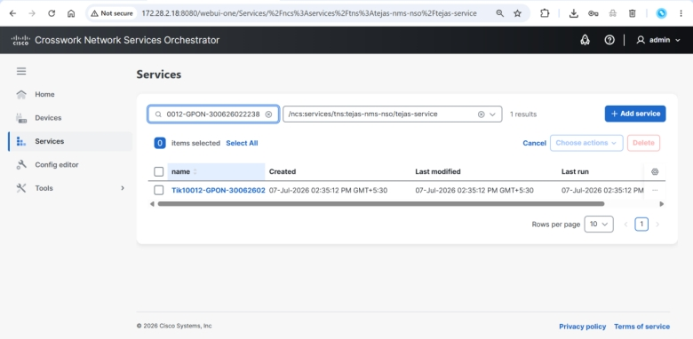  Committed service order confirmed visible in RFS by Service ID.

Test Case 10: Tejas EMS — OLT Service Provisioning Verification
Description: | Verify that the OLT field device was actually provisioned with the service by checking the Tejas EMS application, filtering by ONT Serial Number.
Why This Step: | This is the ultimate proof point: confirming the order didn't just get recorded in software, but was actually pushed down and activated on the physical field device.
Procedure: | 1. Login to the Tejas EMS application.  2. Filter/search using the ONT Serial Number associated with the order.  3. Confirm the service is shown as provisioned on the OLT.
Expected Result: | The OLT service is shown as successfully provisioned against the specified ONT Serial Number in Tejas EMS.
Result: | ☐ OK ☐ Not OK
Evidence / Logs: | 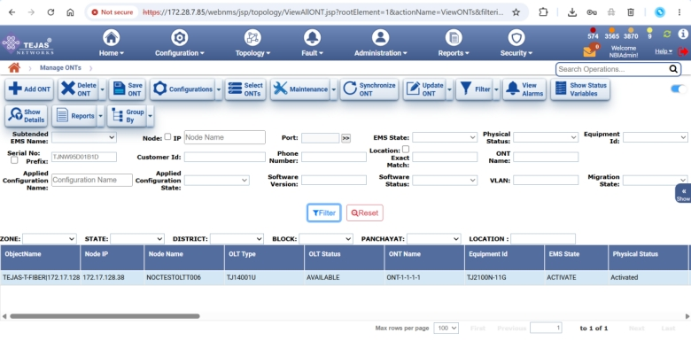  OLT service provisioning confirmed in the Tejas EMS field management system.

Test Case 11: CFS Web Portal — Service Order Deletion
Description: | Delete the committed service order from the CFS web portal (172.28.2.17) by searching for the Service ID, selecting the service, and performing the delete operation.
Why This Step: | Confirms that the rollback/removal path is also available and usable from the business-facing (CFS) system, not only from the CLI, matching how operations staff would actually perform a cancellation.
Procedure: | 1. Login to the CFS web portal (172.28.2.17).  2. Search for the order using its Service ID.  3. Select the service and perform the delete operation.  4. Confirm the operation completes without error.
Expected Result: | The service order delete operation completes successfully from the CFS web portal.
Result: | ☐ OK ☐ Not OK
Evidence / Logs: | 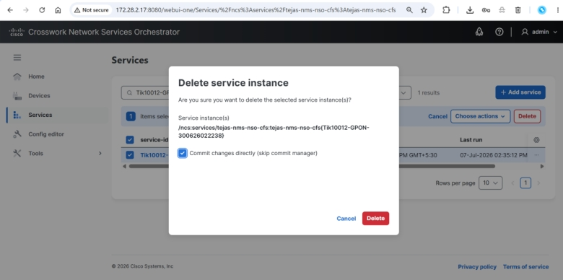  Service order delete operation performed from CFS.

Test Case 12: CFS Web Portal — Verify Service Order Deleted
Description: | Verify that the service order no longer appears in the CFS web portal (172.28.2.17) by searching for the Service ID.
Why This Step: | Confirms the delete operation actually removed the record from the business system of record, and did not merely return a success message.
Procedure: | 1. Login to the CFS web portal.  2. Search for the previously deleted Service ID.  3. Confirm no matching record is returned.
Expected Result: | The Service ID search returns no result, confirming the order has been removed from CFS.
Result: | ☐ OK ☐ Not OK
Evidence / Logs: | 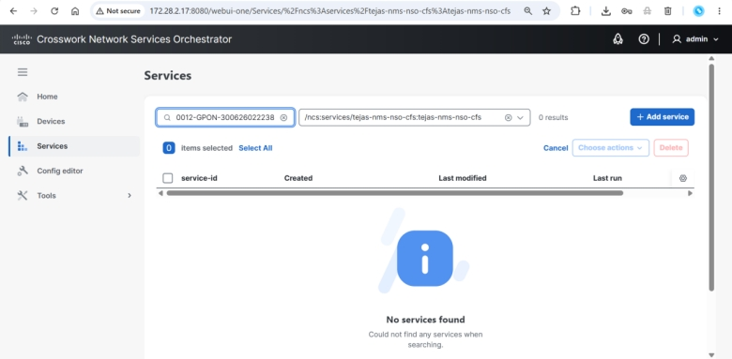  Confirmed the service order no longer exists in CFS.

Test Case 13: RFS Web Portal — Verify Service Order Deleted
Description: | Verify that the service order has also been removed from the RFS web portal (172.28.2.18) by searching for the Service ID.
Why This Step: | Confirms the deletion correctly propagated from CFS down to the RFS resource layer, so no orphaned resource-layer configuration is left behind.
Procedure: | 1. Login to the RFS web portal.  2. Search for the previously deleted Service ID.  3. Confirm no matching record is returned.
Expected Result: | The Service ID search returns no result, confirming the order has been removed from RFS.
Result: | ☐ OK ☐ Not OK
Evidence / Logs: | 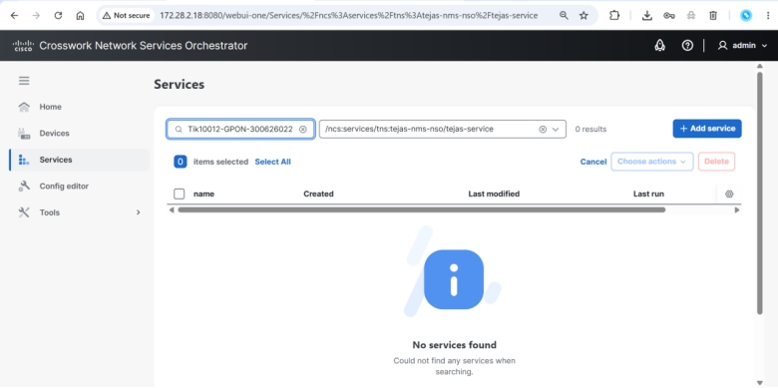  Confirmed the service order no longer exists in RFS.

Test Case 14: Tejas EMS — Verify Service Removed from Field Device
Description: | Verify that the corresponding service has also been removed from the Tejas EMS application, checking by ONT Serial Number or relevant service details.
Why This Step: | Confirms the deletion was carried all the way through to the physical OLT, proving there is no leftover live configuration on the field device after a cancellation — a key safety requirement.
Procedure: | 1. Login to the Tejas EMS application.  2. Search using the ONT Serial Number used in the earlier provisioning test.  3. Confirm the service is no longer shown as active/provisioned.
Expected Result: | The service is confirmed removed from the OLT in Tejas EMS, with no residual configuration.
Result: | ☐ OK ☐ Not OK
Evidence / Logs: | 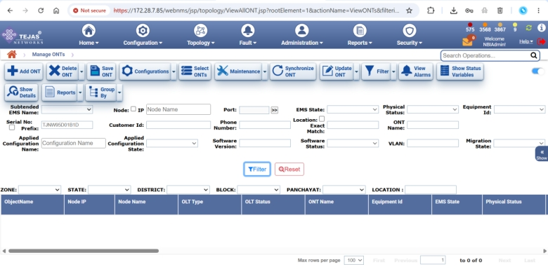  Confirmed the service has been removed from the Tejas EMS field record.

Test Case 15: RFS Cluster Failover Test 1 — RFS-18 & RFS-20 Locked, RFS-19 Unlocked
Description: | Simulate a partial cluster failover by administratively locking RFS-18 and RFS-20, leaving only RFS-19 Unlocked and active.
Why This Step: | Proves that the platform remains usable when the original Leader and one Follower are taken out of service — this is what would happen during maintenance or a real node failure, and the business cannot afford downtime in that scenario.
Procedure: | 1. Login to the NSO cluster management view.  2. Administratively lock RFS-18.  3. Administratively lock RFS-20.  4. Confirm RFS-19 remains Unlocked and continues to serve traffic.
Expected Result: | RFS-18 and RFS-20 show a Locked state; RFS-19 shows Unlocked and remains operational.
Result: | ☐ OK ☐ Not OK
Evidence / Logs: | 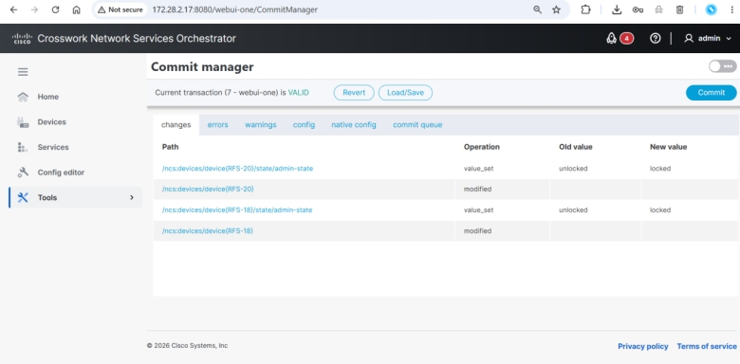  RFS-18 confirmed Locked.  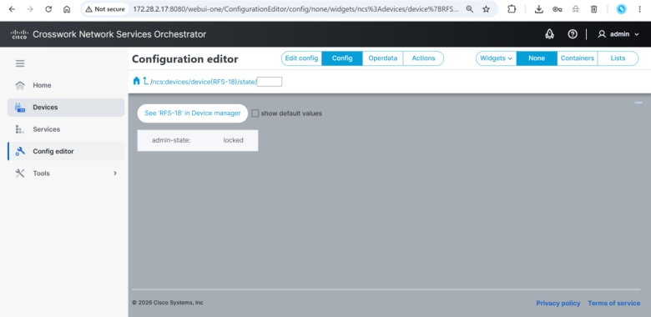  RFS-20 confirmed Locked.  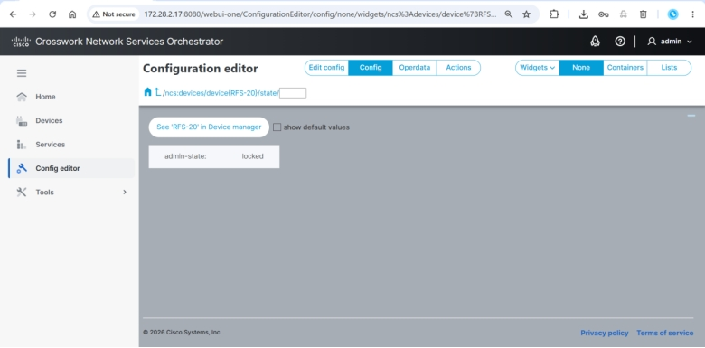  RFS-19 confirmed Unlocked and active.

Test Case 16: CFS Web Portal — Service Order Continuity During Failover Test 1
Description: | With RFS-18 and RFS-20 locked, verify the previously committed service order still exists and is visible in the CFS web portal (172.28.2.17) by searching for the Service ID.
Why This Step: | Confirms that customer service records remain accessible and consistent even while part of the RFS cluster is deliberately taken offline — proving no data loss or visibility gap occurs during a failover.
Procedure: | 1. Login to the CFS web portal while RFS-18 and RFS-20 remain locked.  2. Search for the order using its Service ID.  3. Confirm the order details are still present and correct.
Expected Result: | The service order remains visible and accurate in CFS despite RFS-18 and RFS-20 being locked.
Result: | ☐ OK ☐ Not OK
Evidence / Logs: | 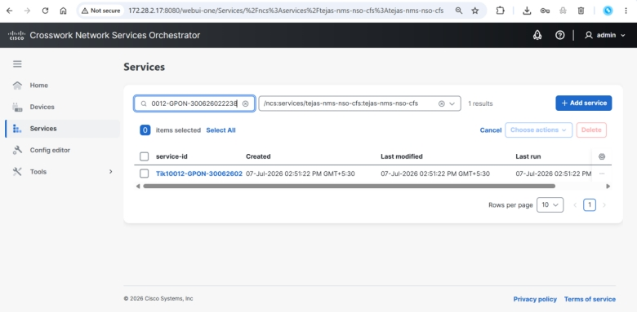  Service order confirmed present in CFS during Failover Test 1 (view 1).  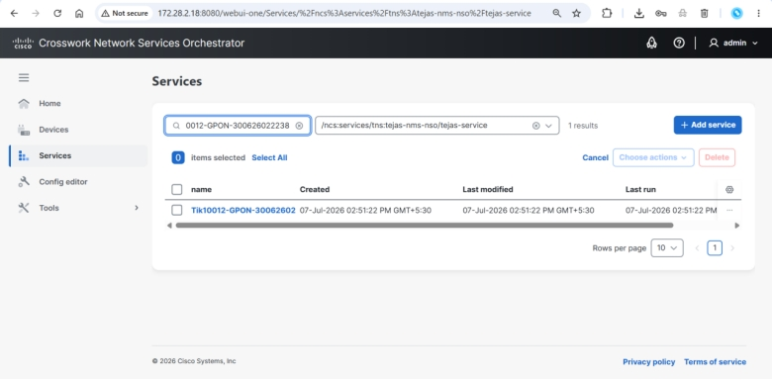  Service order confirmed present in CFS during Failover Test 1 (view 2).  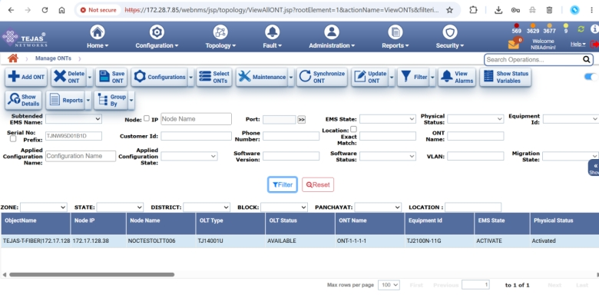  Service order confirmed present in CFS during Failover Test 1 (view 3).

Test Case 17: RFS Cluster Failover Test 2 — RFS-18 & RFS-19 Locked, RFS-20 Unlocked
Description: | Simulate a second failover scenario by administratively locking RFS-18 and RFS-19, leaving only RFS-20 Unlocked and active.
Why This Step: | Extends the failover proof to a different combination of nodes, confirming resilience is not dependent on any single specific node remaining available — any Follower can carry the cluster when needed.
Procedure: | 1. Login to the NSO cluster management view.  2. Administratively lock RFS-18.  3. Administratively lock RFS-19.  4. Confirm RFS-20 remains Unlocked and continues to serve traffic.
Expected Result: | RFS-18 and RFS-19 show a Locked state; RFS-20 shows Unlocked and remains operational.
Result: | ☐ OK ☐ Not OK
Evidence / Logs: | 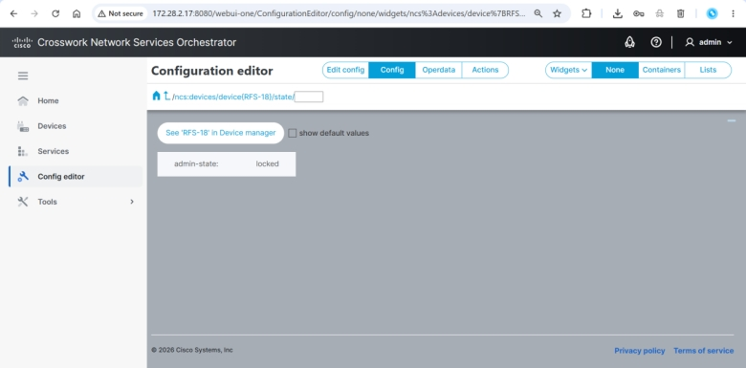  RFS-18 confirmed Locked.  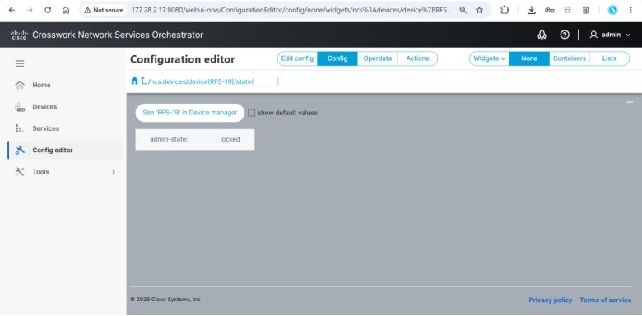  RFS-19 confirmed Locked.  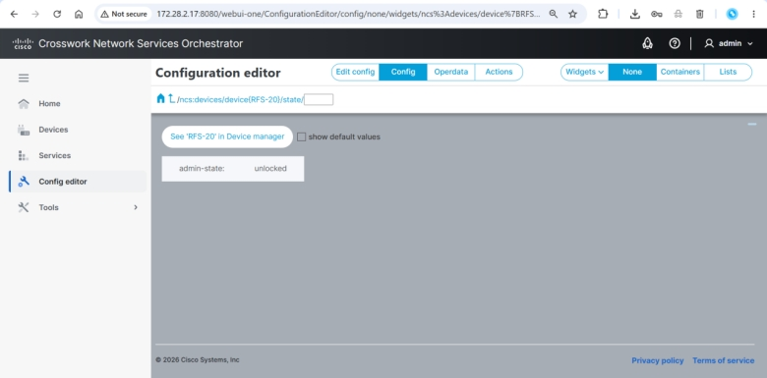  RFS-20 confirmed Unlocked and active.

Test Case 18: CFS & RFS Web Portal — Service Order Continuity During Failover Test 2
Description: | With RFS-18 and RFS-19 locked, verify the committed service order remains visible in both the CFS web portal (172.28.2.17) and the RFS web portal (172.28.2.18).
Why This Step: | Confirms both the business-facing and resource-facing views stay consistent during a second, differently-configured failover, reinforcing that the cluster's resilience is general and repeatable rather than a one-off result.
Procedure: | 1. Login to the CFS web portal and search for the Service ID; confirm the order is present.  2. Login to the RFS web portal and search for the same Service ID; confirm the order is present.
Expected Result: | The service order is visible and consistent in both CFS and RFS during Failover Test 2.
Result: | ☐ OK ☐ Not OK
Evidence / Logs: | 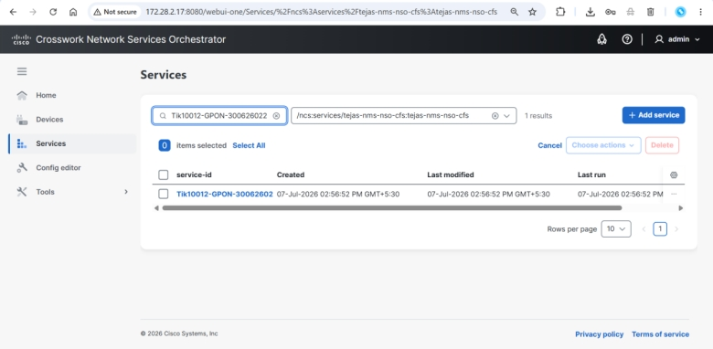  Committed order confirmed visible in CFS during Failover Test 2.  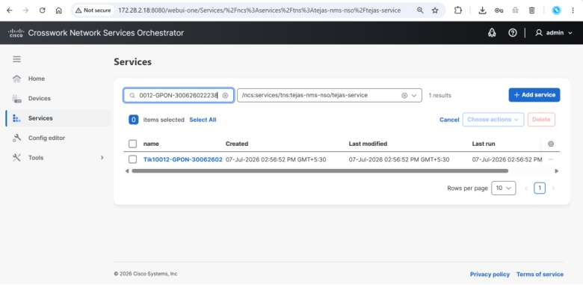  Committed order confirmed visible in RFS during Failover Test 2.

Test Case 19: Tejas EMS — Service Continuity During Failover Test 2
Description: | With RFS-18 and RFS-19 locked, verify the OLT service remains correctly reflected in the Tejas EMS application.
Why This Step: | Confirms the field device state stays consistent with the orchestration layer even while the RFS cluster is in a degraded/failover configuration, so field technicians and monitoring tools continue to see accurate data.
Procedure: | 1. Login to the Tejas EMS application.  2. Search using the relevant ONT Serial Number / service details.  3. Confirm the OLT service is still shown as correctly provisioned.
Expected Result: | The OLT service remains correctly shown as provisioned in Tejas EMS during Failover Test 2.
Result: | ☐ OK ☐ Not OK
Evidence / Logs: | 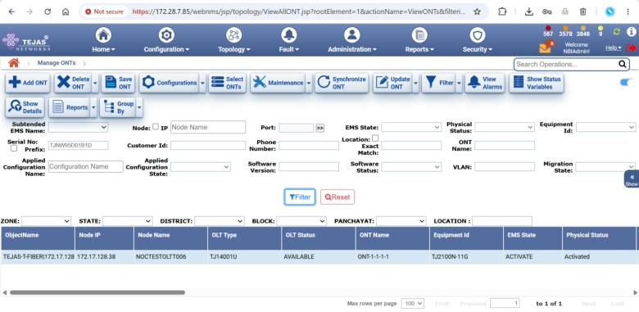  OLT service state confirmed consistent in Tejas EMS during Failover Test 2.

6. Document Acceptance
By signing below, the representatives confirm that the acceptance test procedure described in this document was witnessed and the results recorded are accurate.
Organization | MSI Representative | TPA Representative | T-Fiber Representative
Signature
Name
Designation
E-mail ID
Phone Number
Date

