CISCO NSO
End-to-End Acceptance Test Cases
Environment: 172.28.2.17 | LSA Deployment (RFS/CFS Cluster: RFS-18 Leader, RFS-19 & RFS-20 Followers)

1. Introduction & Executive Summary
This Acceptance Test Procedure (ATP) document outlines the end-to-end verification steps for the Cisco NSO (Network Services Orchestrator) platform. NSO serves as the central automation system, allowing the network team to provision and manage customer fiber connections without manual, device-by-device configuration.
The platform is deployed as an RFS cluster for high availability: RFS-18 operates as the Leader node, while RFS-19 and RFS-20 operate as Follower nodes, with all three nodes verified in an Unlocked, operational state.
The tests confirm that the system is running, the cluster is correctly formed, capable of processing real customer service orders, successfully activating physical field devices (OLTs), and safely rolling back (deleting) orders. Every checkpoint has been validated to ensure faster service activation, reduced human error, full traceability, and safe operations. Test cases are organized CLI-based first, followed by Web UI-based verification.

2. Test Results Summary
The table below summarizes each verification step performed and its outcome, in execution order (CLI-based checks first, followed by Web UI-based checks). Full technical evidence (CLI outputs and UI screenshots) for each step is provided in Section 3.
# | Checkpoint | What It Confirms | Type | Result
1 | System Health Check | Confirmed the orchestration platform (NSO) is running and available. | CLI | PASS
2 | Administrator Access | Confirmed authorized staff can securely log in to the system. | CLI | PASS
3 | Network Device Connectivity | Confirmed the platform can reach and communicate with field network devices (OLTs). | CLI | PASS
4 | Automation Package Check | Confirmed the provisioning automation package is correctly installed and active. | CLI | PASS
5 | Service Order Submission | A real customer service order (fibre connection setup) was submitted for processing. | CLI | PASS
6 | Order Processing | The order was processed and committed successfully with no errors. | CLI | PASS
7 | Audit Log Verification | System logs correctly recorded the full transaction for traceability. | CLI | PASS
8 | RFS Cluster Node Role & Status Verification | Confirmed RFS-18 (Leader), RFS-19 & RFS-20 (Followers) are correctly configured and Unlocked. | Web UI | PASS
9 | Web Portal Verification | The committed order was confirmed visible in both business (CFS) and network-facing (RFS) web dashboards. | Web UI | PASS
10 | Field Device Provisioning | Confirmed the physical field device (OLT/ONT) was actually configured to activate service. | Web UI | PASS
11 | Delete (Safe Rollback) | Confirmed the system can cleanly remove a service order across CFS, RFS, and Tejas EMS. | Web UI | PASS

3. Test Cases

Section 3.1 — CLI Based Test Cases
Test Case 1: System Health Check
Purpose / Why this step: | To ensure the core orchestration platform (NSO) is healthy, active, and ready to accept automation requests before any operational work begins.
Description: | Verification of NSO system health, version, and running status.
Procedure: | 1. Login to the NSO server via terminal.  2. Execute the command `ncs --status`.
Expected Result: | NSO status should show as `started` with all required modules (backplane, netconf, cdb, cli, snmp, webui) running.
Result: | ☑ PASS ☐ FAIL
Logs/Snaps: | root@cfsleader:/home/admin1# ncs --status  vsn: 6.4.11  SMP support: yes, using 128 threads  Using epoll: yes  available modules: backplane, netconf, cdb, cli, snmp, webui  running modules: backplane, netconf, cdb, cli, snmp, webui  daemon pid: 1602699  status: started

Test Case 2: Administrator Access
Purpose / Why this step: | To confirm that authorized staff can securely access the system via CLI, ensuring controlled access to the automation platform.
Description: | Verification of secure SSH login to the NSO server.
Procedure: | 1. Open a terminal/SSH client.  2. Connect to the NSO server using admin credentials: `ssh admin1@172.28.2.17`.
Expected Result: | Successful authentication and access to the Ubuntu/NSO CLI prompt.
Result: | ☑ PASS ☐ FAIL
Logs/Snaps: | PS C:\Users\40034761> ssh admin1@172.28.2.17  admin1@172.28.2.17's password:  Welcome to Ubuntu 24.04.4 LTS (GNU/Linux 6.17.0-20-generic x86_64)  ...  Last login: Tue Jun 30 01:25:56 2026 from 172.28.68.55  admin1@cfsleader:~$

Test Case 3: Network Device Connectivity
Purpose / Why this step: | To verify that the orchestrator can successfully reach and communicate with the field network devices (OLTs), which is a strict prerequisite for automated provisioning.
Description: | Verification of OLT reachability and admin state in NSO.
Procedure: | 1. Enter NSO CLI.  2. Execute the command `show devices list`.
Expected Result: | Field devices (RFS-18, RFS-19, RFS-20) should be listed with an `unlocked` admin state.
Result: | ☑ PASS ☐ FAIL
Logs/Snaps: | admin@ncs> show devices list  NAME ADDRESS DESCRIPTION NED ID ADMIN STATE  RFS-18 172.28.2.18 cisco-nso-nc-6.4 unlocked  RFS-19 172.28.2.19 cisco-nso-nc-6.4 unlocked  RFS-20 172.28.2.20 cisco-nso-nc-6.4 unlocked  [ok][2026-06-30 14:12:54]

Test Case 4: Automation Package Check
Purpose / Why this step: | To ensure the specific service automation packages required for provisioning are correctly installed, loaded, and operational.
Description: | Verification of active automation packages in NSO.
Procedure: | 1. In NSO CLI, execute the command `show packages`.
Expected Result: | Required packages (e.g., `tejas-nms-nso-cfs`, `cisco-nso-nc-6.4`) must show `oper-status up`.
Result: | ☑ PASS ☐ FAIL
Logs/Snaps: | admin@ncs> show packages  packages package tejas-nms-nso-cfs  oper-status up  packages package cisco-nso-nc-6.4  oper-status up

Test Case 5: Service Order Submission
Purpose / Why this step: | To validate that the system can accept and parse a real customer service order containing all necessary technical parameters (VLANs, bandwidth, ONT details).
Description: | Submission of a fibre connection setup order via CLI.
Procedure: | 1. Enter configuration mode.  2. Input service parameters for Service ID `Tik10012-GPON-300626022237` (Device, Package, OLT IP, ONT Serial, VLANs, Bandwidth Profiles).
Expected Result: | The system should accept all parameters without syntax or validation errors.
Result: | ☑ PASS ☐ FAIL
Logs/Snaps: | admin@ncs(config)# services tejas-nms-nso-cfs Tik10012-GPON-300626022237  device tejas-ems-pkga  package A  olt-ip 172.17.128.38  ont-serial TJNW95D01B1D  ont-model TJ2100N-11G  c-vlan 3000  s-vlan 3000  customer-id GOV/ITC/001  upstream-bandwidth-profile UP_GI_30M  downstream-bandwidth-profile TejNMS-DN_GI_30M  provisioning-mode bridge  vlan-tagging tagged  pon-port 1-1-1-1

Test Case 6: Order Processing
Purpose / Why this step: | To confirm that the orchestrator can successfully translate the submitted order into device-level configurations and push them to the network without errors.
Description: | Processing and committing the service order to the network.
Procedure: | 1. While in the service configuration context, execute the `commit` command.
Expected Result: | The commit operation should complete successfully and push configs to the target OLT.
Result: | ☑ PASS ☐ FAIL
Logs/Snaps: | admin@ncs(config-tejas-nms-nso-cfs-Tik10012-GPON-300626022237)# commit  Commit complete.

Test Case 7: Audit Log Verification
Purpose / Why this step: | To ensure every transaction is logged and visible for audit, compliance, and support traceability purposes.
Description: | Verification of system audit logs and commit trails.
Procedure: | 1. Review the system login and commit audit logs in the CLI.
Expected Result: | Logs should correctly record the user, timestamp, source IP, and transaction details.
Result: | ☑ PASS ☐ FAIL
Logs/Snaps: | User admin last logged in 2026-06-30T10:20:15.579897+00:00, to cfsleader, from 172.28.68.74 using rest-http  admin connected from 127.0.0.1 using console on cfsleader  admin@ncs# commit

Section 3.2 — Web UI Based Test Cases
Test Case 8: RFS Cluster Node Role & Status Verification
Purpose / Why this step: | To confirm the RFS cluster is correctly configured for high availability, with a designated Leader node and Follower nodes, and that all cluster members are operational.
Description: | Verification of RFS-18 (Leader), RFS-19 (Follower), and RFS-20 (Follower) cluster roles and Unlocked admin state via WebUI.
Procedure: | 1. Login to the RFS cluster WebUI (`172.28.2.18:8080` and corresponding pages for RFS-19 / RFS-20).  2. Navigate to the cluster / device status view for RFS-18, RFS-19, and RFS-20.  3. Confirm the assigned role (Leader/Follower) and admin state for each node.
Expected Result: | RFS-18 should be shown as the cluster Leader; RFS-19 and RFS-20 should be shown as Followers; all three RFS nodes (18, 19, 20) should be in the Unlocked state.
Result: | ☑ PASS ☐ FAIL
Logs/Snaps: | 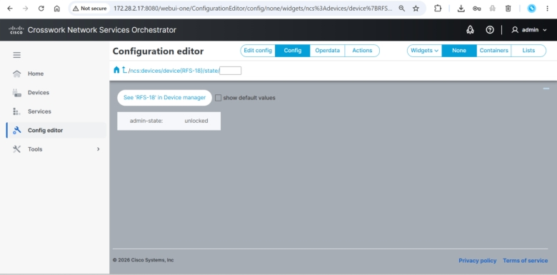  RFS-18 – Role: Leader, State: Unlocked  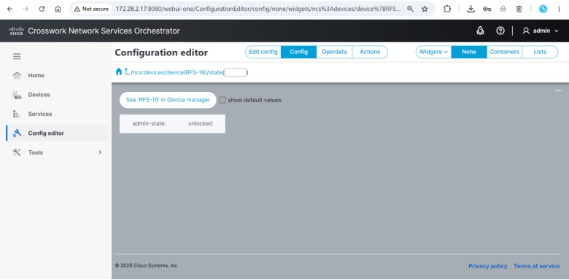  RFS-19 – Role: Follower, State: Unlocked  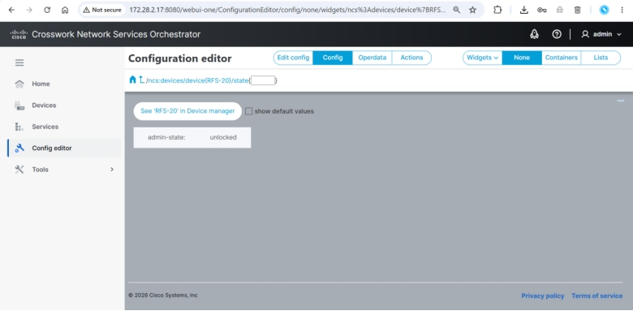  RFS-20 – Role: Follower, State: Unlocked  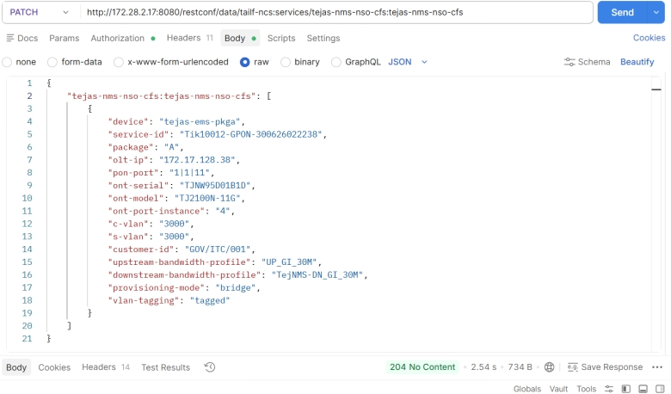  Cluster overview confirming Leader/Follower topology

Test Case 9: Web Portal Verification
Purpose / Why this step: | To confirm the committed order is visible and synchronized across both the business-facing (CFS) and network-facing (RFS) web dashboards for operational monitoring.
Description: | Verification of service order visibility in CFS and RFS WebUI.
Procedure: | 1. Login to CFS WebUI (`172.28.2.17:8080`) and RFS WebUI (`172.28.2.18:8080`).  2. Navigate to the Services dashboard.  3. Search for Service ID `Tik10012-GPON-300626022238`.
Expected Result: | The service order should be visible with correct creation and last-run timestamps in both dashboards.
Result: | ☑ PASS ☐ FAIL
Logs/Snaps: | 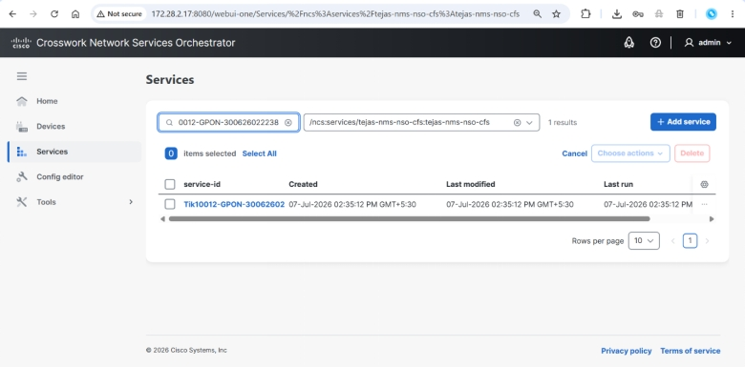  CFS Services Page showing the committed Service ID  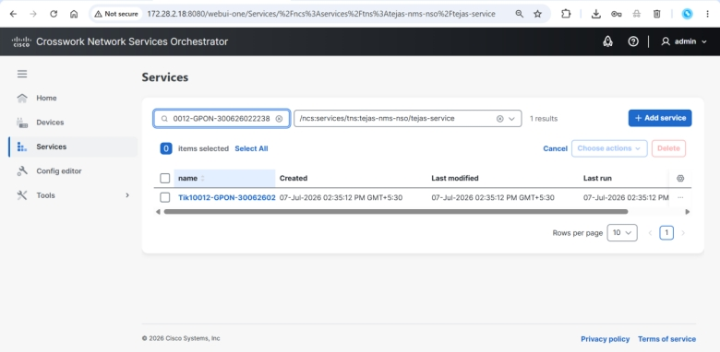  RFS Services Page showing the committed Service ID

Test Case 10: Field Device Provisioning
Purpose / Why this step: | To verify that the physical field device (OLT/ONT) was actually configured and activated in the underlying Element Management System (Tejas EMS).
Description: | Verification of ONT provisioning status in Tejas EMS WebUI.
Procedure: | 1. Login to Tejas EMS WebUI.  2. Navigate to Manage ONTs.  3. Filter/Search by ONT Serial Number `TJNW95D01B1D`.
Expected Result: | The ONT should show as provisioned with EMS State `ACTIVATE` and Physical Status `Activated`.
Result: | ☑ PASS ☐ FAIL
Logs/Snaps: | 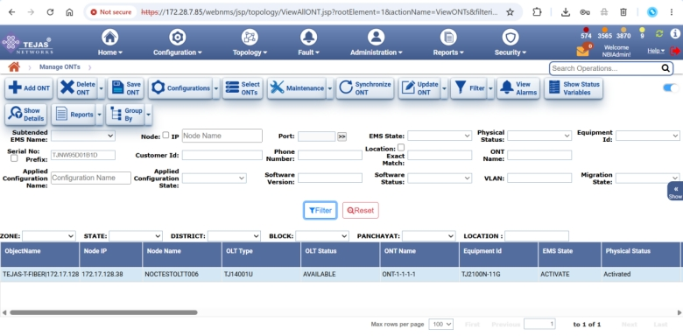  Tejas EMS Manage ONTs page  Node IP: 172.17.128.38 | OLT Type: TJ14001U | ONT Name: ONT-1-1-1-1  Equipment Id: TJ2100N-11G | EMS State: ACTIVATE | Physical Status: Activated

Test Case 11: Delete (Safe Rollback)
Purpose / Why this step: | To prove the system's safe rollback capability, ensuring that service cancellations or corrections cleanly remove the order without leaving the platform or field devices in an inconsistent state.
Description: | Execution and verification of service order deletion across CFS, RFS, and Tejas EMS.
Procedure: | 1. Delete the service order via CFS WebUI / CLI (`delete /ncs:services/tejas-nms-nso-cfs:tejas-nms-nso-cfs(Tik10012-GPON-300626022238)` followed by `commit`).  2. Verify deletion in CFS WebUI, RFS WebUI, and Tejas EMS.
Expected Result: | Service should be cleanly removed. CFS/RFS should show "No services found", and Tejas EMS should reflect the ONT removal/deactivation.
Result: | ☑ PASS ☐ FAIL
Logs/Snaps: | 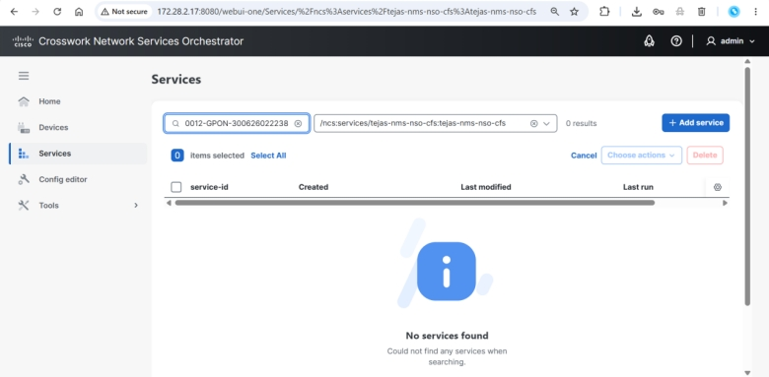  CFS showing “No services found” after deletion  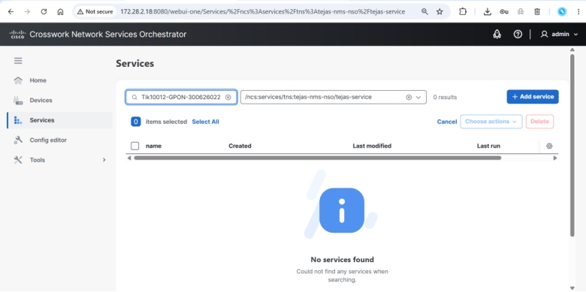  RFS showing “No services found” after deletion  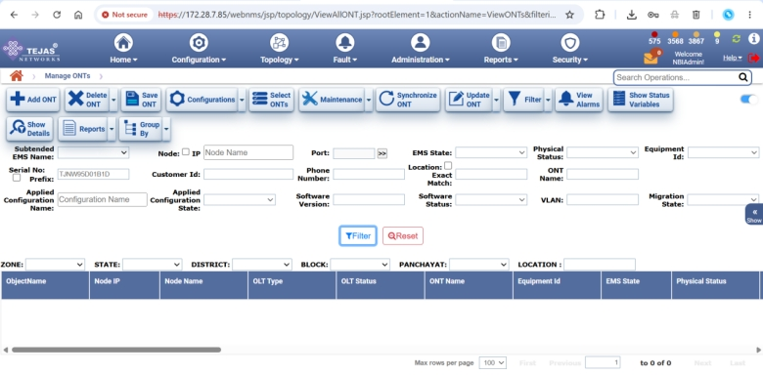  Tejas EMS showing ONT removed/deactivated

4. Document Acceptance
All test cases listed above have been executed and passed. By signing below, the representatives confirm acceptance of the Cisco NSO platform as fit for production use.
Organization | MSI Representative | TPA Representative | T-Fiber Representative
Signature
Name
Designation
E-mail ID
Phone Number
Date

