What is cisco NSO? It is a multi-vendor network automation and service orchestration software.
This section discusses the benefits and architecture of Cisco NSO.
What is Cisco NSO?
What are network automation and service orchestration provided by Cisco NSO?
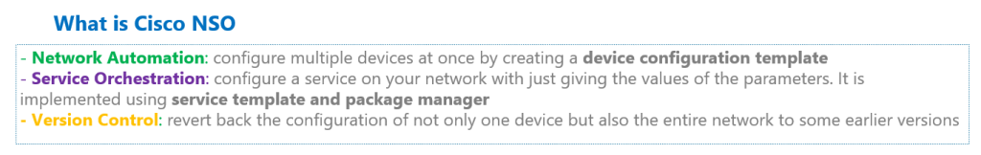What is Cisco NSO
Network automation means that you can configure multiple devices at the same time by creating a device configuration template.
Service orchestration means that you can configure a service on your network without giving any commands, but just giving the values of the parameters required to implement the service.
For example, if you want to configure a new VLAN on your network, simply enter the name of the new VLAN and the switches in which you want to have this new network. A new VLAN number is configured in the corresponding switches and it is added to the allowed VLAN list of the corresponding trunk interfacesby cisco NSO
Service orchestration will be implemented using service template which will be discussed during the course.
Additionally, it has the capability of version control like many other automation software. By version control, you can revert back the configuration of not only one device but also the entire network to some earlier versions.
NSO is a multi-vendor automation software
Cisco NSO is a multi-vendor automation software which support more than 170 device types or vendors.
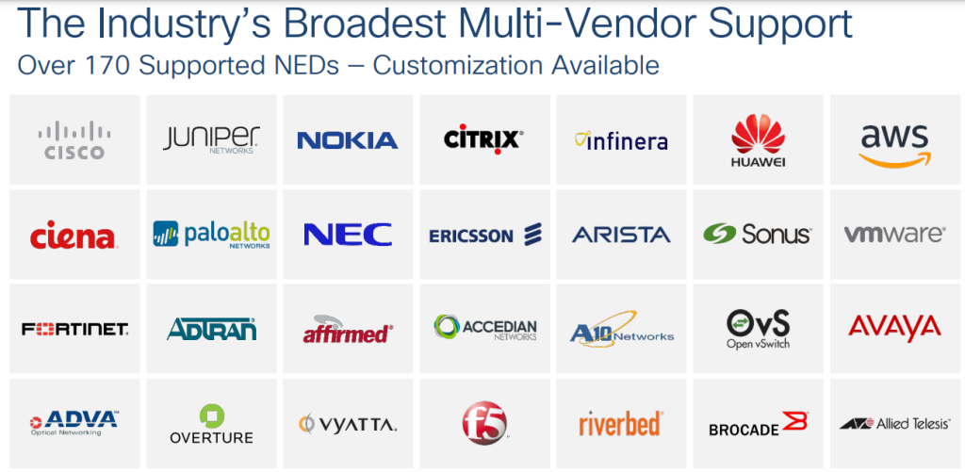Cisco NSO Multi-Vendor supported devices list
Cisco NSO must have a driver for any device supported by this software. Network device drivers in this software are called NED or network element drivers.
See the links below for a list of some supported NEDs. link1 link2
As you can see, the list of the most important network device vendors can be found in the supported devices list.
Architecture of Cisco NSO
To learn more about Cisco NSO, let’s take a look at the NSO architecture and components. This photo which is taken from cisco documents, shows the most important components of this software.
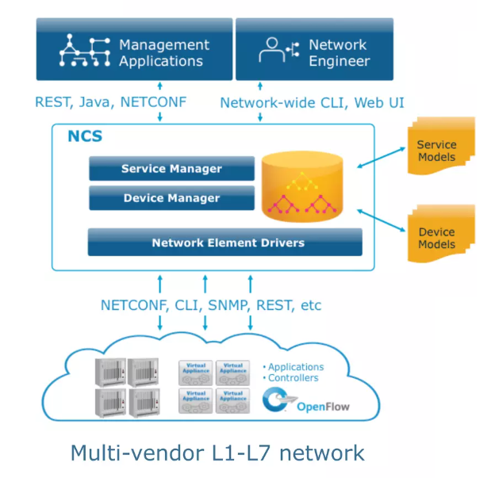Cisco NSO Architecture
From southbound, there is a NED or device driver for each device supported In this software.
Depending on the type of devices supported, it communicates with the devices using different methods. CLI, SNMP, NETCONF, and RESTCONF are the main communication methods that this software uses to get or change the configuration of network devices.
More than 170 devices are currently supported by NSO over the southbound interface.
From the northbound, not only network administrators, but also applications can communicate with network devices via this software.
NSO can be managed via CLI and GUI. These methods are primarily used by network administrators to automate networks and orchestrate services through NSO.
NSO can also be managed through NETCONF and RESTCONF which is mainly used by network developer’s and applications to get or set the data of network devices through cisco NSO.
Suppose you as an administrator, orchestrate MPLS VPN service in NSO through CLI or WEB GUI. Therefore, to add a new MPLS VPN customer, we give just the list of PE routers and interfaces in which the new customer is connected.
In the next step, we develop an application to add new customers in MPLS service through the application. In other words, for each new customer, the list of PE routers and interfaces connected to the new customer is given through the application.
This application then communicates with NSO via NETCONF or RESTCONF protocol to transfer each customer information.
Both NETCONF and RESTCONF protocols use YANG data model, which is fully supported by NSO. About the Yang data model and the RESTCONF and NETCONF protocol, we have already prepared a course that you can study from this link.
You see the name “NCS” in the photo which is the old name of “NSO“. You will see the old name many times throughout the course since the name of the software and commands are still “NCS”.
Device manager and Service manager are two main components of this software.
With device manager, you can automate network devices through creating device configuration templates which will be discussed in a few sections.
With service manager, you can orchestrate network services through creating new packages including, configuration template, yang data model and logic codes.
Creating services through NSO is one the most important topic discussed in this course which will be discussed during the course.
=========================================================================
2. Install Cisco NSO version 6.0 on Ubuntu 22.04
How to install Cisco NSO version 6.0 on Ubuntu version 22.04 is the topic of this section.
Install Cisco NSO version 6.0 on Ubuntu 22.04
To install cisco NSO, I have already installed an ubuntu client system with version 22.04.
Let’s check the version of my Ubuntu.
majid@majid-ubuntu:~$ cat /etc/lsb-release
DISTRIB_ID=Ubuntu
DISTRIB_RELEASE=22.04
DISTRIB_CODENAME=jammy
DISTRIB_DESCRIPTION="Ubuntu 22.04.2 LTS"
prerequisite to Install NSO
This is the main cisco documentation link to get and install cisco NSO software.
As a prerequisite, we need Java, Apache Ant, Python 3 and development tools, which must be installed on a Linux or macOS system. Direct installation on Windows systems is currently not possible.
There are two types of installation, “System Install” for a centralized and always-on production environment and “Local Install” which is used for evaluation and lab environment.
Cisco NSO official documentation provides details on both methods. However, in this section we will install the local version of this software.
I have already prepared step by step documentation how to install Cisco NSO version 6.0 on Ubuntu version 22.04.
As the first step, we instal the pre-requisites.
sudo apt-get install default-jdk
sudo apt-get install ant
sudo apt-get install python3 python3-pip python3-setuptools
sudo apt install libxml2-utils
sudo apt-get install tree
sudo apt-get install -y xsltproc
pip3 install paramiko
Download NSO and NED from Cisco Website
Then we have to download the software and some free NED (network element drivers) from cisco website.
The latest version is version 6.0 and in addition to “Cisco Network Services Orchestrator Linux Installer”, we are allowed to install free NED for Cisco ASA, Cisco IOS, IOS-XR and NX-OS.
My cisco account is a normal account and not a special account but I could download the software and NEDs from cisco website.
nso-6.0-freetrial.linux.x86_64.signed.bin
ncs-6.0-cisco-asa-6.16-freetrial.signed.bin
ncs-6.0-cisco-ios-6.88-freetrial.signed.bin
ncs-6.0-cisco-iosxr-7.43-freetrial.signed.bin
ncs-6.0-cisco-nx-5.23.6-freetrial.signed.bin
Install NSO
I have already uploaded the downloaded software and packages in a folder with the name of “cisco_nso”.
Before proceeding with the installation, I need to explain the folder names that I will be using in my installation. Of course you can use your favourite names.
I will use the folder “cisco_nso” for storing the downloaded packages.
I will use the folder “nso-6.0” as an installation directory. In other words, NSO will be installed in this folder.
With installing NSO, actually it does not start and you have just prepared it run the software.
For running of the cisco NSO, you have to run an instance of NSO. Different instance of NSO can be run for different lab environments.
We will create and run an instance of NSO in a folder with the name of “nso-instance”. This folder is actually the running instance of NSO which can be customized for each lab environment.
For each instance of NSO only the required NED drivers and service packages will be loaded.
# cisco_nso: to store downloaded files
# nso-6.0: to install nso
# nso-instance: running instance of NSO installation
In the next step, we verify the certificate and extract the installer file using “sh” command.
We ignore certificate verification and just extract the binary installer file. A new binary file with the name of “nso-6.0.linux.x86_64.installer.bin” will be created which we use to install the software.
cd cisco_nso
sh nso-6.0-freetrial.linux.x86_64.signed.bin --skip-verification
Then we create a folder with the name of “nso-6.0”, in home directory, as we discussed.
Then we install local version of NSO using “sh” command and “–local-install” option in “nso-6.0” folder.
# install ncs
mkdir $HOME/nso-6.0
sh nso-6.0.linux.x86_64.installer.bin $HOME/nso-6.0 --local-install
Add new NEDs in NSO
In the installed directory “nso-6.0” there is a folder called “packages“. Inside that folder is the “neds” folder, which contains some free NSO drivers for Cisco IOS, IOS-XR, ASA, NX-OS, Juniper Junos, and A10 device types.
# existing neds
majid@majid-ubuntu:~/cisco_nso$ ls ~/nso-6.0/packages/neds/
a10-acos-cli-3.0 cisco-asa-cli-6.6 cisco-ios-cli-3.8 cisco-iosxr-cli-3.5 dell-ftos-cli-3.0
alu-sr-cli-3.4 cisco-ios-cli-3.0 cisco-iosxr-cli-3.0 cisco-nx-cli-3.0 juniper-junos-nc-3.0
However, we are going to add the new downloaded drivers into packages which has the newer version of IOS, IOS-XR, NX-OS and ASA software.
For that we extract downloaded ned drives using “sh” command. Drivers with the format of “.tar.gz” will be created. Then we will unzip and add these files into existing ned drivers in installed directory.
cd ~/cisco_nso/
sh ncs-6.0-cisco-nx-5.23.6-freetrial.signed.bin --skip-verification
sh ncs-6.0-cisco-asa-6.16-freetrial.signed.bin --skip-verification
sh ncs-6.0-cisco-ios-6.88-freetrial.signed.bin --skip-verification
sh ncs-6.0-cisco-iosxr-7.43-freetrial.signed.bin --skip-verification

majid@majid-ubuntu:~/cisco_nso$ ls -l ncs*.tar.gz
-rw-r--r-- 1 majid majid 7140942 Okt 18 2022 ncs-6.0-cisco-asa-6.16.tar.gz
-rw-r--r-- 1 majid majid 54021270 Nov 4 2022 ncs-6.0-cisco-ios-6.88.tar.gz
-rw-r--r-- 1 majid majid 39305257 Okt 7 2022 ncs-6.0-cisco-iosxr-7.43.tar.gz
-rw-r--r-- 1 majid majid 9895988 Nov 12 2022 ncs-6.0-cisco-nx-5.23.6.tar.gz

majid@majid-ubuntu:~/cisco_nso$ cd ~/nso-6.0/packages/neds/
tar -zxvf ~/cisco_nso/ncs-6.0-cisco-asa-6.16.tar.gz
tar -zxvf ~/cisco_nso/ncs-6.0-cisco-ios-6.88.tar.gz
tar -zxvf ~/cisco_nso/ncs-6.0-cisco-iosxr-7.43.tar.gz
tar -zxvf ~/cisco_nso/ncs-6.0-cisco-nx-5.23.6.tar.gz
Setup Environment Variable
Now NSO software is installed but still not started.
Before starting an instance of cisco NSO, we have to setup the environment variables.
In the installed directory “nso-6.0”, there is already a bash script with the name of “ncsrc” which setup the environment variable.
Therefore, we need to source “ncsrc” file before running an instance of cisco NSO.
majid@majid-ubuntu:~/nso-6.0$ source $HOME/nso-6.0/ncsrc
Create and Run NSO Instance
Then we create the folder “nso-instance” folder, as we discussed which will be used to keep the running instance of NSO.
Then we run the instance of NSO with “ncs-setup” command. We only load the required ned drivers that we need in the lab environment with “–package” parameter. The “nso-instance” folder, will be chosen as destination folder with “–dest” parameter.
# create an instance of ncs with ncs-setup
mkdir $HOME/nso-instance

ncs-setup --package ~/nso-6.0/packages/neds/cisco-iosxr-cli-7.43 \
--package ~/nso-6.0/packages/neds/cisco-asa-cli-6.16 \
--package ~/nso-6.0/packages/neds/cisco-ios-cli-6.88 \
--package ~/nso-6.0/packages/neds/cisco-nx-cli-5.23 \
--package ~/nso-6.0/packages/neds/juniper-junos-nc-3.0 \
--dest ~/nso-instance
Now an instance of NSO is created. To run it, we have to go inside “nso-instance” directory and run the command “ncs”.
# start ncs
cd $HOME/nso-instance
ncs
Check if NSO is installed correctly
As you see to run nso, we use the command “ncs”, which is the old name of nso. The name of the software has changed but still the commands are started with the old name.
To make sure that nso is running, we can use the command “ncs –status | grep status”.
majid@majid-ubuntu:~/nso-instance$ ncs --status | grep status
status: started
db=running id=34 priority=1 path=/ncs:devices/device/live-status-protocol/device-type
You can also connect to GUI and web version of NSO software with port number 8080 and username and password admin/admin.
http://192.168.2.101:8080/login.html
admin/admin
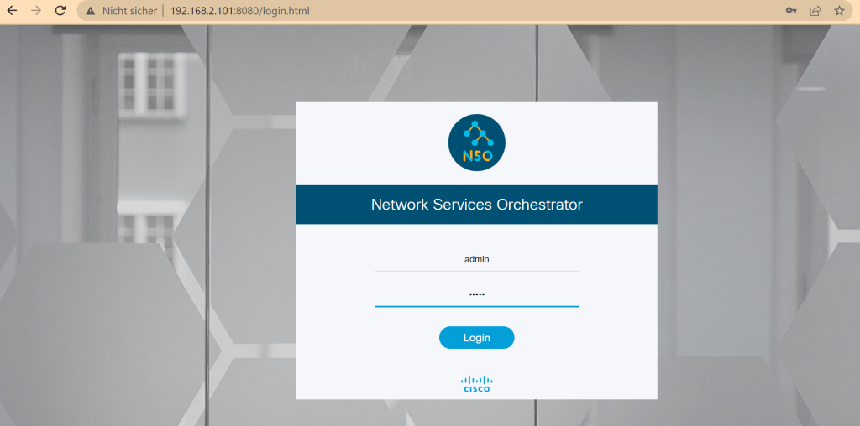Install Cisco NSO: web version of cisco NSO
connect to NSO
With command “ncs_cli” we can connect to NSO CLI environment.
There are two options for the CLI environment. With “-C” we connect to the Cisco XR style and with “-J” option we connect to the juniper style. You can choose whichever is more convenient for you. We will use cisco CLI style during the course.
# connect to NSO CLI
ncs_cli -C -u admin # cisco style
ncs_cli -J -u admin # juniper style
In the NSO CLI environment, with the command “show ncs-state version” you can check the version of NSO which is installed in your system.
admin@ncs# show ncs-state version
ncs-state version 6.0
And with the command “show packages package package-version”, you can check ned drivers that are loaded in current nso instance.
admin@ncs# show packages package package-version
PACKAGE
NAME VERSION
--------------------------------
cisco-asa-cli-6.16 6.16
cisco-ios-cli-6.88 6.88
cisco-iosxr-cli-7.43 7.43
cisco-nx-cli-5.23 5.23.6
juniper-junos-nc-3.0 3.0.14.2

admin@ncs#
connect to NSO in a new bash CLI
To add one important point, when you run “ncs_cli” command in a new bash environment, you get the message that the command is not found.
To solve the problem, you have to again setup nso environment variable with “ncsrc” command. Then “ncs_cli” command will be run.
majid@majid-ubuntu:~/nso-instance$ ncs_cli -C -u admin
ncs_cli: command not found
majid@majid-ubuntu:~/nso-instance$ source $HOME/nso-6.0/ncsrc
majid@majid-ubuntu:~/nso-instance$ ncs_cli -C -u admin

User admin last logged in 2023-06-08T01:05:03.377881+00:00, to majid-ubuntu, from 192.168.2.175 using cli-ssh
admin connected from 192.168.2.175 using ssh on majid-ubuntu
admin@ncs#
next step
The next step is to connect the NSO instance with your physical or virtual devices. But probably you don’t have any devices to connect NSO to them.
We have the option to use the devices in netsim simulator which is embedded in nso instance. This will be discussed in the next section.
=========================3==========================================
. cisco nso netsim to add devices in nso lab
After installing and starting Cisco NSO, we now need to prepare some network devices to be connected and managed through Cisco NSO.
Network devices for connecting to Cisco NSO can be physical, virtual, or NetSim simulator devices which is included in Cisco NSO software.
use netsim to add network devices in the lab
I have already prepared a virtual Cisco IOS-XE CSR1000V that will be used mainly during the course.
I downloaded the CSR1000V “ova” file from this link on the Cisco website and imported it into the VMware ESX server.
But in addition to CSR1000v, just to show, in this section I will add some devices via netsim simulator.
We will use the existing packages to be loaded in netsim simulator.
Here is an example to add a network via netsim simulator.
Do not forget to setup environment variable using “ncsrc” before using netsim simulator if you have rebooted nso machine or using a new bash environment. Otherwise you receive the message that the command does not exist.
source $HOME/nso-6.0/ncsrc
First as an optional step, we delete the existing network in simulator using “ncs-netsim” command and “delete-network” option.
Then we add a new network using “create-network” and “add-to-network” parameter and existing drivers in packages folder.
In our example, we add three ios device, one asa, one device with ios-xr, one with nx-os and finally one juniper device.
Then we will start the new network using “ncs-netsim start” command.
# add devices using "netsim"
cd ~/nso-instance/
ncs-netsim delete-network # if already exist
ncs-netsim create-network packages/cisco-ios-cli-6.88 3 ios
ncs-netsim add-to-network packages/cisco-asa-cli-6.16 1 asa
ncs-netsim add-to-network packages/cisco-iosxr-cli-7.43 1 iosxr
ncs-netsim add-to-network packages/cisco-nx-cli-5.23 1 nxos
ncs-netsim add-to-network packages/juniper-junos-nc-3.0 1 junos
ncs-netsim start
During the course, we can configure netsim network devices through cisco nso software. But if you want to connect to the netsim network devices directly, you can use the command “ncs-netsim cli-i <DEVICE-NAME>”.
The option “cli-i” means “Cisco IOS Style”. The other options are “cli” and “cli-c” which in order means “J-Style” (Juniper Style) and “Cisco XR Style”.
cli : J-Style
cli-c : Cisco XR Style
cli-i : Cisco IOS Style
If you connect to one of ios devices in netsim, and check some commands, you will notice that “show ip interface brief” command does not work. This is the limitation of netsim simulator.
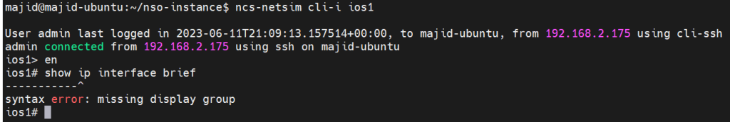cisco nso netsim commands limitation
majid@majid-ubuntu:~/nso-instance$ ncs-netsim cli-i ios1

admin connected from 192.168.2.175 using ssh on majid-ubuntu
ios1> en
ios1# show ip interface brief
-----------^
syntax error: missing display group
ios1#
run nso and netsim after restart
Now we are ready to connect cisco nso to real and also netsim simulated devices which is pre-requisite to automate and orchestrate network services. This is the main topic of the next section.
But before we move on to the next section, let’s look at how to start cisco nso and netsim devices, after we restart nso machine.
Here I have prepared a bash script showing the steps to run NSO and Netsim devices after reboot.
Set up the environment variable, run the “ncs” command to run nso and the “ncs-netsim start” command to start netsim devices. Finally, we connect to the NSO command environment
majid@majid-ubuntu:~/devnet/cisco_nso$ cat run_nso_after_restart
#!/bin/bash

echo "setup nso environment variable"
source $HOME/nso-6.0/ncsrc
echo -e "done \n"

echo "starting nso instance with running ncs command..."
echo "please wait. it takes a few minutes ..."
cd ~/nso-instance/
ncs
echo -e "done \n"

echo "starting netsim devices"
ncs-netsim start
echo -e "done \n"

echo -e "connect to nso CLI environment \n"
ncs_cli -C -u admin
majid@majid-ubuntu:~/devnet/cisco_nso$ ./run_nso_after_restart
setup nso environment variable
done

starting nso instance with running ncs command...
please wait. it takes a few minutes ...
done

starting netsim devices
DEVICE ios0 OK STARTED
DEVICE ios1 OK STARTED
DEVICE ios2 OK STARTED
DEVICE asa0 OK STARTED
DEVICE iosxr0 OK STARTED
DEVICE nxos0 OK STARTED
DEVICE junos0 OK STARTED
done

connect to nso CLI environment

admin connected from 192.168.2.175 using ssh on majid-ubuntu
admin@ncs#

===========================4========================================
4. connect and sync nso to network devices
connect and sync cisco nso to network devices is what we will discuss in this section.
connect NSO to network devices
In the previous sections, we installed Cisco NSO and prepared a CSR1000V device and some NetSim emulated devices.
In this section, we will connect Cisco NSO to all of these devices and sync the configuration of the devices to Cisco NSO so that they can be managed from Cisco NSO from now on.
To connect Cisco NSO to a device, we need to know the IP address of the device, the authentication information used to connect to the device, and the connection method, Telnet or SSH.
To do this, we configure an authentication group including username, password, and optional enable password.
More than one authentication group can be configured, since different network devices will probably need different credentials to connect to them.
For each device, we configure in Cisco NSO which authentication group to use to connect to the network device.
Here we have configured authentication group “RAYKA” with username “rayka”, password “rayka-co.com” and optional enable password “rayka-co.com”.
Then we configure a device named “R1” and IP address “192.168.2.91” to use authentication group “RAYKA”, the connection protocol “SSH” and ignore host key verification.
# add authentication group
devices authgroups group RAYKA
default-map remote-name rayka
default-map remote-password rayka-co.com
default-map remote-secondary-password rayka-co.com

# add a device
devices device R1
address 192.168.2.91
authgroup RAYKA
ssh host-key-verification none
device-type cli ned-id cisco-ios-cli-6.88
device-type cli protocol ssh
state admin-state unlocked
commit
connect
end
We need to unlock the device since all devices are locked by default when added to Cisco NSO.
Then we commit the configuration, which means to apply the configuration. otherwise, the configuration is added to the candidate configuration, but is not active until it is committed.
We will talk more about commit command in the next section.
Then we check the connectivity to the network device with “connect” command to make sure that all parameters are configured correctly.
In my case, the connection is refused and we receive the error “SSH key exchange failed”.
admin@ncs(config-device-R1)# devices device R1
admin@ncs(config-device-R1)# address 192.168.2.91
admin@ncs(config-device-R1)# authgroup RAYKA
admin@ncs(config-device-R1)# ssh host-key-verification none
admin@ncs(config-device-R1)# device-type cli ned-id cisco-ios-cli-6.88
admin@ncs(config-device-R1)# device-type cli protocol ssh
admin@ncs(config-device-R1)# state admin-state unlocked
admin@ncs(config-device-R1)# commit
Commit complete.
admin@ncs(config-device-R1)# connect
result false
info Failed to authenticate towards device R1: SSH key exchange failed
admin@ncs(config-device-R1)# *** ALARM connection-failure: Failed to authenticate towards device R1: SSH key exchange failed
admin@ncs(config-device-R1)#
The problem is that the protocol “ssh-rsa” is not in the list of allowed algorithms in cisco nso but it is the cisco csr1000v default ssh algorithm.
Let’s look at the list of acceptable algorithms in Cisco NSO and then add the “SSH-RSA” algorithm to the list to solve the problem.
admin@ncs# show running-config devices global-settings ssh-algorithms public-key | details
devices global-settings ssh-algorithms public-key [ ssh-ed25519 ecdsa-sha2-nistp256 ecdsa-sha2-nistp384 ecdsa-sha2-nistp521 rsa-sha2-512 rsa-sha2-256 ]
admin@ncs(config)# devices global-settings ssh-algorithms public-key ssh-rsa
admin@ncs(config)# commit
Commit complete.
admin@ncs(config)# devices device R1
admin@ncs(config-device-R1)# connect
result true
info (admin) Connected to R1 - 192.168.2.91:22
admin@ncs(config-device-R1)#
Now the connection result is true and we can connect to the configured device.
connect NSO to netsim devices
In the next step we will connect cisco nso to netsim emulated devices.
To do this, we need the IP address, port, and credentials to connect Cisco NSO to netsim emulated devices.
The “ncs-netsim” command has the “ncs-xml-init” option that exports the list of devices, IP address, port, credentials and the algorithm used to connect to them in the format of an XML output.
ncs-netsim ncs-xml-init
This is exactly like what we have done for router R1.
Then we can export the xml output into a file and load the file into nso configuration file. Then we are allowed to connect to netsim emulated devices.
Let’s create the list of netsim emulated devices with “ncs-netsim” command and export the xml output into a file.
majid@majid-ubuntu:~/devnet/cisco_nso$ cd ~/nso-instance/
majid@majid-ubuntu:~/nso-instance$ ls
logs ncs-cdb ncs.conf netsim packages README.ncs scripts state storedstate target
majid@majid-ubuntu:~/nso-instance$ source $HOME/nso-6.0/ncsrc
majid@majid-ubuntu:~/nso-instance$ ncs-netsim ncs-xml-init > devices.xml
majid@majid-ubuntu:~/nso-instance$ ls
devices.xml logs ncs-cdb ncs.conf netsim packages README.ncs scripts state storedstate target
If we check inside the xml file, you see the list of devices and information to connect to devices.
majid@majid-ubuntu:~/nso-instance$ cat devices.xml | egrep "name|address|port|ned-id"
<name>ios0</name>
<address>127.0.0.1</address>
<port>10022</port>
<ned-id xmlns:id="http://tail-f.com/ns/ned-id/cisco-ios-cli-6.88">id:cisco-ios-cli-6.88</ned-id>
<name>ios1</name>
<address>127.0.0.1</address>
<port>10023</port>
<ned-id xmlns:id="http://tail-f.com/ns/ned-id/cisco-ios-cli-6.88">id:cisco-ios-cli-6.88</ned-id>
<name>ios2</name>
<address>127.0.0.1</address>
<port>10024</port>
<ned-id xmlns:id="http://tail-f.com/ns/ned-id/cisco-ios-cli-6.88">id:cisco-ios-cli-6.88</ned-id>
<name>asa0</name>
<address>127.0.0.1</address>
<port>10025</port>
<ned-id xmlns:id="http://tail-f.com/ns/ned-id/cisco-asa-cli-6.16">id:cisco-asa-cli-6.16</ned-id>
<name>iosxr0</name>
<address>127.0.0.1</address>
<port>10026</port>
<ned-id xmlns:id="http://tail-f.com/ns/ned-id/cisco-iosxr-cli-7.43">id:cisco-iosxr-cli-7.43</ned-id>
<name>nxos0</name>
<address>127.0.0.1</address>
<port>10027</port>
<ned-id xmlns:id="http://tail-f.com/ns/ned-id/cisco-nx-cli-5.23">id:cisco-nx-cli-5.23</ned-id>
<name>junos0</name>
<address>127.0.0.1</address>
<port>12028</port>
<ned-id xmlns:id="http://tail-f.com/ns/ned-id/juniper-junos-nc-3.0">id:juniper-junos-nc-3.0</ned-id>
Now we load the xml file including the list of devices into configuration file and commit the changes to apply the new configuration.
majid@majid-ubuntu:~/nso-instance$ ncs_cli -u admin -C
!
User admin last logged in 2023-06-15T15:03:10.186059+00:00, to majid-ubuntu, from 192.168.2.175 using cli-ssh
admin connected from 192.168.2.175 using ssh on majid-ubuntu
!
admin@ncs# config t
Entering configuration mode terminal
admin@ncs(config)# load merge devices.xml
Loading.
9.81 KiB parsed in 0.18 sec (54.48 KiB/sec)
!
admin@ncs(config)# commit
Commit complete.
admin@ncs(config)#
If you review the new configuration, you will see that all new devices are added to the configuration, including the IP address and port to connect to the device, the public key, and the default authentication group, which is public-key authentication.
...
devices device ios0
address 127.0.0.1
port 10022
ssh host-key ssh-rsa
key-data ...
!
ssh host-key ssh-ed25519
key-data AAAAC3NzaC1lZDI1NTE5AAAAIIPA15JhvDCk+JZ5yViUjPw9k+Vl8kKS1BWEO9w/iTTx
!
authgroup default
device-type cli ned-id cisco-ios-cli-6.88
ssh-algorithms public-key [ ssh-ed25519 ssh-rsa ]
state admin-state unlocked
...
Now we can check the connectivity to network devices using “devices connect” in configuration mode to make sure that everything is working as we expect.
admin@ncs(config)# devices connect
connect-result {
device R1
result true
info (admin) Connected to R1 - 192.168.2.91:22
}
connect-result {
device asa0
result true
info (admin) Connected to asa0 - 127.0.0.1:10025
}
connect-result {
device ios0
result true
info (admin) Connected to ios0 - 127.0.0.1:10022
}
...
With the command “show devices list” in enable mode in cisco nso, you can check the list of devices added to cisco nso. You can always use this command to review and check the list of your devices.
admin@ncs# show devices list
NAME ADDRESS DESCRIPTION NED ID ADMIN STATE
--------------------------------------------------------------------
R1 192.168.2.91 - cisco-ios-cli-6.88 unlocked
asa0 127.0.0.1 - cisco-asa-cli-6.16 unlocked
ios0 127.0.0.1 - cisco-ios-cli-6.88 unlocked
ios1 127.0.0.1 - cisco-ios-cli-6.88 unlocked
ios2 127.0.0.1 - cisco-ios-cli-6.88 unlocked
iosxr0 127.0.0.1 - cisco-iosxr-cli-7.43 unlocked
junos0 127.0.0.1 - juniper-junos-nc-3.0 unlocked
nxos0 127.0.0.1 - cisco-nx-cli-5.23 unlocked
Sync NSO to network devices
We’ve connected the Cisco NSO to the network devices, but we’re still not ready to start automating and orchestrating with Cisco NSO.
This is because the configuration of the device needs to be synchronized in Cisco NSO. At this point, it is possible to configure devices through Cisco NSO rather than directly, which is a prerequisite for automating and orchestrating network devices and services.
There are two configuration synchronization options. The option “sync-from” syncs configuration from network device to Cisco NSO and “sync-to” option syncs configuration from Cisco NSO to network devices.
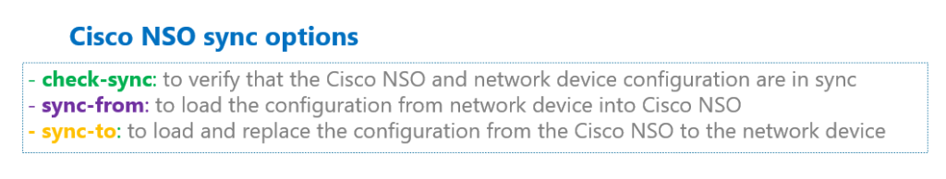cisco nso sync options
The option “sync-from” is usually used when we connect cisco nso to a new network device. With this option we load the configuration from network device to the cisco nso.
The option “sync-to” is typically used when we configure the network device directly and not through Cisco NSO. In this case, the configuration is no longer synchronized. therefore, we use “sync-to” option to replace the configuration of network device with the configuration stored in cisco nso.
However, these are not the only application of “sync-from” and “sync-to” option and can also be used in any application to replace configuration from network device to Cisco NSO or vice versa.
cisco nso ""check-sync" option
With the command “devices check-sync” you can check if the configuration of devices are synchronized.
With the command “devices device R1 check-sync” you can check if the configuration of specific device (here, R1) is synchronized.
admin@ncs(config)# devices check-sync
sync-result {
device R1
result unknown
}
sync-result {
device asa0
result unknown
}
sync-result {
device ios0
result unknown
}
...
admin@ncs(config)# devices device R1 check-sync
result out-of-sync
cisco nso "sync-from option"
If they are not synchronized, then we load the configuration from network device into cisco nso using “devices sync-from” to load and synchronize the configuration of all devices into cisco nso or “devices device R1 sync-from” to load and synchronize the configuration of specific device into cisco nso.
admin@ncs(config)# devices sync-from
sync-result {
device R1
result true
}
sync-result {
device asa0
result true
}
sync-result {
device ios0
result true
}
...
admin@ncs(config)# devices device R1 sync-from
result true
After we have loaded the configuration into Cisco NSO and synced it, we can use the “devices check-sync” command again to verify that it has been synced correctly.
admin@ncs(config)# devices check-sync
sync-result {
device R1
result in-sync
}
sync-result {
device asa0
result in-sync
}
sync-result {
device ios0
result in-sync
}
...
admin@ncs(config)# devices device R1 check-sync
result in-sync
We can also check the configuration of the device through Cisco NSO to make sure it is loaded into Cisco NSO from the network device.
With the command “show running-config devices devices R1”, you can check the configuration of specific device.
admin@ncs# show running-config devices device R1
...
interface Loopback100
ip address 4.5.6.7 255.255.255.0
no shutdown
exit
interface GigabitEthernet1
no switchport
negotiation auto
no mop enabled
no mop sysid
ip address 192.168.2.91 255.255.255.0
no shutdown
exit
...
The commands “show configuration”, “show running-config” and “show full-configuration” are three versions to check the configuration. The difference between these commands will be discussed in the next section.
cisco nso "sync-to" option
To see also the application of “sync-to” command, change the configuration of a sample network device directly and not through cisco nso.
Then we check the sync status with “check-sync” command. You will see that the device is not synced anymore.
With “sync-to” option we replace the configuration of network device with the version in cisco nso. Therefore, it is expected that the new configuration, configured directly into device will be deleted.
Let’s verify the result of “sync-to” option.
R1(config)#logging host 1.1.1.1
admin@ncs(config)# devices device R1 check-sync
result out-of-sync
info got: a3219f3ba1124a9da96915afd5b8a3c5 expected: f942ae0a72ad69e5954fbc0c9847244

admin@ncs(config)# *** ALARM out-of-sync: got: a3219f3ba1124a9da96915afd5b8a3c5 expected: f942ae0a72ad69e5954fbc0c9847244
admin@ncs(config)# devices device R1 sync-to
result true
R1(config)#do sh runn | inc logging
R1(config)#

===========================5========================================

==========================6=========================================

