Step1 : To buy a domain

https://account.godaddy.com/products

Domain - sixtyworkingdaystolearndevops.shop

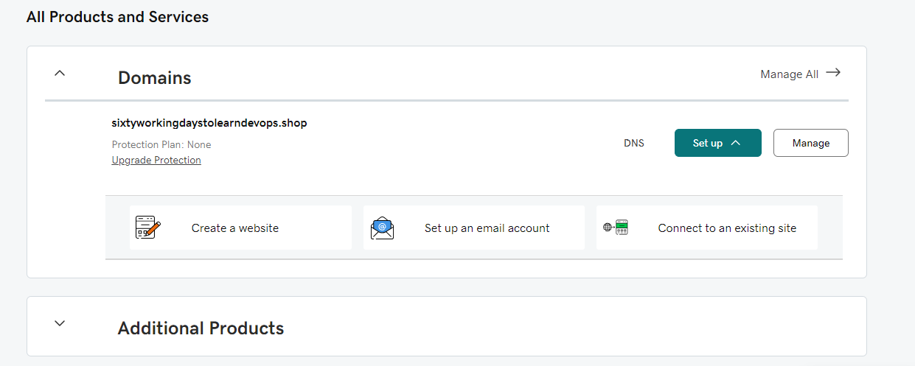

Step2:

Create a VM, install nginx and run web application

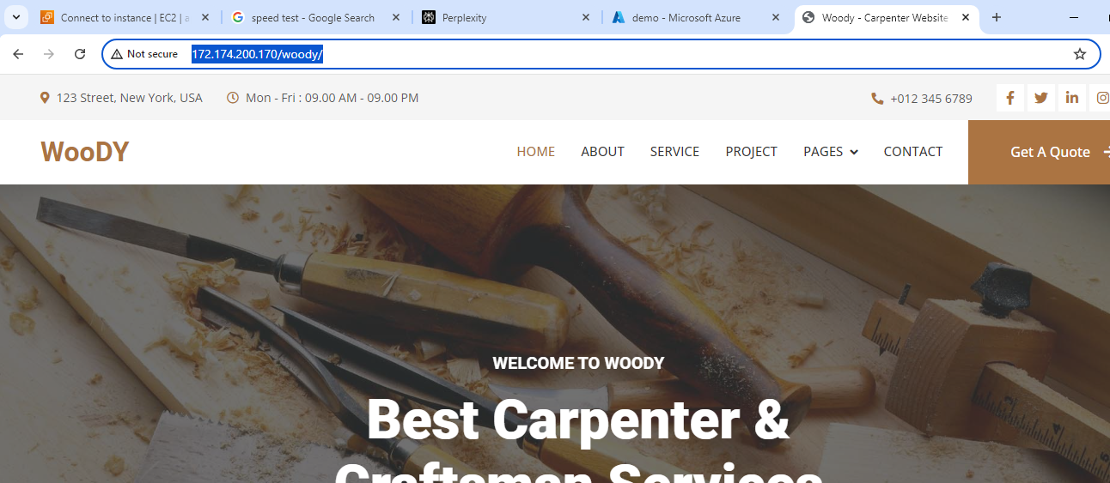

To apply ssl certificate to nginx

Install Certbot

sudo apt-get update

sudo apt-get install certbot python3-certbot-nginx

To generate certificate for my domain.

sudo certbot --nginx -d sixtyworkingdaystolearndevops.shop -d [www.sixtyworkingdaystolearndevops.shop](http://www.sixtyworkingdaystolearndevops.shop)



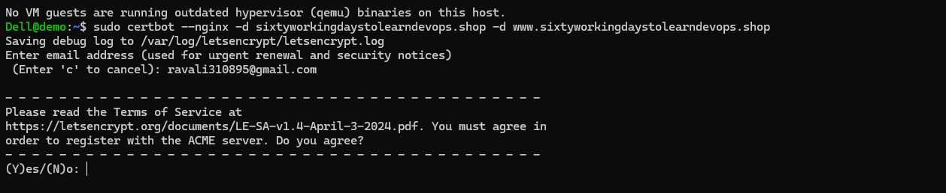

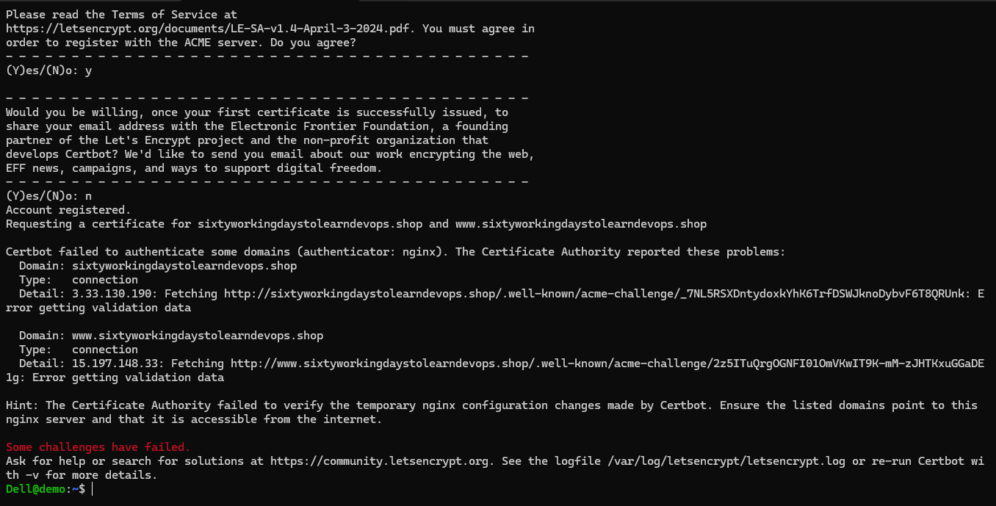

To add the IP address of your machine in DNS

Log into Your Domain Registrar: GoDaddy

<https://dcc.godaddy.com/control/portfolio/sixtyworkingdaystolearndevops.shop/settings?tab=dns&itc=mya_vh_buildwebsite_domain>

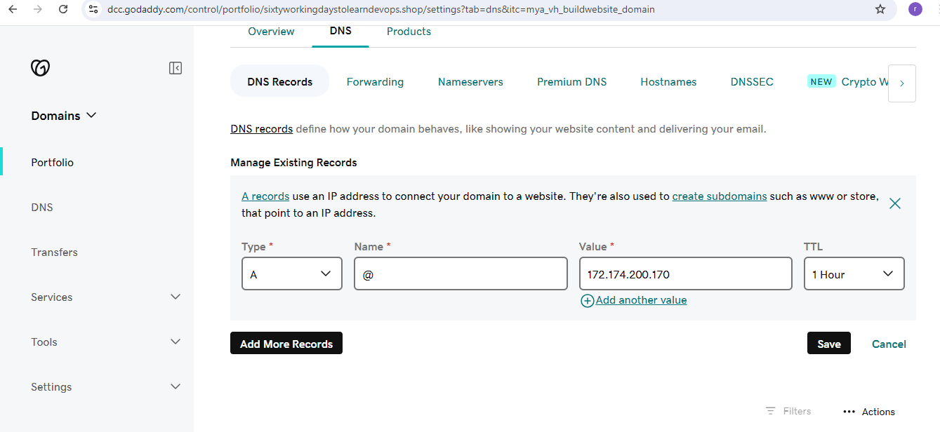

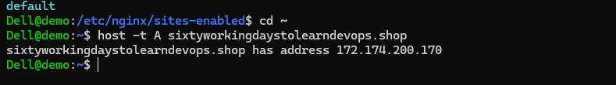

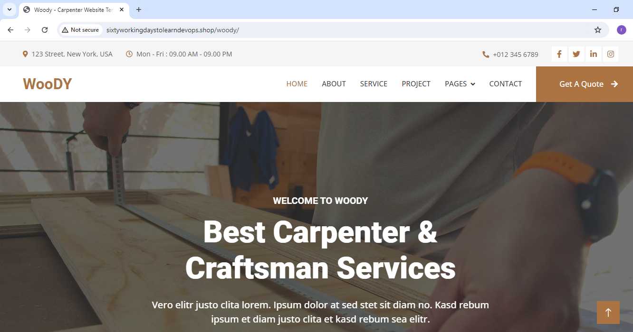

To generate certificate for your domain.

sudo certbot --nginx -d sixtyworkingdaystolearndevops.shop -d [www.sixtyworkingdaystolearndevops.shop](http://www.sixtyworkingdaystolearndevops.shop)

