**ITS 462 Lab6: Transform XML with XSLT + XPath.**

***6.1 Denison Public library.***   
Helen Young is a programmer at Denison Public Library in Ennis, Montana. The library has recently set up a database system in which lists of library items are written to XML documents. Helen wants to be able to view those lists as HTML code within her web browser. She has asked you to help develop an XSLT style sheet to write that HTML code. A preview of the web

page is shown in Figure 1.

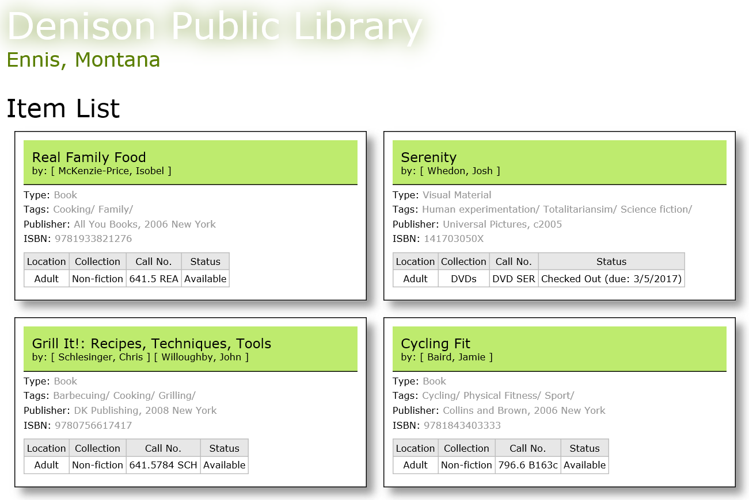

Figure 1: libary item list

The sample list she’s compiled includes books and DVDs. If an item is currently checked out, she wants the page to display the due date for the item. Helen has already created a CSS style sheet for the page; your job will be to create the XSLT style sheet.

Complete the following:

1. Using your text editor, open the **items.xml** and **library.xsl** files from the attached zipped

folder. Enter ***your name*** and the ***date*** in the comment section of each file, and save them

respectively.

1. Go to the **items.xml** file in your text editor. Review the content of the file and its structure. Add a processing instruction after the comment section that attaches the **library.xsl** style sheet to this XML document. Close the file, save your changes.
2. Go to the **library.xsl** file in your text editor and go down to the root template. Add the following commands to the template:

<html>

<head>

<title>Denison Public Library</title>

<link href=”libstyles.css”

rel=”stylesheet” type=”text/css” />

</head>

<body>

<header>

<h1>Denison Public Library</h1>

<h2>Ennis, Montana</h2>

</header>

</body>

</html>

1. Within the root template directly above the </body> tag, insert the following:

<section>

<h1>Item List</h1>

*item template*

</section>  
where *item template* applies the template for the itemlist/item path.

1. Create a template for the item element to display information on each library item. Add the following HTML code to the template:

<article>

</article>

1. Within the <article></article> tags, insert the following to display the title and authors of

the library item:

<h1>*title*</h1>

<h2>by: [*author*] [*author*] …

where *title* is the value of the title element and [*author*] [*author*] … is the list of authors for the work. (Hint: Use the for-each instruction to go through each author element in the

authors/author path.)

1. Below the h2 heading, insert the following:

<p>

Type:

<span>

*type*

</span>

</p>

where *type* is the value of the type element.

1. Below the closing </p> tag, insert the following:

<p>

Tags:

<span>

*subject*/*subject*/……

</span>

</p>

where *subject/subject/…* is a list of the subject values within the subjects/subject path

separated with the “/” symbol.   
(Hint: Use the for-each instruction with the subjects/subject path and display the value of the context node within the for-each element.)

1. Below the list of subjects, insert the following:

<p>

Publisher:

<span>*publisher*</span>

</p>

<p>

ISBN:

<span>*isbn*</span>

</p>

where *publisher* and *isbn* are the values of the publisher and isbn elements.

1. Below the closing </p> tag, insert the following table:

<table>

<tr>

<th>Location</th>

<th>Collection</th>

<th>Call No.</th>

<th>Status</th>

</tr>

<tr>

<td>*location*</td>

<td>*collection*</td>

<td>*callno*</td>

<td>

*status*

(due: *return*)

</td>

</tr>

</table>  
where *location*, *collection*, *callno*, and *status* are the values of the location, collection, callno, and status elements. If the status element contains a return attribute, display the text (due: *return*) where *return* is the value of the return attribute.

1. Save your changes to the file.
2. Generate your result document using your web browser (IE is preferred). Verify that the layout and content of first several items match those shown in Figure 1.

**What you need to submit to blackboard:**

1. **Lab report including** 
   1. **Your XML source code**
   2. **Your XSLT source code**
   3. **Screenshot displaying your result xml on your web browser**

**(Note:**

* **Lab report must be separated from your zipped folder**
* **There is a template in lab folder (check “Lab Resources”) from Blackboard, use it!)**

1. **Zipped folder including xml and xslt file.**